Fault Condition Two and Three Report

Fault condition two and three of ASHRAE Guideline 36 is related to flagging mixing air temperatures of the AHU that are out of acceptable ranges. Fault condition 2 flags mixing air temperatures that are too low and fault condition 3 flags mixing temperatures that are too high when in comparision to return and outside air data. The mixing air temperatures in theory should always be in between the return and outside air temperatures ranges. Fault condition two equation as defined by ASHRAE:

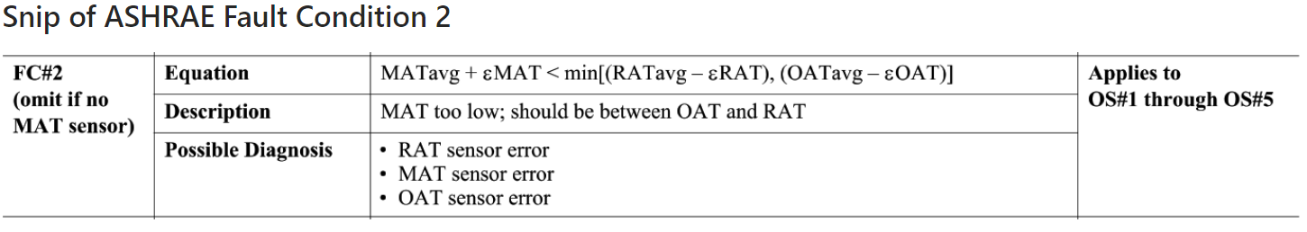

Fault condition three equation as defined by ASHRAE:

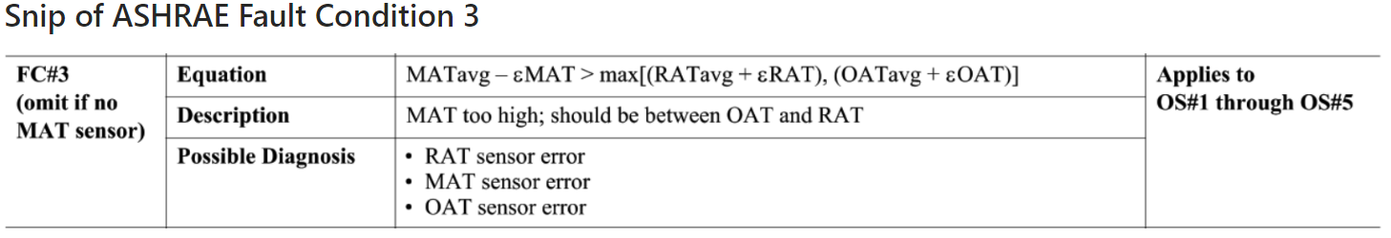

## Dataset Plot

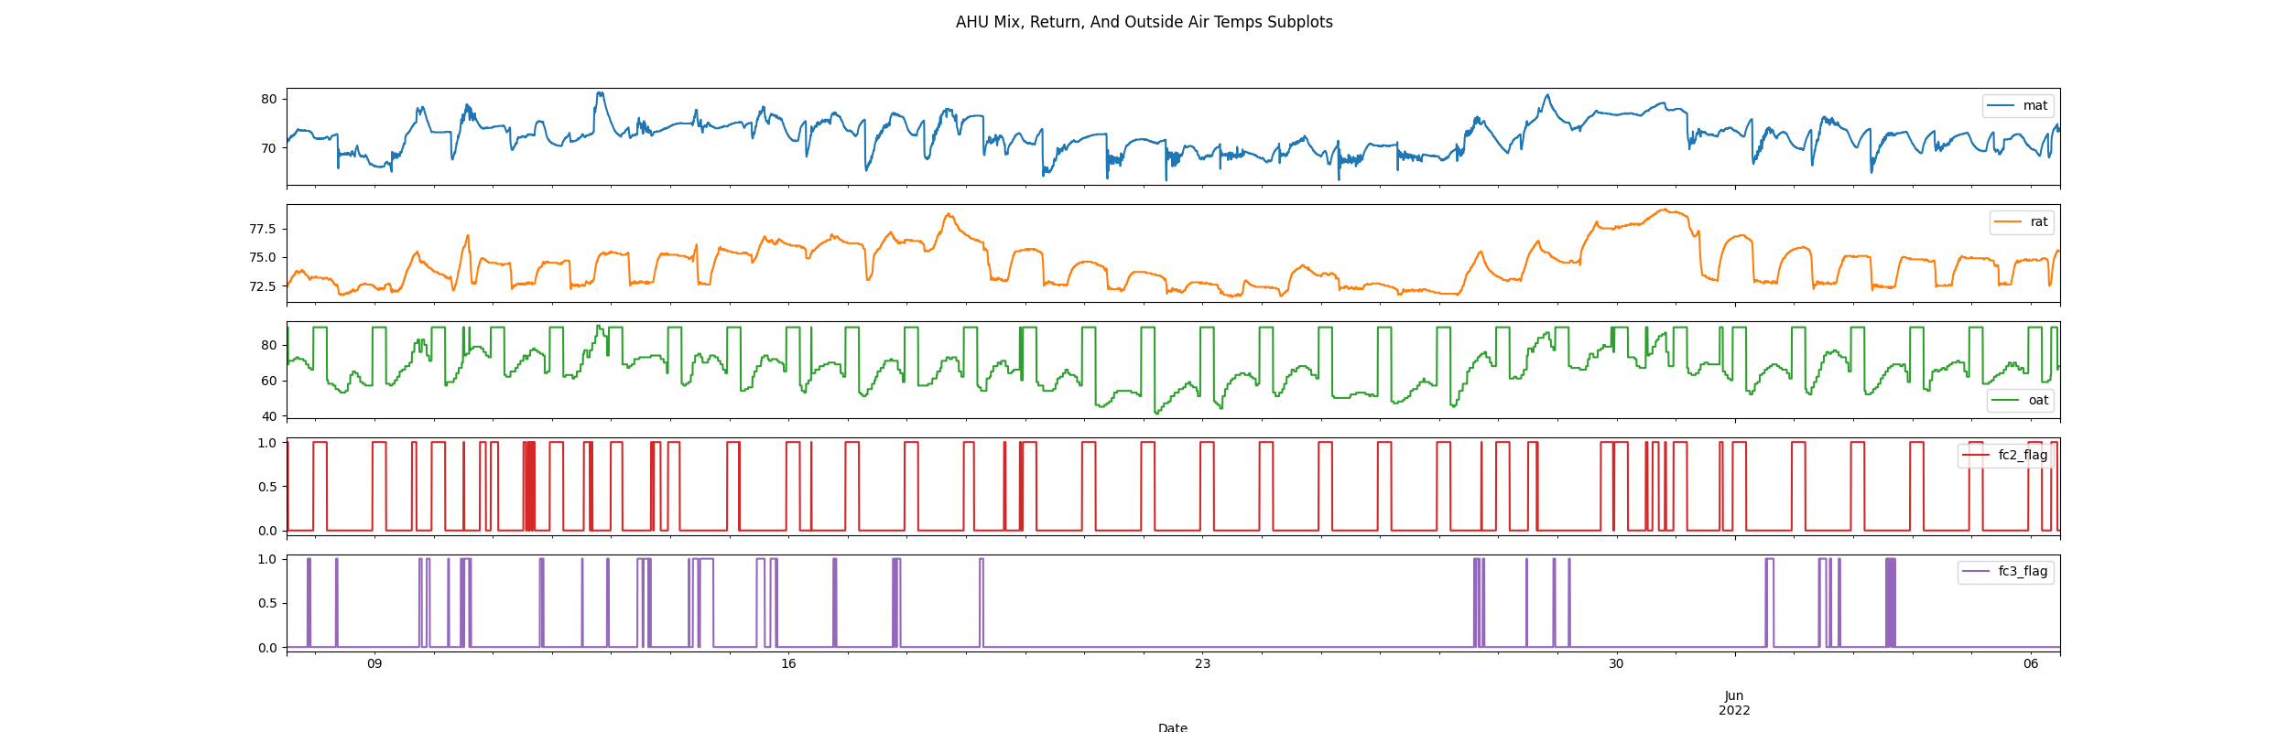

## Dataset Statistics

* Total time calculated in dataset: 29 days 23:55:00
* Total time in hours calculated in dataset: 719.92
* Total time in hours for when FDD flag 2 is True: 18.0
* Total time in hours for when FDD flag 3 is True: 22.92
* Percent of time in the dataset when the Fault flag 2 is True: 25.83%
* Percent of time in the dataset when the Fault flag 3 is True: 6.52%
* Percent of time in the dataset when flag 2 is False: 74.17%
* Percent of time in the dataset when flag 3 is False: 93.48%

## Time-of-day Histogram Plots

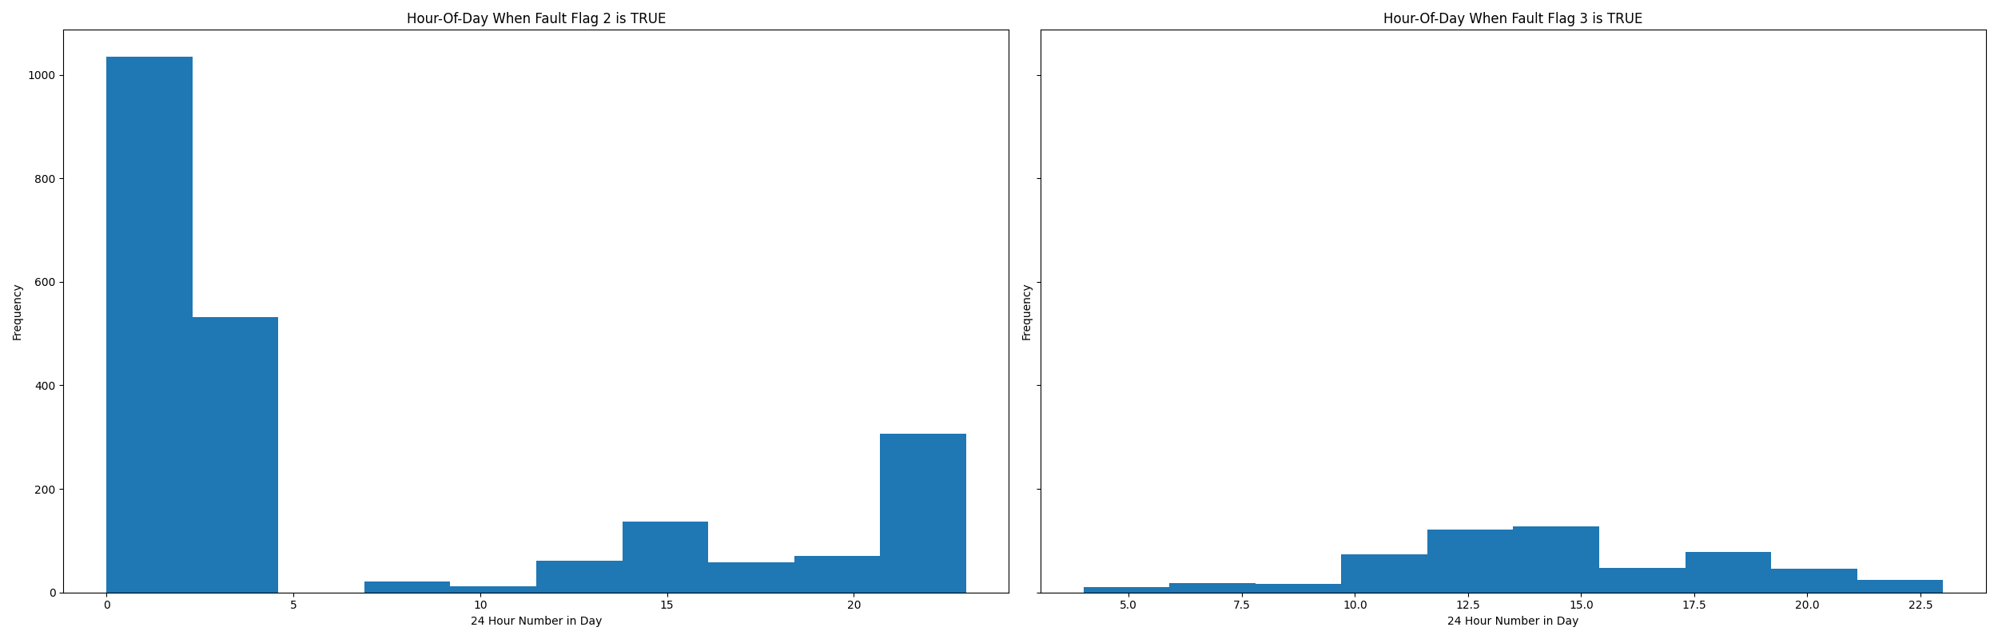

* Average mix air temp for when in fault condition 2 is True (mixing temp is LOW outside the ranges of return and outside temp): 72.07 °F
* Average mix air temp for when in fault condition 3 is True (mixing temp is HIGH and outside the ranges of return and outside temp): 75.34 °F

## Mix Temp Statistics

* count 8639.000000  
  mean 72.259440  
  std 3.106969  
  min 63.200000  
  25% 69.900000  
  50% 72.400000  
  75% 74.400000  
  max 81.300000  
  Name: mat, dtype: float64

## Return Temp Statistics

* count 8639.000000  
  mean 74.300475  
  std 1.775012  
  min 71.500000  
  25% 72.700000  
  50% 74.300000  
  75% 75.500000  
  max 79.200000  
  Name: rat, dtype: float64

## Outside Temp Statistics

* count 8639.000000  
  mean 70.390439  
  std 13.560452  
  min 41.000000  
  25% 59.500000  
  50% 68.000000  
  75% 85.000000  
  max 91.000000  
  Name: oat, dtype: float64

## Suggestions based on data analysis

* The percent True of time in the dataset for when the mixing air temperature is out of theoretical range is very high which indicates hardware problems associated with the HVAC controls. The electronic inputs on the HVAC controller could be corrupt or the sensor may need to be replaced. Mixing temperature sensors are supposed to be a long (often 20’) precisely installed averaging type sensor where it takes a good instalation to get a good actual averaged mixed air temperature reading versus return and discharge air sensors where quite often these are just short probe type sensors installed into the AHU duct work. To troubleshoot sensor values, try in the field to use testing probes inserted into the air stream of the AHU when it is running. Make sure to use high precision calibrated 3rd party tools are higher accuracy than the BAS controller sensors. Good commissioning agents from a A/E firms that specialize in field calibration of BAS can potentially be used to validate sensor readings as well. Another thing to watch out for is control system programming (quite often a service bandage on something broken) can also be utilized to override sensor values of field level device I/O in the cases where data plots look unusual and when high fault flags occur.

Report generated: Mon Dec 5 10:16:17 2022