Fault Condition Four Report

Fault condition four of ASHRAE Guideline 36 is related to flagging control programming that is hunting causing excessive oscilating between heating, economizing, economizing plus mechanical cooling, and mechanical cooling operating states. Fault condition four equation as defined by ASHRAE:

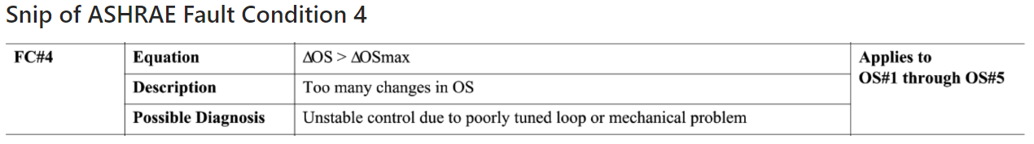

## Heating, Cooling, and OA Damper Signal Plot

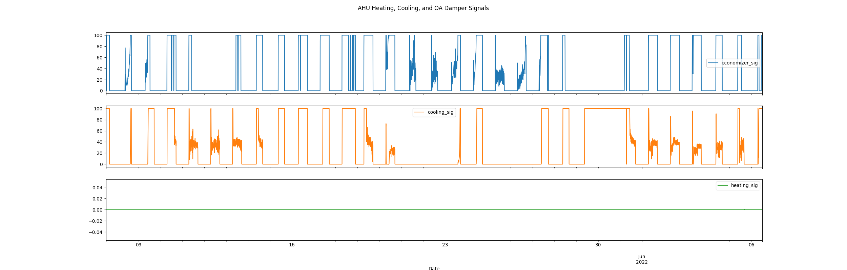

## Calculated Operating States Plot

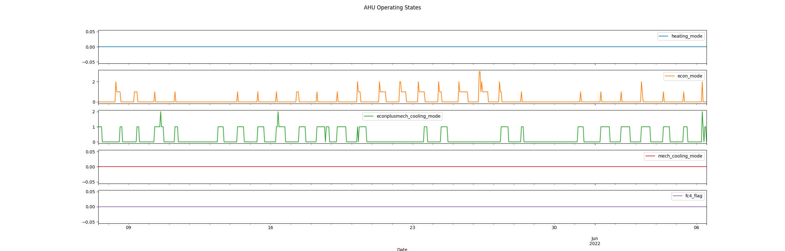

## Dataset Statistics

* Total time calculated in dataset: 30 days 00:00:00
* Total time in hours calculated in dataset: 720.0
* Total time in hours while AHU is in a heating mode: 0.0
* Total percent time in while AHU is in a heating mode: 0.0%
* Total time in hours while AHU is in a economizing mode: 0.0
* Total percent time in while AHU is in a economizing mode: 14.15%
* Total time in hours while AHU is in a economizing plus mechanical cooling mode: 12.0
* Total percent time in while AHU is in a economizing plus mechanical cooling mode: 25.94%
* Total time in hours while AHU is in a mechanical cooling mode: 0.0
* Total percent time in while AHU is in a mechanical cooling mode: 0.0%
* No fault condition 4 calcualted in the dataset

## Heating Signal Statistics

* count 8634.0  
  mean 0.0  
  std 0.0  
  min 0.0  
  25% 0.0  
  50% 0.0  
  75% 0.0  
  max 0.0  
  Name: heating_sig, dtype: float64

## Cooling Signal Statistics

* count 8638.000000  
  mean 24.319542  
  std 39.250299  
  min 0.000000  
  25% 0.000000  
  50% 0.000000  
  75% 37.400000  
  max 100.000000  
  Name: cooling_sig, dtype: float64

## Economizer Free Cooling Statistics

* count 8640.000000  
  mean 24.416516  
  std 41.145222  
  min 0.000000  
  25% 0.000000  
  50% 0.000000  
  75% 35.925000  
  max 100.000000  
  Name: economizer_sig, dtype: float64

Report generated: Mon Dec 5 10:21:51 2022