Fault Condition Ten Report

Fault condition ten of ASHRAE Guideline 36 is an AHU economizer + mechanical cooling mode only with an attempt at flagging conditions where the outside air temperature and mixing air temperatures are not approximetely equal when the AHU is in a 100% outside air mode. Fault condition ten equation as defined by ASHRAE:

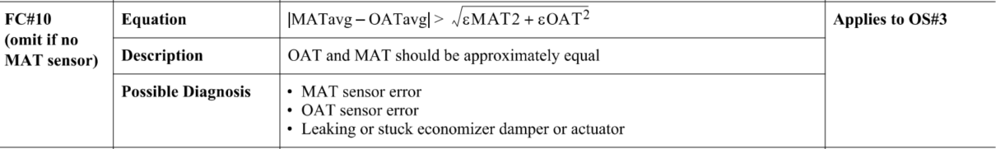

## Dataset Plot

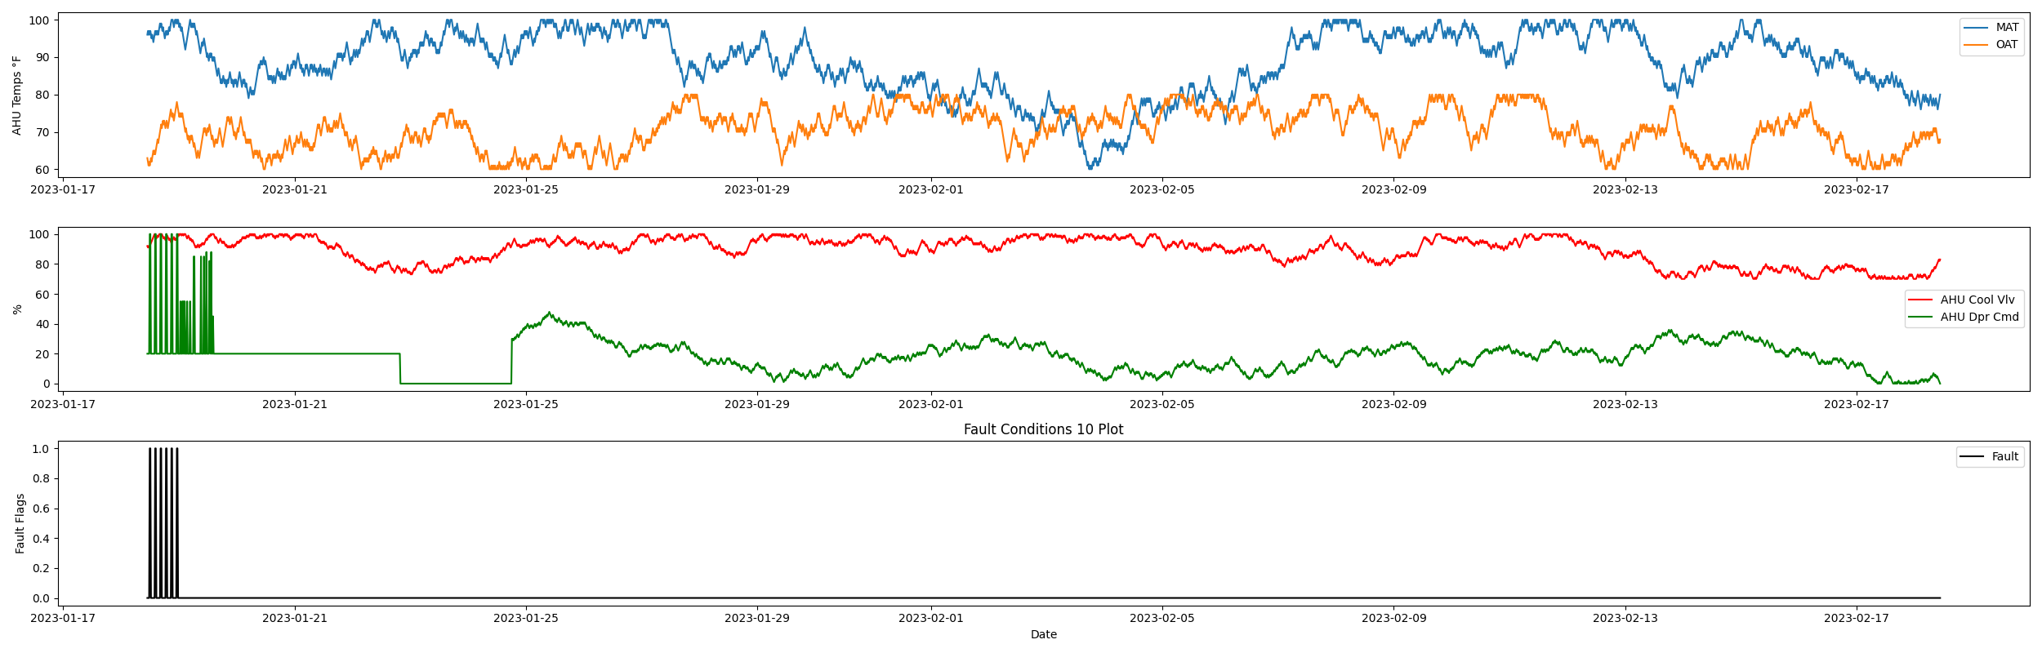

## Dataset Statistics

* Total time in days calculated in dataset: 30.99
* Total time in hours calculated in dataset: 743.75
* Total time in hours for when fault flag is True: 3.0
* Percent of time in the dataset when the fault flag is True: 0.4%
* Percent of time in the dataset when the fault flag is False: 99.6%
* Calculated motor runtime in hours based off of VFD signal > zero: 278.0

## Time-of-day Histogram Plots

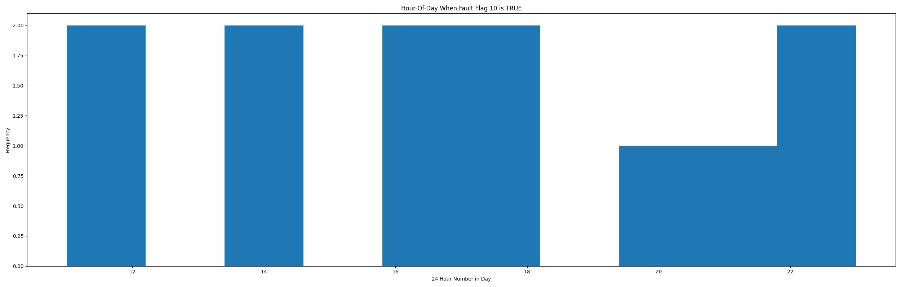

* When fault condition 9 is True the average outside air is 70.33 in °F and the mixing air temperature is 97.92 in °F.

# Summary Statistics filtered for when the AHU is running

### Mixing Air Temp

* count 1112.000000  
  mean 86.273381  
  std 8.969741  
  min 60.000000  
  25% 81.000000  
  50% 86.000000  
  75% 94.000000  
  max 100.000000  
  Name: oat, dtype: float64

### Outside Air Temp

* count 1112.000000  
  mean 70.627698  
  std 5.494443  
  min 60.000000  
  25% 66.000000  
  50% 71.000000  
  75% 75.000000  
  max 80.000000  
  Name: mat, dtype: float64

## Suggestions based on data analysis

* The percent True metric that represents the amount of time for when the fault flag is True is low inidicating the AHU components are within calibration for this fault equation Ok.

Report generated: Thu Feb 23 10:45:45 2023