Fault Condition Eleven Report

Fault condition eleven of ASHRAE Guideline 36 is an AHU economizer + mechanical cooling mode only with an attempt at flagging conditions where the outside air temperature is too low for 100% outside air AHU operating mode. Fault condition Eleven equation as defined by ASHRAE:

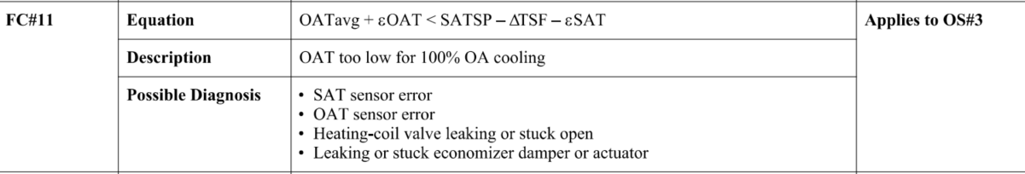

## Dataset Plot

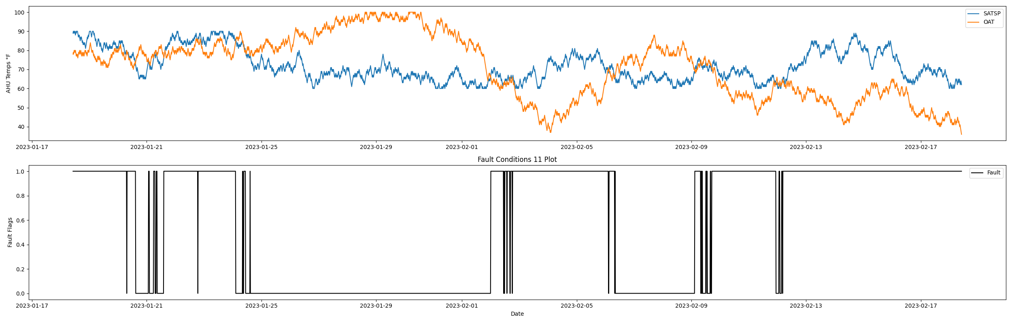

## Dataset Statistics

* Total time in days calculated in dataset: 30.99
* Total time in hours calculated in dataset: 743.75
* Total time in hours for when fault flag is True: 430.75
* Percent of time in the dataset when the fault flag is True: 57.93%
* Percent of time in the dataset when the fault flag is False: 42.07%

## Time-of-day Histogram Plots

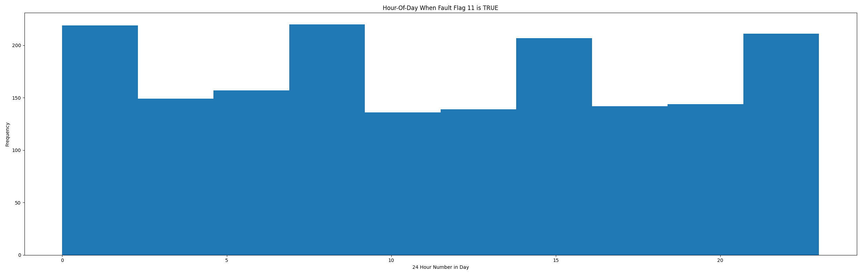

* When fault condition 11 is True the average AHU mix air is 60.97 in °F and the supply air temperature is 75.07 in °F.

## Supply Air Temp Setpoint Statistics

* count 2976.000000  
  mean 71.878696  
  std 8.066555  
  min 60.000000  
  25% 66.000000  
  50% 70.000000  
  75% 78.000000  
  max 90.000000  
  Name: satsp, dtype: float64

## Outside Air Temp Statistics

* count 2976.000000  
  mean 71.205645  
  std 16.524127  
  min 36.000000  
  25% 57.000000  
  50% 75.000000  
  75% 83.000000  
  max 100.000000  
  Name: oat, dtype: float64

## Suggestions based on data analysis

* The percent True metric that represents the amount of time for when the fault flag is True is high indicating temperature sensor error or the heating coil could be leaking potentially creating simultenious heating/cooling scenorio which can be an energy penalty for running the AHU in this fashion. Also visually verify with the AHU off via lock-out-tag-out that the mixing dampers operates effectively. To do this have one person the BAS sending operator override commands to drive the damper back and forth. The other person should put on eyes on the operation of the actuator motor driving the OA dampers 100 percent open and then closed and visually verify the dampers rotate effectively per BAS command where to also visually verify the dampers have a good seal when in the closed position. Also consider looking into BAS programming that may need tuning or parameter adjustments for the staging between OS state changes between AHU modes of operation.

Report generated: Sat Feb 18 13:50:46 2023