Fault Condition Twelve Report

Fault condition Twelve of ASHRAE Guideline 36 is an AHU economizer + mechanical cooling mode and AHU mechanical cooling mode only with an attempt at flagging conditions when the AHU mixing air temperature is warmer than the supply air temperature. Fault condition Twelve equation as defined by ASHRAE:

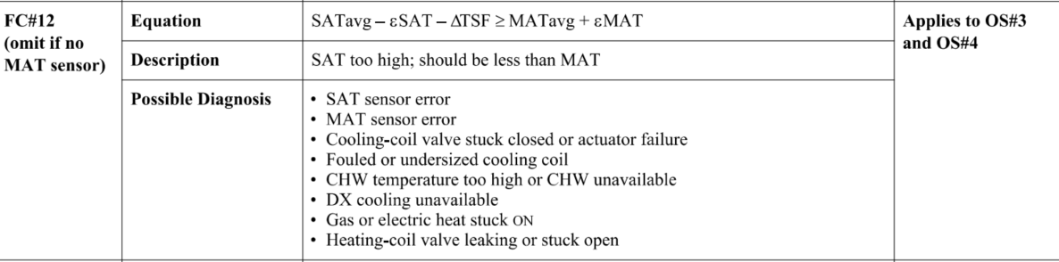

## Dataset Plot

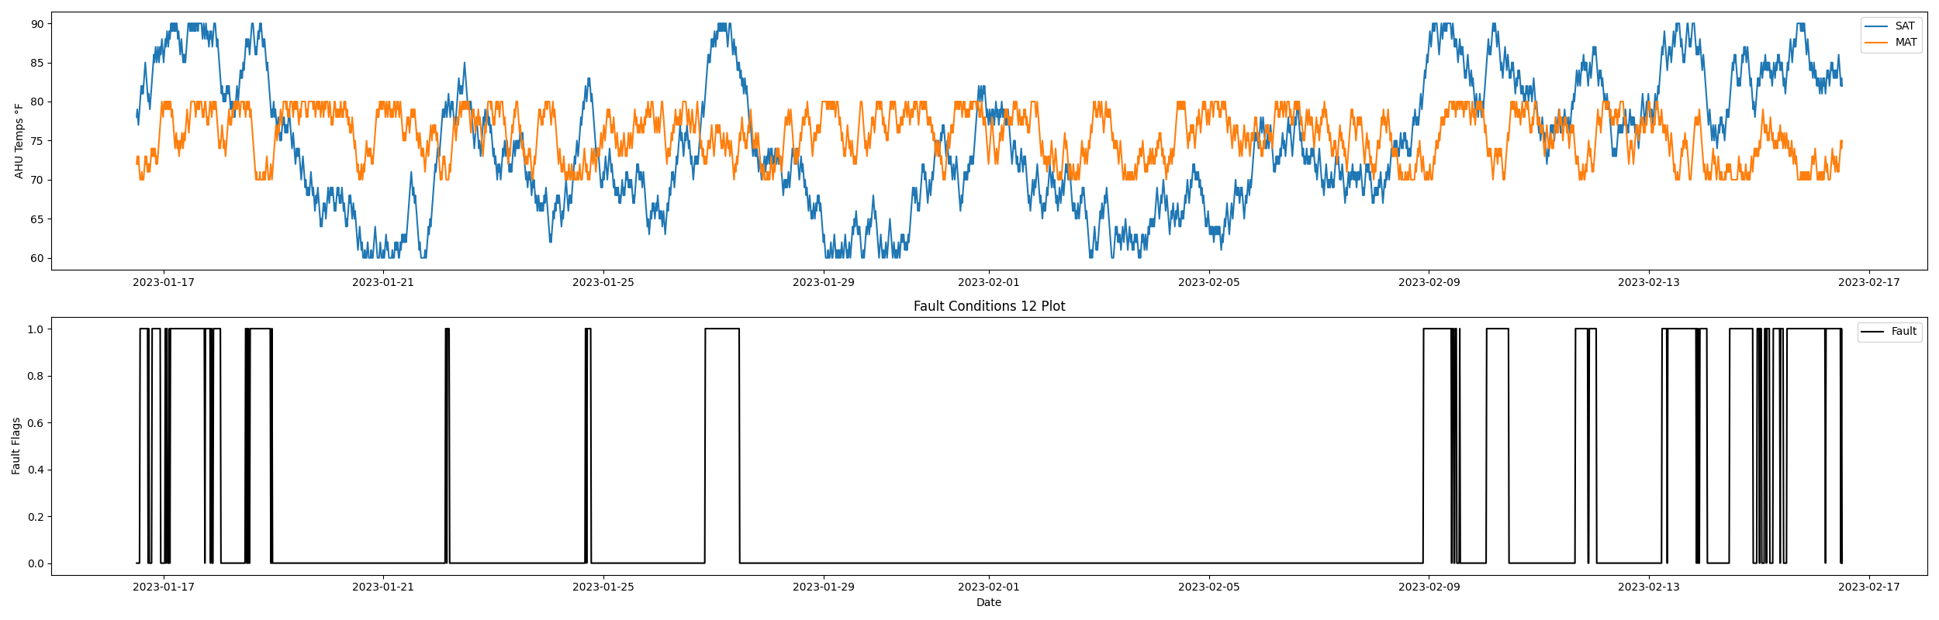

## Dataset Statistics

* Total time in days calculated in dataset: 30.99
* Total time in hours calculated in dataset: 743.75
* Total time in hours for when fault flag is True: 151.25
* Percent of time in the dataset when the fault flag is True: 20.33%
* Percent of time in the dataset when the fault flag is False: 79.67%

## Time-of-day Histogram Plots

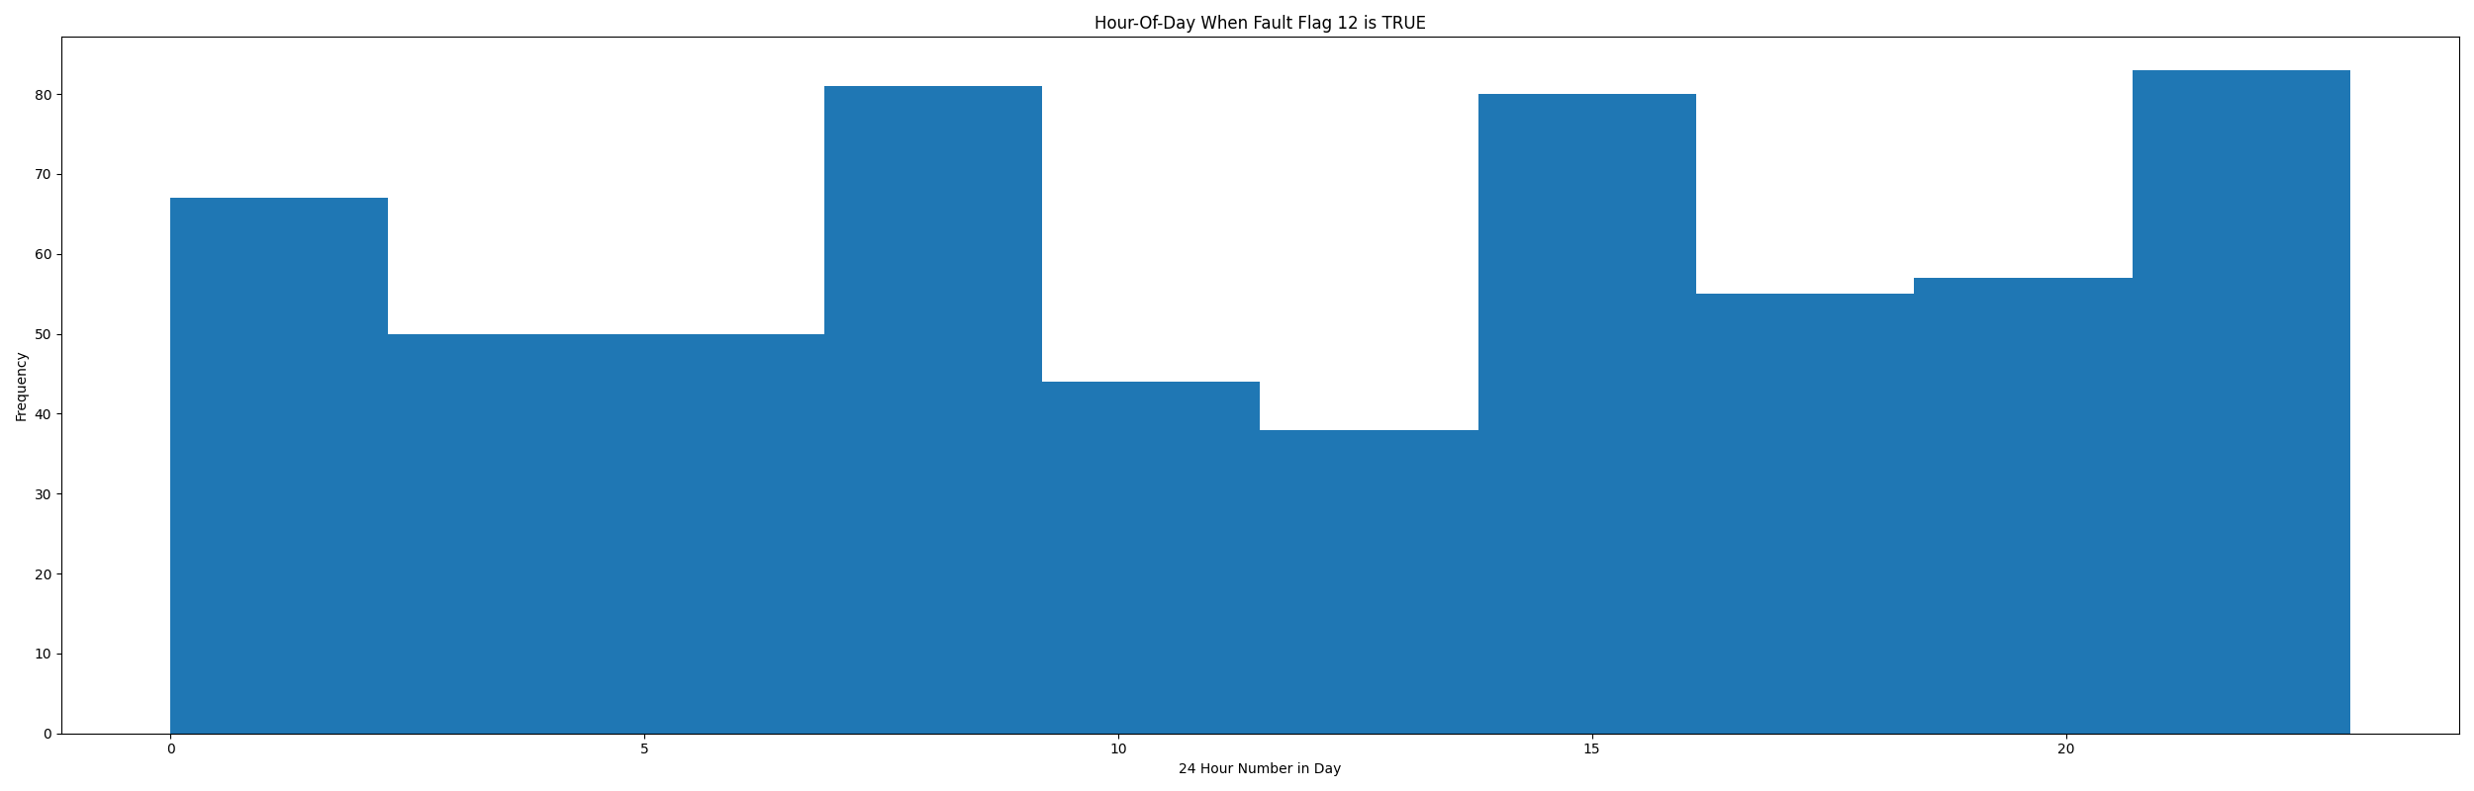

* When fault condition 12 is True the average AHU mix air is 73.63 in °F and the supply air temperature is 86.27 in °F.

## Supply Air Temp Statistics

* count 2976.00000  
  mean 74.47547  
  std 8.49728  
  min 60.00000  
  25% 68.00000  
  50% 74.00000  
  75% 82.00000  
  max 90.00000  
  Name: sat, dtype: float64

## Mix Air Temp Statistics

* count 2976.000000  
  mean 75.668347  
  std 3.121175  
  min 70.000000  
  25% 73.000000  
  50% 76.000000  
  75% 78.000000  
  max 80.000000  
  Name: mat, dtype: float64

## Suggestions based on data analysis

* The percent True metric that represents the amount of time for when the fault flag is True is high temperature sensor error or the heating/cooling coils are leaking potentially creating simultenious heating/cooling which can be an energy penalty for running the AHU in this fashion. Verify AHU mix/supply temperature sensor calibration in addition to potential mechanical with a leaking valve. A leaking valve can be troubleshot by verifying delta temperature of the fluid entering and leaving the coil when the AHU is running with a valve in a BAS operator override in a 100% closed command.

Report generated: Sat Feb 18 13:11:00 2023