Fault Condition Thirteen Report

Fault condition thirteen of ASHRAE Guideline 36 is an AHU cooling mode only with an attempt at verifying an AHU cooling valve is not stuck or leaking by verifying AHU supply temperature to supply temperature setpoint. Fault condition thirteen equation as defined by ASHRAE:

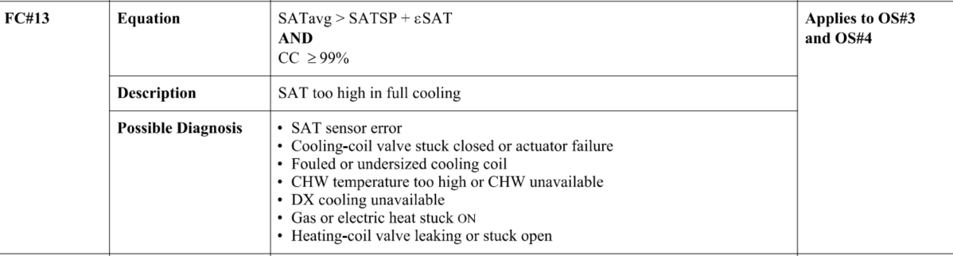

## Dataset Plot

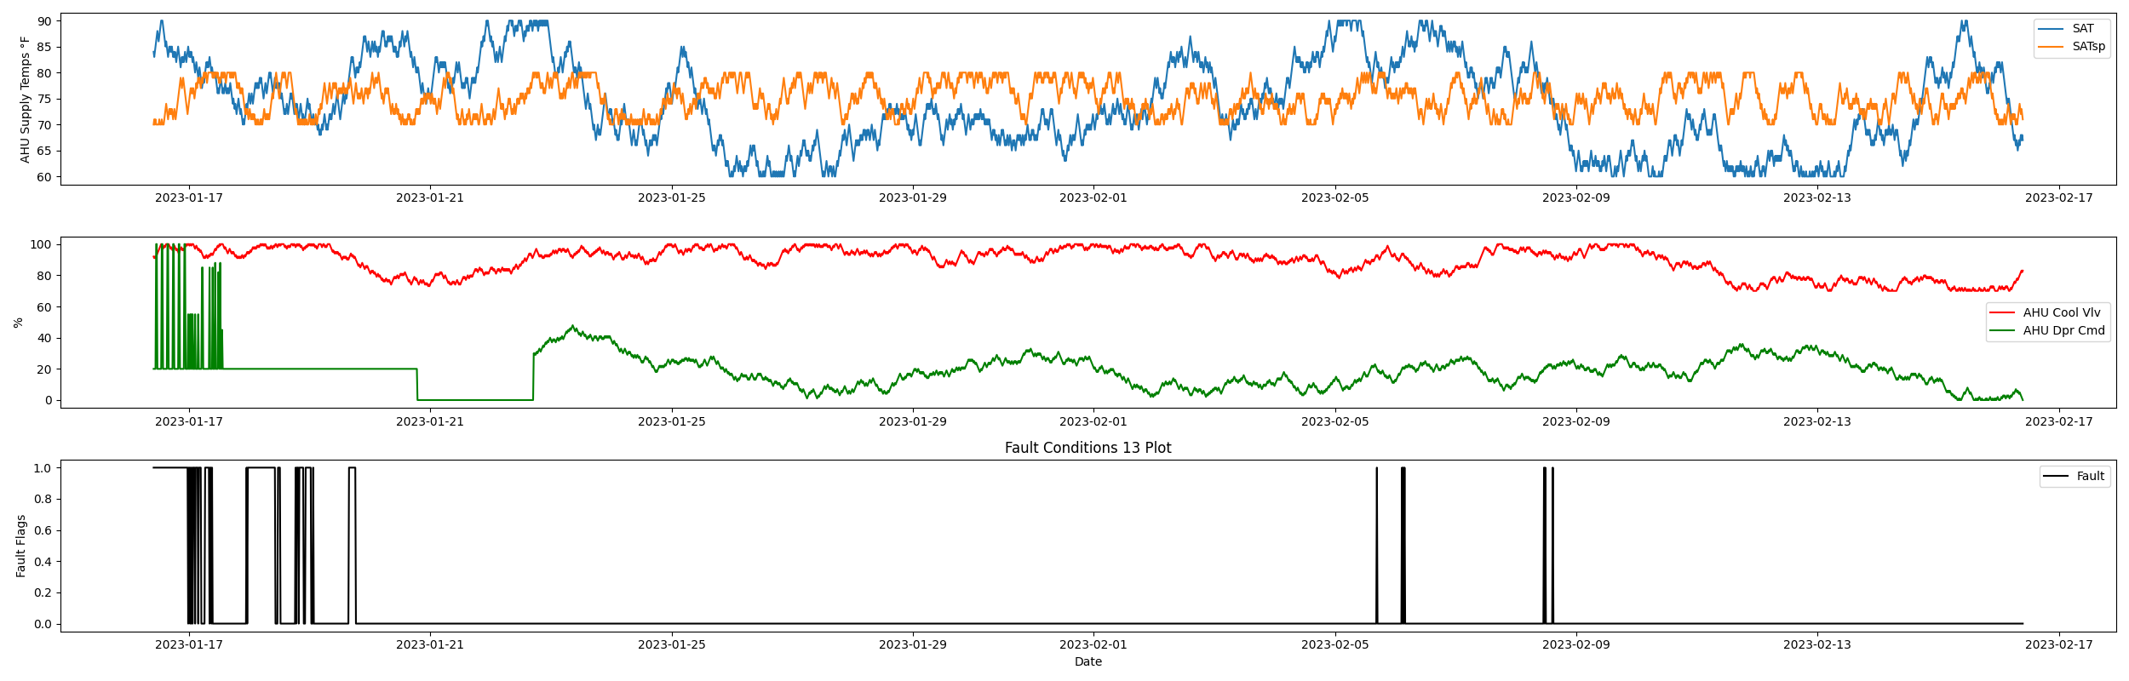

## Dataset Statistics

* Total time in days calculated in dataset: 30.99
* Total time in hours calculated in dataset: 743.75
* Total time in hours for when fault flag is True: 41.75
* Percent of time in the dataset when the fault flag is True: 5.65%
* Percent of time in the dataset when the fault flag is False: 94.35%
* Calculated motor runtime in hours based off of VFD signal > zero: 278.0

## Time-of-day Histogram Plots

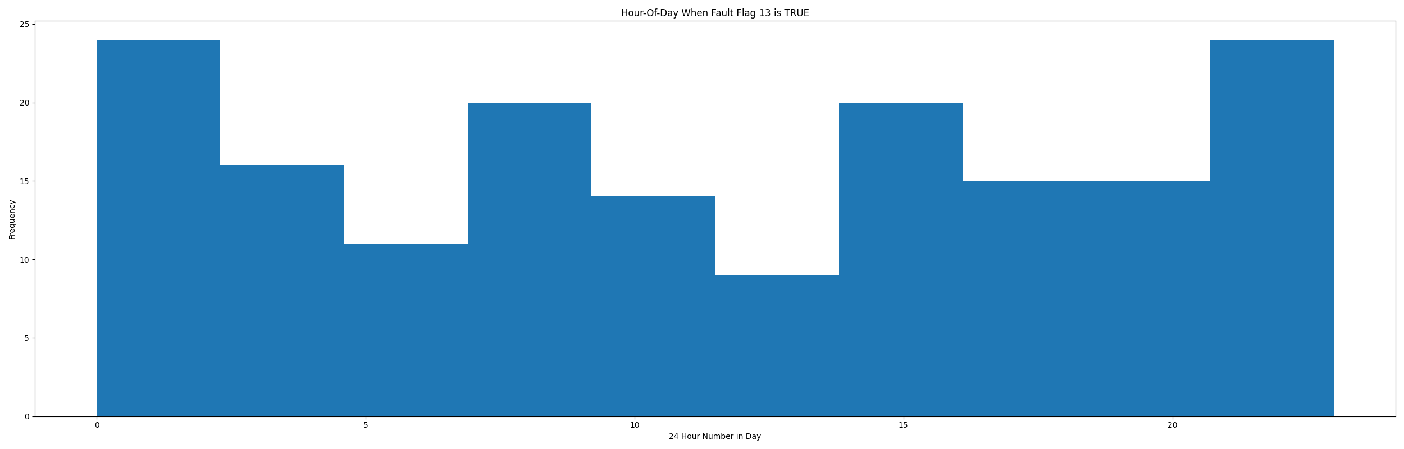

* When fault condition 13 is True the average AHU supply air setpoint is 73.52 in °F and the supply air temperature is 80.08 in °F.

# Summary Statistics filtered for when the AHU is running

### Supply Air Temp

* count 1112.000000  
  mean 79.610612  
  std 5.662929  
  min 65.000000  
  25% 75.000000  
  50% 80.000000  
  75% 84.000000  
  max 90.000000  
  Name: sat, dtype: float64

### Supply Air Temp Setpoint

* count 1112.000000  
  mean 74.653777  
  std 2.958109  
  min 70.000000  
  25% 72.000000  
  50% 75.000000  
  75% 77.000000  
  max 80.000000  
  Name: satsp, dtype: float64

### Cooling Coil Valve

* count 1112.000000  
  mean 88.461331  
  std 8.929181  
  min 70.000000  
  25% 82.000000  
  50% 91.000000  
  75% 96.000000  
  max 100.000000  
  Name: clg, dtype: float64

## Suggestions based on data analysis

* The percent True metric that represents the amount of time for when the fault flag is True is high indicating the AHU cooling valve maybe broken or there could be a flow issue with the amount of cold water flowing through the coil or that the chiller system leaving temperature reset is too aggressive and there isnt enough cold air being produced by this cooling coil. If this AHU has a DX cooling coil there could be a problem with the refrigerant charge. It could be worth viewing mechanical blue prints for this AHU design schedule to see what cold water temperature this coil was designed for and compare it to actual cold water supply temperatures. IE., an AHU cooling coil sized to have a 44°F water flowing through it may have significant performance reduction with 48°F water flowing through it and under design day type high load conditions this AHU may not meet setpoint or properly dehumidify the air for the building which could potentially also lead to IAQ or mold issues if %RH levels in the zones are kept within tollerance. Also check excessive outside air faults in fault condition 6 that the AHU isnt taking in too much outdoor air which could also cause coil performance issues if the load on the coil is higher than what it was intended for.

Report generated: Thu Feb 23 10:56:53 2023