Fault Condition One Report

Fault condition one of ASHRAE Guideline 36 is related to flagging poor performance of a AHU variable supply fan attempting to control to a duct pressure setpoint. Fault condition equation as defined by ASHRAE:

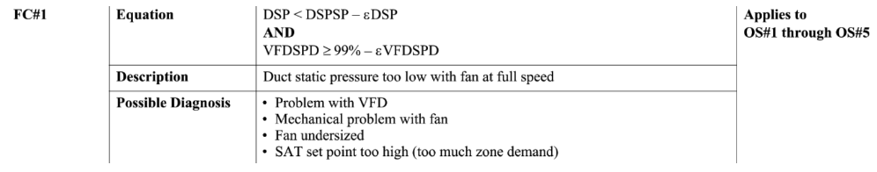

## Dataset Plot

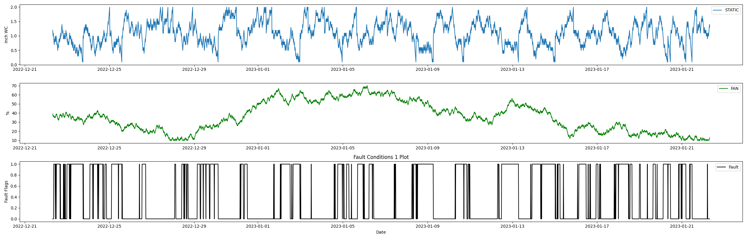

## Dataset Statistics

* Total time in days calculated in dataset: 30.99
* Total time in hours calculated in dataset: 743.75
* Total time in hours for when fault flag is True: 274.0
* Percent of time in the dataset when the fault flag is True: 36.83%
* Percent of time in the dataset when the fault flag is False: 63.17%

## Time-of-day Histogram Plots

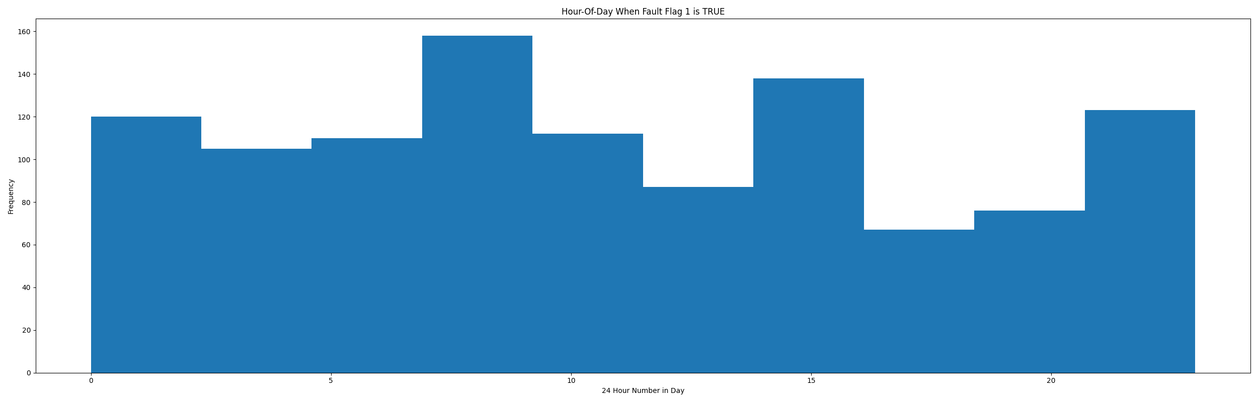

* Average duct system pressure for when in fault condition (fan VFD speed > 95%): 0.66"WC

## VFD Speed Statistics

* count 2976.000000  
  mean 35.933132  
  std 16.206915  
  min 10.000000  
  25% 22.000000  
  50% 35.000000  
  75% 51.000000  
  max 70.000000  
  Name: supply_vfd_speed, dtype: float64

## Duct Pressure Statistics

* count 2976.000000  
  mean 1.093523  
  std 0.414623  
  min 0.092784  
  25% 0.792784  
  50% 1.092784  
  75% 1.392784  
  max 1.992784  
  Name: duct_static, dtype: float64

## Duct Pressure Setpoints Statistics

* count 2976.0  
  mean 1.0  
  std 0.0  
  min 1.0  
  25% 1.0  
  50% 1.0  
  75% 1.0  
  max 1.0  
  Name: duct_static_setpoint, dtype: float64

## Suggestions based on data analysis

* The percent True metric that represents the amount of time for when the fault flag is True is high indicating the fan is running at high speeds and appearing to not generate good duct static pressure
* No duct pressure setpoint reset detected (BAD)

Report generated: Thu Feb 16 09:36:17 2023