Fault Condition Two Report

Fault condition two and three of ASHRAE Guideline 36 is related to flagging mixing air temperatures of the AHU that are out of acceptable ranges. Fault condition 2 flags mixing air temperatures that are too low and fault condition 3 flags mixing temperatures that are too high when in comparision to return and outside air data. The mixing air temperatures in theory should always be in between the return and outside air temperatures ranges. Fault condition two equation as defined by ASHRAE:

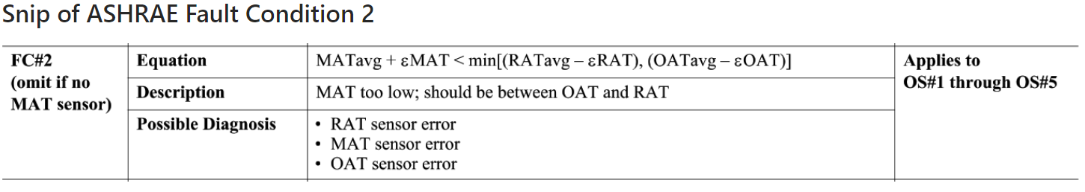

## Dataset Plot

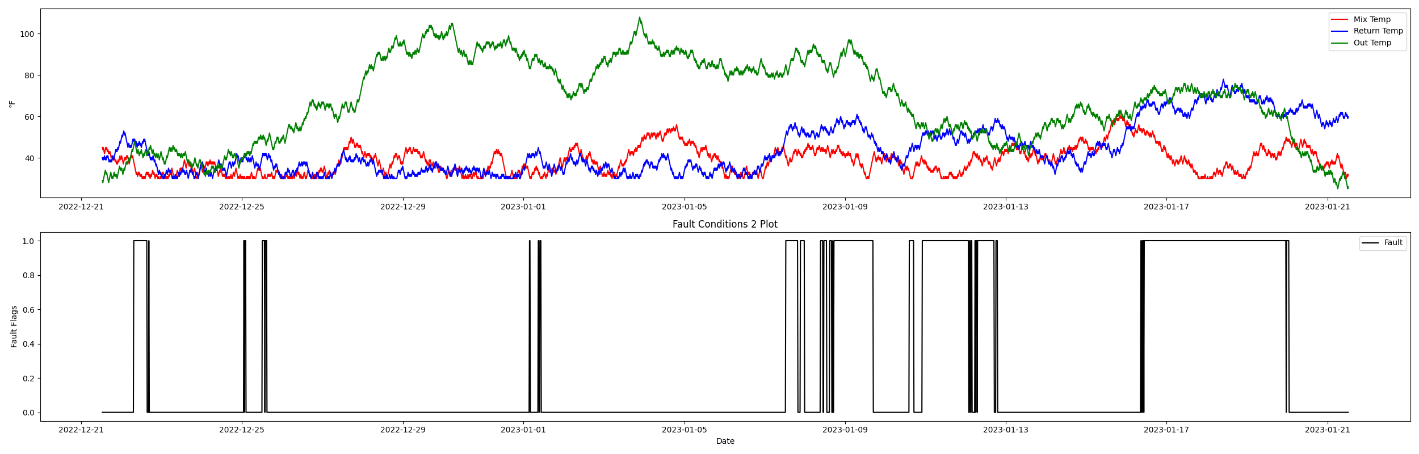

## Dataset Statistics

* Total time in days calculated in dataset: 30.99
* Total time in hours calculated in dataset: 743.75
* Total time in hours for when fault flag is True: 182.25
* Percent of time in the dataset when the fault flag is True: 24.5%
* Percent of time in the dataset when the fault flag is False: 75.5%

## Time-of-day Histogram Plots

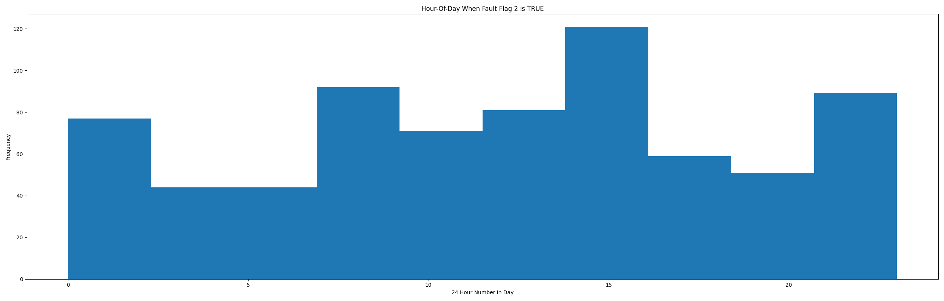

* When fault condition 2 is True the average mix air temp is 37.56°F, outside air temp is 67.8°F, and return air temp is 59.12°F. This could possibly help with pin pointing AHU operating conditions for when this fault is True.

## Mix Temp Statistics

* count 2976.000000  
  mean 38.668347  
  std 6.553148  
  min 30.000000  
  25% 33.000000  
  50% 38.000000  
  75% 43.000000  
  max 61.000000  
  Name: mat, dtype: float64

## Return Temp Statistics

* count 2976.000000  
  mean 44.080645  
  std 12.098790  
  min 30.000000  
  25% 34.000000  
  50% 40.000000  
  75% 53.000000  
  max 78.000000  
  Name: rat, dtype: float64

## Outside Temp Statistics

* count 2976.000000  
  mean 68.164651  
  std 20.050921  
  min 25.000000  
  25% 52.000000  
  50% 70.000000  
  75% 86.000000  
  max 108.000000  
  Name: oat, dtype: float64

## Suggestions based on data analysis

* The percent True of time is low inidicating the AHU temperature sensors are within calibration

Report generated: Thu Feb 16 09:28:25 2023