Fault Condition Four Report

Fault condition four of ASHRAE Guideline 36 is related to flagging AHU control programming that is hunting between heating, economizing, economizing plus mechanical cooling, and mechanical cooling operating states. This fault diagnostic does NOT flag simultaneous heating and cooling, just excessive cycling between the states or operating modes the AHU maybe going in and out of. Fault condition four equation as defined by ASHRAE:

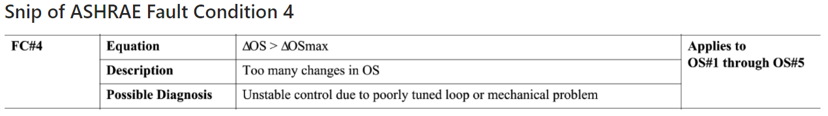

## Calculated Operating States Plot

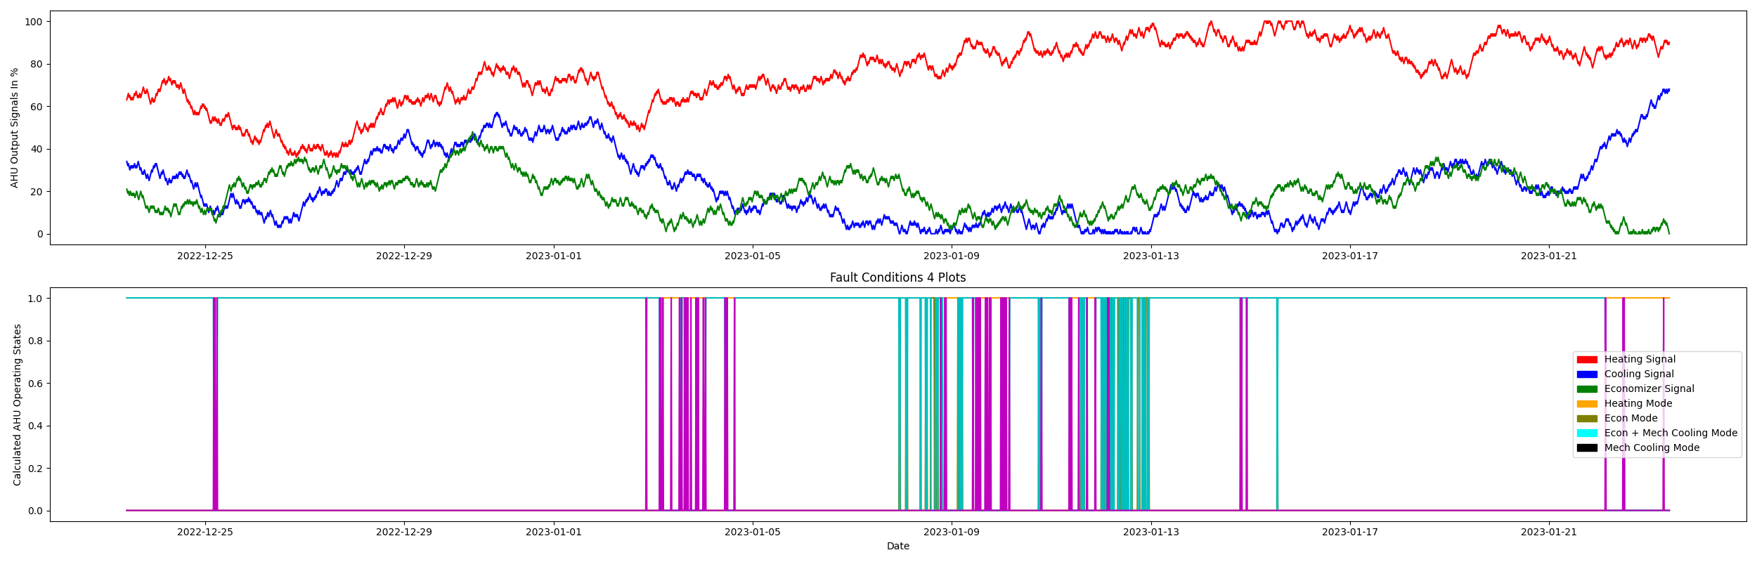

## Dataset Statistics

* Total time in days calculated in dataset: 30.96
* Total time in hours calculated in dataset: 743.0
* Total time in hours while AHU is in a heating mode: 743.0
* Total percent time in while AHU is in a heating mode: 100.0%
* Total time in hours while AHU is in a economizing mode: 44.0
* Total percent time in while AHU is in a economizing mode: 5.91%
* Total time in hours while AHU is in a economizing plus mechanical cooling mode: 679.0
* Total percent time in while AHU is in a economizing plus mechanical cooling mode: 91.4%
* Total time in hours while AHU is in a mechanical cooling mode: 60.0
* Total percent time in while AHU is in a mechanical cooling mode: 8.06%
* No fault condition 4 calcualted in the dataset

## Heating Signal Statistics

* count 2976.000000  
  mean 75.679435  
  std 15.645099  
  min 36.000000  
  25% 66.000000  
  50% 77.000000  
  75% 89.000000  
  max 100.000000  
  Name: heating_sig, dtype: float64

## Cooling Signal Statistics

* count 2976.000000  
  mean 22.199597  
  std 15.901836  
  min 0.000000  
  25% 9.000000  
  50% 19.000000  
  75% 32.000000  
  max 68.000000  
  Name: cooling_sig, dtype: float64

## Economizer Free Cooling Statistics

* count 2976.000000  
  mean 19.188844  
  std 9.399765  
  min 0.000000  
  25% 12.000000  
  50% 20.000000  
  75% 25.000000  
  max 48.000000  
  Name: economizer_sig, dtype: float64

Report generated: Tue Feb 7 12:41:50 2023