Fault Condition Five Report

Fault condition five of ASHRAE Guideline 36 is (an AHU heating mode or winter time conditions only fault equation) related to flagging supply air temperatures that are out of acceptable ranges based on the mix air temperature and an assumption for heat created by the AHU supply fan in the air stream. Fault condition five equation as defined by ASHRAE:

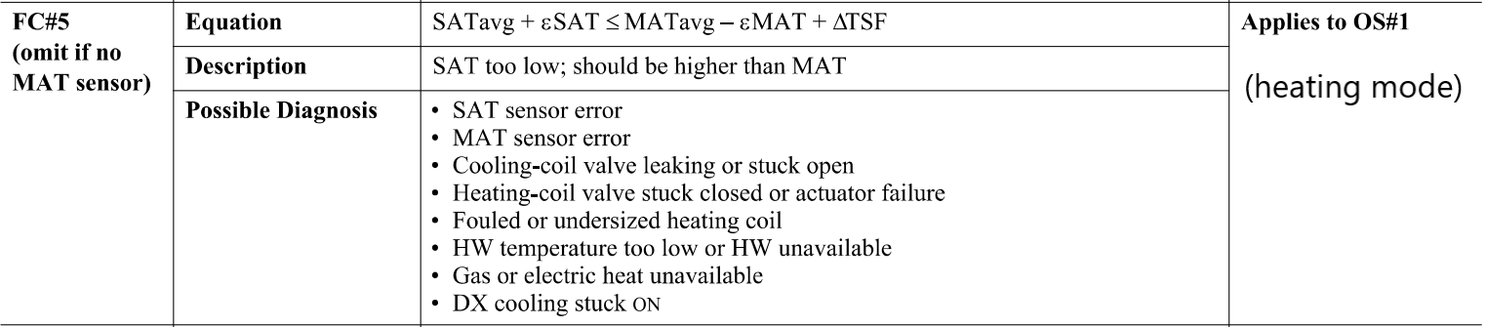

## Dataset Plot

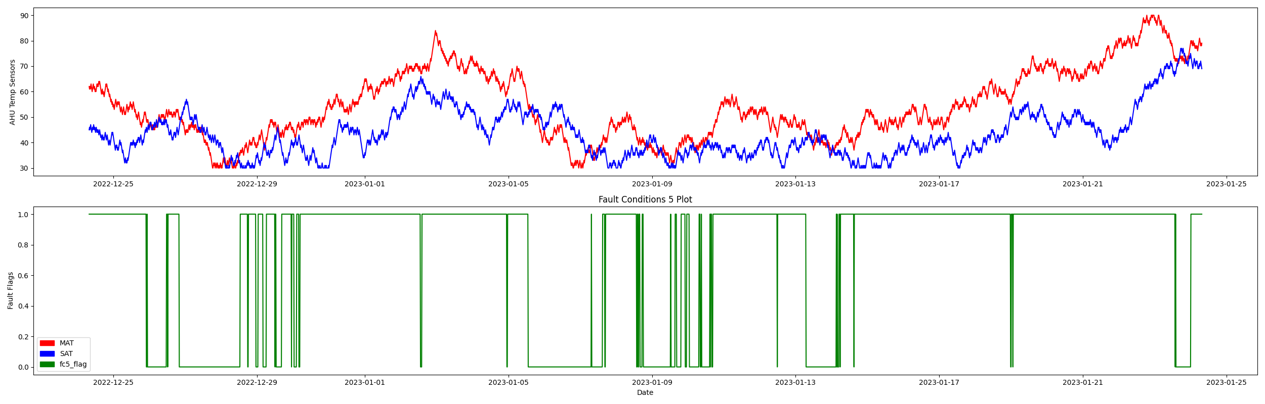

## Dataset Statistics

* Total time in days calculated in dataset: 30.99
* Total time in hours calculated in dataset: 743.75
* Total time in hours for when fault flag 5 is True: 552.5
* Percent of time in the dataset when the fault flag 5 is True: 74.29%
* Percent of time in the dataset when fault flag 5 is False: 25.71%

## Time-of-day Histogram Plots

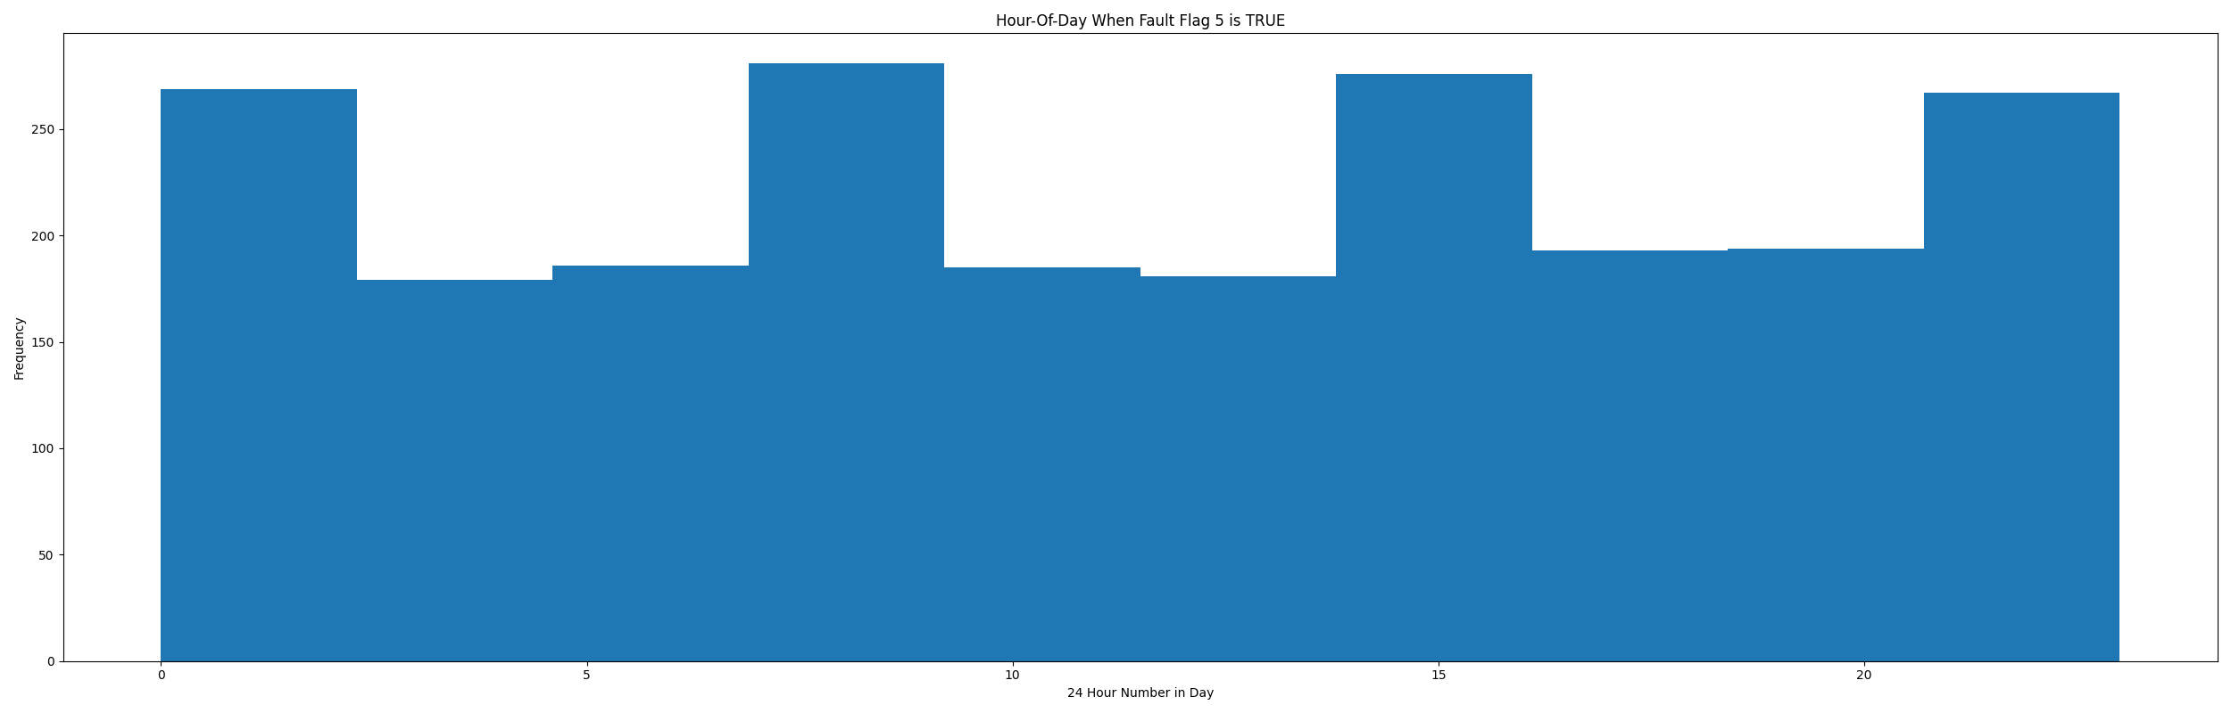

* When fault condition 5 is True the average AHU mix air temp is 58.86°F and the supply air temp is 43.37°F. This could possibly help with pin pointing AHU operating conditions for when this fault is True.

## Mix Temp Statistics

* count 2976.000000  
  mean 54.530914  
  std 13.599792  
  min 30.000000  
  25% 45.000000  
  50% 52.000000  
  75% 66.000000  
  max 90.000000  
  Name: mat, dtype: float64

## Supply Temp Statistics

* count 2976.000000  
  mean 43.476478  
  std 9.652349  
  min 30.000000  
  25% 36.000000  
  50% 41.000000  
  75% 49.000000  
  max 77.000000  
  Name: sat, dtype: float64

## Suggestions based on data analysis

* The percent True metric that represents the amount of time for when the fault flag is True is high indicating the AHU temperature sensors are out of calibration

Report generated: Tue Feb 7 12:40:48 2023