Fault Condition Six Report

Fault condition six of ASHRAE Guideline 36 is an attempt at verifying that AHU design minimum outside air is close to the calculated outside air fraction through the outside, mix, and return air temperature sensors. Fault condition six equation as defined by ASHRAE:

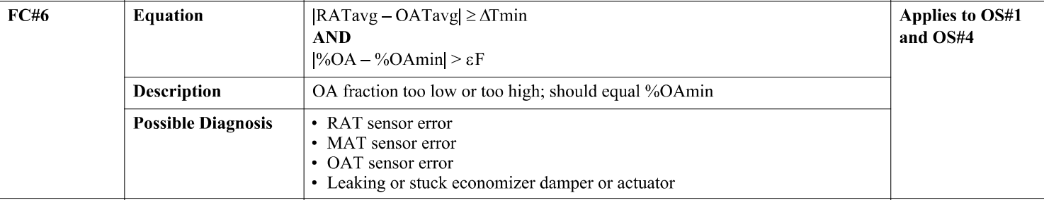

## Dataset Plot

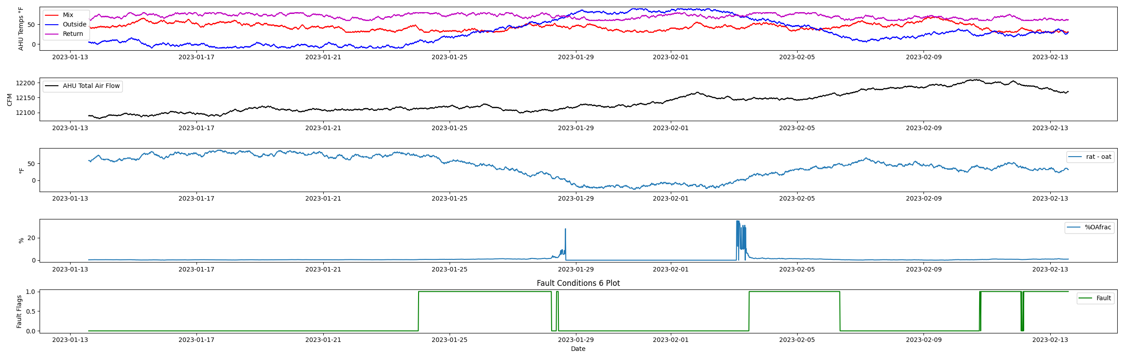

## Dataset Statistics

* Total time in days calculated in dataset: 30.99
* Total time in hours calculated in dataset: 743.75
* Total time in hours for when fault flag 6 is True: 237.25
* Percent of time in the dataset when the fault flag 6 is True: 31.89%
* Percent of time in the dataset when fault flag 6 is False: 68.11%

## Time-of-day Histogram Plots

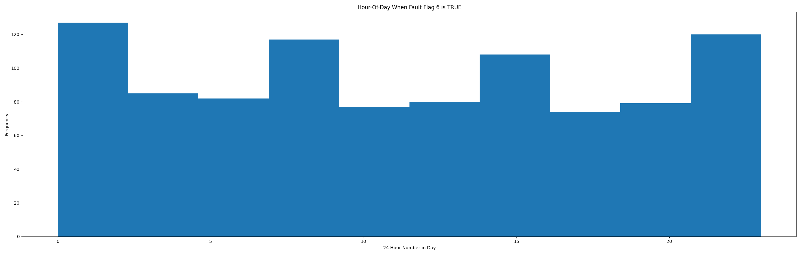

* When fault condition 6 is True the average AHU xxx is 1.03°F and the xxx is 1.03°F. This could possibly help with pin pointing AHU operating conditions for when this fault is True.

## Mix Temp Statistics

* count 2976.000000  
  mean 43.660282  
  std 9.019187  
  min 30.000000  
  25% 36.000000  
  50% 43.000000  
  75% 50.000000  
  max 70.000000  
  Name: mat, dtype: float64

## Outside Temp Statistics

* count 2976.000000  
  mean 29.658266  
  std 31.713134  
  min -10.000000  
  25% 1.000000  
  50% 23.000000  
  75% 54.000000  
  max 90.000000  
  Name: oat, dtype: float64

## Return Temp Statistics

* count 2976.000000  
  mean 70.804435  
  std 6.134520  
  min 60.000000  
  25% 66.000000  
  50% 71.000000  
  75% 76.000000  
  max 80.000000  
  Name: rat, dtype: float64

## Calculated OA Fraction Statistics

* count 2976.000000  
  mean 0.776762  
  std 2.505592  
  min 0.000000  
  25% 0.212121  
  50% 0.387755  
  75% 0.804480  
  max 35.000000  
  Name: percent_oa_calc, dtype: float64

## Suggestions based on data analysis

* The percent True metric that represents the amount of time for when the fault flag is True is high indicating the AHU temperature sensors are out of calibration

Report generated: Sun Jan 15 14:59:41 2023