Fault Condition Seven Report

Fault condition seven of ASHRAE Guideline 36 is an AHU heating mode only with an attempt at verifying an AHU heating or cooling valve is not stuck or leaking by verifying AHU supply temperature to supply temperature setpoint. Fault condition seven equation as defined by ASHRAE:

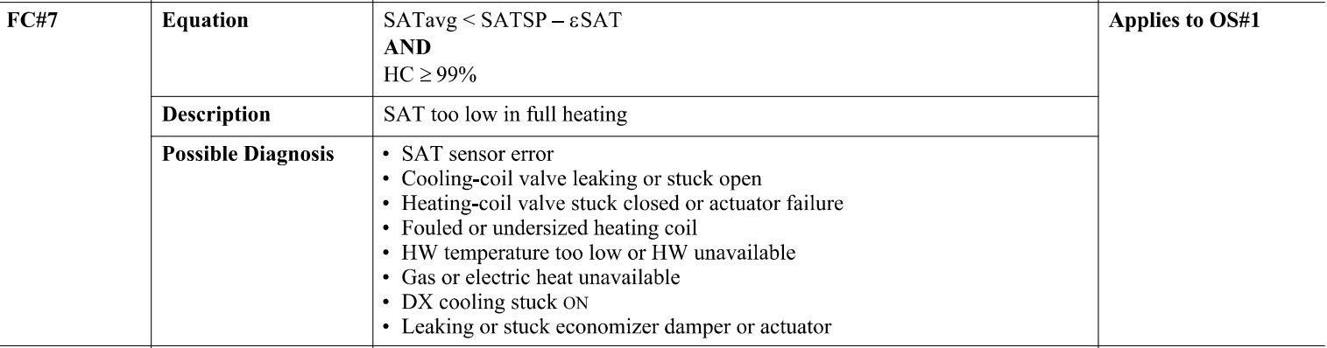

## Dataset Plot

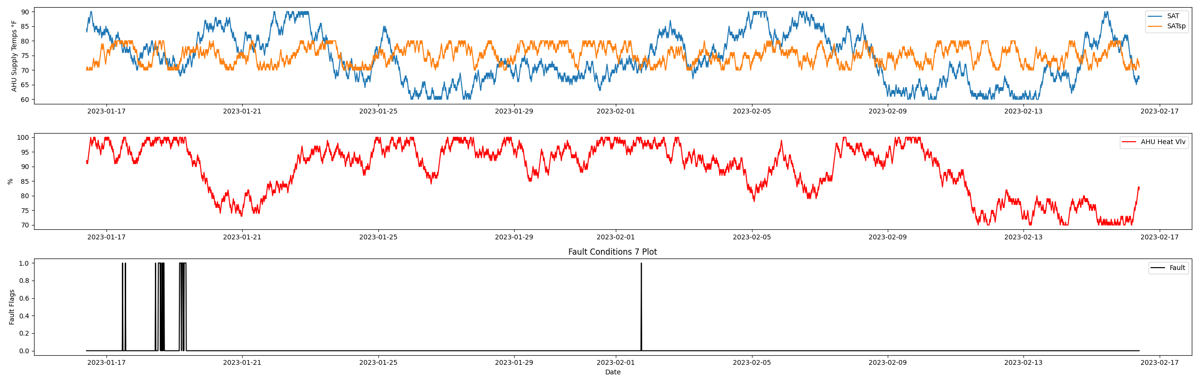

## Dataset Statistics

* Total time in days calculated in dataset: 30.99
* Total time in hours calculated in dataset: 743.75
* Total time in hours for when fault flag is True: 7.75
* Percent of time in the dataset when the fault flag is True: 1.04%
* Percent of time in the dataset when the fault flag is False: 98.96%
* Calculated motor runtime in hours based off of VFD signal > zero: 278.0

## Time-of-day Histogram Plots

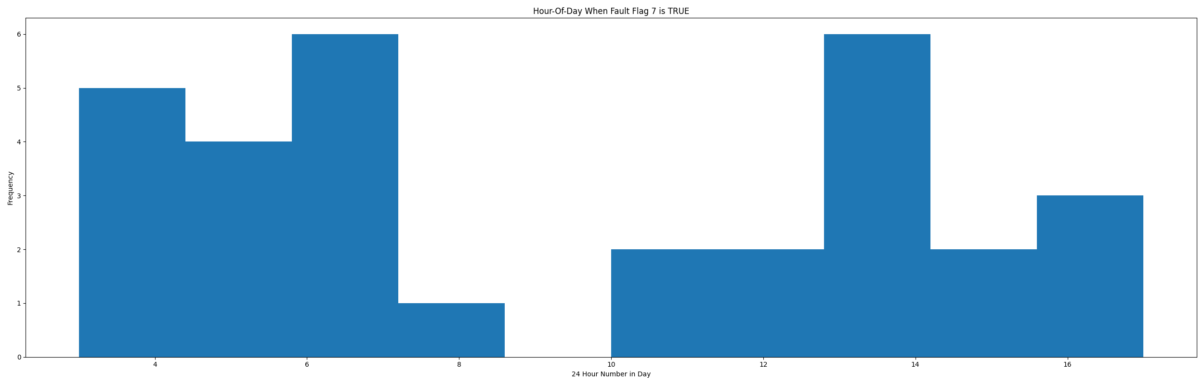

* When fault condition 7 is True the average AHU supply air setpoint is 71.94 in °F and the supply air temperature is 77.06 in °F.

# Summary Statistics filtered for when the AHU is running

### Supply Air Temp

* count 1112.000000  
  mean 79.610612  
  std 5.662929  
  min 65.000000  
  25% 75.000000  
  50% 80.000000  
  75% 84.000000  
  max 90.000000  
  Name: sat, dtype: float64

### Supply Air Temp Setpoint

* count 1112.000000  
  mean 74.653777  
  std 2.958109  
  min 70.000000  
  25% 72.000000  
  50% 75.000000  
  75% 77.000000  
  max 80.000000  
  Name: satsp, dtype: float64

### Heating Coil Valve

* count 1112.000000  
  mean 88.461331  
  std 8.929181  
  min 70.000000  
  25% 82.000000  
  50% 91.000000  
  75% 96.000000  
  max 100.000000  
  Name: htg, dtype: float64

## Suggestions based on data analysis

* The percent True metric that represents the amount of time for when the fault flag is True is low inidicating the AHU heating valve operates Ok.

Report generated: Wed Feb 22 10:25:20 2023