Fault Condition Eight Report

Fault condition Eight of ASHRAE Guideline 36 is an AHU economizer free cooling mode only with an attempt at flagging conditions when the AHU mixing air temperature the supply air temperature are not approximately equal. Fault condition eight equation as defined by ASHRAE:

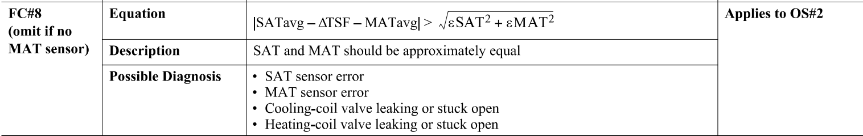

## Dataset Plot

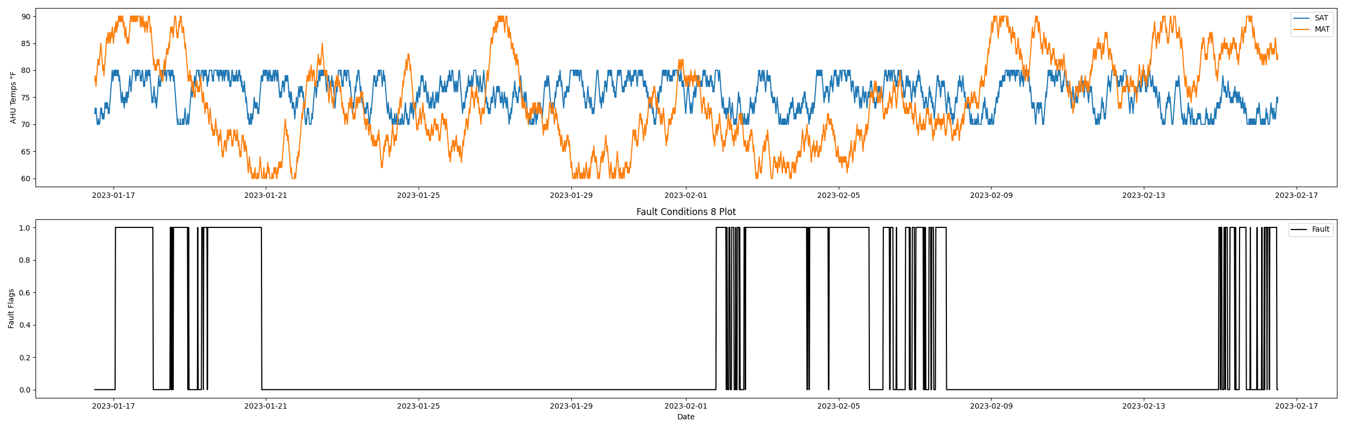

## Dataset Statistics

* Total time in days calculated in dataset: 30.99
* Total time in hours calculated in dataset: 743.75
* Total time in hours for when fault flag is True: 203.5
* Percent of time in the dataset when the fault flag is True: 27.35%
* Percent of time in the dataset when the fault flag is False: 72.65%
* Calculated motor runtime in hours based off of VFD signal > zero: 278.0

## Time-of-day Histogram Plots

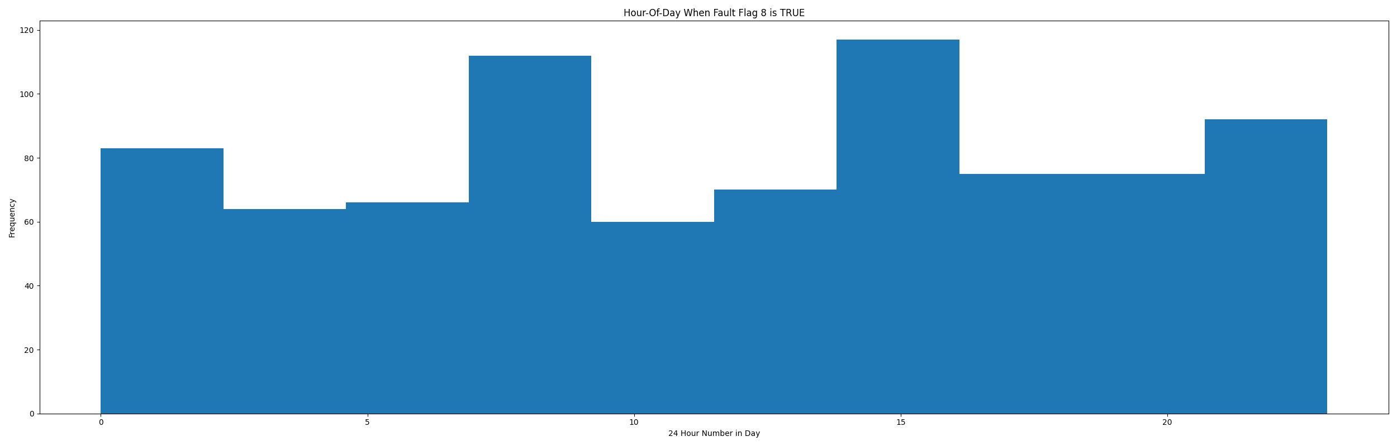

* When fault condition 8 is True the average AHU mix air is 71.99 in °F and the supply air temperature is 75.91 in °F.

# Summary Statistics filtered for when the AHU is running

### Supply Air Temp

* count 1112.000000  
  mean 75.747302  
  std 3.169384  
  min 70.000000  
  25% 73.000000  
  50% 76.000000  
  75% 79.000000  
  max 80.000000  
  Name: mat, dtype: float64

### Mix Air Temp

* count 1112.000000  
  mean 73.429856  
  std 9.065644  
  min 60.000000  
  25% 66.000000  
  50% 71.000000  
  75% 82.000000  
  max 90.000000  
  Name: sat, dtype: float64

## Suggestions based on data analysis

* The percent True metric that represents the amount of time for when the fault flag is True is high indicating temperature sensor error or the heating/cooling coils are leaking potentially creating simultenious heating/cooling which can be an energy penalty for running the AHU in this fashion. Verify AHU mix/supply temperature sensor calibration in addition to a potential mechanical issue of a leaking valve. A leaking valve can be troubleshot by isolating the valve closed by manual shut off valves where piping lines enter the AHU coil and then verifying any changes in the AHU discharge air temperature.

Report generated: Wed Feb 22 10:25:31 2023