Fault Condition Two and Three Report

Fault condition two and three of ASHRAE Guideline 36 is related to flagging mixing air temperatures of the AHU that are out of acceptable ranges. Fault condition 2 flags mixing air temperatures that are too low and fault condition 3 flags mixing temperatures that are too high when in comparision to return and outside air data. The mixing air temperatures in theory should always be in between the return and outside air temperatures ranges. Fault condition two equation as defined by ASHRAE:

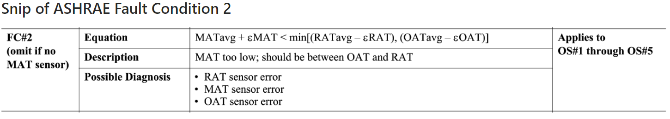

Fault condition three equation as defined by ASHRAE:

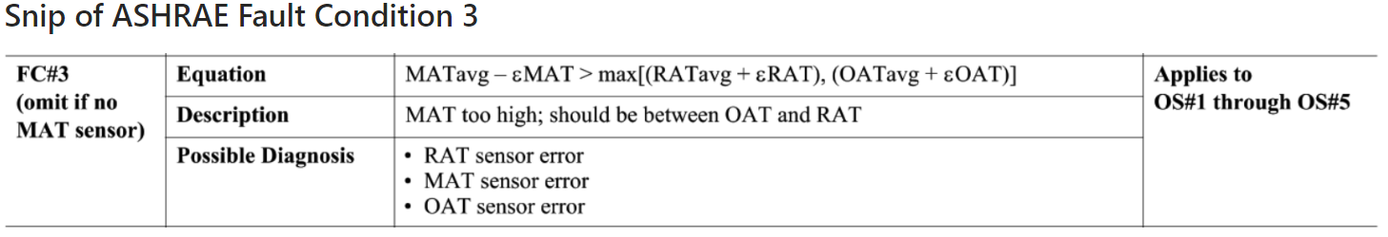

## Dataset Plot

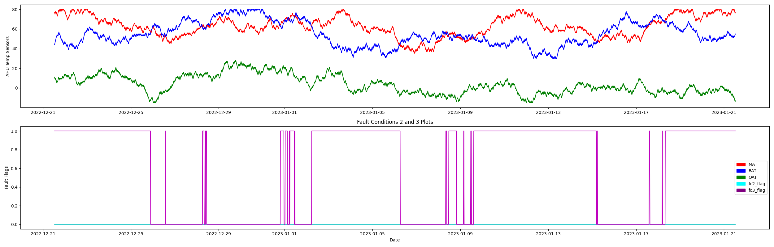

## Dataset Statistics

* Total time calculated in dataset: 30 days 23:45:00
* Total time in hours calculated in dataset: 743.75
* Total time in hours for when FDD flag 2 is True: 0.0
* Total time in hours for when FDD flag 3 is True: 8.25
* Percent of time in the dataset when the Fault flag 2 is True: 0.0%
* Percent of time in the dataset when the Fault flag 3 is True: 59.21%
* Percent of time in the dataset when flag 2 is False: 100.0%
* Percent of time in the dataset when flag 3 is False: 40.79%

## Time-of-day Histogram Plots

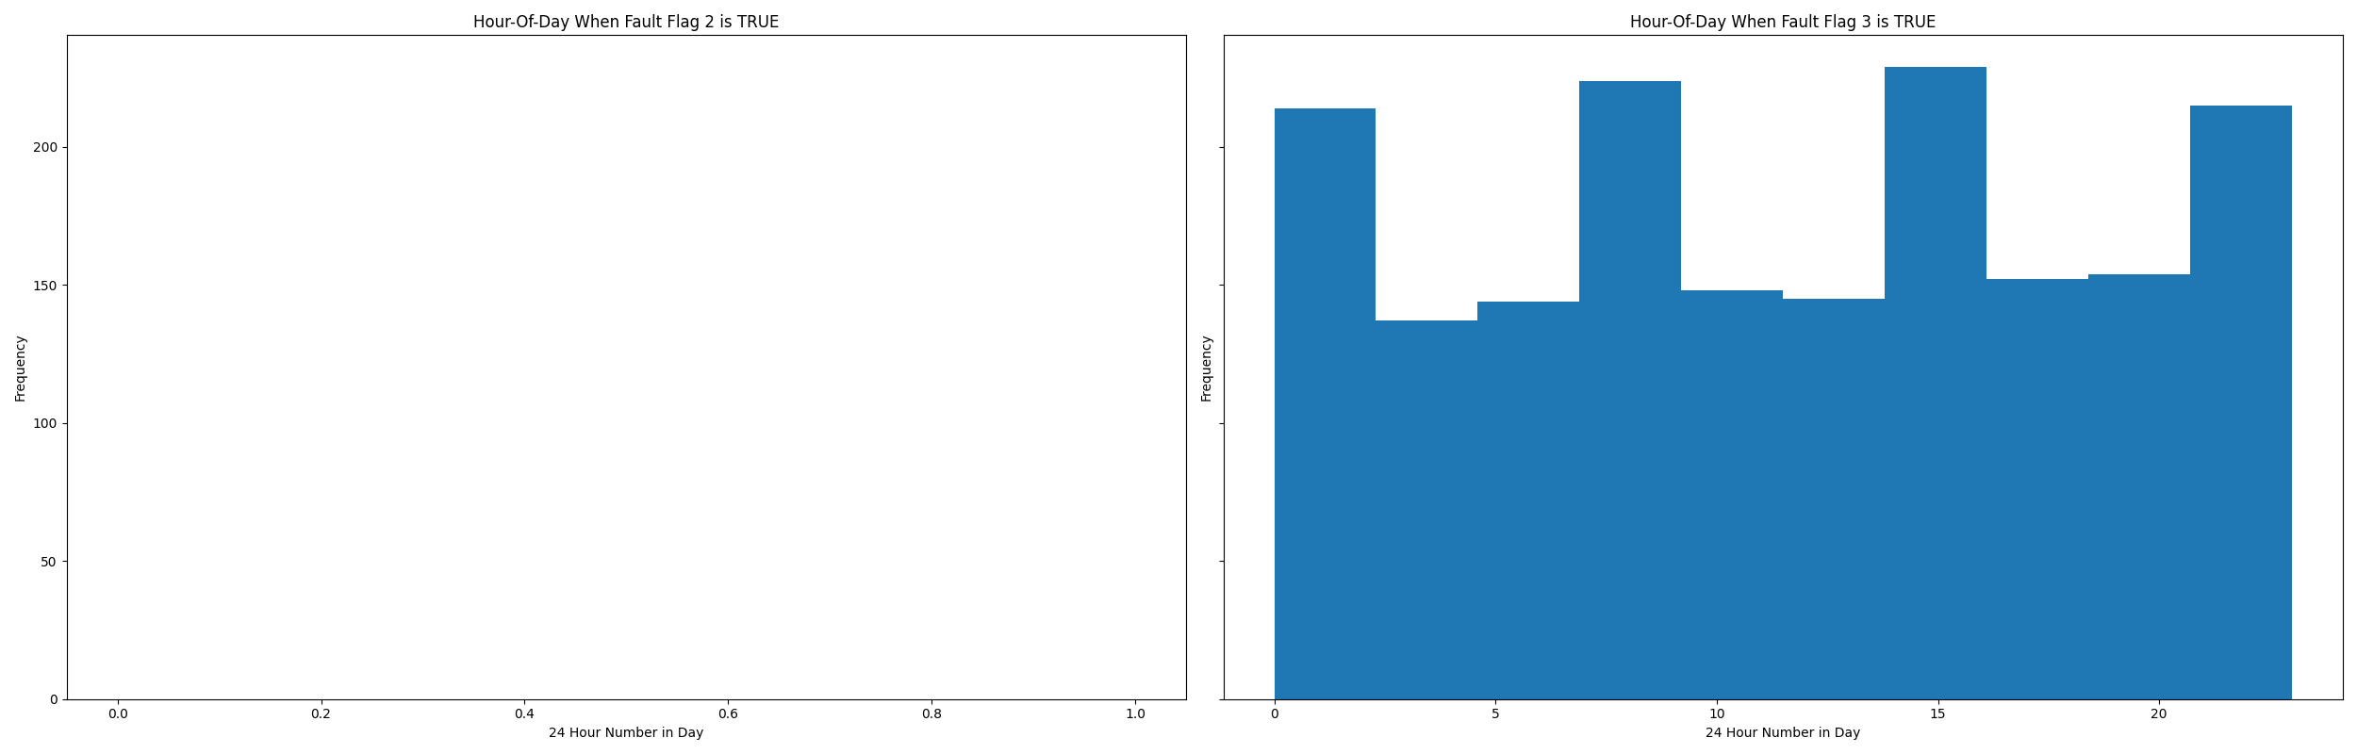

* Average mix air temp for when in fault condition 2 is True (mixing temp is LOW outside the ranges of return and outside temp): nan °F
* Average mix air temp for when in fault condition 3 is True (mixing temp is HIGH and outside the ranges of return and outside temp): 67.48 °F

## Mix Temp Statistics

* count 2976.000000  
  mean 62.676411  
  std 10.425621  
  min 35.000000  
  25% 55.000000  
  50% 62.000000  
  75% 71.000000  
  max 80.000000  
  Name: mat, dtype: float64

## Return Temp Statistics

* count 2976.000000  
  mean 54.769153  
  std 12.117498  
  min 30.000000  
  25% 46.000000  
  50% 53.000000  
  75% 64.000000  
  max 80.000000  
  Name: rat, dtype: float64

## Outside Temp Statistics

* count 2976.000000  
  mean 3.531250  
  std 9.564941  
  min -15.000000  
  25% -4.000000  
  50% 2.000000  
  75% 11.000000  
  max 28.000000  
  Name: oat, dtype: float64

## Suggestions based on data analysis

* The percent True of time is low inidicating the AHU temperature sensors are within calibration

Report generated: Wed Dec 21 14:33:07 2022