Fault Condition Four Report

Fault condition four of ASHRAE Guideline 36 is related to flagging control programming that is hunting causing excessive oscilating between heating, economizing, economizing plus mechanical cooling, and mechanical cooling operating states. Fault condition four equation as defined by ASHRAE:

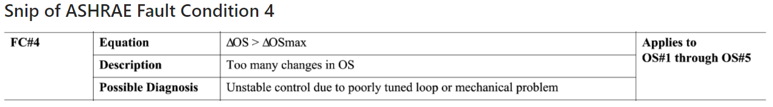

## Heating, Cooling, and OA Damper Signal Plot

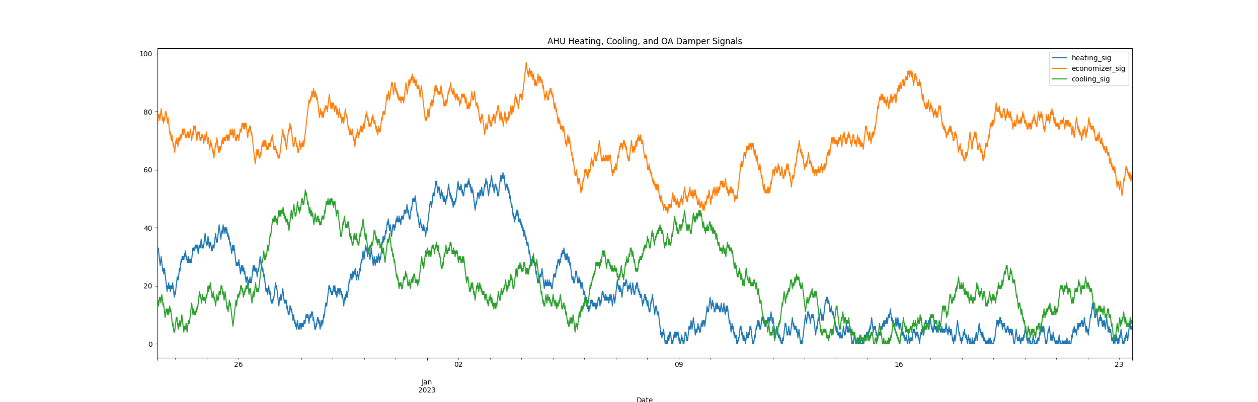

## Calculated Operating States Plot

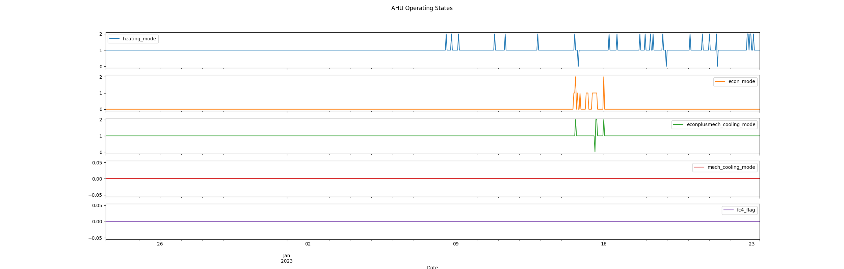

## Dataset Statistics

* Total time calculated in dataset: 30 days 23:00:00
* Total time in hours calculated in dataset: 743.0
* Total time in hours while AHU is in a heating mode: 21.0
* Total percent time in while AHU is in a heating mode: 102.69%
* Total time in hours while AHU is in a economizing mode: 13.0
* Total percent time in while AHU is in a economizing mode: 2.28%
* Total time in hours while AHU is in a economizing plus mechanical cooling mode: 18.0
* Total percent time in while AHU is in a economizing plus mechanical cooling mode: 100.4%
* Total time in hours while AHU is in a mechanical cooling mode: 0.0
* Total percent time in while AHU is in a mechanical cooling mode: 0.0%
* No fault condition 4 calcualted in the dataset

## Heating Signal Statistics

* count 2976.000000  
  mean 17.432796  
  std 16.166784  
  min 0.000000  
  25% 4.000000  
  50% 12.000000  
  75% 28.000000  
  max 59.000000  
  Name: heating_sig, dtype: float64

## Cooling Signal Statistics

* count 2976.000000  
  mean 20.983535  
  std 12.727502  
  min 0.000000  
  25% 11.000000  
  50% 19.000000  
  75% 31.000000  
  max 53.000000  
  Name: cooling_sig, dtype: float64

## Economizer Free Cooling Statistics

* count 2976.000000  
  mean 71.762097  
  std 11.025708  
  min 45.000000  
  25% 65.000000  
  50% 72.000000  
  75% 79.250000  
  max 97.000000  
  Name: economizer_sig, dtype: float64

Report generated: Fri Dec 23 10:24:06 2022