Fault Condition One Report

Fault condition one of ASHRAE Guideline 36 is related to flagging poor performance of a AHU variable supply fan attempting to control to a duct pressure setpoint. Fault condition equation as defined by ASHRAE:

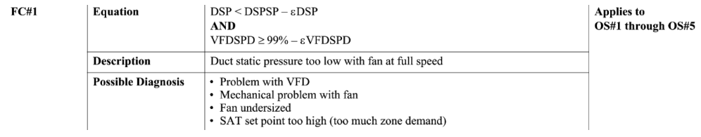

## Dataset Plot

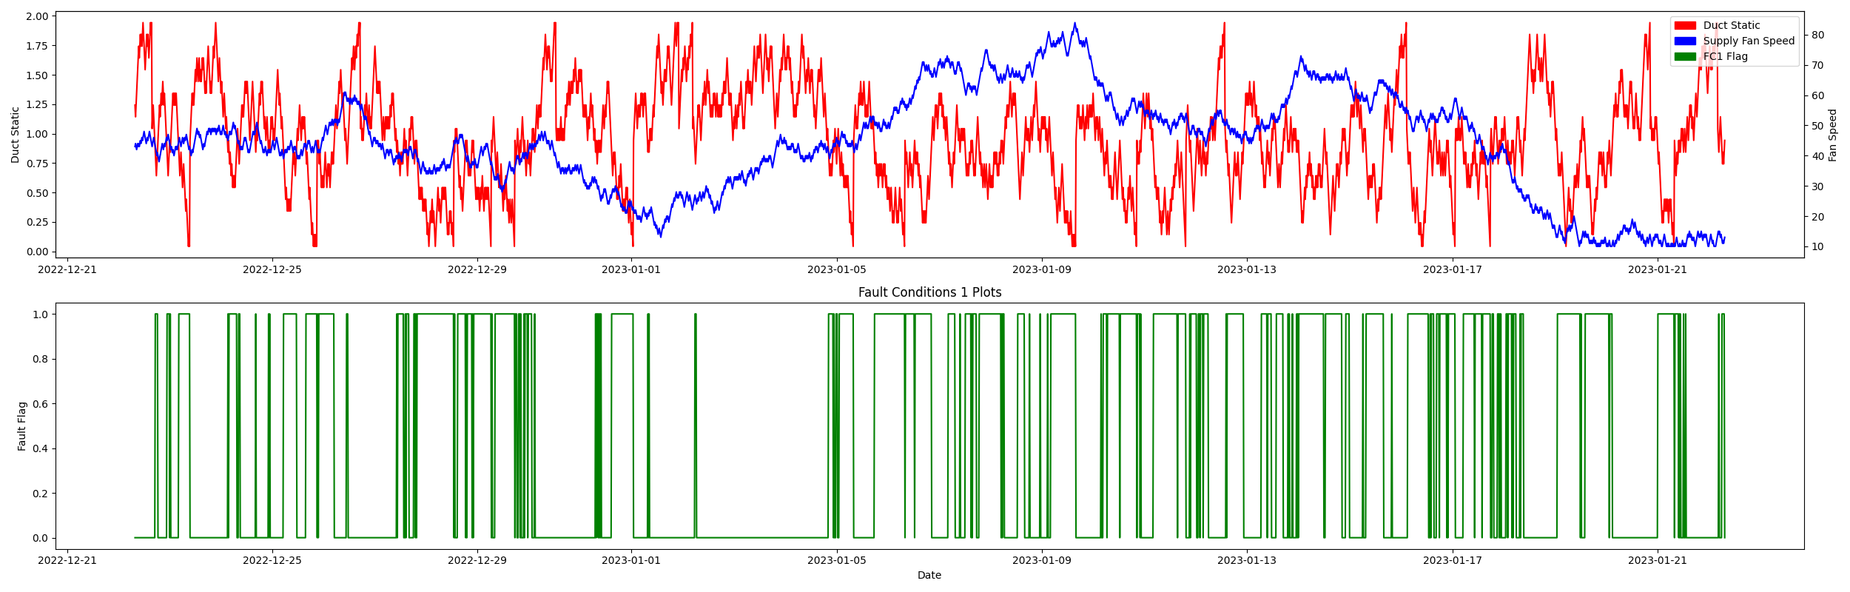

## Dataset Statistics

* Total time calculated in dataset: 30 days 23:45:00
* Total time in hours calculated in dataset: 743.75
* Total time in hours for when fault flag is True: 19.25
* Percent of time in the dataset when the fault flag is True: 44.52%
* Percent of time in the dataset when the fault flag is False: 55.48%

## Time-of-day Histogram Plots

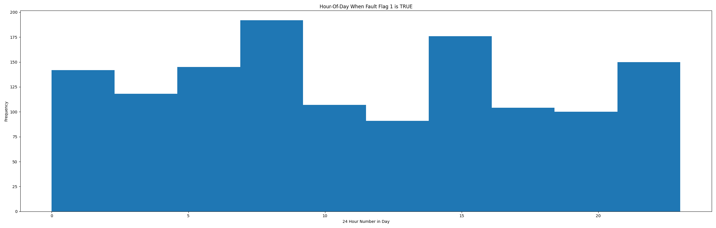

* Average duct system pressure for when in fault condition (fan VFD speed > 95%): 0.58"WC

## VFD Speed Statistics

* count 2976.000000  
  mean 43.700269  
  std 17.152824  
  min 10.000000  
  25% 34.000000  
  50% 44.000000  
  75% 55.000000  
  max 84.000000  
  Name: supply_vfd_speed, dtype: float64

## Duct Pressure Statistics

* count 2976.000000  
  mean 0.959243  
  std 0.414788  
  min 0.042913  
  25% 0.642913  
  50% 0.942913  
  75% 1.242913  
  max 1.942913  
  Name: duct_static, dtype: float64

## Duct Pressure Setpoints Statistics

* count 2976.0  
  mean 1.0  
  std 0.0  
  min 1.0  
  25% 1.0  
  50% 1.0  
  75% 1.0  
  max 1.0  
  Name: duct_static_setpoint, dtype: float64

## Suggestions based on data analysis

* Fan is appears to generate good duct static pressure (GOOD)
* No duct pressure setpoint reset detected (BAD)

Report generated: Thu Dec 22 08:48:20 2022