Formatting Guidelines for MS Word Users

Name LastName^{[1]}, Name LastName^{[2]}, Name LastName^{[3]}

[1] Institution1. The journal uses double blind review
[2] Institution2. Please, if your are submitting for review do not include author’s names
[3] Institution3. Please, if your are submitting for review do not include author’s affiliations
[1] please@if.you.are.submitting.for.review.do.not.include.email
[2] please@if.you.are.submitting.for.review.do.not.include.email
[3] please@if.you.are.submitting.for.review.do.not.include.email

Abstract This paper summarizes the journal's formatting guidelines. It is important to follow these guidelines in order to achieve a uniform appearance. The journal will not carry out editing of the papers. Some hints on how to write and submit papers are also explained. Every paper should include a list of English keywords (optionally also in Spanish).

Resumen Este documento incluye la guía de edición de la revista, con la intención de que todos los artículos tengan un formato uniforme. La revista no se puede hacer cargo de la edición final del artículo. También se incluyen algunas recomendaciones útiles para la correcta edición del artículo. Es obligatorio que cada artículo incluya un resumen en español y un abstract en inglés. La lista de palabras clave (Keywords) debe estar en inglés, aunque se puede incluir también en español, si los autores así lo consideran oportuno.

Keywords: Style, Revista Iberoamericana de Inteligencia Artificial, Sample document.
Palabras clave: Estilo, formato, recomendaciones.

- Introduction
Paper size is A4 (210 x 297 mm). Authors should use the LaTeX or MsWord formats available at the Journal's Web page. Author's names should be omitted in the paper when submitting for review. The journal carries out double-blind review. Each paper must include an informative abstract (both in English and Spanish) and a list of English keywords (optionally also in Spanish). If the paper is written in Spanish, authors will be required upon submission to enter an English version of the paper's title and abstract electronically.
Figures should be centered and included in the text. You may find an example in figure 1. Tables should follow a similar scheme. You may find an example in table 1.
  - References
References should be clear and complete. Sample references are these [4], [1], [2] and this one [3]. Do not forget to include DOI numbers in your references when available. You can associate hyperlinks to DOI numbers in MS Word using Insert>Hyperlink. Note that if some reference has DOI 10.1441/ia.v1i1.1000, then the hyperlink should be set to http://dx.doi.org/10.1441/ia.v1i1.1000. See for example reference [5] below.

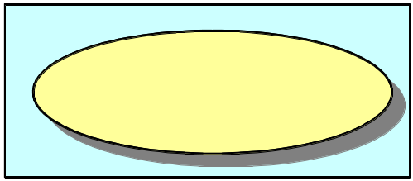
Figure 1. This is the caption of the sample figure.

Table 1: A sample table for a sample file.
Sample algorithm | Sample performance
A | Bad
B | Excellent
C | Unstable
D | Unforgettable

  - What is a DOI?
The DOI (Digital Object Identifier) is a unique identifier assigned by publishers to electronically published items (books, journal papers, etc.) The DOI system provides a framework for persistent identification. The physical location of a digital object may change over time, but its DOI name will not change. Currently, a DOI number can be resolved prefixing http://dx.doi.org/ to the DOI. Therefore links of the form http://dx.doi.org/[DOI] are expected to work properly over time, regardless of the physical location changes of the referenced items. To learn more about the DOI see http://www.doi.org
  - Where can I find the DOI of my references?
DOI numbers should appear explicitly in the first page of printed journal papers, either at the top or bottom of the page, like in figure 2. Electronic journals display DOI numbers in the papers access or home pages, like in figure 3. If you cannot find the DOI of a reference at first sight it probably does not have one, so do not worry. Many articles do not have DOI numbers assigned (older ones).
  - Why it is important to include DOI numbers in references (when available)?
New papers published by Inteligencia Artificial are assigned a DOI number as a free service to their authors. Documents receiving a DOI are expected to include DOI numbers in their own references.
Including DOI numbers in your references (when available) will make your paper more useful and comfortable to read for readers and reviewers.

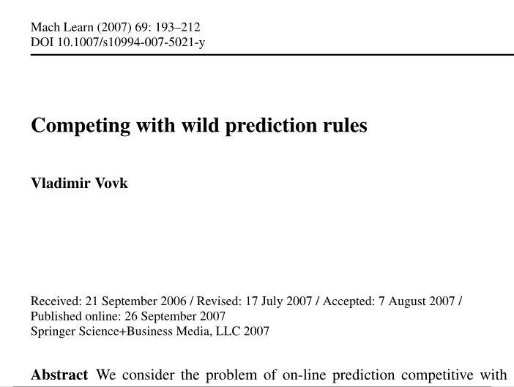
Figure 2.DOI in a printed document.

Figure 3.DOI in a document available on the Web.
- Note for MsWord users
Users of MsWord should carefully format their documents using the sample document found at the Journal’s Web page. The page layout and paragraph styles of the sample document should be carefully preserved.
  - Title of paper
The title of the paper should use the Title style. Author’s names, affiliations and email should not be included in manuscripts submitted for review. Definitive documents should use the Authorname, Authoraffiliation and Email styles. Abstract and Keywords should follow the Abstract style.
  - Headings
Documents should be structured using up to three levels of headings. The titles of headings should follow the Heading 1, Heading 2, and Heading 3 styles.
    - Headings of Acknowledgements and References
The heading of acknowledgements should use the Acknowledgementsheading style. The heading of references should use the Referenceheading style. The references should use the Reference style. Pay special attention at the sample references at the end of this document.
  - Figures and Tables
Figures and tables should be placed preferably at the top or bottom of a page. Figures should be followed by a figure caption using the Figurecaption style. Tables should be preceded by a table caption using the Tablecaption style. Figures and tables should be numbered and referenced accordingly in the text.
- Journal Scope
Inteligencia Artificial is a quarterly journal promoted and sponsored by Iberamia (Sociedad Iberoamericana de Inteligencia Artificial) (http://iberamia.dsic.upv.es/inicial.html‎). The journal publishes high-quality original research papers reporting theoretical or applied advances in all branches of Artificial Intelligence. In addition to rapid publication and dissemination of unsolicited contributions, Inteligencia Artificial is committed to producing monographs and special issues on topics of special relevance to the AI community.
- Manuscript Submission and Review
Paper submission should be carried out through the journal's Web page http://journal.iberamia.org/. Click the ”ABOUT” button and follow the author's guidelines.
Following this process the author implicitly transfers copyright of accepted papers to IBERAMIA, accepting their publication electronically (freely available through the Journal's Web pages) and in printed volumes.
Inteligencia Artificial welcomes research papers written in Spanish or English. Manuscripts should be uploaded in PDF format through the journal's Web pages (http://journal.iberamia.org/ - link 'Submissions'). All research papers falling within the journal's scope will be subject to double-blind peer-review by at least two anonymous reviewers. Authors must omit their names in submitted manuscripts. The journal publishes four issues per year, each one at the start of each season (spring, summer, autumn, and winter). The journal will not carry out editing of manuscripts. Authors should adhere strictly to the norms in the "Journal's formatting guidelines". Accepted papers will be published electronically at the journal's Web pages, with free access from the Internet. The journal encourages authors to add links in their personal pages pointing to the journal's pages containing their contributions.
- Originality and Copyright
Research papers submitted to Inteligencia Artificial cannot have been published previously, nor be under review for publication elsewhere. However, the journal welcomes extended and improved versions of papers published in conferences and workshops, which will be subject to a new peer-review process. Authors implicitly accept publication of submitted papers by IBERAMIA, both electronically (with free access from the Internet) and in print, as well as dissemination through other media and entities with which IBERAMIA may establish agreement, transferring AEPIA all the necessary rights.
- Monographs and Special Issues
The journal welcomes monograph or special issue proposals related to specific areas of Artificial Intelligence. Proposals to coordinate monographs or special issues should be sent through email to the Editor (editor@iberamia.org). Contributions to monographs or special issues can be original works including new research papers, extended and improved versions of papers published in conferences and workshops, and survey papers that summarize the topics of a particular monograph or special issue. In all cases, the publication of contributions is conditioned to acceptance in a new peer-review process carried out by an international scientific committee under the journal's supervision.
- Theses Summaries
Inteligencia Artificial is specially interested in the publication of Ph.D. dissertation summaries that provide a quick and state-of-the-art reference in particular topics of Artificial Intelligence. Summaries can be submitted following the regular submission process, stating "RESUMEN DE TESIS" in the heading, and should be limited to 2-4 pages.

Acknowledgements
This is the place for acknowledgements.

References
[1] P.E. Hart, N.J. Nilsson, and B. Raphael. A formal basis for the heuristic determination of minimum cost paths. IEEE Trans. System Science and Cybernetics SSC-4, 2:100-107, 1968.
[2] Richard E. Korf. Iterative-deepening A*: an optimal admissible tree search. In Proc. of the IX Int. Joint Conf.. on Artificial Intelligence (IJCAI’85), pages 1034-1036, 1985.
[3] Tobias Oetiker, Hubert Partl, Irene Hyna, and Elisabeth Schlegl. The not so short introduction to LaTeX2e, 2008.
[4] Judea Pearl. Heuristics. Addison-Wesley, Readin, Massachusetts, 1984.
[5] V. Vovk. Competing with wild prediction rules, Machine Learning, 69:193--212, 2007. doi: 10.1007/s10994-007-5021-y

