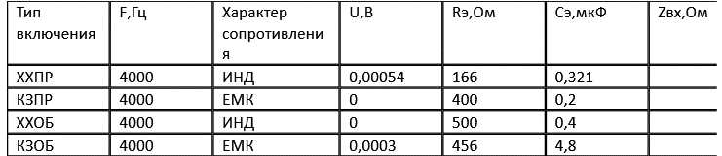.

|  |  |  |  |  |  |
| --- | --- | --- | --- | --- | --- |
| **Zн** | **ac** | **aог** | **aон** | **aвз** | **ap** |
| **600** | **16..84+j6.53** | **0.005-j0.09** | **3.768+j0.032** | **0.773+j0** | **21,386+j6.472** |

**Таблица 3-**

|  |  |  |  |  |  |
| --- | --- | --- | --- | --- | --- |
| **Zн** | **PЕ** | **PU** | Rг/Zн | 10lg|Rг/Zн| | **ap** |
| **600** | **-63.138** | **-63.138** | **1** | **0** | **0** |