|  |
| --- |
| Unlimited games |
| Space Patrol |
| Game Design Document |
| Version #02  All work Copyright © 2012 by Unlimited Games.  All rights reserved. |
| **Group 05** |
| **300895515 - Roberto Ito**  **300916412 - Yayun Yang** |

|  |
| --- |
| January 21th 2019 |

**Table of Contents**

Version History 3

I. Game Overview 4

II. Game Play Mechanics 4

III. Camera 4

IV. Controls 4

V. Interface Sketch 5

VI. Game World 5

VII. Levels 5

VIII. Game Progression 5

IX. Characters 5

X. Enemies 6

XI. Weapons 6

XII. Items 6

XIII. Scoring 6

XIV. Sound Index 7

XV. Story Index 7

XVI. Art and Multimedia Index 7

XVII. Design Notes 7

XVIII. Future Features 7

# Version History

Version 1.0

Creation of the GDD.

Version 1.1

* New Interface Sketch.
* Scoring table improvement.
* Sound index update.
* Art and Media index update.

Version 1.2

* Roberto Ito - Created hit animations for the enemies, player, and bosses.
* Roberto Ito - Added 3 bosses appearing in interval of time.
* Roberto Ito - Developed three bosses assets, animations, spawn, shoot, collision, and score points.
* Yayun Yang - Background modification.
* Yayun Yang - Enemy moving Pattern changed for level 1.
* Yayun Yang - 2 more level added.
* Yayun Yang – background sound problems fixed for level 2 & 3. New sounds are added for game menu, game over page, bullet shooting.
* Yayun Yang – enemy move pattern added for all 3 levels.

Version 1.3

* Roberto Ito – Gauge health meter.
* Roberto Ito – Second weapon missile assets, animation, spawn, collision, and score points.
* Roberto Ito – Meteors assets, animation, spawn, collision, and score points.
* Roberto Ito – Tutorial.
* Roberto Ito – Win screen.
* Yayun Yang – Merge level 2 &3 files with Game.js.
* Yayun Yang – Background image change and added rolling down effect.
* Yayun Yang – Bullet shooting effect optimization.

# Game Overview

*Flight in your spaceship destroying obstacles and enemies that want to stop you to have your revenge against the Space Patrol Organization. Enemies shoot against your spaceship creating a hard path. You must have nerves of steel and good reflexes to get into this challenge. Do not wait to start having fun with this addicting game.*

# Game Play Mechanics

*Use the arrow keys to move your spaceship.*

*Use the space bar to shoot (Laser or Missile), and destroy obstacles and enemies.*

*When the player got shot, its health meter decreases and after five shots it dies.*

*If the player collides with any object, they lose a life.*

*The player has five lives.*

# Camera

*Orthographic.*

# Controls

*Arrow keys: Move the spaceship.*

*Space bar: Shoot (Laser or Missile).*

*B: Bomb. (For future development)*

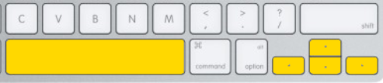

# Interface Sketch

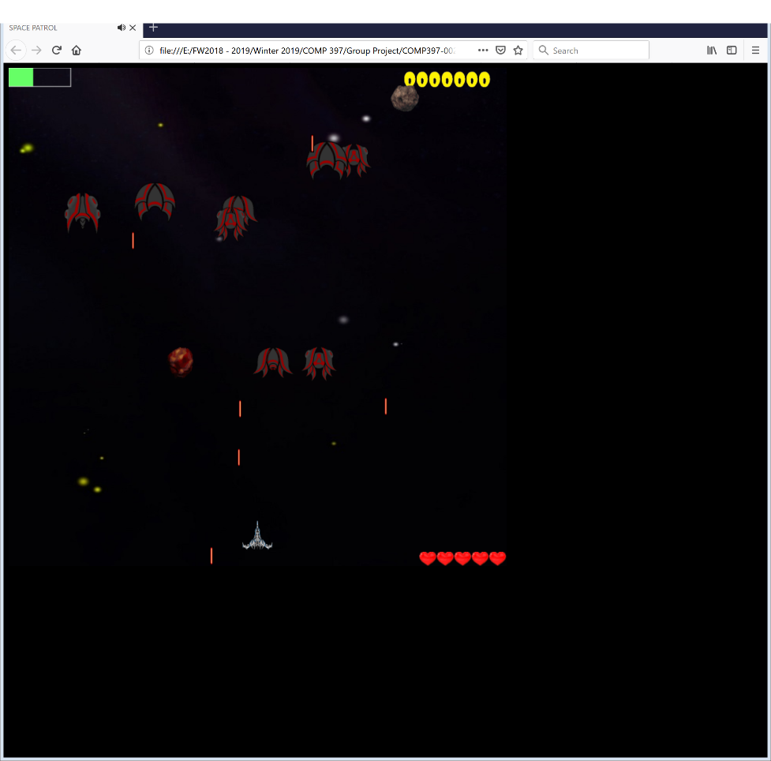

*The gauge in the left top is the player’s health meter.*

*The number to the right top is the score.*

*Lives are in the bottom right.*

# Game World

*It is a space background with some objects floating, for example, asteroids.*

*The enemies come from the top-down direction.*

# Levels

*There are three levels in a single player mode.*

*The levels are similar with different background, difficulties and bosses.*

# Game Progression

*The player has to pass through three different levels destroying the enemies, bosses and avoiding space objects.*

# Characters

Hero’s spaceship is silver and can use different weapons.

# Enemies

Meteor: A static object that appears some times through the level.

Enemy: Enemy spaceship that shoots against the player’s spaceship.

Boss: A different enemy spaceship with special weapons.

# Weapons

Normal shoot: Laser.

Second weapon: Missiles.

# Items

After killing an enemy, a missile can appear in the stage. If the player gets this missile, the laser will be replaced by the missile, a more powerful weapon.

# Scoring

|  |  |
| --- | --- |
| ***Object*** | ***Points*** |
| *Enemy 1* | *10* |
| *Enemy 2* | *20* |
| *Enemy 3* | *30* |
| *Enemy 4* | *40* |
| *Meteor 1* | *5* |
| *Meteor 2* | *10* |
| *Boss 1* | *1000* |
| *Boss 2* | *2000* |
| *Boss 3* | *3000* |

# Sound Index

* The level1.mp3 from bensound.com.
* The explosion.mp3 from Beginning HTML 5 Games with CreateJS book example.

# Story Index

# Art and Multimedia Index

* Explosion sprite sheet from shutterstock.
* Hero’s spaceship from millionth vector.
* Alien Spaceship Pack from OpenGameArt.

# Design Notes

# Future Features

Bombs and cheat code.