Roberto Mejia Lacayo
Eunice Chin, Mahta Khosravi, Mark Vaughan
SCI 400
11 December 2024
Symmetry Deviation Analysis to Detect Brain Tumours in MRI Scans
Introduction
The development of artificial intelligence in the field of medical imaging has grown at a notable rate, with new algorithms, model architectures, training methodologies, and dataset processes being the focus of more computer vision-related academic papers than ever. MRI brain tumour detection is an especially emergent field, thanks to the powerful object detection, image classification, and image segmentation capabilities of current models. While the existing literature relies heavily on well-established methods such as further fine-tuning pre-trained object recognition models via traditional transfer learning (TTL), models have continually leapt forward in their power and usefulness. However, there is a certain lack of creativity and innovation that this space seemingly lacks, which could take inspiration from an interdisciplinary lens to create a solution that is efficient, accurate, and generally pushes the current boundaries of research. To address this, it is imperative to consider alternative strategies that exploit the unique anatomical characteristics of the brain, such as the symmetry that is created between the two hemispheres. This method of symmetry deviation analysis (SDA) would potentially provide further insight into realizing improved model performance. Given this missing area of research, the question arises: can SDA in MRI brain scans improve brain-tumour detection compared to TTL based-methods of tumour detection? To properly explore this question, a comparative analysis of two models, one trained for SDA and one trained through traditional transfer-learning, will be conducted. Applying various techniques and modalities inspired by precedents set by existing papers such as abiding by dataset hygiene guidelines, working with the ResNet50 neural network architecture, and proprietary training methodologies will assist in guiding this study towards an equally impactful outcome. The crux of the research however, will take advantage of the symmetrical patterns within the brain, as current models appear proficient in their pattern-recognition capabilities.
Literature Review
The most relevant advancements in this field rely on convolutional neural networks (CNNs), due to their architectures being well-suited for use on images. The most popular current methods revolve around common themes such as transfer-learning, data augmentation, and a relatively traditional approach through existing object-detection methodologies.
Kouli et al. performed a meta-analysis on more than 200 papers, ultimately arriving at the conclusion that deep learning networks improve on nearly every facet of tumour detection over previous machine learning methods. Younis et al. in particular achieved an accuracy score of up to 100% in some categories with ResNet50 largely in part to a lengthy process involving a massive dataset, extensive data augmentation via image preprocessing, and an intensive training process in which various optimization techniques and algorithms were introduced throughout development. Yet, the paper did not have any notable implementation - a testament to the results possible through meticulous traditional transfer learning.
The most unique papers continued to build on CNNs and transfer learning. Abd-Ellah et al. achieved 98.88% accuracy with a custom-built architecture, still predicated on the same concepts: data augmentation and a persistent desire to refine the tumour image detection capabilities on entire images.
The challenge of working through dataset imbalances with CNNs is well-documented
and explored due to the prevalence of imbalanced data throughout the real world. Researchers have found that CNNs often fail to generalize effectively once they have been exposed to a limited number of latent features, as they learn best from a wide array of distinct patterns from which to identify minority classes to better handle minority classes (Dablain et al., 2024). Unfortunately, current methods to address issues surrounding dataset imbalance, data augmentation strategies, re-sampling, and other methods have gained popularity in recent times. However, Dablain et al. argue that these methods focus on rebalancing class sizes or weights rather than diversify the latent features and patterns within the images themselves, which may limit the models’ ability to generalize under a certain ceiling.
Symmetry deviation analysis remains relatively overlooked in medical computer vision applications. However, two studies incorporated the concept, albeit with certain limitations. Sonoda et al. first attempted to incorporate the concept to automate the classification of classical choroidal vascular patterns in eyes with pachychoroid diseases. The study was performed with three supervised machine learning models built on either random forest, CNN, and Support Vector Machine (SVM) algorithms. The symmetry classification accuracy of the three models was measured with an AUC value greater than 0.94. Another impactful metric was the confidence level of the models when compared against the human raters: in the case of agreement between the two groups, the AI models held a higher level of certainty in their classifications.
Hanafy et al. published a similarly promising paper quantifying the metrics of a commercial AI-based system to analyze mammograms and produce visual heatmaps to highlight areas where the system detected asymmetries. Although the researchers were only measuring the system and not involved with training or architecture implementation, the study holds insight into the metrics associated with symmetry-based systems. They found that the system was on par with ultrasound readings, with an accuracy of 92.16%, as isolated mammography, ultrasound, and combined ultrasound/mammography scored 80%, 92.1%, and 90.2%, respectively. The key advantage held by the AI system was better characterization of abnormalities, which increased its specificity and lowered the false-positive rate. This is particularly relevant for tumours that grow asymmetrically or distort the surrounding tissues, as the system was able to pick them out more consistently. Despite the system being designed for mammographic work, the results are favourable with regards to applying SDA in MRI brain tumour detection.
Clearly, the literature points to a very plausible new method of detecting tumours in brain scans. Although the direct approach of SDA has yet to emerge in the interface between brain scans and CNNs, similar systems have successfully matched and improved on existing architectures in the medical space.
Hypothesis & Predictions
Null Hypothesis
There will be no statistically significant difference in the performance of SDA or TTL medical imaging approaches to brain tumour detection in MRI scans, with respect to metrics including accuracy, precision, recall, and F1-score.
Alternate Hypothesis
The integration of SDA in medical imaging for brain tumour detection in MRI scans will outperform TTL methods in terms of metrics including accuracy, precision, recall, and F1-score.
Predictions
Models trained via SDA will exhibit overall superior diagnostic potential over TTL due to the leverage of anatomical features found in the human brain and its natural symmetry. The precision of the SDA model in particular will show improvement in differentiating between tumour and non-tumour regions as supported by existing literature in the field of medical imaging using CNNs. Recall may remain within statistically insignificant levels of differences due to the baseline pre-trained architecture of the CNN. However, the interaction between precision and recall will show a stronger F1-score due to the improved precision.
Methodology
Dataset
The dataset was released by computer engineer and radiologist Fernando Feltrin, who elected to publish the dataset on the popular data science site kaggle.com for open-access research purposes. This specific dataset was chosen due to the uniformity of MRI orientation. With the limited resources and scope of this research project, a relatively homogenous dataset was needed to facilitate model training processes. The dataset was originally supplied with various classes, such as “normal”, “glioma”, and “neurocitoma” to name a few. However, as the project had dealt with purely tumour versus non-tumour detection, the decision was made to re-classify the images in the dataset into two classes: tumour and non-tumour. This was due to the possibility of introducing multiple varying levels of dataset imbalances. Unfortunately, this came with the caveat of the resulting dataset being imbalanced as well: the majority of the images fall under the “tumour” category. With only 563 images in the “non-tumour” category, the overwhelming 3804 images in the “tumour” pose a significant risk to force a bias into the model’s classification algorithm. Thus, aggressive data augmentation measures were employed to attempt to counteract the issues that commonly arise from class imbalances. Images were replicated and underwent various image transformations such as horizontal flips, rotations, and colour and contrast adjustments. Presumably, this partially affected the models’ ability to generalize well as seen in the results.
One thing to note is that due to the dataset not coming with a label file denoting each image file as tumourous or non-tumourous, a brief function was developed to generate a file based on its name; all files with the term “normal” in the name were given a binary value of 0, with the rest being labelled as 1, for tumour. The data was later split using the standard 70/20/10 ratios, with 70% being used for training, 20% for validation, and 10% for testing.
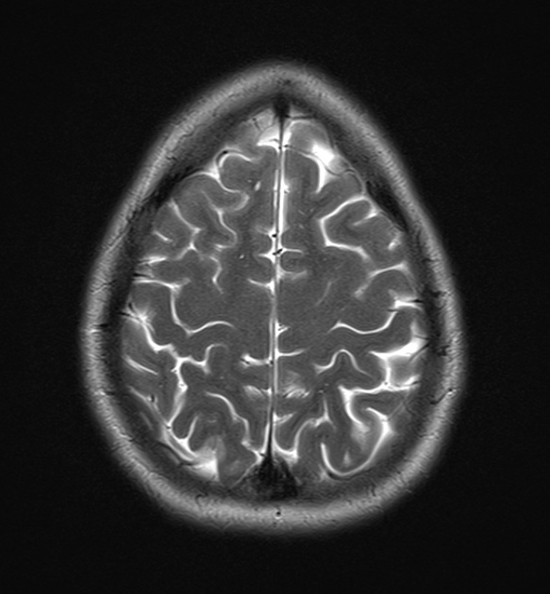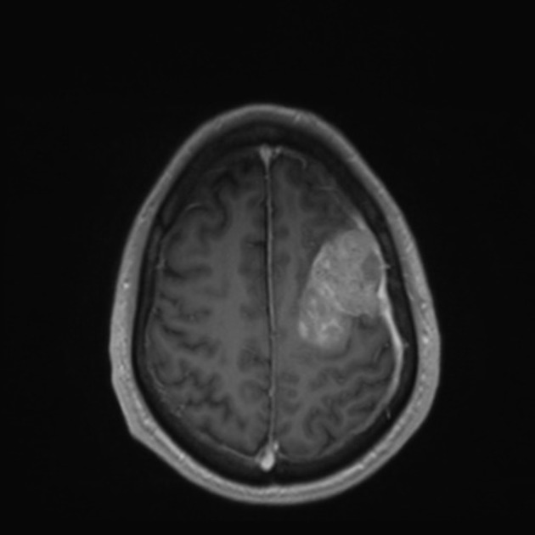
Dataset sample (left: non-tumour, right: tumour)

MRI Dataset Class & Image Augmentation
To ensure optimal model performance and remove any unnecessary image-processing in the model architectures, a custom PyTorch dataset class, MRIDataset, was developed to handle image loading, labelling, and augmentation. The unique requirements of the SDA model necessitated a flexible output style, such that both models would be compatible with the one class despite each model taking in a different number of images.
The first issue targeted by the MRIDataset class was the matter of loading the images and validating the label file. It further cleaned and formatted the label and image names to accurately align them for use with the models’ training, testing, and validation phases. Extraneous whitespace was removed, images without associated labels were flagged and counted, and the appropriate files were loaded into a list for future usage. Images were also processed to ensure model compatibility, which meant conforming to model requirements of 224 x 224 pixel-sized grayscale images. A data augmentation pipeline was also employed in an effort to counteract the small size of the dataset. Random horizontal flips, random rotations, colour jitter, and image normalization increased the dataset’s variability by a variety of methods meant to test the models’ ability to generalize to a variety of appearances and cases.
The MRIDataset object’s design allowed for experimentation under a different method of instantiation for each model. Creating the dataset object with a flag denoting whole image analysis allowed the dataset to instantiate itself of the 224 x 224 sized images, ready to pass them onto the TTL model. Passing in a flag denoting SDA usage switched the class’s behaviour and split images down the midline with some additional padding to offset lost symmetry near the hemisphere area. Apart from the image-splitting behaviour, both types of MRIDataset objects functioned the same.
Algorithmic Differences between SDA and TTL Models & Training Loop
Both models were built upon the same premise of transfer learning, which takes advantage of the built-in architecture, which allows for the freezing and unfreezing of pre-trained convolution layers at different depths at will, ensuring a high level of modularity with respect to the type of training or task at hand. In this investigation, the initial shallow layers were kept frozen, so as not to overwrite existing feature weights and learned features. Additionally, both models ran for 10 epochs in each phase of testing and validation for a relatively optimized balance between computational speed and increased model performance, based on existing literature-based precedents.
The TTL model followed a standard fine-tuning methodology, traditionally employed in every subfield of computer vision model applications. In the scope of this paper, the model used its pre-trained convolutional layers to extract meaningful features from the images (e.g. those that defined hemisphere boundaries, common structures, and general cerebral shape). These features were then fed into the final fully connected layer which acts as a binary classifier to differentiate benign vs malignant images. Essentially, each MRI scan passed through the ResNet50 pipeline and a loss function built on a standard binary cross-entropy was used to compute and optimize the training layers throughout the epochs. Metrics including accuracy, precision, recall, and F1-score were calculated throughout this training stage.
The SDA model took on a more complex approach, in which the MRIDataset object provided images split down the midline to better reflect the structure of a hemisphere. Each image was split with some additional padding on the side it was cropping out as to provide context of overlapping hemispheres to the models. These inputs were then processed independently through a modified application of ResNet50, sent to an identity layer to output feature maps for each hemisphere before concatenating the maps along a feature dimension. This concatenated feature map served as an intermediate to the final fully connected layer which outputted the prediction of tumour presence. This encapsulated the idea of simulating inter-hemisphere relationships that a human would be able to pick up from a spatial perspective.

Results
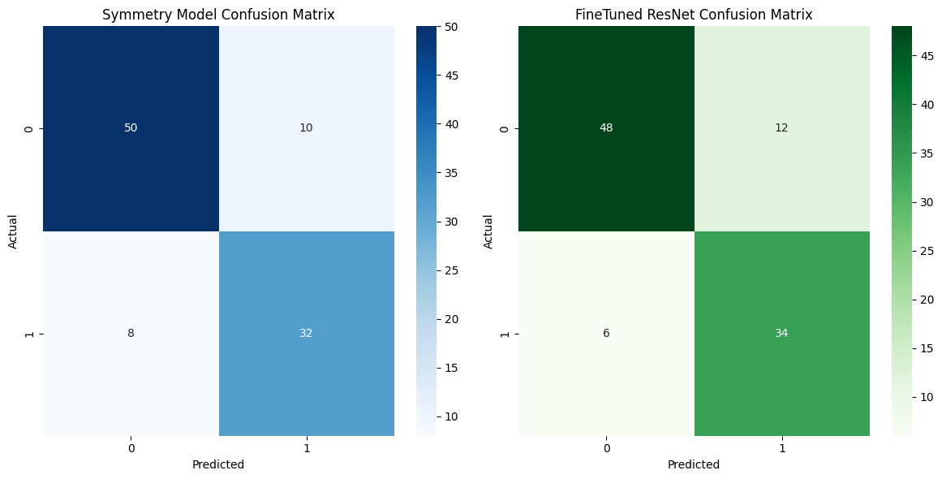
Confusion matrices for test run

The SDA model showed consistent performance with a mean validation accuracy of 89.52 ±2.15 and a mean validation F1-score of 93.95 ±1.32. The mean training loss was relatively low (0.35 ± 0.20), while mean precision and mean recall were high, at 94.34% ± 2.21 and 93.69% ± 3.34, respectively. This slightly outperformed the TTL model, which wasn’t as consistent in its validation loss, clocking in at a mean of 0.55 (±0.48). Mean validation accuracy and mean F1-score were slightly lower at 86.40% (±7.08) and 91.90% (±4.79), respectively. The lack of consistency also affected overall accuracy, with it reaching a higher peak of 93.88% but also a lower minima of 73.50%. Paired t-tests revealed that neither the accuracy nor the F-1 scores held any level of statistically significant difference. The t-value for accuracy was 1.358, with the p-value being relatively high at 0.207. The F-1 score’s t-value was in the same ballpark at 1.293 with a p value of 0.228.
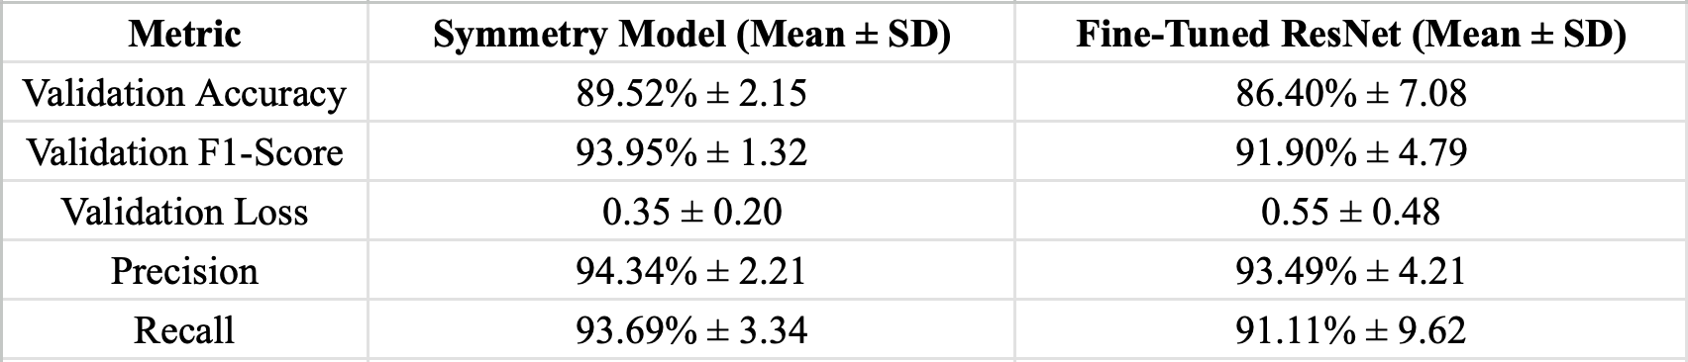
Visualizing the models’ accuracy and F-1 score over the epochs provides a visual representation of the two most holistic metrics used to measure CNN performance. Both models show consistently high training metrics, but validation loss curves show that the SDA model tended to show more variability – a possible symptom of overfitting to training data and lacking the ability to generalize to fresh, unseen data.
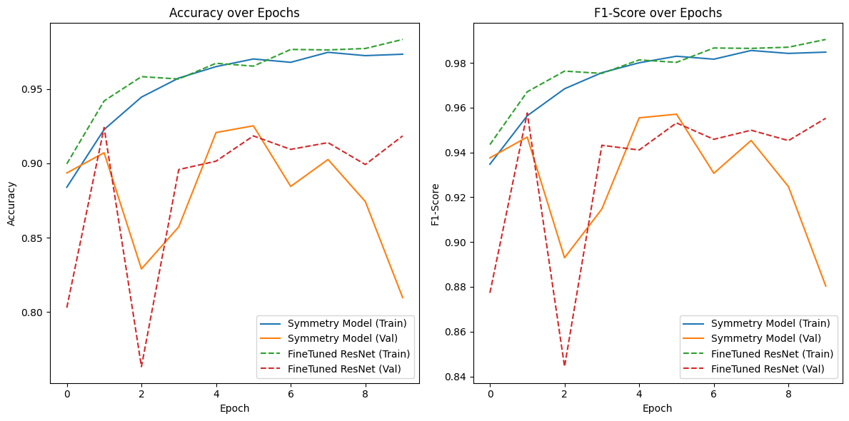
Graphical representations of performance over epochs (left: accuracy, right: F1-score)
Discussion
The results of this study point to a budding potential in the integration of SDA as a new approach to medical imaging, particularly in brain scans and tumour detection. While there was no large difference in algorithmic performance, the comparable results show that future exploration of SDA may hold an advantage due to the simulated spatial and morphological information encapsulated in the hemisphere comparisons made by the CNN. This aligns with prior studies which found success through symmetry-based means of medical imaging. Clinically, these results hold very little weight at the moment. However, the universal anatomical markers that have served as heuristics for human analytics such as hemisphere midlines showed no negative effect on this specific execution of SDA-based imaging. With refinement and evolution, false-positives and false-negatives could be reduced, potentially saving lives or flagging problematic scans for human approval. Overall diagnostic confidence would allow radiologists and doctors of all skill levels to make better-informed decisions and treatment plans for patients. However, ethical concerns surrounding the over-reliance of a black box neural network, as well as compliance with any regulatory standards surrounding automated medical imaging should be addressed in order to provide patients with the best possible care.
Limitations
This study faced various obstacles and limitations that affected the results. The dataset was of a smaller size, which would likely prevent the models from generalizing to fresh clinical data on a large scale. Additionally, the class imbalance exhibited by the dataset was an issue that may have skewed the models’ learning. The dataset was divided into multiple classes with multiple types of tumours, classifying between a simplified tumour/non-tumour binary introduced that imbalance. Additionally, truncating the learning at that depth of classification would prevent medical-grade deployment, as clinical distinctions often make use of tumour types, locations, and severity. Computational constraints hindered efficiency, forcing the study into smaller batch sizes, fewer optimization calculations, and slower training times, likely leading to decreased performance. Inexperience with the technologies involved led to an overreliance of older and better documented software practices and libraries, leading to an out of date and potentially inefficient implementation. The largest and most important limitation was caused due to the scope of the paper – the symmetry deviation analysis was restricted to a left/right analysis of overall asymmetries in the MRI scans, leading to a binary yes/no classification of the overall image. However, the presence of multiple tumours and spatial data is not possible at this time within the given implementation. Further studies should investigate possible capability enhancements in this area to better detect and localize tumours.
Future Work
To build on this research, the limitations would need to be addressed. A better and balanced dataset would likely yield improvements in SDA model learning and generalization, and updated code would improve computational efficacy. Expanding the research to include tumour subtype classification or image segmentation to locate the tumour would introduce a more tangible clinical output. Real-time implementations were the subject of other studies, and could provide greater clinical usability to these implementations.
Conclusion
This study has demonstrated the potential in SDA as a complementary method to existing methods of automated medical imaging and brain tumour detection. The proposed method attempts to fill the gap in the literature through distinct anatomical exploits and outputs a possibility for improvements in medical CNN applications. While the results are moderately promising, this shows a variety of challenges facing clinical applications of AI, namely the data constraints, computational requirements, and need for input from a variety of parties and agents to ensure accurate, fair, and ethical outcomes. With more interest and sustained support from the relevant communities, assimilating biologically creative platforms such as structural symmetry can make their way into AI algorithms to push diagnostic tools forward toward a more holistic and effective approach to patient care and clinical decision-making.
Works Cited
Abd-Ellah, M.K., Awad, A.I., Khalaf, A.A.M. et al. Automatic brain-tumor diagnosis using cascaded deep convolutional neural networks with symmetric U-Net and asymmetric residual-blocks. Sci Rep 14, 9501 (2024). https://doi.org/10.1038/s41598-024-59566-7
Kouli, Omar et al. “Automated brain tumor identification using magnetic resonance imaging: A systematic review and meta-analysis.” Neuro-oncology advances vol. 4,1 vdac081. 27 May. 2022, doi:10.1093/noajnl/vdac081
Mennatallah Mohamed Hanafy, et al. “Mammographically Detected Asymmetries in the Era of Artificial Intelligence.” Egyptian Journal of Radiology and Nuclear Medicine, vol. 54, no. 1, 27 Feb. 2024, https://doi.org/10.1186/s43055-023-00979-1. Accessed 1 Oct. 2024
Sonoda, Shozo, et al. “Artificial Intelligence for Classification Uncertain Images by Humans in Determining Choroidal Vascular Running Pattern and Comparisons with Automated Classification between Artificial Intelligence.” PLOS ONE, vol. 16, no. 5, 14 May 2021, p. e0251553, https://doi.org/10.1371/journal.pone.0251553. Accessed 1 Oct. 2024.
Younis, Ayesha, et al. “Abnormal Brain Tumors Classification Using ResNet50 and Its Comprehensive Evaluation.” IEEE Access, 1 Jan. 2024, pp. 1–1, https://doi.org/10.1109/access.2024.3403902.

