Ex 1:

1. Verify assumptions:

* Normality in each subgroups (6 subgroups given by the 2 groupings) , we perform a multivariate Shapiro which allow us to assume gaussianity since we don’t reject the normality assumption

P = 0.2369077 0.4612391 0.9702243 0.6525198 0.5279147 0.6612603

* Homogeneity in the 6 subgroups:

Perorm a barlett test :

# H0: sigma.1 = .. = sigma.g

# H1: there exist i,j s.t. sigma.i!=sigma.j

P value = 98% -> accept homogeneity

* Hypothesis verified

Build the anova two ways model

1. Df Sum Sq Mean Sq F value Pr(>F)

group1 1 32.79 32.79 62.176 7.12e-13 ***

group2 2 0.16 0.08 0.149 0.862

group1:group2 2 0.21 0.11 0.201 0.818

by this output we can see:

* ### H0: tau.1 = tau.2 = 0 vs H1: (H0)^c

### i.e.,

### H0: The effect Fact1 doesn't significantly influence the alchol

### H1: The effect Fact1 significantly influences the alchol

Reject H0 ->

group1 (color of the wine) is significant so there seems to be a difference in the alcohol between wines with different colors

* H0: beta.1 = beta.2 = 0 vs H1: (H0)^c

### i.e.,

### H0: The effect Fact2 doesn't significantly influence the alchol

### H1: The effect Fact2 significantly influences the alchol

Accept H0 ->

group 2 (region) does not ignificantly influence the alchol

* the interaction between the groupings do not seem to be significant

We can go on removing the interaction and so building an additive model:

* group1 still significant
* group 2 not significant
* remove group2

model : x.jk = mu + tau.i + eps.jk; eps.jk~N(0,sigma^2)

Estimate mu, tau.i:

mu = 7.981784

tau1 = 0.4675426

tau2= -0.4675426

estimate of thesigma^2: 0.5156073

1. BF for the means in the 2 groups identified by colors (grouping 1)

red 8.201944 ; 8.696709

white 7.266859 ; 7.76162

BF for the variance = 0.3748061 0.7442128

Commento?

Ex2)

1. I want to use LDA or QDA to build the classifier

Check the assumptions fir LDA:

* Gaussianity in each group:

Pvalue in the 3 groups = 0.424 0.416 0.256

* Accept normality
* Homogeneity:

The homogeneity does not seem to be met

* We use QDA which only need the assumption of normality

Prior probabilities of groups:

walking sitting laying

0.125 0.500 0.375

Group means:

accel gyro

walking 0.6877333 0.6447333

sitting 0.3588000 0.3376667

laying 0.2147333 0.1474000

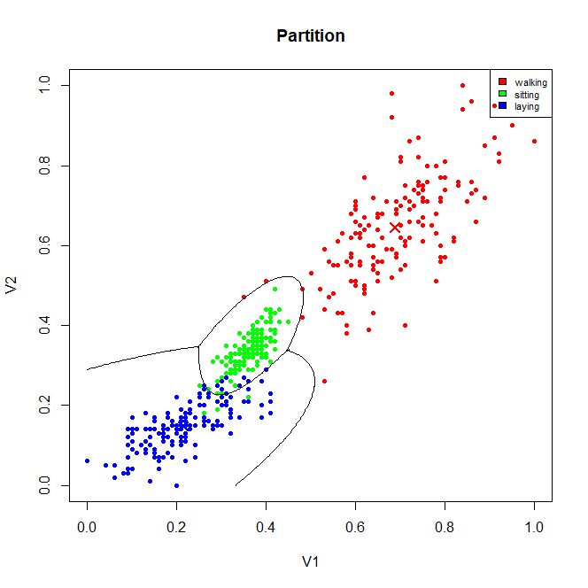

1. APER

class.assigned

class.true walking sitting laying

walking 147 3 0

sitting 0 145 5

laying 0 10 140

APER = 3/150 * 0.125 + 5/150*0.5 + 10/150* 0.375 = 0.04416667

Small -> good

1. The predicted activity is Sitting with a posterior probability of 0.5372111
2. KNN

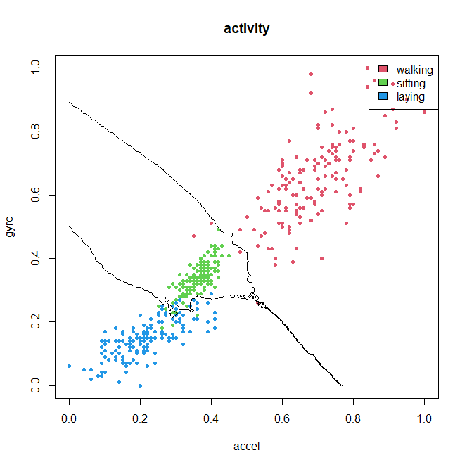

Come calcolo l’error rate? Ok

Ex3:

Construct a linear model with z1= mean_temp and z2=mean_wind numerical regressors and the categorical regressor Holiday/not holiday (dummy variable = 1 if Holiday)

# y = B0[g] + B1[g]*z1 + B2[g]*z2 + eps

Estimated parameters:

B0 B1 B2

Holiday 4084.388 118.60701 -224.9999

No_holiday 3286.108 87.42783 -441.7284

Sigma^2 =

verify assumption:

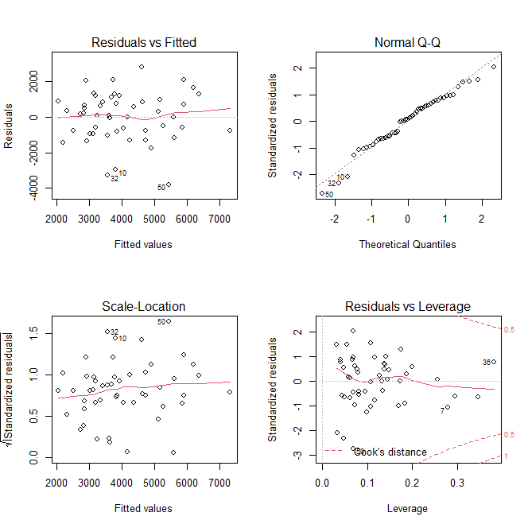

The residuals seem to have mean zero and seem to be homogeneus ->

We can say that maybe the data 10,32,50 are outliers and we should look at them to understand if we can remove them

The qqplot is quite good indeed also the Shapiro test allow us to assume gaussianity

* Assumptions verified

Test about the weather: I perform a linear hypothesis test to check if we can put at 0 all the coefficients related to z1 and z2 -> the pvalue= 0.0002863 -> at 5% we reject H0 (ie all the coeff are 0) -> there is statistical evidence of a dependence of the mean number of bikes rented on weather information

Test about the holiday: perform again a linear hypothesis test to check if we can put at 0 all the coeff related to the dummy variable : pvalue = 0.009922 -> at 5% we reject -> there is statistical evidence of a dependence of the mean number of bikes rented on holiday information.

1. From the output of the model we see that a lor of regressors are not significant and this may impact the goodness of the model indeed we see that the R^2 adj is quite low-> reduce the model

The final model is:

fit <- lm(y ~ z1 + dummy , data = dataset)

all the regressors are now significant.

Estimates:

B0 B1

Holiday 3880.735 97.49175

No_holiday 2456.943 97.49175

1. PI = [1121.848 ,7029.589]

Point estimate = 4075.718

Ex4)

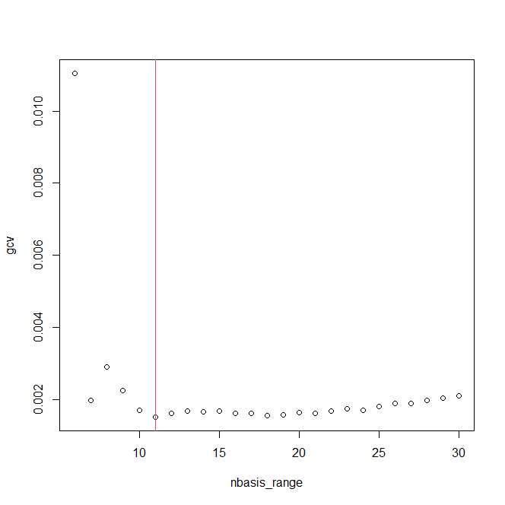

As we can see from the plot the optimale number of basis is 11.

Estimated coeff = 0.02401024 0.10070402 0.33763038 -> check -> sì

b) smoothed data

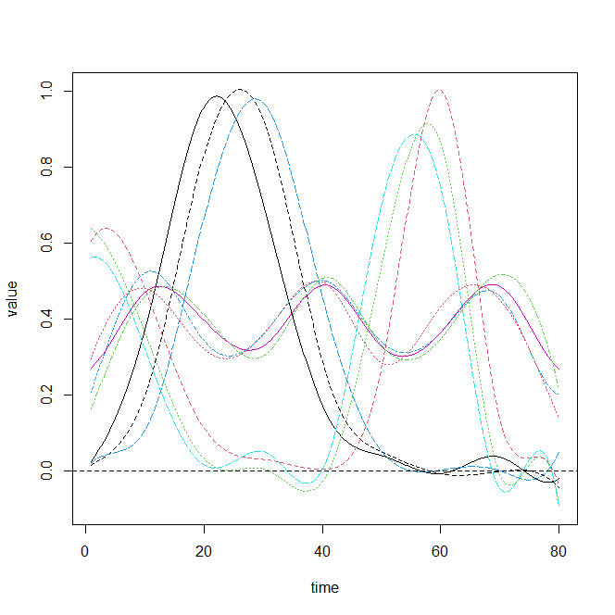

1. K-mean allignment

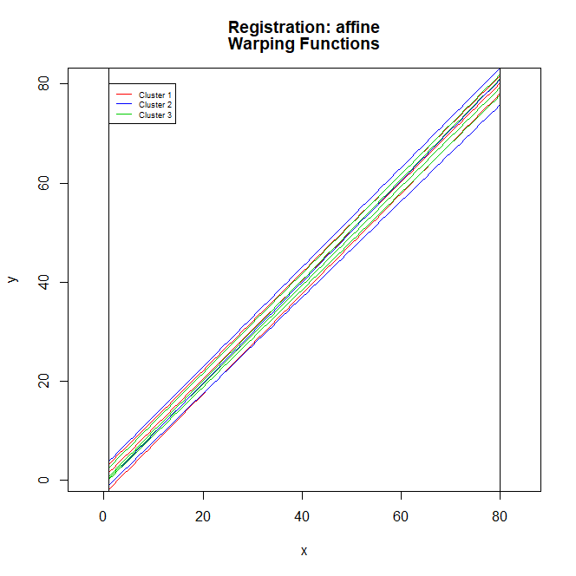

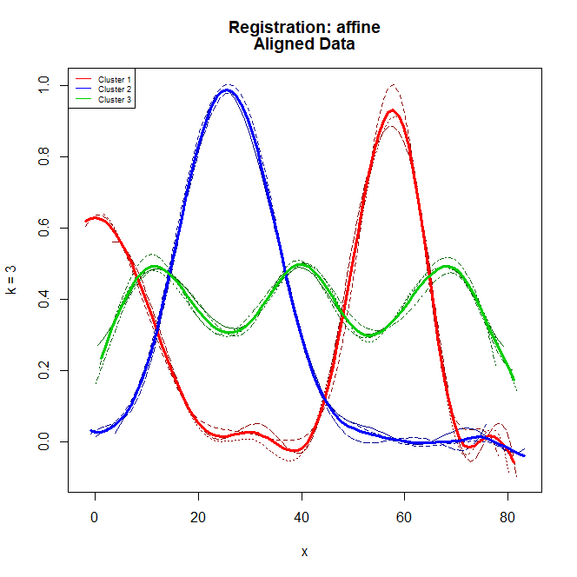

The result of the k-mean alignment is good for the functions but we don’t see a clustering in the warping functions

Devo farlo su quelle smooth? Come?