# DigitalTechne proposition

## Our vision

Tightly coupling a physical object, like an artwork, to a unique digital information (like a NFT) enable a wide range of opportunities, such as fighting fakes, ensure ownership, use new financial services. DigitalTechne is developing a comprehensive set of services addressing this idea.

## Product Brief

Aim of this document is to briefly describe the services developed and supported by Digital Techne. Digital Techne was born with the aim of introducing a “disruptive” service in the art market, through the diffusion of a genomic seal, invisible to the naked eye, containing a genetic code, unique for each work, able to make it “unique” and therefore recognisable over time with respect to any counterfeits. The service is then supported by an advanced IT infrastructure, based on blockchain and using NFT, which on one hand is able to make the association between physical work and genomic code unalterable over time, thus determining an indissoluble association between the physical work and its electronic folder, and on the other to provide a digital certificate to the owner(s) of the work that allows an easy digital use of the work, making it useable even as a financial collateral.

It is clear that the solution we propose represents an important element of enhancement and protection of the artistic heritage, as it is able to give certainty about its authenticity, also allowing the creation, organisation and management of an electronic folder linked to the work itself, if not already existing, where all the information relevant to the work is stored, from the attribution, to the origin, to the state of conservation and to anything else important for a specific work, a fundamental element for increasing in value. It’s clear as much that the value of this technology is not confined to the art market but can be applied to any valuable object in almost all the segments of luxury.

The solution has zero environmental impact and allows target market stakeholders to adhere to new organisational and business models, thus also opening the door to service, process and market innovations. Thanks to the genomic seal that uniquely identifies the artwork, a complete equivalence between the physical artwork and its dematerialised version is achieved, allowing an immediate, safe and “certified” use of the artworks as financial collateral, also enabling evolved services of Decentralised Finance (DeFi) such as shared ownership and the relative purchase and sale of certificates. This possibility will greatly expand the potential pool of users, both by allowing access to the high end of the art market to users with a limited portfolio, and by allowing the use of the artworks as financial collateral, without incurring heavy costs of investigation and risk management, even to owners of works of low economic value.

## In depth description

Moving on to a more in-depth description of our proposal, the project intends to realise three closely related services.

1. **Genome seal artwork marking service and issuing the relevant certificate via NFT**. The marking will be made with a special disposable pen with DNA ink (genomic PEN) made by us to prevent the possibility of multiple use of the same ink, ensuring the destruction of the genetic material at the end of the first application.

The digital representation of the DNA and other informations such as date, description etc) are the initial payload used for minting a NFT.

The genomic PEN will be the subject of a patent and will therefore constitute an industrial right that will limit/eliminate competition. The distinction between the genomic seal and the Genomic Pen should be clarified: the Genomic Pen is the physical object similar to a marker inside which the cartridges containing the invisible genomic ink are loaded and which is necessary to mark the artwork with this ink. The genomic seal is instead that very small trace containing the genomic code, invisible to the human eye, which is applied to the work through the use of the Genomic Pen. The knowledge of the genomic code contained in the seal applied to the work through the Genomic Pen is then maintained inviolably, and made available for possible verification, through the blockchain and the Digital Techne application. It is worth noting that the science tells us that DNA has a persistence over time of thousands of years, making the genomic seal a perennial identification of the physical object. Moreover our tests showed that a tiny drop of our ink contains enough genomic material to carry on more than 50 verification tests. The verification of the originality of the physical artwork can be carried out in any genomic laboratory in the world, using a simple swab that is briefly placed on the genomic seal and subsequently sent to the laboratory to be analysed.

Since the Genomic Pen is the so-called unique value proposition and a key element of our service, it is good to clarify the reasons and its operation. It is clear that for the success of the service it is necessary to guarantee its safety, which essentially implies in making it impossible, even for a corrupt official, to mark a work and a copy of it with the same genome. For this purpose we have studied a special 'pen' that guarantees to be able to mark only one work with a certain genomic ink. This is because the pen contains two tanks, one containing DNA ink and the other containing an enzyme that destroys the genetic material contained in the ink residue of the tank with DNA. At the end of the first use the DNA-destroying enzyme is released into the genomic ink tank and any subsequent improper use will not result in the release of any genomic trace.

Finally, as an element of greater safety, certainly appropriate for artworks of great value, “spikes” are artificially inserted in known positions of the DNA chain, in order to make the genomic seal completely non-reproducible, even if the evolution of genomic technology would allow an entire DNA to be generated in the laboratory from a fragment of it. In other words, they are introduced into the genomics some spikes (proteins) in positions not publicly known, which in any case would not be amplifiable with the genome, being 'foreign bodies'. This element of additional security makes the service completely secure even to the potential developments of the technology described above.

2. **Blockchain-based “electronic folder of the artwork” service** where qualified operators (such as Foundations, Action Houses, Artists, ..) or the owners of the works will be able to store all the documentation deemed relevant related to them, including those related to the origin.

Thanks to blockchain technology, every element present in the electronic file will be temporally marked and stored in a permanent, immutable and unalterable way, highlighting the qualified operator who recorded the documentation, since the perception on the reliability of the recorded data is strongly connected to the reputation of the operator who entered them by validating them, and is always linked to the NFT.

The information can be made secret or accessible in a differentiated way by controlling the dissemination and access to the information in the file (obviously the owners of the work will decide the levels of secrecy to be applied). This Service can be customised for operators in the sector, such as Foundations, Museums or Auction Houses and may also contain the updated condition reports of each work. The condition reports are nothing more than certifications carried out by qualified professionals that attest to the state of preservation of the work, and that are a fundamental element for the correct evaluation of the value of a work and its usability in a financial context.

3. **Work ID Card Issuance Service via NFT**. Once the process of marking and registering the work and all the information related to it is completed, the owner is issued an NFT representing a real identity card of the registered work with all references to the electronic file and the applied genomic seal, with the possibility of using the same NFT as collateral within next generation financial services. Although the NFT and the blockchain are not the absolute innovative components of the project, being cutting-edge technologies but now mature, it is certainly innovative the use that is made of these technologies within the project to allow us to develop new advanced and transparent services in the art market and create a transparent ecosystem of information related to works of art that also allows this market to face the digital revolution, drawing considerable benefits.

All our services have been developed and are running on the Rebus blockchain and can be accessed using **TECHNE**, the native utility token of the Digital Techne’s services.

## Current Status of the project

Currently Digital Techne has completed the development of the technology and has successfully realized a Proof of Concept demonstrating the functionality of the technology. In the following you will find some pictures that shows how the genomic seal is applied to the artwork, how or it is invisible at the naked eye and how it is recognizable by using fluorescent lamp.

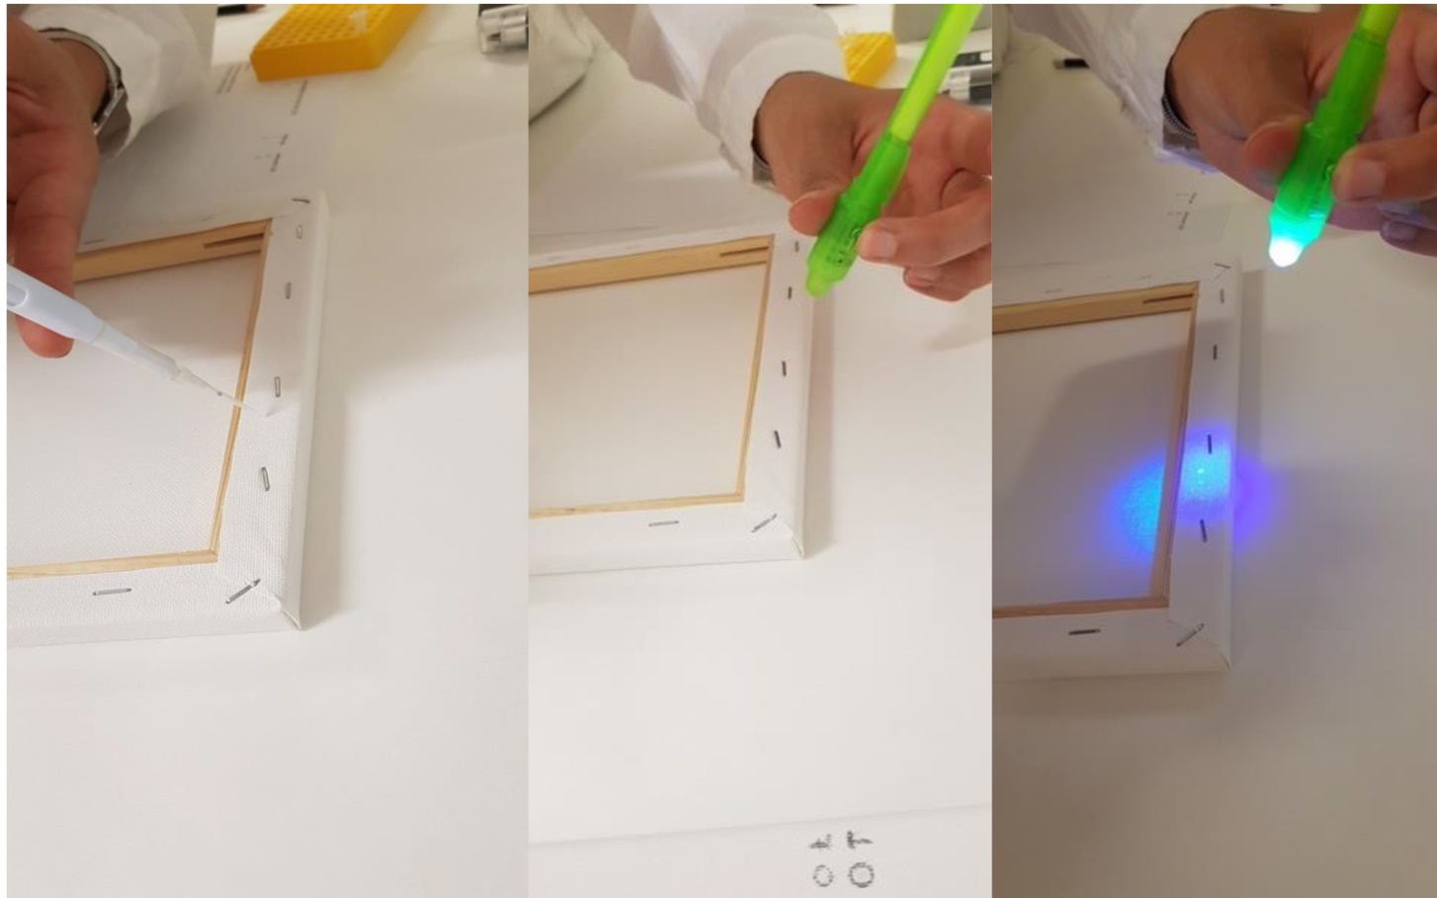

Currently the company is consolidating the products and the services through a process of industrialisation of its components, and in particular of the Genomic Pen, and the creation of a small genomic laboratory, thus resulting not only in an optimisation of the service but also a significant reduction in costs. At the same time, the company aims to carry out some pilot projects that allow a fine tuning of the service and to develop the market, starting with the Italian one. In the medium term, the company aims to gradually expand its market on an international scale, as innovation creates competitive advantages on a global basis, including by developing partnerships with realities that can use the genomic tag to expand their core business (such as auction houses or financial companies), also evaluating the use of the genomic seal in sectors other than art. In the next few days the company will announce the agreement with some artists that will be testimonials of the value that our services bring to artistic production and some special initiative bound to this events.

In parallel the company is closing a financing round, also including public funding, to haste the industrialisation process and the development of the market.