**The Techne token**

Introducing Digital Techne tokenomics

**Our vision**

The transformation of the wealth management sector, the global art market and the cultural creative sectors (CSS) are rapidly creating new needs and opportunities at the intersection of art and finance.

* As high-net-worth-individuals seek holistic wealth management offering
* As art and collectible assets require the same attention as other assets
* As younger generations introduce new values
* As the need grows for new sustainable and innovative mechanism for the culture and creative sector
* As purpose-led investment and innovation is increasingly demanded in the cultural sector
* As trust, transparency and regulation rise up the agenda
* As technologies matures and offers new ways to do business
* As culture is recognized as a major engine for sustainable socio-economic
* As all of this is part of a global phenomenon

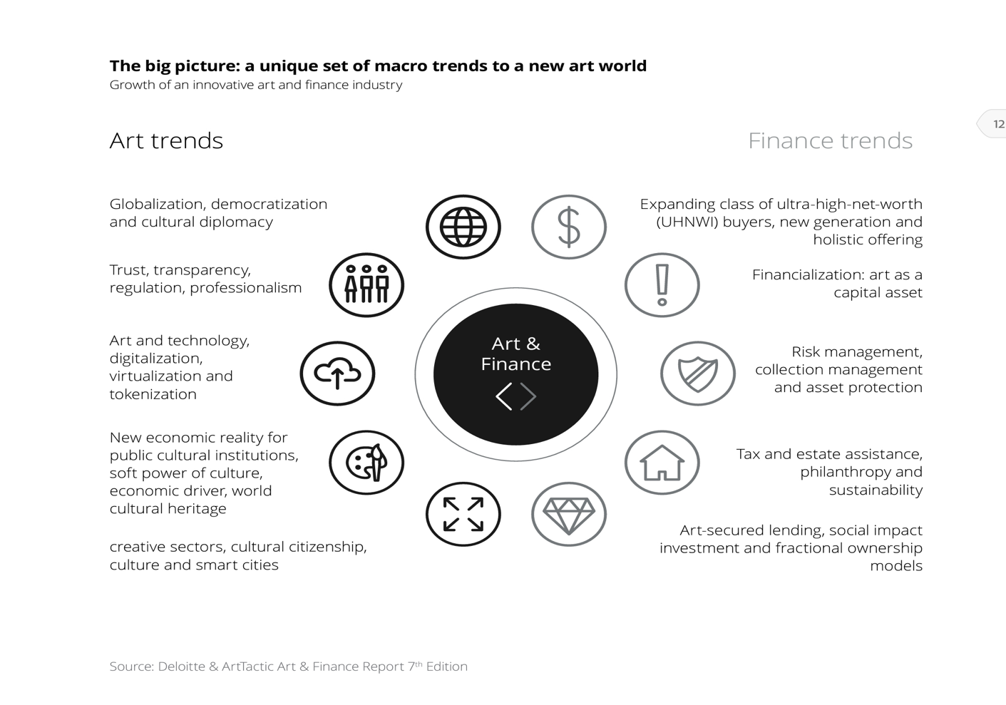Thus, there are solid elements to support the growth of an innovative art and finance industry in the years to come.

Technology is certainly the key enabler for the art and finance industry, addressing the various friction points and ultimately driving more efficiency and growth, including the possibility to open brand new financial markets.

In our vision the contemporary use of Blockchain/NFT and Genomic technology for artwork is the key factor for disrupting art and finance industry. Blockchain has long been considered a key technology for this market because of its potential to improve authentication and provenance. Another key potential of Blockchain technology is that while collectors and dealers may not wish to share their personal ownership details with a central registry, the blockchain would allow proof of ownership with encryption without sharing actual identity. In this way provenance could be tracked to help verify a history of ownership, while protecting the privacy of individuals. And of course blockchain is a key factor for implementing a safe and transparent fractional ownership of artworks. NFTs are the blockchain tools that can be used on one side as “passport” of a digital object, and on the other side to proof the ownership of a given digital object.

Finally genomic technology gives the promise to supply object with a unique and not counterfeitable characteristic that can distinguish any original artwork.

**Mission**

Based on the assumption made, our mission is to create a genomic solution, backed by Blockchain and NFT technology, linking a physical artwork to digital information, giving assurance of authenticity and at the same time offering the necessary infrastructure to develop the art finance industry. In a nutshell the idea can be summarized as follows:

The foundation of the solution is a unique genomic tag, completely invisible at the eye, embedded in the artwork. The digital representation of this DNA is stored in the blockchain, jointly with the complete folder of informations related to the artwork, so that authenticity can be checked at any time in any genomic laboratory worldwide. The owner(s) of the artwork have then an NFT that at the same time is a passport of the artwork itself and a proof of the ownership. Digital Techne solution is then able to fully digitize an artwork, or any other collectible, allowing at the same time a certain proof of authenticity. The NFT representing the so digitized artwork can be immediately used as a collateral for financial operations, and in particular for art-secured lending services, and at the same time, in case of fractional ownership, it allows to create a digital market to easily buy and sell these fractional ownerships.

**Token Economics**

TECHNE is the native utility token of the Digital Techne services and it is necessary to access all the digital company services, i.e. the registration of the genomic mark, creation of NFTs, trading of NFTs, proof of ownership verification, and so on. The token paid in the transaction will be distributed according to a logic, that will be flexible, but that generally foresee a split with 80% to the Company, 10% to the Artist and 10% to other third parties that may be involved. All the transactions related to the services, included the possible purchase/sell of NFTs will take place with other common tokens, like Rebus, Verto, USDT, or in some case with fiat money.

The Techne register and services are built using the Rebus blockchain and it’s ecosystem.

TECHNE will be listed on the Rebus’ Decentralized Exchange (DEX) as well as on the major exchanges.

The total max supply will be fixed as indicated in this document.

Basically there will be 2 minting pools:

* Minting pool 1 for the community - slow distribution, long maturity
* Minting pool 2 for the founders, partners and qualified providers - fast distribution, short maturity
* Treasury

**Minting pool 1 token distribution and allocation (10 years)**

The minting pool 1 works as follows: the users stake a defined token (   Verto) in the minting pool and, with the defined distribution policy, they receive the token Techne on a block basis. The total amount of tokens that will be minted in minting pool 1 is  1B of tokens in ten (10) years.

**TOTAL MINTING POOL 1:  1B**

**Minting pool 2 token distribution and allocation (12 months)**

**Founders**

80M:

**Partners and qualified providers**

40M:

**Platform partner**

3M:

**TOTAL MINTING POOL 2:  123M**

**Digital Techne treasury and liquidity program**

377M:   Minted at the genesis.

Within this total amount, **60M** will be distributed among **Investors, 20M** will be used to reward **Artists** that will used the company’s service for their artistic production and **70M** are allocated for distribution among the **Developers**.

Thus, the total of remaining **treasury** is **227**