**CS 4560 – Team on a Cob – OU WXC Performance Program**

**GUI Mockups**

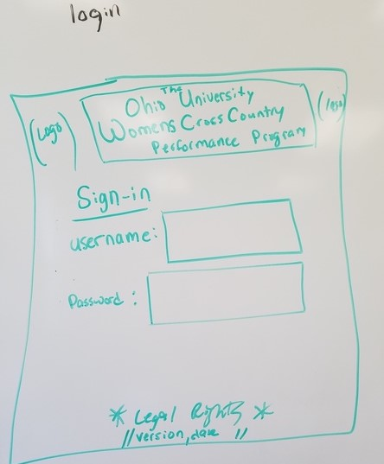

**Diagram Name:**

User Sign-in page

**Description:**

The functionality of this page allows a user (student/trainer/admin) to sign on the application. There will also be the version of the application as well as the date the update was published.

**Use Case Involvement:**

Before utilizing this application, one must first be verified as an athlete, trainer, or admin. This is important to the flow of events for all of the other use cases. Users can begin by clicking the empty fields and entering the unique information that identifies them within the system. Once the information has been entered, they can click the sign in button to continue. Access will be granted if they are correctly identified as a user of the system and denied otherwise.

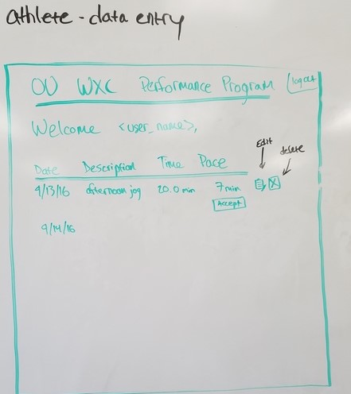

**Diagram Name:**

Athlete Data Entry Page

**Description:**

This diagram represents what the athletes will input into the application. It will be customized to the athlete’s name and list all of the current month's data. Along with these illustrations will be the ability to edit (in case a mis-type occurred), removal of a workout, both of these features will trigger a confirmation button to ensure it is intentional.

**Use Case Involvement:**

This page will be involved specifically for athletes who enter data for the day. The data will be added into the corresponding areas and once confirmed, will be stored in the AWS database. The athlete will also be able to modify preexisting data that had been entered at an earlier time. Within this process, the athlete would simply hit the edit button for the corresponding entry, edit the data, and confirm the changes. After clicking the confirmation button, the data will be updated in the AWS database. With the conclusion of both of these cases, the athlete and trainer will be able to see the data that has been stored in AWS.

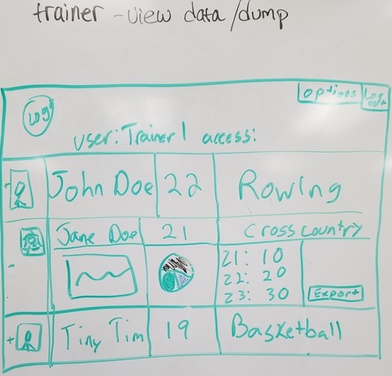

**Diagram Name:**

Trainer View / Export Data Page

**Description:**

This diagram represents what the trainer will see based off the athlete's input. Information relative to the data manipulated by the equations will be illustrated both numerically and graphically here.

**Use Case Involvement:**

Once the trainer signs in, they will be able to see an overview of all athletes under their watch. They will have the ability to click a specific athlete to expand/contract and view graphs, data, etc. for that specific athlete. Another option they will have is to force a data dump (labeled as export in this diagram). Upon clicking this button, it will force the raw data to be accessible in a preferred format.

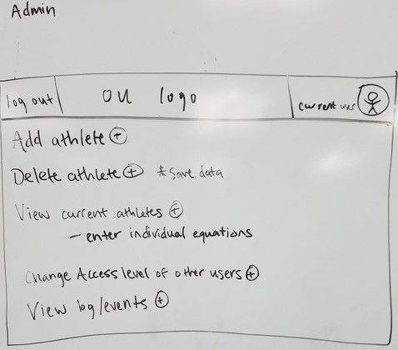

**Diagram Name:**

Administration View Page

**Description:**

This diagram represents the highest control of the application. Certain privileges will only be available to this group. The ability to add new athletes into the system, removal of an athlete, modification of equations for specific athletes, modification of access level for other users, as well as access to a log/events are the features that will be limited to administrators.

**Use Case Involvement:**

Once verified, admins can add a new athlete that is not currently into the system by clicking a button and entering basic athlete information. There will also be a similar removal of an athlete button that removes a specified athlete from the system. Finally, there will be an option to view the athletes equations with an option of being able to click to edit the equation for the specified athlete.