**CS 4560 – Team on a Cob – OU WXC Performance Program**

**Graphical Architecture Illustration:**

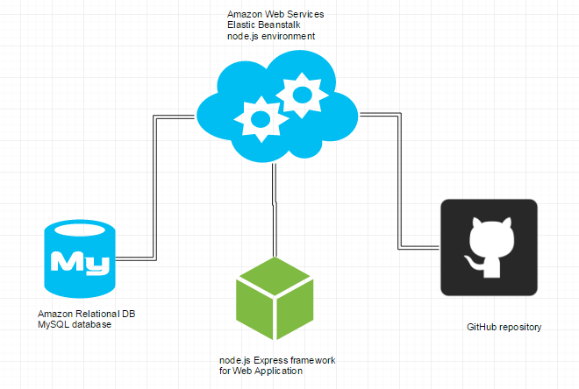

**Textual Explanation:**

AWS offers their *Elastic Beanstalk* service which sets up an environment (specifically, we chose a node.js environment) that comes packaged along with many other services such as load balancer for scaling, Amazon S3 buckets for cloud storage of source, Amazon EC2, Amazon IAM (access management tool), and optionally an Amazon Relational Database (which we set up as a MySQL database).

The MySQL database will store all of the athletes’ data they are entering through the web application. To develop the web application itself, we plan on utilizing the node.js Express framework. Amazon EB also allows functionality to connect with a git repository through the command line interface (EB CLI) which will allow us to deploy the most recent version of the site simply by committing our changes and then logging into the AWS console and deploying the new version, or simply just by running the *eb deploy* command from the command line.   
  
Web development as a whole is very new to us so it took a lot of deliberation to decide on using these things. As we begin to get these processes actually set up, we may decide to add or change technologies once we discover exactly how to use the ones we have selected. There is certainly a learning curve to our team for this area, but we are eager to learn!

**Hello World examples:**

**AWS Elastic Beanstalk node.js environment:**

We set up an environment on AWS EB running node.js

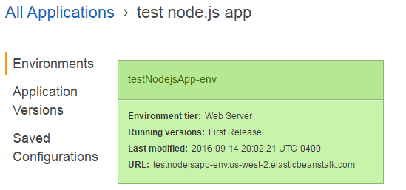

Once running and deploying a test hello world app, we can see the health is OK.

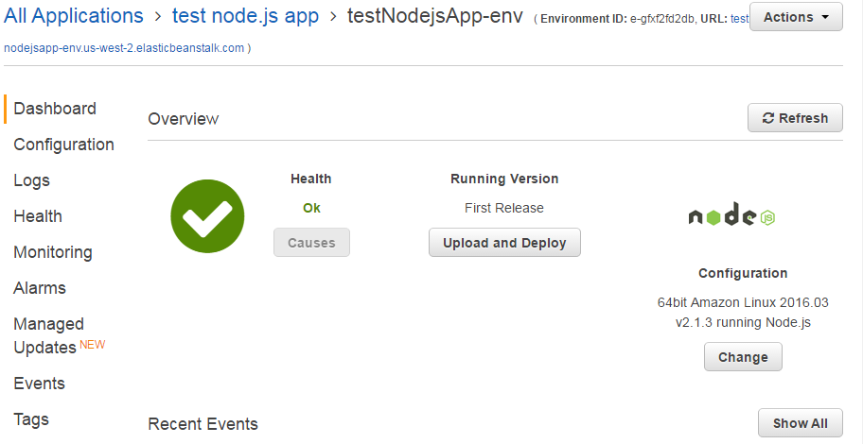

By viewing the URL, we can see the app and server are working!

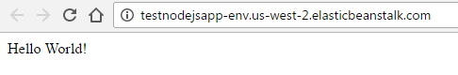

**Express sample app:**We first installed express onto a node.js environment and created a sample application called app.js which looks as follows. Then we ran the application which was viewable on port 3000.

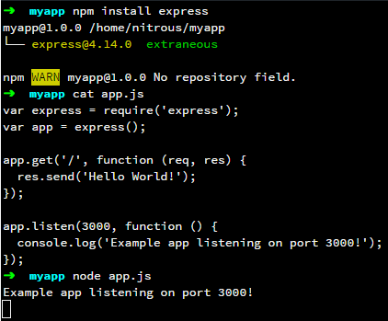

Which we can see through this test nitrous service.

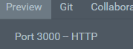

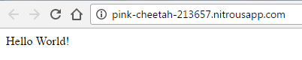

And it is also working!

**Amazon RDS MySQL example:**

Using the IDE MySQL Workbench, we were able to connect to the database that AWS was running.

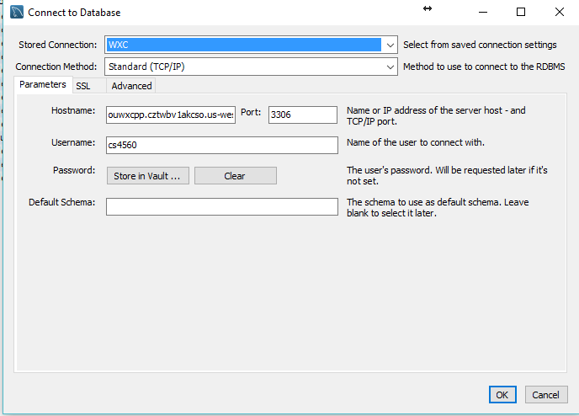

Using a simple create table statement/gui we were able to succesfully add a table to the schema.

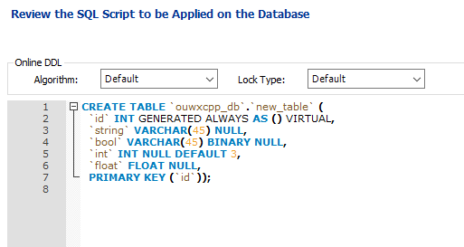

We were also able to successfully add data to the table!

