**INSTRUCTIONS**

**WEB TREND CONTROL FOR EDGE HMI**

**Technologies:**

* JavaScript
* NodeJS
* HTML

**Programs:**

* ITEH v8.1 InTouch Edge HMI NodeJS
* Microsoft SQL server 2019.
* Microsoft SQL tools 18.

**Connection to DataBase:**

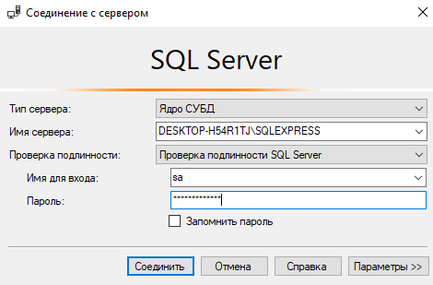

**Run Application in ITEH v8.1 InTouch Edge HMI:**

Finally, to create the custom widget, follow the instructions of the video below:

<https://www.youtube.com/watch?v=xfxpQfLYiDg&feature=youtu.be>