## **Pacific geoduck (*Panopea generosa)* resilience to natural pH variation**

**Laura H. Spencera, Micah Horwithb, Alexander T. Lowec, Yaamini R. Venkataramana, Emma Timmins-Schiffmand, Brook L. Nunnd, Steven B. Robertsa**

aUniversity of Washington, School of Aquatic and Fishery Sciences, 1122 NE Boat St, Seattle, WA 98105, United States

bWashington State Department of Natural Resources, 1111 Washington St SE, MS 47027, Olympia, WA 98504, United States

cUniversity of Washington, Biological Sciences, 24 Kincaid Hall, Seattle, WA 98105, United States

dUniversity of Washington, Genome Sciences, William H. Foege Hall, 3720 15th Ave NE, Seattle, WA 98195, United States

**Corresponding Author**: Laura H. Spencer, [lhs3@uw.edu](mailto:lhs3@uw.edu)

***DRAFT REVISION, DUE TO CBPD JANUARY 10***

## **Abstract**

Pacific geoduck aquaculture is a growing industry, however little is known about how geoduck respond to varying environmental conditions, or how production might be impacted by low pH associated with ocean acidification. Ocean acidification research is increasingly incorporating multiple environmental drivers and natural pH variability into biological response studies for more complete understanding of the effects of projected ocean conditions. In this study, eelgrass habitats and environmental heterogeneity across four estuarine bays were leveraged to examine low pH effects on geoduck under different natural regimes, using proteomics to assess physiology. Juvenile geoduck were deployed in eelgrass and adjacent unvegetated habitats for 30 days while pH, temperature, dissolved oxygen, and salinity were monitored. Across the four bays pH was lower in unvegetated habitats compared to eelgrass habitats, however this did not impact geoduck growth, survival, or proteomic expression patterns in gill tissue. However, across all sites temperature and dissolved oxygen corresponded to growth and targeted protein abundance patterns. Specifically, three protein abundance levels (trifunctional-enzyme β-subunit, puromycin-sensitive aminopeptidase, and heat shock protein 90-⍺) and shell growth positively correlated with dissolved oxygen variability and inversely correlated with mean temperature. These results demonstrate that geoduck may be resilient to low pH in a natural setting, and other abiotic factors (i.e. temperature, dissolved oxygen variability) may have a greater influence on geoduck physiology. In addition this study contributes to the understanding of how eelgrass patches influences water chemistry.

**Key words**

Aquaculture, comparative physiology, ocean acidification, Panopea generosa, proteomics

**Introduction**

The Pacific geoduck, *Panopea generosa,* is native to the North American Pacific Coast and is a burgeoning aquaculture species with strong overseas demand as a luxury commodity [(Coan et al. 2000; Shamshak and King 2015; Vadopalas et al. 2010)](https://paperpile.com/c/u9FQbA/JrjU+99xk+7qP0). The largest burrowing clam in the world, cultured geoduck reach upwards of 180mm and are harvested after growing approximately 6-7 years in sub- or intertidal sediment [(Vadopalas et al. 2015; WA DNR website 2018; Washington Sea Grant 2013)](https://paperpile.com/c/u9FQbA/IhJB+fVHs+DHbe). The long grow-out period and high per-animal value highlights the importance of site selection for farmers to maximize investment, however there remains a paucity of data on the optimal environmental conditions for geoduck aquaculture.

As marine calcifiers, geoduck may be vulnerable to ocean acidification due to their reliance on calcite and aragonite (forms of calcium carbonate) for shell secretion [(Orr et al. 2005; Weiss et al. 2002)](https://paperpile.com/c/u9FQbA/D0BJ+t6Di), both of which become less biologically available as seawater pH declines with pCO2 enrichment [(Feely et al. 2008)](https://paperpile.com/c/u9FQbA/n9ln). A broadening body of research on marine calcifiers indicates that, generally, projected low pH will shift organisms’ physiology to the detriment of species-wide abundances and distributions [(Pörtner 2008; Pörtner and Farrell 2008)](https://paperpile.com/c/u9FQbA/nvrr+se7S+UIGG+8iDj+3VtT+6yKw+UfoG). However, broad generalizations of how ocean acidification affects calcifiers are few due to varying pH sensitivity between taxa ([Gazeau et al. 2007; Ries et al. 2009)](https://paperpile.com/c/u9FQbA/9TPY+exhM+p6Yq+UfoG+xoOe+aW0K) and life stage [(Kurihara 2008; Kroeker et al. 2010)](https://paperpile.com/c/u9FQbA/UIGG+8iDj). For example, Miller et al. (2009) found that larvae of two species in the oyster genus *Crassostrea* varied in their response to elevated pCO2, as calcification rates were significantly reduced in the Eastern oyster (*C. virginica*), but the Suminoe oyster (*C. ariakesnsis*) showed no negative response. Thus lessons learned from other bivalve species cannot directly be applied to geoduck without investigation.

The effect of low pH on cultured geoduck needs to be explored to help the aquaculture industry make informed site selection, selective breeding, and investment decisions. For practical application, geoduck ocean acidification studies should best replicate the natural environment in which they are grown, which is primarily Washington State (90% of global production) in the Puget Sound estuary where environmental drivers vary between subbasin, season, and diurnal cycle [(Moore et al. 2008; Shamshak and King 2015)](https://paperpile.com/c/u9FQbA/nMik+99xk). Lessons from more advanced ocean acidification research on other taxa can also be leveraged. For example a significant conclusion is that low pH is not occurring in isolation, but rather in conjunction with changes in other environmental drivers such as temperature (meta-analyses: Byrne and Przeslawski 2013; Harvey et al. 2013; Kroeker et al. 2013), dissolved oxygen (Gobler et al. 2014), and salinity (Przeslawski et al. 2015), and thus single-stressor studies are limited in their predictive capacity. For example, an additive, negative effect of elevated pCO2 and temperature was observed in survival of the juvenile giant fluted clam (*Tridacna squamosa*) (Watson et al. 2012). Another consideration is the incorporation of naturally-occurring diurnal pH variability into ocean acidification studies, as variable pH can have differing effects on marine calcifiers compared to persistent low pH (Review, Boyd et al. 2016). For example, a study assessing diurnal variability in temperature and pH observed a synergistic effect of thermal and pH variation on porcelain crab metabolism (Paganini et al. 2014).

To best predict the effect of ocean acidification on geoduck aquaculture this project deployed geoduck in variable environmental conditions and leveraged the natural pH differences between eelgrass and unvegetated habitats in Washington State estuaries. Ocean acidification studies are increasingly exploiting naturally low pH systems to monitor the environmental heterogeneity alongside test organisms, for example in hydrothermal vents (Tunnicliffe et al. 2009; Kerrison et al. 2011), shallow CO2 seeps (Duquette et al. 2017), coastal upwelling regions and eutrophic estuaries (Howarth et al. 2011; Thomsen et al. 2013). For example, Ringwood and Keppler (2002) deployed *Mercenaria mercenaria* clams in the Charleston Harbor estuary in South Carolina while collecting physical-chemical parameters, and observed that while salinity was the primary determinant of growth, pH was also important particularly when salinity was low, and when pH dropped below a 7.5. Compared to controlled laboratory studies, these deployment studies can uniquely incorporate daily cycles in air exposure, temperature, pH, dissolved oxygen, salinity, and food availability.

Estuaries along the United States Pacific Coast are ideal, natural mesocosms for examining the effect of ocean acidification on commercially vital calcifiers, as they contain dense macroalgae beds [(Bulthuis 1995)](https://paperpile.com/c/u9FQbA/5bnn), environmental conditions that vary considerably between subbasins [(Babson et al. 2006; Banas et al. 2004; Dethier et al. 2010; Moore et al. 2008; Yang and Khangaonkar 2010)](https://paperpile.com/c/u9FQbA/o0ys+aC1Q+nQNA+nMik+uvf0), and have rich communities of native and cultured shellfish [(Dethier et al. 2006; Miller et al. 2009; Washington Sea Grant 2015)](https://paperpile.com/c/u9FQbA/fbu6+p6Yq+CfQJ). Furthermore, coastal estuaries have already shifted towards lower pH, warmer averages, and are projected to continue along this trend [(Abatzoglou et al. 2013; Busch et al. 2013; Doney et al. 2007; Feely et al. 2012, 2010, 2008; Mote and Salathé 2010)](https://paperpile.com/c/u9FQbA/B3GR+gpwf+BUbn+3bME+uqqi+n9ln+ZobN). The buffering capacity of macroalgae (seagrass meadows, kelp forests) allows for block-designed experiments to examine the effect of pH, while controlling for varying background environments and maintaining diurnal fluctuations [(Middelboe and Hansen 2007; Palacios and Zimmerman 2007; Wahl et al. 2018; Groner et al. 2018)](https://paperpile.com/c/u9FQbA/3RDC+2gzC+IcB4).

In order to better inform geoduck aquaculture practices, we set out to examine how low pH and other natural variation in environmental conditions influence geoduck growth and physiology, using eelgrass as a primary determinant of water chemistry. Physiology was evaluated with a unique two-phase proteomics approach using Selected Reaction Monitoring, with targets identified using Data Independent Acquisition, and selected based on prior environmental stress response studies.

Environmental stressors are thought to elicit a broad and generic transcriptional stress response in marine bivalves, with several protein categories implicated as key damage mitigators. The inducible heat shock proteins are associated with acute heat, inflammation, heavy metals, and reactive oxygen species, and act as chaperones to recognize and bind to unfolded or improperly folded proteins [(Review, Bozaykut et al. 2014)](https://paperpile.com/c/u9FQbA/JDfa). Induction of HSP90, for example, has been universally observed thus far in bivalve species [(Review, Fabbri et al. 2008)](https://paperpile.com/c/u9FQbA/M75P). Reactive oxygen species (ROS), or free-radicals, result in oxidative stress and higher ROS levels are associated with several environmental stressors including temperature, oxygen variability, salinity, heavy metals, and pH (Review, Lushchak, 2011). Upregulation of anti-oxidants such as catalase, peroxiredoxins, and superoxide dismutase (among others) have been observed in bivalves under hypercapnia and heat stress (Tomanek et al. 2011; Matozzo et al. 2013; Hu et al. 2015), and under heavy metal exposure (Giarratano et al. 2014). Metabolic function is known to be altered under low pH, hypoxia and salinity stress, generally shifting to anaerobic metabolism to minimize the mitochondrial ROS production associated with aerobic metabolism (Tomanek 2014).

In addition to antioxidant, aerobic and lipid metabolism, and general stress-response proteins, this study targeted proteins involved in mitotic growth, detoxification, acid-base and ion regulation, all quantified simultaneously to characterize the physiological response in the Pacific geoduck under variable pH environments. This novel application demonstrates the advances in proteomic research and the potential it has to improve aquaculture production.

## **Methods**

### **Experimental Design**

*Panopea generosa* juveniles (14.0 +/- 0.85 mm) were used in this experiment. Animals were of the same cohort, hatched from broodstock harvested from Puget Sound in Washington State, and reared in a commercial facility in Dabob Bay, WA at controlled conditions (18°C, salinity of 30ppt and pH 8.2). Geoduck were out-planted in four bays throughout Western Washington State from June 21 to July 21, 2016: Fidalgo Bay (FB), Port Gamble Bay (PG), and Case Inlet (CI) in Puget Sound, and Willapa Bay (WB) located off the southwest Pacific Coast of Washington (Table 1, Figure 1). All locations were selected based on the criteria that both eelgrass beds (“eelgrass”), and unvegetated sediment (“unvegetated”) habitats were present. Clams were placed in 10 cm diameter polymerizing vinyl chloride (PVC) pipes buried in sediment with 5 cm exposed; this method replicates aquaculture techniques. Five clams were placed in each of the 3 tubes in both the eelgrass and unvegetated habitat, with a total of 30 clams across 6 tubes per bay. Pipes were covered with a protective mesh exclosure to limit predation. The replicate structures surrounded and were equidistant to a suite of water quality sensors capturing pH (Honeywell Durafet II Electrode, in custom-built housing), salinity (via conductivity, Dataflow Systems Ltd. Odyssey Conductivity and Temperature Logger), dissolved oxygen (Precision Measurement Engineering MiniDOT Logger), and temperature (via dissolved oxygen probes). Sensors were modified for submersible, autonomous data collection, and logged at 10-minute intervals for the duration of the 30-day outplant.

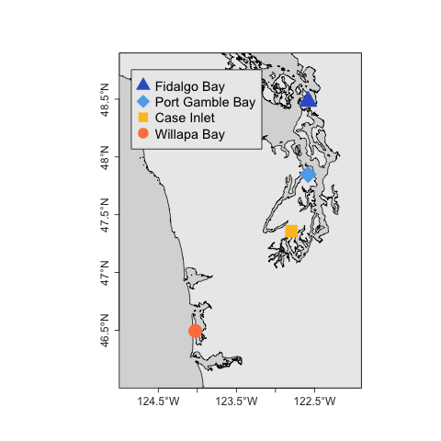

**Figure 1:** Geoduck juveniles were deployed for 30 days in 2 habitats (eelgrass beds, unvegetated) within 4 bays in Western Washington State

|  |  |  |
| --- | --- | --- |
| **Bay** | **Eelgrass Habitat** | **Unvegetated Habitat** |
| Fidalgo Bay | 48° 28' 52.8312'' N  122° 35' 0.7044'' W | 48° 28' 54.0876'' N  122° 35' 0.708'' W |
| Port Gamble Bay | 47° 50' 52.7388'' N  122° 34' 58.5084'' W | 47° 50' 33.6336'' N  122° 35' 1.7952'' W |
| Case Inlet | 47° 21' 30.3808'' N  122° 47' 47.2182'' W | 47° 21' 28.5721'' N  122° 47' 44.7457'' W |
| Willapa Bay | 46° 29' 42.288'' N  124° 1' 35.472'' W | 46° 29' 40.124'' N  124° 1' 34.0882'' W |
| **Table 1**: Coordinates for geoduck placement. | | |

### **Collection and Sampling**

Animals were collected during low tide and transferred on wet ice to shore where mortality and size were recorded. Live animals were dissected, ctenidia tissue was isolated and flash-frozen in an ethanol-dry ice bath. Ctenidia was selected for proteomic analysis due to its direct interaction with the environment, importance in gas and ion regulation, and its implication in environmental stress response (Timmins-Schiffman et al., 2014, Matozzo et al. 2013, Zhang et al. 2015, Thompson et al. 2015). During sampling all instruments were sterilized between samples via bleach then ethanol, and rinsed with nanopure water. Samples were held on dry ice while transported back to the lab and stored at -80℃.

### **Environmental and Growth Data**

Temperature, pH, salinity and dissolved oxygen data were compared between outplant locations. Outliers for all environmental parameters were removed, as determined using Tukey Interquartile Range (IQR) method [(Tukey 1977)](https://paperpile.com/c/u9FQbA/kC6k), excluding data outside the inner fence (1.5*IQR). Tidal charts from [WWW Tide/Current Predictor](https://paperpile.com/c/u9FQbA/6NZ0) and salinity data (<20ppt) were also used to remove DO and pH data corresponding to periods of tidal exposure. Four probe failures occurred during deployment (Supplemental Table 1, *failed*) and these data were not included in the analysis (pH at Port Gamble-eelgrass, salinity at Port-Gamble unvegetated & Case-Inlet eelgrass, DO in Fidalgo Bay eelgrass). Salinity data from two additional locations was not reliably measured (Willapa Bay-unvegetated, Fidalgo Bay-unvegetated), so habitat comparisons were not performed for salinity data. For each parameter at each location, daily mean and daily standard deviation time series were calculated. Relative growth for each animal was determined as (Lf-Li) , where Lf= final geoduck shell length, Li = average initial geoduck shell length within each exclosure (n=5). Differences in growth and environmental parameters between habitat were compared using 2-way analysis of variance (ANOVA) applied to regression models (value ~ habitat*bay). Bays and ad-hoc regions (north vs. south bays) were tested using 1-way ANOVA. Pairwise comparisons were tested with the t-statistic. Significance for all tests was defined as P < 0.05, corrected for multiple comparisons using the Bonferroni correction.

### **Protein Analysis**

Protein Preparation

Relative protein abundance was ultimately assessed in a two-phase proteomics approach using Selected Reaction Monitoring (SRM), with targets identified using Data Independent Acquisition (DIA). Tissues were prepared separately for DIA and SRM, both following the protocol in Timmins-Schiffman et al. (2014) with a few exceptions. For DIA, 8 ctenidia tissue samples were analyzed, one sample from each location and habitat: FB-eelgrass (G048), FB-unvegetated (G058), PGB-eelgrass (G077), PGB-unvegetated (G068), CI-eelgrass (G010), CI-unvegetated (G018), WB-eelgrass (G131), WB-unvegetated (G119). For SRM new ctenidia samples were examined, 12 individuals per bay (Fidalgo Bay, Port Gamble Bay, Case Inlet, Willapa Bay), with 6 from each habitat (eelgrass, unvegetated) for 48 samples total. Tissue was homogenized with sterile plastic pestle in 100 µl lysis buffer (50 mM NH4HCO3, 6M urea solution) and sonicated with Sonic Dismembrator (Fisher Scientific, Model 120) at 50% amplitude for ten seconds, three times. Protein concentration was quantified via Pierce™ BCA Protein Assay Kit (ThermoFischer Scientific, Waltham, MA USA).

Mini-Trypsin Digestion

Aliquots of protein (30 µg for DIA, 100 µg for SRM) were suspended in Lysis Buffer (50 mM NH4HCO3 + 6 M urea solution) to a total volume of 100 µl followed by: 1) a 1 hour incubation at 37°C with 200 mM Tris(2-carboxyethyl)phosphine (2.5µl) and 1.5 M Tris at pH 8.8 (6.6 µl); 2) 1 hour at room temperature in dark with 200 mM iodoacetamide (20 µl); 3) 1 hour at room temperature with 200 mM diothiothreitol (20 µl); 4) 1 hour at room temperature with 2 ug/µl Lysyl Endopeptidase (Lys-C, Wako Chemicals) (3.3 µg); 5) overnight at room temperature in 25 mM NH4HCO3 (800 µl) + high pressure liquid chromatography grade methanol (200 µl) + Pierce Trypsin Protease, MS Grade (1 ug/µl, Thermo Scientific) at 1:30 enzyme:protein ratio (3.3 µg). Samples were evaporated to near dryness at 4°C using a CentriVap Benchtop Vacuum Concentrator.

Desalting

Samples were desalted to isolate peptides using MacroSpin Columns (Nest Group, 50-450 µl, Peptide Protein C18). Peptides were reconstituted in 5% acetonitrile + 0.1% trifluoroacetic acid (TFA) (100 µl), then 10% formic acid (70 µl) was added to achieve pH ≤2. Columns were washed with 60% acetonitrile + 0.1% TFA (Solvent A, 200 µl) four times, then equilibrated with 5% acetonitrile + 0.1% TFA (Solvent B, 200 µl) three times. Peptides were bound to the column by running the digest through the column twice, followed by peptide elution with two additions each of Solvent A (100 ul). Columns were spun for 3 minutes at 3000 rpm on VWR Galaxy 16DH digital microcentrifuge at each stage. Samples were evaporated to near dryness at 4°C, then reconstituted in the Final Solvent (3% acetonitrile + 0.1% formic acid) (60 µl for 0.5 µg/µl final concentration of protein, and 50 µl for 2 µg/µl final concentration for DIA & SRM, respectively).

Autosampler preparation and internal standard

Final mixtures for mass spectrometry included 3.13 fmol/µl Peptide Retention Time Calibration mixture (PRTC), 0.33 µg/µl and 0.5 µg/µl protein for DIA and SRM, respectively, in Final Solvent for 15µl total volume. To confirm that peptides were quantified correctly in SRM, 10 µg from 5 randomly selected geoduck peptide samples were pooled, and 8 dilutions were prepared by combining with oyster peptides at known percentages of total protein content (10%, 13.3%, 20%, 40%, 60%, 80%, 87.7%, 90%) and analyzed alongside other samples.

### **Data Independent Acquisition**

Data acquisition

Data Independent Acquisition (DIA)was performed to assess global protein abundance patterns and to identify consistently detectable peptides for SRM targets. Eight samples, one per deployment location, were analyzed in technical duplicates via liquid chromatography tandem mass spectrometry (LC-MS/MS) with the Thermo Scientific™ Orbitrap Fusion Lumos™ Tribrid™. Prior to sample analysis, the 30 cm analytical column and 3 cm trap were packed in-house with with C18 beads (Dr. Maisch HPLC, Germany, 0.3 μm). For each sample, 3 µl of protein + PRTC solution (1.0 µg of geoduck protein) was injected and analyzed in MS1 over 400-900 *m/z* range, in 5 *m/z* overlapping isolation windows from 450-850 *m/z* with 15K resolution in MS2. Final Solvent blanks were run between each geoduck peptide injection to ensure against peptide carry-over. Lumos MS/MS method and sequence files are available in the project repository (GitHub).

Protein identification and analysis

Proteins were inferred using an assembled, translated, and annotated *P. generosa* gonad transcriptome (combined male and female) [(Timmins-Schiffman et al. 2017)](https://paperpile.com/c/u9FQbA/0ZkK). Transcriptome peptides were queried against those detected by the Lumos MS/MS using PEptide-Centric Analysis (PECAN) [(Ting 2017)](https://paperpile.com/c/u9FQbA/tL1a) to create a peptide spectral library (.blib type file). DIA raw files were first demultiplexed using MSConvert (ProteoWizard version 3.0.10738, 2017-04-12) [(Chambers et al. 2012)](https://paperpile.com/c/u9FQbA/Xv4J) with filters set to vendor centroiding for msLevels [2,3] ( --”peakPicking true 1-2”), and optimizing overlapping spectra (“demultiplex optimization-overlap only”). The transcriptome fasta file was tryptic digested *in silico* in Protein Digestion Simulator (version 2.2.6471.25262), set to Fully Tryptic from 400-6000 fragment mass range, 5 minimum residues allowed, 3 maximum missed cleavages and peak matching thresholds set to 5 ppm mass tolerance, and 0.05 ppm NET tolerance. Skyline version 3.7.0.11317 [(MacLean et al. 2010)](https://paperpile.com/c/u9FQbA/Oca6) automatically selected transition peaks and quantified peptide abundances using peak area integration. All PRTC peptide peak selections were manually verified and corrected. Skyline peak selection error rate was calculated by manually checking chromatograms from 100 proteins across all DIA samples. Auto-selected peaks were assigned correct or incorrect selection based on transition retention time alignment across replicates, using PRTC peptides as a reference. Transition peak area, defined henceforth as abundance, was exported from Skyline for analysis in R version 2.4-3 [(R Core Team 2016)](https://paperpile.com/c/u9FQbA/mt2A). Abundance was normalized by the total ion current (TIC) for each injection. Technical replicate, bay and habitat differences were assessed to inform SRM analysis via non-metric multidimensional scaling (NMDS) analysis using `metaNMDS` in the vegan package [(Oksanen et al. n.d.)](https://paperpile.com/c/u9FQbA/OIaD) on log(x+1) transformed abundances using a Bray-Curtis dissimilarity matrix. Technical replicate spectral abundances clustered together on NMDS plots, thus were averaged across each sample. Bay and habitat differences in global abundance were visually but not quantitatively analyzed (Supplemental Figure 4).

### **Selected Reaction Monitoring**

Target selection

Thirteen proteins were selected for SRM targets (Table 2). First, candidate proteins (~200) were selected based on biological function listed in the Universal Protein Knowledgebase [(Apweiler et al. 2004)](https://paperpile.com/c/u9FQbA/sDv2) and evidence of stress response in bivalves from the scientific literature. Candidate proteins were screened for detectability using DIA results. Selected proteins were required to have ≥3 high quality peptides, each with ≥3 transitions, present in all DIA biological and technical replicate data. Quality peptides had uniform peak morphology and retention time in Skyline across replicates. A total of 49 peptides were selected for SRM: 39 to quantify 13 target proteins (116 transitions), and 10 for internal standard (30 transitions). A full list of transition targets are published on panoramaweb.org and available in the project repository (GitHub).

|  |  |  |
| --- | --- | --- |
| **SRM Protein Targets** | **Top Blast Hit Uniprot SpID (E-value)** | **Peptide sequences** |
| heat shock protein 90-alpha | P30946  (0) | GVVDSEDLPLNISR  EVVQSSAFVER  DSSTMGYMAAK |
| heat shock protein 70 | Q91233  (0) | TTPSYVAFNDTER  NAVVTVPAYFNDAQR  IINEPTAAALAYGLDK |
| superoxide dismutase | P28757  (1e-57) | THGAPTDEER  ISLTGPHSIIGR  TIVVHADVDDLGK |
| catalase | P00432  (0) | AGELGGSDPDYAMR  LYSYSDTHR  LTANIAGHLIGAQEFIQK |
| peroxiredoxin-1 | Q6B4U9  (2e-95) | ALFIIDDK  QITMNDLPVGR  LVQAFQFTDK |
| puromycin-sensitive aminopeptidase | Q11011  (0) | LNSGSVGVYR  SLTENFVTEEQAK  SIQQSVENIR |
| protein disulfide-isomerase | P07237  (0) | NNKPSDYQGGR  DNVVVIGFFK  MDSTANEVEDVK |
| ras-related protein rab-11B | O35509  (1e-85) | VVLVGDSGVGK  STIGVEFATR  AQLWDTAGQER |
| sodium/potassium-transporting ATPase subunit alpha | Q13733  (9e-62) | TVIEPMAGDGLR  MVTGDNVNTAR  LLDQVWPDLR |
| glycogen phosphorylase (muscle form) | Q9WUB3  (0) | APNSFNLR  VLYPNDNFFEGK  TSFDAFPDK |
| trifunctional enzyme  β-Subunit (mitochondrial) | O46629  (0) | AAQDNGLLTDVLAYK  ALELGLKPK  FNLWGGSLSLGHPFGATGVR |
| cytochrome P450 | P00185  (7e-39) | IITRPFNVNGLLAYDSR  WLDESGVFLPEEHPSR  QSLLPFGATGPR |
| arachidonate 5-lipoxygenase | P09917  (2e-94) | APGLPAQIK  MDVEGTLPEDLK  GLGLGGVPGQNGK |

**Table 2:** SRM proteins targets selected based on biological function and detectability across DIA samples

Data acquisition

SRM samples were analyzed on a Vantage Triple-Stage Quadrupole Mass Spectrometer (Thermo Scientific, San Jose, CA, USA), and injected by a nanoACQUITY UPLC® system (Waters, Milford, MA, USA) at random in two technical replicates. For each sample, 2 µl of protein + PRTC solution (1.0 µg of geoduck protein) was injected, trapped on a 3 cm pre-column and separated on a 30 cm analytical column using a chromatography gradient of 2-60% acetonitrile over 60 minutes. Columns were prepared as in DIA (above). Samples were injected in randomized groups of 5, followed by a Peptide Retention Time Calibration (PRTC) plus bovine serum albumin peptides (BSA) standard, then Final Solvent blank. Vantage MS sequence and method files are available in the project repository (GitHub).

Protein identification and quality assurance

Peptides were identified and quantified via Skyline-daily version 3.7.1.11357 [(MacLean et al. 2010)](https://paperpile.com/c/u9FQbA/Oca6). Raw SRM files were imported into a Skyline-daily project along with the target protein transitions, and the spectral library (.blib file) created previously in the DIA Protein Identification step. SRM peptides were verified by regressing PRTC peptide retention time (RT) in SRM against retention time in DIA. A fitted model from PRTC peptides predicted RT of protein target peptides. Where necessary, peak selection and boundaries were manually adjusted for SRM peptide chromatograms, and actual RT were regressed against predict RT to confirm correct selection (F(1,38): 5768, p-value: < 2.2e-16, Adjusted R-squared: 0.9933) (Supplemental Figure 5). Transition peak area, defined henceforth as abundance, was exported from Skyline for further analysis in R [(R Core Team 2016)](https://paperpile.com/c/u9FQbA/mt2A). Abundance results from the separate serial dilution samples were used to remove peptides that did not adhere to the dilution curve. Briefly, dilution abundances (exported from Skyline) for each transition were normalized by the most dilute sample abundance, then regressed against predicted ratios. Peptides with slope coefficient 0.2<x<1.5 and adjusted R2 >0.7 were included in analysis. Ten of the 39 peptides were discarded from the dataset based on dilution standards results (Supplemental Figure 6). To determine and remove disparate technical replicates, NMDS analysis was performed as described above. Technical replicates with ordination distance >0.2 were removed, and only samples with two technical replicates were preserved for analysis (Supplemental Figure 7). Thirteen technical replicates from different samples and all replicates from three sample were discarded, for 84% technical replicate and 94% biological replicate retention. Within samples, transitions with coefficients of variation (CV) > 40% between technical replicates were also discarded (2% of all transitions across 21 samples). In final dataset for differential analysis, 10 proteins, 26 peptides, and 77 transitions were retained. Mean transition abundance was calculated for replicates, with zero in the place of n/a values, which Skyline generates for replicates without peaks. Transition abundances within each peptide were summed for a total peptide abundance before analyzing for differential abundance.

**Differential protein analysis**

After data quality screening, peptide abundance was analyzed for differences between locations and habitats. NMDS plots visualized patterns in peptide abundances by bay and habitat as described above. Global peptide abundance was compared between bay and habitats using two-way ANOVA on log-transformed abundances. For protein-specific comparisons, peptide abundances were grouped by protein, box-cox transformed [(Box and Cox 1964)](https://paperpile.com/c/u9FQbA/Y7Wy) and normality confirmed via qqplot [(Wickham 2017)](https://paperpile.com/c/u9FQbA/U6WI). Two-way ANOVA tested abundances for each protein between eelgrass and unvegetated habitats within and between bays. Pairwise comparisons for differentially abundant proteins were tested with the t-statistic. Peptides within proteins were regressed against each other to confirm stable abundance patterns. For all statistical analyses, significance was defined as alpha ≤ 0.05, corrected for multiple comparisons using the Bonferroni correction.

**Correlative analysis**

To understand how environmental and biometric parameters covaried, Pearson's product-moment correlation and scatter plots were assessed between protein abundances, growth, and environmental summary statistics (mean and variance). Each protein was assessed independently. Due to salinity probe malfunction, salinity data were not included in correlation tests.

All analyses were performed in RStudio version 1.1.383 [(R Core Team 2016)](https://paperpile.com/c/u9FQbA/mt2A).Data and R scripts are available in the project repository, currently located at github.com/RobertsLab/Paper-geoduck-eelgrass-OA, and Skyline project files are published to panoramaweb.org.

## **Results**

Environmental & Growth Data

Mean pH differed significantly between habitats across all bays (F(1,206)=180.0, p=1.1e-28) (Figure 2). During the deployment pH was recorded from 6.71 to 8.34, with mean pH 7.86±0.15 in eelgrass, and 7.51±0.25 in unvegetated habitats. Variability in pH was significantly different between bays (F(3,206=43.8, p=1.0e-20), but variability did not differ between habitats. On average across all locations, pH fluctuated daily by 0.46±0.23 pH units. Considerable heterogeneity between bays was observed in the other environmental parameters. Mean temperature was significantly different between all bays (F(3,236) =129.4, p=2.2e-48), and temperature decreased with latitude (coldest in Fidalgo Bay, warmest in Willapa bay). Temperature did not differ between habitats within bays (Supplemental Figure 1). Dissolved oxygen (DO) varied between bays in both daily standard deviation (F(3,210)=132.8, p=4.6e-47) and mean (F(3,210)=56.7, p=1.1e-25). DO variability was substantially higher in the two northern bays (SD was 5.6 and 3.9 mg/L in FB, PGB), as compared to the southern bays (2.5 and 1.4mg/L in CI, WB), but variability did not differ between habitats (Supplemental Figure 2). Mean salinity differed by bay (F(3,136)=254.3, p=2.3e-54), with the largest differences between Fidalgo Bay (mean 29.9 ppt) and the other three bays (mean 23.4-27.0 ppt) (Supplemental Figure 3). Growth significantly differed between northern and southern bays (F(1,97)=54.8, P=4.9-11), but not between habitats either within or across all bays. Geoduck in Fidalgo Bay and Port Gamble Bay grew larger compared to Willapa Bay, and Case Inlet (Figure 3). Survival did not differ among locations (Supplemental Table 1).

|  |
| --- |
| **Figure 2**: Daily mean pH in eelgrass (dashed lines) and unvegetated (solid lines) across bays during geoduck deployment. Gray ribbons denote daily standard deviation. Data from Port Gamble bay eelgrass are not included due to probe failure. |

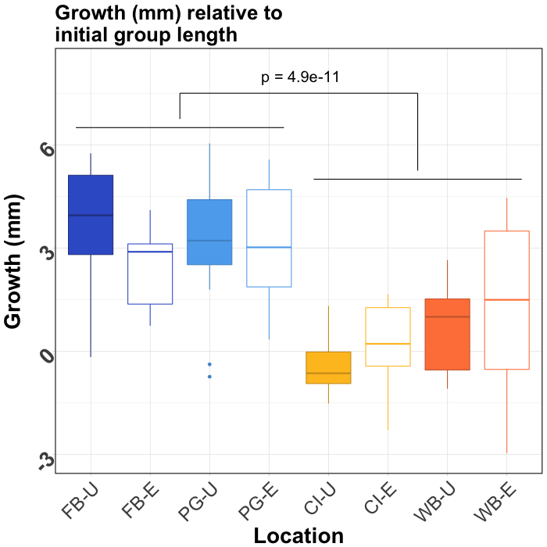

|  |
| --- |
| **Figure 3:** Geoduck shell growth after 30 days across Willapa Bay (WB), Case Inlet (CI), Port Gamble Bay (PG), and Fidalgo Bay (FB), where -U and -E represent unvegetated (filled boxes) and eelgrass habitats (empty boxes), respectively. Growth is relative to the mean initial shell length within deployment groups (n=5 per group, 3 groups per location). Boxes contain all biological replicates lying within the interquartile range (IQR), with median growth indicated by line in middle of boxes. Whiskers extend to the largest value no greater than 1.5*IQR, and dots indicate outliers beyond 1.5*IQR. Geoduck that did not survive deployment are not included. Growth differed significantly between southern bays (WB, CI) and northern bays (PG, FB) (p=4.9e-11) but not between habitats within bays. |

Protein Detection and Variance

In DIA, a total of 298,345 peptide transitions were detected from 30,659 distinct peptides across the 8 samples (one sample per habitat from each bay). These peptides were associated with 8,077 proteins, and more than half of the proteins (4,252) were annotated using Universal Protein Resource database (UniProt). Automated peak selection (Skyline) success rate was 71%.

In SRM, final dataset after screening included 10 proteins, 26 peptides, and 77 transitions. The 3 proteins fully screened from the dataset were heat shock protein 70, peroxiredoxin-1, and ras-related rab. The SRM mean coefficients of variation (CV) of technical replicate abundances across all transitions decreased from 18.2% to 9.6% after screening. Transition abundance CV within bays ranged from 24.9% to 83.2% with mean 50.1%, and within deployment locations CV ranged from 11.6% to 93.0% with mean 48.9% (Supplemental Table 3). Within proteins, regression analysis indicated that peptide abundances from the same protein differed slightly, however the relative abundances across samples was consistent. This indicates a small degree of background variability in peptide detection, digestion, or stability within proteins that applied to all samples (Pep1xPep2: R2A=0.985, coefficient=0.682; Pep1xPep3: R2A=0.990, coefficient=0.954; Pep2xPep3: R2A=0.990, coefficient=0.954).

Protein Abundance Differences

None of the 10 targeted proteins were significantly different in abundance between habitats within or across bays (Figure 4, Supplemental Table 2). NMDS plots of all transitions in DIA and those targeted in SRM revealed clustering of overall proteomic response by bay (Supplemental Figures 4 & 8). In SRM, Fidalgo Bay and Port Gamble Bay samples clustered together (henceforth “northern bays”), and some overlap between Case Inlet and Willapa Bay (“southern bays”) indicated similar protein abundances within these ad-hoc regions (Supplemental Figure 8). This was verified from the ANOVA results, which detected significant differences in abundances between northern and southern bays in three proteins: HSP90-⍺ (HSP90) (F(1,133)=20.5, p-adj=1.8e-4), trifunctional-enzyme subunit β-subunit (TEβ) (F(1,88)=11.1, p-adj=0.018), and puromycin-sensitive aminopeptidase (PSA) (F(1,130)=9.11, p-adj=0.043). HSP90 and TEβ abundances were also significantly different between bays (respectively: F(3,131)= 7.80, p-adj=0.0011; F(3,345)= 5.19, p-adj=0.034). For these three proteins, abundances were lowest in Case Inlet (southernmost in Puget Sound) followed by WIllapa Bay (southernmost overall), then Port Gamble Bay, and highest in Fidalgo Bay (northernmost).

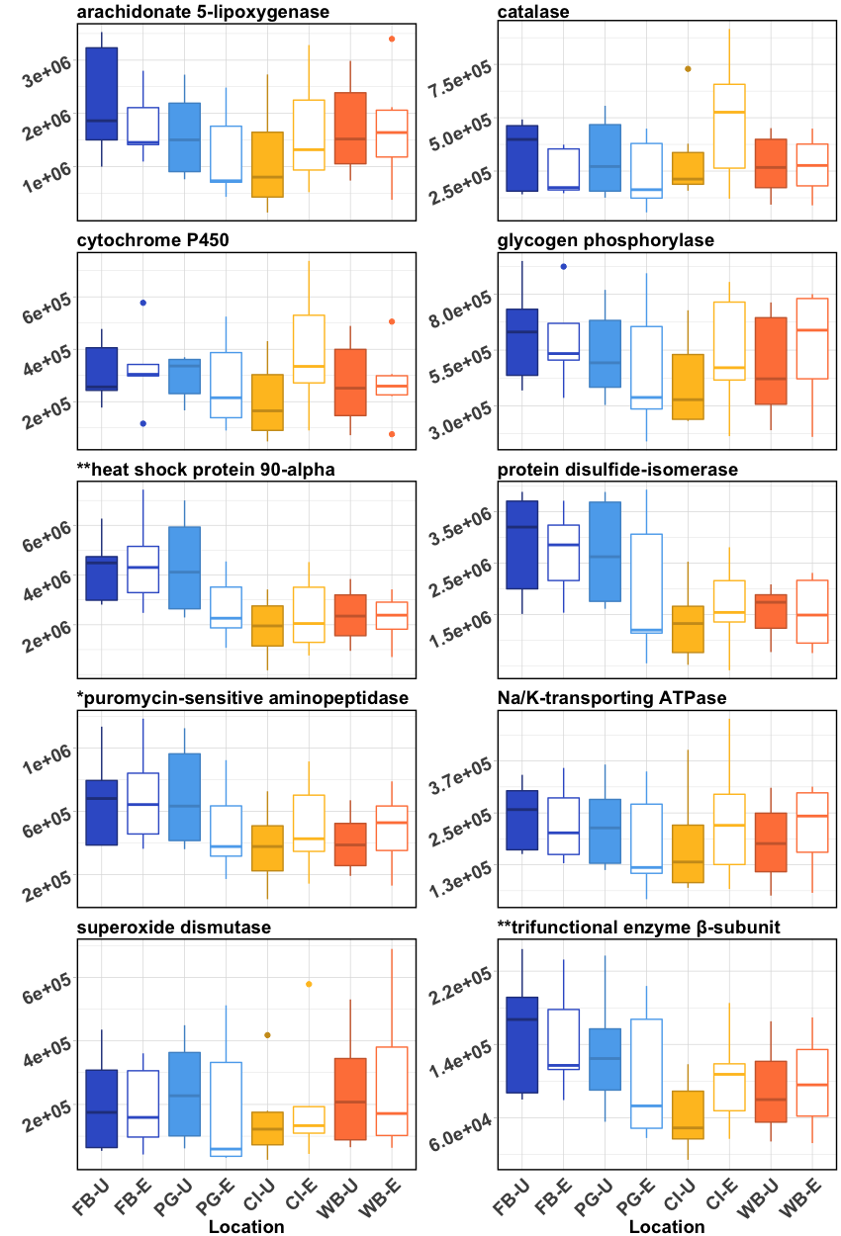

## **Figure 4:** Boxplots of protein mean spectral abundances (mean of 2 or 3 peptides targeted for each protein). For each location, n=5 or 6 geoduck. Boxes contain all biological replicates lying within the interquartile range (IQR), with median abundances indicated by line in middle of boxes. Whiskers extend to the largest value no greater than 1.5*IQR, and dots indicate outliers beyond 1.5*IQR. Note varying abundance ranges between proteins. Fidalgo Bay (FB), Port Gamble Bay (PG), Case Inlet (CI), and Willapa Bay (WB), where -U and -E represent unvegetated (filled boxes) and eelgrass (white boxes) habitats, respectively.Differentially abundant proteins between region and bay are indicated by (**), and bay only by (*). No protein abundances were significantly different between habitats.

Correlation between Environment, Abundance, and Growth

Growth positively correlated with peptide abundance for 8 of the 10 targeted proteins, including the three proteins that were differentially abundant between bays (Table 3). Growth also correlated with most environmental parameters (excluding salinity SD). Heat Shock Protein 90 correlated positively with dissolved oxygen SD. Mean and SD pH did not correlate with any peptide abundance patterns or growth. None of the environmental parameters, nor growth, correlated significantly with peptide abundances pooled across all proteins.

|  |  |  |  |  |
| --- | --- | --- | --- | --- |
|  | **Growth** | **heat shock protein 90** | **puromycin sensitive aminopeptidase** | **trifunctional enzyme β-subunit** |
| **Growth** | **---** | **r=0.55**  **p=2.15e-11** | **r=0.48**  **p=6.67e-9** | **r=0.41**  **p=8.59e-6** |
| **Tmean** | **r= -0.39**  **p=8.11e-21** | r= -0.36  p=0.060 | r= -0.24  p=0.48 | r= -0.21  p=0.70 |
| **Tsd** | **r= 0.39**  **p=2.10e-20** | r= 0.24  p=0.42 | r= 0.15  p=1 | r= 0.11  p= 1 |
| **DOmean** | **r= 0.45**  **p=2.12e-28** | r= 0.26  p=0.34 | r=0.18  p=0.91 | r=0.21  p=0.66 |
| **DOsd** | **r= 0.48**  **p=2.64e-32** | **r=0.41**  **p=0.021** | r=0.31  p=0.16 | r=0.31  p=0.15 |
| **pHmean** | **r= -0.32**  **p=1.08e-12** | r= -0.09  p=1 | r=-0.02  p=1 | r=-0.03  p=1 |
| **pHsd** | **r= 0.30**  **p=8.72e-11** | r= 0.22  p=0.73 | r=0.06  p=1 | r=0.04  p=1 |
| **Table 3:** Correlation analysis results between growth, environmental parameters, and peptide abundance (z-transformed). Correlation coefficient r shown with p-values adjusted via Bonferroni correction (number of comparisons). Correlations deemed significant are in bold. | | | | |

## **Discussion**

This study tested the effects of varying pH on geoduck, a valuable aquaculture species in a natural setting, and confirmed that *Zostera marina* eelgrass can effectively alter local pH during warm summer months (June and July). With this design, future ocean acidification research on cultured shellfish can augment findings from controlled laboratory studies with field deployments to incorporate natural variability associated with an organism’s habitat. Global and targeted proteomics was assessed alongside growth and environmental data for an integrated view of how geoduck respond to varying environmental conditions. Proteomics is a powerful approach suitable for comparative physiological studies of non-model, marine organisms (Tomanek, 2014). Using a two step method, this study detected substantially more proteins (8,077) compared to the previous geoduck study using Data Dependent Analysis (3,651) [(Timmins-Schiffman et al. 2017)](https://paperpile.com/c/u9FQbA/0ZkK). This produced a valuable protein catalogue for future projects, as researchers can now skip directly to the targeted SRM phase to greatly reduce the cost and time associated with a discovery analysis.

Geoduck exhibited no phenotypic differences between pH conditions, counter to our predictions. We predicted that within eelgrass habitats pH would be higher, creating a refuge against the less alkaline surrounding waters and reducing oxidative stress. Concordantly, proteins involved in the oxidative stress response would be less abundant inside eelgrass habitats (such as superoxide dismutase, peroxiredoxin-1, catalase, and HSP), possibly translating to differential growth. While pH in eelgrass habitats was found to be consistently higher in this study, no differences in abundance of selected proteins, growth or survival were found between habitats across all four bays. This suggests that juvenile geoduck may tolerate a wide pH range in the context of the natural environment in which they are cultured.

Earlier studies on other clam species point to some degree of pH tolerance, but also describe complex responses to low pH that vary between metrics, species, and when secondary stressors are applied [(Ries et al. 2009; Ringwood and Keppler 2002; Waldbusser et al. 2010)](https://paperpile.com/c/u9FQbA/13F1+1Dz2+6oCa+LFqG+UfoG+VwM5+SBmr). For example, juvenile carpet shell clams (*Ruditapes decussatus*)under ambient (8.2) and reduced pH (7.8, 7.5) for 75 days displayed no difference in size, weight, or calcification rate [(Range et al. 2011)](https://paperpile.com/c/u9FQbA/LFqG), but other physiological parameters (clearance, ingestion, respiration, ammonia excretion) differed at day 87 [(Fernández-Reiriz et al. 2011)](https://paperpile.com/c/u9FQbA/13F1). In the hard shell clam *Mercenaria mercenaria,* protein oxidation, biomineralization, and standard metabolic rate (SMR, measured as resting oxygen consumption) in adults were largely unaffected by hypercapnia alone, but when combined with elevated temperature SMR increased and shell strength decreased [(Ivanina et al. 2013; Matoo et al. 2013)](https://paperpile.com/c/u9FQbA/1Dz2+6oCa). Interestingly, the baltic clam (*Macoma balthica*) grew significantly larger in low pH (7.35 vs. 7.85 for 29 days), and were largest when combined with low dissolved oxygen (3.0 mg/L vs. 8.5 mg/L) [(Jansson et al. 2015)](https://paperpile.com/c/u9FQbA/BpqW). Geoduck metrics examined in this study were not affected by varying pH, but other physiological parameters (metabolic rate, biomineralization, reproductive development, cytoskeleton) may be affected in gill or other tissues such as mantle or hepatopancreas, and should be examined in future studies.

The complex, mixed responses exhibited in clam species may, in part, be a function of local adaptation to varying environmental drivers. Pacific geoduck are native to the Puget Sound, a region that experiences regular episodes of low pH in certain areas [(Busch et al. 2013; Feely et al. 2010, 2008)](https://paperpile.com/c/u9FQbA/gpwf+uqqi+n9ln), and thus the species may have evolved under selective pressure to withstand periods of low pH. The native Northeast Pacific Coast oyster, *Ostrea lurida,* also shows signs of pH tolerance as veliger larvae compared to the non-native Pacific oyster (*Crassostrea gigas*) [(Waldbusser et al. 2016)](https://paperpile.com/c/u9FQbA/aW0K), a stage primarily found to be vulnerable in other calcifying species [(](https://paperpile.com/c/u9FQbA/BCeV+UIGG)for reviews see [Byrne and Przeslawski 2013; Kurihara 2008)](https://paperpile.com/c/u9FQbA/BCeV+UIGG). Geoduck are also infaunal organisms, extending their long siphons into the water column for feeding and retreating to deep burrows during low tide or when disturbed [(Goodwin and Pease 1987)](https://paperpile.com/c/u9FQbA/2tlR). Sediment and burrow chemistry, while influenced by the overlying water column, can have lower pH due to aerobic microbial activity [(Gattuso and Hansson 2011)](https://paperpile.com/c/u9FQbA/1YVB), another potential source of selective pressure shaping this giant clam’s pH tolerance [(Gattuso and Hansson 2011; Widdicombe and Spicer 2008)](https://paperpile.com/c/u9FQbA/1YVB+S2Mh). An important future step is to assess the relative influence of sediment pH and overlying water column pH on burrowing calcifiers. This is particularly applicable when comparing habitats that likely have varying bacterial communities and activity.

While pH was not a universal predictor of geoduck phenotype in this study, mean temperature and dissolved oxygen variability correlated significantly with biometric parameters and separated into two groups: northern bays (Fidalgo and Port Gamble Bays), and southern bays (Case Inlet, and Willapa Bay). Geoduck grew less (or not at all, in Case Inlet) with lower levels of selected proteins in the southern bays, which were warmer with less variable dissolved oxygen content.

Temperatures in the southern bays (16-18°C) during the deployment dates may have been thermally stressful, depleting energy reserves due to elevated metabolism and denatured protein repair, particularly if food availability was limited [(Newell and Branch 1980)](https://paperpile.com/c/u9FQbA/RHC6+t7wp+yLZG). Similar food-dependent growth and survival was observed in the California mussel under thermal stress (*Mytilus californianus*) (Fitzgerald-Dehoog et al. 2012) and in the Blue mussel (*M. edulis*) under thermal (Lesser et al. 2010) and pH stress (Thomsen et al. 2013). Proteomics data from the southern bays did not suggest acute stress, as key stress-response proteins (HSP90 and HSP70) were inversely related to temperature, however tissues were collected at day 30 and a stress signal could have been captured with earlier or more frequent samples. Conversely, ectothermic organisms acclimatized to lower temperature can compensate for depressed enzymatic reaction rates by increasing concentrations of proteins [(Lesser and Kruse 2004)](https://paperpile.com/c/u9FQbA/sHhd), and this may be at play in the protein data from geoduck placed in northern, colder bays. Temperature also tends to control microbial communities in the ocean, which could have been a factor influencing geoduck growth [(Sunagawa et al. 2015)](https://paperpile.com/c/u9FQbA/8IGB).

Whether dissolved oxygen (DO) variability could have influenced geoduck in this study is less clear. Less DO fluctuation in the southern bays could be an indication of less phytoplankton biomass, translating to lower food availability [(Anderson and Taylor 2001; Bergondo et al. 2005; Winter et al. 1975)](https://paperpile.com/c/u9FQbA/UVFu+M7IA+E1M9). While we were unable to monitor chlorophyll during the outplant, both southern bays, Willapa Bay and Case Inlet, may have phytoplankton populations that are controlled by shellfish grazers due to long residence times and aquaculture activity [(Banas et al. 2007; Washington Sea Grant 2015)](https://paperpile.com/c/u9FQbA/VOd2+CfQJ). It is possible that food availability was different between northern and southern locations during the outplant period (June-July), and could be the underlying cause of higher growth and abundances of selected proteins in the northern sites [(Carmichael et al. 2004; Liu et al. 2016; Loosanoff and Davis 1963](https://paperpile.com/c/u9FQbA/Hp9T+8Yeq+iacT)), although this warrants additional data collection.

## **Conclusion**

This is the first study to investigate geoduck performance alongside varying pH conditions, and contributes a geoduck peptide database useful for quantifying multiple proteins simultaneously. The primary finding is that geoduck aquaculture may be less impacted by ocean acidification compared to other environmental stressors, for example ocean warming. Geoduck ocean acidification research is in its infancy, and these results are a snapshot into geoduck physiology at one developmental stage, using one tissue type (ctenidia), with individuals from one genetic pool, and with present-day pH levels in Washington State. To best inform current and future geoduck aquaculture, further foundational studies are needed to elucidate the species’ pH limits in conjunction with more acute environmental stressors, and expanded to include other key tissues and functions (e.g. mantle for shell secretion), and whole-animal physiological studies (e.g. metabolic rate, reproductive development).

This study also demonstrates applied use of systems such as eelgrass beds in estuaries to test pH effects in a natural system. There is growing interest in using macroalgae as an ocean acidification bioremediation tool, also known as phytoremediation [(Greiner et al. 2013;](https://paperpile.com/c/u9FQbA/7fYl+5KM0+qSxe)  [Groner et al. 2018](https://paperpile.com/c/u9FQbA/hcPm); [Hendriks et al. 2014; Washington State Blue Ribbon Panel on Ocean Acidification 2012)](https://paperpile.com/c/u9FQbA/7fYl+5KM0+qSxe). Incorporating seagrass into shellfish-pH interaction studies can help evaluate the potential for merging mariculture with shellfish aquaculture to improve growing conditions for vulnerable cultured species.

## **Acknowledgements**

Our gratitude to the following people who assisted with this project: Grace Crandall, Kaitlyn Mitchell and Jose Guzman assisted with protein extraction. Jarrett Egertson contributed to DIA acquisition design. Austin Keller adapted MSConvert to correctly demultiplex and convert DIA files. Han-Yin Yang, Brian Searle and Sean Bennett assisted with running PECAN.

This work was supported by the National Science Foundation Graduate Research Internship Program, the NOAA Ocean Acidification Program and in part by the University of Washington's Proteomics Resource (UWPR95794) and the Washington Department of Natural Resources.

**Reference List**

[Abatzoglou, John T., David E. Rupp, and Philip W. Mote. 2013. “Seasonal Climate Variability and Change in the Pacific Northwest of the United States.” *Journal of Climate* 27 (5): 2125–42. https://doi.org/](http://paperpile.com/b/u9FQbA/B3GR)[10.1175/JCLI-D-13-00218.1](http://dx.doi.org/10.1175/JCLI-D-13-00218.1)[.](http://paperpile.com/b/u9FQbA/B3GR)

[Anderson, Timothy H., and Gordon T. Taylor. 2001. “Nutrient Pulses, Plankton Blooms, and Seasonal Hypoxia in Western Long Island Sound.” *Estuaries* 24 (2): 228–43. https://doi.org/](http://paperpile.com/b/u9FQbA/UVFu)[10.2307/1352947](http://dx.doi.org/10.2307/1352947)[.](http://paperpile.com/b/u9FQbA/UVFu)

[Apweiler, Rolf, Amos Bairoch, Cathy H. Wu, Winona C. Barker, Brigitte Boeckmann, Serenella Ferro, Elisabeth Gasteiger, et al. 2004. “UniProt: The Universal Protein Knowledgebase.” *Nucleic Acids Research* 32 (Database issue): D115–19. https://doi.org/](http://paperpile.com/b/u9FQbA/sDv2)[10.1093/nar/gkh131](http://dx.doi.org/10.1093/nar/gkh131)[.](http://paperpile.com/b/u9FQbA/sDv2)

[Babson, A. L., M. Kawase, and P. MacCready. 2006. “Seasonal and Interannual Variability in the Circulation of Puget Sound, Washington: A Box Model Study.” *Atmosphere-Ocean* 44 (1): 29–45. https://doi.org/](http://paperpile.com/b/u9FQbA/o0ys)[10.3137/ao.440103](http://dx.doi.org/10.3137/ao.440103)[.](http://paperpile.com/b/u9FQbA/o0ys)

[Banas, N. S., B. M. Hickey, P. MacCready, and J. A. Newton. 2004. “Dynamics of Willapa Bay, Washington: A Highly Unsteady, Partially Mixed Estuary.” *Journal of Physical Oceanography* 34 (11): 2413–27. https://doi.org/](http://paperpile.com/b/u9FQbA/aC1Q)[10.1175/JPO2637.1](http://dx.doi.org/10.1175/JPO2637.1)[.](http://paperpile.com/b/u9FQbA/aC1Q)

[Banas, N. S., B. M. Hickey, J. A. Newton, and J. L. Ruesink. 2007. “Tidal Exchange, Bivalve Grazing, and Patterns of Primary Production in Willapa Bay, Washington, USA.” *Marine Ecology Progress Series* 341: 123–39. https://doi.org/](http://paperpile.com/b/u9FQbA/VOd2)[10.3354/meps341123](http://dx.doi.org/10.3354/meps341123)[.](http://paperpile.com/b/u9FQbA/VOd2)

[Ban, Stephen S., Nicholas A. J. Graham, and Sean R. Connolly. 2014. “Evidence for Multiple Stressor Interactions and Effects on Coral Reefs.” *Global Change Biology* 20 (3): 681–97. https://doi.org/](http://paperpile.com/b/u9FQbA/Klih)[10.1111/gcb.12453](http://dx.doi.org/10.1111/gcb.12453)[.](http://paperpile.com/b/u9FQbA/Klih)

[Baumann, Hannes, Ryan B. Wallace, Tristen Tagliaferri, and Christopher J. Gobler. 2015. “Large Natural pH, CO2 and O2 Fluctuations in a Temperate Tidal Salt Marsh on Diel, Seasonal, and Interannual Time Scales.” *Estuaries and Coasts* 38 (1): 220–31. https://doi.org/](http://paperpile.com/b/u9FQbA/Kg36)[10.1007/s12237-014-9800-y](http://dx.doi.org/10.1007/s12237-014-9800-y)[.](http://paperpile.com/b/u9FQbA/Kg36)

[Bergondo, Deanna L., Dana R. Kester, Heather E. Stoffel, and Wendy L. Woods. 2005. “Time-Series Observations during the Low Sub-Surface Oxygen Events in Narragansett Bay during Summer 2001.” *Marine Chemistry* 97 (1): 90–103. https://doi.org/](http://paperpile.com/b/u9FQbA/M7IA)[10.1016/j.marchem.2005.01.006](http://dx.doi.org/10.1016/j.marchem.2005.01.006)[.](http://paperpile.com/b/u9FQbA/M7IA)

[Box, G. E. P., and D. R. Cox. 1964. “An Analysis of Transformations.” *Journal of the Royal Statistical Society. Series B, Statistical Methodology* 26 (2): 211–52.](http://paperpile.com/b/u9FQbA/Y7Wy) <http://www.jstor.org/stable/2984418>[.](http://paperpile.com/b/u9FQbA/Y7Wy)

[Boyd, Philip W., Christopher E. Cornwall, Andrew Davison, Scott C. Doney, Marion Fourquez, Catriona L. Hurd, Ivan D. Lima, and Andrew McMinn. 2016. “Biological Responses to Environmental Heterogeneity under Future Ocean Conditions.” *Global Change Biology* 22 (8): 2633–50. https://doi.org/](http://paperpile.com/b/u9FQbA/nvrr)[10.1111/gcb.13287](http://dx.doi.org/10.1111/gcb.13287)[.](http://paperpile.com/b/u9FQbA/nvrr)

[Bulthuis, Douglas A. 1995. “Distribution of Seagrasses in a North Puget Sound Estuary: Padilla Bay, Washington, USA.” *Aquatic Botany* 50 (1): 99–105. https://doi.org/](http://paperpile.com/b/u9FQbA/5bnn)[10.1016/0304-3770(94)00443-P](http://dx.doi.org/10.1016/0304-3770(94)00443-P)[.](http://paperpile.com/b/u9FQbA/5bnn)

[Busch, D. Shallin, Chris J. Harvey, and Paul McElhany. 2013. “Potential Impacts of Ocean Acidification on the Puget Sound Food Web.” *ICES Journal of Marine Science: Journal Du Conseil* 70 (4): 823–33. https://doi.org/](http://paperpile.com/b/u9FQbA/gpwf)[10.1093/icesjms/fst061](http://dx.doi.org/10.1093/icesjms/fst061)[.](http://paperpile.com/b/u9FQbA/gpwf)

[Byrne, Maria, and Rachel Przeslawski. 2013. “Multistressor Impacts of Warming and Acidification of the Ocean on Marine Invertebrates’ Life Histories.” *Integrative and Comparative Biology* 53 (4): 582–96. https://doi.org/](http://paperpile.com/b/u9FQbA/BCeV)[10.1093/icb/ict049](http://dx.doi.org/10.1093/icb/ict049)[.](http://paperpile.com/b/u9FQbA/BCeV)

[Carmichael, R. H., Andrea C. Shriver, and I. Valiela. 2004. “Changes in Shell and Soft Tissue Growth, Tissue Composition, and Survival of Quahogs, Mercenaria Mercenaria, and Softshell Clams, Mya Arenaria, in Response to Eutrophic-Driven Changes in Food Supply and Habitat.” *Journal of Experimental Marine Biology and Ecology* 313 (1): 75–104. https://doi.org/](http://paperpile.com/b/u9FQbA/Hp9T)[10.1016/j.jembe.2004.08.006](http://dx.doi.org/10.1016/j.jembe.2004.08.006)[.](http://paperpile.com/b/u9FQbA/Hp9T)

[Chambers, Matthew C., Brendan Maclean, Robert Burke, Dario Amodei, Daniel L. Ruderman, Steffen Neumann, Laurent Gatto, et al. 2012. “A Cross-Platform Toolkit for Mass Spectrometry and Proteomics.” *Nature Biotechnology* 30 (10): 918–20. https://doi.org/](http://paperpile.com/b/u9FQbA/Xv4J)[10.1038/nbt.2377](http://dx.doi.org/10.1038/nbt.2377)[.](http://paperpile.com/b/u9FQbA/Xv4J)

[Chapman, Robert W., Annalaura Mancia, Marion Beal, Artur Veloso, Charles Rathburn, Anne Blair, A. F. Holland, et al. 2011. “The Transcriptomic Responses of the Eastern Oyster, Crassostrea Virginica, to Environmental Conditions.” *Molecular Ecology* 20 (7): 1431–49. https://doi.org/](http://paperpile.com/b/u9FQbA/DRHc)[10.1111/j.1365-294X.2011.05018.x](http://dx.doi.org/10.1111/j.1365-294X.2011.05018.x)[.](http://paperpile.com/b/u9FQbA/DRHc)

[Clark, Dana, Miles Lamare, and Mike Barker. 2009. “Response of Sea Urchin Pluteus Larvae (Echinodermata: Echinoidea) to Reduced Seawater pH: A Comparison among a Tropical, Temperate, and a Polar Species.” *Marine Biology* 156 (6): 1125–37. https://doi.org/](http://paperpile.com/b/u9FQbA/9TPY)[10.1007/s00227-009-1155-8](http://dx.doi.org/10.1007/s00227-009-1155-8)[.](http://paperpile.com/b/u9FQbA/9TPY)

[Coan, Eugene V., Paul Valentich Scott, and Frank R. Bernard. 2000. *Bivalve Seashells of Western North America: Marine Bivalve Mollusks from Arctic Alaska to Baja California*. Santa Barbara Museum of Natural History.](http://paperpile.com/b/u9FQbA/JrjU)

[Cornwall, Christopher E., Christopher D. Hepburn, Christina M. McGraw, Kim I. Currie, Conrad A. Pilditch, Keith A. Hunter, Philip W. Boyd, and Catriona L. Hurd. 2013. “Diurnal Fluctuations in Seawater pH Influence the Response of a Calcifying Macroalga to Ocean Acidification.” *Proc. R. Soc. B* 280 (1772): 20132201. https://doi.org/](http://paperpile.com/b/u9FQbA/eGzS)[10.1098/rspb.2013.2201](http://dx.doi.org/10.1098/rspb.2013.2201)[.](http://paperpile.com/b/u9FQbA/eGzS)

[DeBiasse, Melissa B., and Morgan W. Kelly. 2016. “Plastic and Evolved Responses to Global Change: What Can We Learn from Comparative Transcriptomics?” *The Journal of Heredity* 107 (1): 71–81. https://doi.org/](http://paperpile.com/b/u9FQbA/se7S)[10.1093/jhered/esv073](http://dx.doi.org/10.1093/jhered/esv073)[.](http://paperpile.com/b/u9FQbA/se7S)

[Dethier, Megan N., Tom Mumford, Tom Leschine, Kurt Presh, Si Simenstad, Hugh Shipman, Doug Myers, et al. 2006. “Native Shellfish in Nearshore Ecosystems of Puget Sound.” WASHINGTON UNIV SEATTLE.](http://paperpile.com/b/u9FQbA/fbu6) <http://www.dtic.mil/docs/citations/ADA477852>[.](http://paperpile.com/b/u9FQbA/fbu6)

[Dethier, Megan N., Jennifer Ruesink, Helen Berry, Amy G. Sprenger, and Blain Reeves. 2010. “Restricted Ranges in Physical Factors May Constitute Subtle Stressors for Estuarine Biota.” *Marine Environmental Research* 69 (4): 240–47. https://doi.org/](http://paperpile.com/b/u9FQbA/nQNA)[10.1016/j.marenvres.2009.10.015](http://dx.doi.org/10.1016/j.marenvres.2009.10.015)[.](http://paperpile.com/b/u9FQbA/nQNA)

[Doney, Scott C., Natalie Mahowald, Ivan Lima, Richard A. Feely, Fred T. Mackenzie, Jean-Francois Lamarque, and Phil J. Rasch. 2007. “Impact of Anthropogenic Atmospheric Nitrogen and Sulfur Deposition on Ocean Acidification and the Inorganic Carbon System.” *Proceedings of the National Academy of Sciences of the United States of America* 104 (37): 14580–85. https://doi.org/](http://paperpile.com/b/u9FQbA/BUbn)[10.1073/pnas.0702218104](http://dx.doi.org/10.1073/pnas.0702218104)[.](http://paperpile.com/b/u9FQbA/BUbn)

[Duquette, Ashley, James B. McClintock, Charles D. Amsler, Alberto Pérez-Huerta, Marco Milazzo, and Jason M. Hall-Spencer. 2017. “Effects of Ocean Acidification on the Shells of Four Mediterranean Gastropod Species near a CO2 Seep.” *Marine Pollution Bulletin* 124 (2): 917–28. https://doi.org/](http://paperpile.com/b/u9FQbA/tvyA)[10.1016/j.marpolbul.2017.08.007](http://dx.doi.org/10.1016/j.marpolbul.2017.08.007)[.](http://paperpile.com/b/u9FQbA/tvyA)

[Feely, Richard A., Simone R. Alin, Jan Newton, Christopher L. Sabine, Mark Warner, Allan Devol, Christopher Krembs, and Carol Maloy. 2010. “The Combined Effects of Ocean Acidification, Mixing, and Respiration on pH and Carbonate Saturation in an Urbanized Estuary.” *Estuarine, Coastal and Shelf Science* 88 (4): 442–49. https://doi.org/](http://paperpile.com/b/u9FQbA/uqqi)[10.1016/j.ecss.2010.05.004](http://dx.doi.org/10.1016/j.ecss.2010.05.004)[.](http://paperpile.com/b/u9FQbA/uqqi)

[Feely, Richard A., Terrie Klinger, Jan A. Newton, and Meg Chadsey. 2012. *Scientific Summary of Ocean Acidification in Washington State Marine Waters*. US Department of Commerce, National Oceanic and Atmospheric Administration, Office of Oceanic and Atmospheric Research.](http://paperpile.com/b/u9FQbA/3bME) <https://pdfs.semanticscholar.org/5964/ffc14ae680fc855864a55b10351ed86e5935.pdf>[.](http://paperpile.com/b/u9FQbA/3bME)

[Feely, Richard A., Christopher L. Sabine, J. Martin Hernandez-Ayon, Debby Ianson, and Burke Hales. 2008. “Evidence for Upwelling of Corrosive‘ Acidified’ Water onto the Continental Shelf.” *Science* 320 (5882): 1490–92.](http://paperpile.com/b/u9FQbA/n9ln) <http://science.sciencemag.org/content/320/5882/1490.short>[.](http://paperpile.com/b/u9FQbA/n9ln)

[Fernández-Reiriz, Ma José, Pedro Range, Xosé Antón Álvarez-Salgado, and Uxio Labarta. 2011. “Physiological Energetics of Juvenile Clams Ruditapes Decussatus in a High CO₂ Coastal Ocean.” *Marine Ecology Progress Series* 433: 97–105.](http://paperpile.com/b/u9FQbA/13F1) <http://www.jstor.org/stable/24875417>[.](http://paperpile.com/b/u9FQbA/13F1)

[Frieder, Christina A., Jennifer P. Gonzalez, Emily E. Bockmon, Michael O. Navarro, and Lisa A. Levin. 2014. “Can Variable pH and Low Oxygen Moderate Ocean Acidification Outcomes for Mussel Larvae?” *Global Change Biology* 20 (3): 754–64. https://doi.org/](http://paperpile.com/b/u9FQbA/ow7h)[10.1111/gcb.12485](http://dx.doi.org/10.1111/gcb.12485)[.](http://paperpile.com/b/u9FQbA/ow7h)

[Gattuso, Jean-Pierre, and Lina Hansson. 2011. *Ocean Acidification*. OUP Oxford.](http://paperpile.com/b/u9FQbA/1YVB) <https://market.android.com/details?id=book-eoxpAgAAQBAJ>[.](http://paperpile.com/b/u9FQbA/1YVB)

[Gazeau, Frédéric, Christophe Quiblier, Jeroen M. Jansen, Jean-Pierre Gattuso, Jack J. Middelburg, and Carlo H. R. Heip. 2007. “Impact of Elevated CO2 on Shellfish Calcification.” *Geophysical Research Letters* 34 (7): L07603. https://doi.org/](http://paperpile.com/b/u9FQbA/exhM)[10.1029/2006GL028554](http://dx.doi.org/10.1029/2006GL028554)[.](http://paperpile.com/b/u9FQbA/exhM)

Giarratano, Erica, Mónica N. Gil, and Gabriela Malanga. 2014. “Biomarkers of Environmental Stress in Gills of Ribbed Mussel Aulacomya Atra Atra (Nuevo Gulf, Northern Patagonia).” Ecotoxicology and Environmental Safety 107 (September): 111–19.

[Gobler, Christopher J., Elizabeth L. DePasquale, Andrew W. Griffith, and Hannes Baumann. 2014. “Hypoxia and Acidification Have Additive and Synergistic Negative Effects on the Growth, Survival, and Metamorphosis of Early Life Stage Bivalves.” *PloS One* 9 (1): e83648. https://doi.org/](http://paperpile.com/b/u9FQbA/zvFS)[10.1371/journal.pone.0083648](http://dx.doi.org/10.1371/journal.pone.0083648)[.](http://paperpile.com/b/u9FQbA/zvFS)

[Goodwin, C. Lynn, and Bruce Pease. 1987. *The Distribution of Geoduck (Panope Abrupta) Size, Density, and Quality in Relation to Habitat Characteristics such as Geographic Area, Water Depth, Sediment Type, and Associated Flora and Fauna in Puget Sound, Washington*. State of Washington, Department of Fisheries, Shellfish Division.](http://paperpile.com/b/u9FQbA/2tlR)

[Grant, Washington Sea. 2013. “Final Report: Geoduck Aquaculture Research Program.” *Report to the Washington State Legislature. Washington Sea Grant Technical Report WSG-TR*, 13–03.](http://paperpile.com/b/u9FQbA/DHbe)

[Greiner, Jill T., Karen J. McGlathery, John Gunnell, and Brent A. McKee. 2013. “Seagrass Restoration Enhances ‘Blue Carbon’ Sequestration in Coastal Waters.” *PloS One* 8 (8): e72469. https://doi.org/](http://paperpile.com/b/u9FQbA/7fYl)[10.1371/journal.pone.0072469](http://dx.doi.org/10.1371/journal.pone.0072469)[.](http://paperpile.com/b/u9FQbA/7fYl)

[Groner, Maya L., Colleen A. Burge, Ruth Cox, Natalie Rivlin, Mo Turner, Kathryn L. Van Alstyne, Sandy Wyllie-Echeverria, John Bucci, Philip Staudigel, and Carolyn S. Friedman. 2018. “Oysters and Eelgrass: Potential Partners in a High pCO2 Ocean.” *Ecology*, May. https://doi.org/](http://paperpile.com/b/u9FQbA/hcPm)[10.1002/ecy.2393](http://dx.doi.org/10.1002/ecy.2393)[.](http://paperpile.com/b/u9FQbA/hcPm)

[Gunderson, Alex R., Eric J. Armstrong, and Jonathon H. Stillman. 2016. “Multiple Stressors in a Changing World: The Need for an Improved Perspective on Physiological Responses to the Dynamic Marine Environment.” *Annual Review of Marine Science* 8: 357–78. https://doi.org/](http://paperpile.com/b/u9FQbA/ZXHI)[10.1146/annurev-marine-122414-033953](http://dx.doi.org/10.1146/annurev-marine-122414-033953)[.](http://paperpile.com/b/u9FQbA/ZXHI)

[Harvey, Ben P., Dylan Gwynn-Jones, and Pippa J. Moore. 2013. “Meta-Analysis Reveals Complex Marine Biological Responses to the Interactive Effects of Ocean Acidification and Warming.” *Ecology and Evolution* 3 (4): 1016–30. https://doi.org/](http://paperpile.com/b/u9FQbA/pnf4)[10.1002/ece3.516](http://dx.doi.org/10.1002/ece3.516)[.](http://paperpile.com/b/u9FQbA/pnf4)

[Hendriks, Iris E., Y. S. Olsen, L. Ramajo, L. Basso, A. Steckbauer, T. S. Moore, J. Howard, and C. M. Duarte. 2014. “Photosynthetic Activity Buffers Ocean Acidification in Seagrass Meadows.” *Biogeosciences*  11 (2): 333.](http://paperpile.com/b/u9FQbA/5KM0) <http://search.proquest.com/openview/dd8bd20d2b762c317796efc36e6dd278/1?pq-origsite=gscholar&cbl=105740>[.](http://paperpile.com/b/u9FQbA/5KM0)

[Hofmann, Gretchen E., Jennifer E. Smith, Kenneth S. Johnson, Uwe Send, Lisa A. Levin, Fiorenza Micheli, Adina Paytan, et al. 2011. “High-Frequency Dynamics of Ocean pH: A Multi-Ecosystem Comparison.” *PloS One* 6 (12): e28983. https://doi.org/](http://paperpile.com/b/u9FQbA/C3Ih)[10.1371/journal.pone.0028983](http://dx.doi.org/10.1371/journal.pone.0028983)[.](http://paperpile.com/b/u9FQbA/C3Ih)

[Howarth, Robert, Francis Chan, Daniel J. Conley, Josette Garnier, Scott C. Doney, Roxanne Marino, and Gilles Billen. 2011. “Coupled Biogeochemical Cycles: Eutrophication and Hypoxia in Temperate Estuaries and Coastal Marine Ecosystems.” *Frontiers in Ecology and the Environment* 9 (1): 18–26. https://doi.org/](http://paperpile.com/b/u9FQbA/PUop)[10.1890/100008](http://dx.doi.org/10.1890/100008)[.](http://paperpile.com/b/u9FQbA/PUop)

Hu, Menghong, Lisha Li, Yanming Sui, Jiale Li, Youji Wang, Weiqun Lu, and Sam Dupont. 2015. “Effect of pH and Temperature on Antioxidant Responses of the Thick Shell Mussel Mytilus Coruscus.” Fish & Shellfish Immunology 46 (2): 573–83.

[Ivanina, Anna V., Gary H. Dickinson, Omera B. Matoo, Rita Bagwe, Ashley Dickinson, Elia Beniash, and Inna M. Sokolova. 2013. “Interactive Effects of Elevated Temperature and CO2 Levels on Energy Metabolism and Biomineralization of Marine Bivalves Crassostrea Virginica and Mercenaria Mercenaria.” *Comparative Biochemistry and Physiology. Part A, Molecular & Integrative Physiology* 166 (1): 101–11. https://doi.org/](http://paperpile.com/b/u9FQbA/1Dz2)[10.1016/j.cbpa.2013.05.016](http://dx.doi.org/10.1016/j.cbpa.2013.05.016)[.](http://paperpile.com/b/u9FQbA/1Dz2)

[Jansson, Anna, Joanna Norkko, Sam Dupont, and Alf Norkko. 2015. “Growth and Survival in a Changing Environment: Combined Effects of Moderate Hypoxia and Low pH on Juvenile Bivalve Macoma Balthica.” *Journal of Sea Research* 102 (August): 41–47. https://doi.org/](http://paperpile.com/b/u9FQbA/BpqW)[10.1016/j.seares.2015.04.006](http://dx.doi.org/10.1016/j.seares.2015.04.006)[.](http://paperpile.com/b/u9FQbA/BpqW)

[Kerrison, Philip, Jason M. Hall-Spencer, David J. Suggett, Leanne J. Hepburn, and Michael Steinke. 2011. “Assessment of pH Variability at a Coastal CO2 Vent for Ocean Acidification Studies.” *Estuarine, Coastal and Shelf Science* 94 (2): 129–37. https://doi.org/](http://paperpile.com/b/u9FQbA/flcF)[10.1016/j.ecss.2011.05.025](http://dx.doi.org/10.1016/j.ecss.2011.05.025)[.](http://paperpile.com/b/u9FQbA/flcF)

[Kroeker, Kristy J., Rebecca L. Kordas, Ryan Crim, Iris E. Hendriks, Laura Ramajo, Gerald S. Singh, Carlos M. Duarte, and Jean-Pierre Gattuso. 2013. “Impacts of Ocean Acidification on Marine Organisms: Quantifying Sensitivities and Interaction with Warming.” *Global Change Biology* 19 (6): 1884–96. https://doi.org/](http://paperpile.com/b/u9FQbA/BVpW)[10.1111/gcb.12179](http://dx.doi.org/10.1111/gcb.12179)[.](http://paperpile.com/b/u9FQbA/BVpW)

[Kroeker, Kristy J., Rebecca L. Kordas, Ryan N. Crim, and Gerald G. Singh. 2010. “Meta-Analysis Reveals Negative yet Variable Effects of Ocean Acidification on Marine Organisms.” *Ecology Letters* 13 (11): 1419–34. https://doi.org/](http://paperpile.com/b/u9FQbA/8iDj)[10.1111/j.1461-0248.2010.01518.x](http://dx.doi.org/10.1111/j.1461-0248.2010.01518.x)[.](http://paperpile.com/b/u9FQbA/8iDj)

[Kurihara, H. 2008. “Effects of CO2-Driven Ocean Acidification on the Early Developmental Stages of Invertebrates.” *Marine Ecology Progress Series* 373 (December): 275–84. https://doi.org/](http://paperpile.com/b/u9FQbA/UIGG)[10.3354/meps07802](http://dx.doi.org/10.3354/meps07802)[.](http://paperpile.com/b/u9FQbA/UIGG)

[Lesser, Michael P., Meredith A. Bailey, Daniel G. Merselis, and John R. Morrison. 2010. “Physiological Response of the Blue Mussel Mytilus Edulis to Differences in Food and Temperature in the Gulf of Maine.” *Comparative Biochemistry and Physiology. Part A, Molecular & Integrative Physiology* 156 (4): 541–51. https://doi.org/](http://paperpile.com/b/u9FQbA/RHC6)[10.1016/j.cbpa.2010.04.012](http://dx.doi.org/10.1016/j.cbpa.2010.04.012)[.](http://paperpile.com/b/u9FQbA/RHC6)

[Lesser, Michael P., and Valerie A. Kruse. 2004. “Seasonal Temperature Compensation in the Horse Mussel, Modiolus Modiolus: Metabolic Enzymes, Oxidative Stress and Heat Shock Proteins.” *Comparative Biochemistry and Physiology. Part A, Molecular & Integrative Physiology* 137 (3): 495–504. https://doi.org/](http://paperpile.com/b/u9FQbA/sHhd)[10.1016/j.cbpb.2003.10.022](http://dx.doi.org/10.1016/j.cbpb.2003.10.022)[.](http://paperpile.com/b/u9FQbA/sHhd)

[Liu, W., C. M. Pearce, R. S. McKinley, and I. P. Forster. 2016. “Nutritional Value of Selected Species of Microalgae for Larvae and Early Post-Set Juveniles of the Pacific Geoduck Clam, Panopea Generosa.” *Aquaculture*  452 (Supplement C): 326–41. https://doi.org/](http://paperpile.com/b/u9FQbA/8Yeq)[10.1016/j.aquaculture.2015.10.019](http://dx.doi.org/10.1016/j.aquaculture.2015.10.019)[.](http://paperpile.com/b/u9FQbA/8Yeq)

[Loosanoff, Victor L., and Harry C. Davis. 1963. “Rearing of Bivalve Mollusks.” In *Advances in Marine Biology*, edited by F. S. Russell, 1:1–136. Academic Press. https://doi.org/](http://paperpile.com/b/u9FQbA/iacT)[10.1016/S0065-2881(08)60257-6](http://dx.doi.org/10.1016/S0065-2881(08)60257-6)[.](http://paperpile.com/b/u9FQbA/iacT)

Lushchak, Volodymyr I. 2011. “Environmentally Induced Oxidative Stress in Aquatic Animals.” Aquatic Toxicology 101 (1): 13–30.

[MacLean, Brendan, Daniela M. Tomazela, Nicholas Shulman, Matthew Chambers, Gregory L. Finney, Barbara Frewen, Randall Kern, David L. Tabb, Daniel C. Liebler, and Michael J. MacCoss. 2010. “Skyline: An Open Source Document Editor for Creating and Analyzing Targeted Proteomics Experiments.”](http://paperpile.com/b/u9FQbA/Oca6) *[Bioinformatics](http://paperpile.com/b/u9FQbA/Oca6)*  [26 (7): 966–68. https://doi.org/](http://paperpile.com/b/u9FQbA/Oca6)[10.1093/bioinformatics/btq054](http://dx.doi.org/10.1093/bioinformatics/btq054)[.](http://paperpile.com/b/u9FQbA/Oca6)

[Matoo, Omera B., Anna V. Ivanina, Claus Ullstad, Elia Beniash, and Inna M. Sokolova. 2013. “Interactive Effects of Elevated Temperature and CO2 Levels on Metabolism and Oxidative Stress in Two Common Marine Bivalves (Crassostrea Virginica and Mercenaria Mercenaria).”](http://paperpile.com/b/u9FQbA/6oCa) *[Comparative Biochemistry and Physiology. Part A, Molecular & Integrative Physiology](http://paperpile.com/b/u9FQbA/6oCa)* [164 (4): 545–53. https://doi.org/](http://paperpile.com/b/u9FQbA/6oCa)[10.1016/j.cbpa.2012.12.025](http://dx.doi.org/10.1016/j.cbpa.2012.12.025)[.](http://paperpile.com/b/u9FQbA/6oCa)

Matozzo, Valerio, Andrea Chinellato, Marco Munari, Monica Bressan, and Maria Gabriella Marin. 2013. “Can the Combination of Decreased pH and Increased Temperature Values Induce Oxidative Stress in the Clam Chamelea Gallina and the Mussel Mytilus Galloprovincialis?” Marine Pollution Bulletin 72 (1): 34–40.

[Middelboe, Anne Lise, and Per Juel Hansen. 2007. “High pH in Shallow-Water Macroalgal Habitats.” *Marine Ecology Progress Series* 338: 107–17.](http://paperpile.com/b/u9FQbA/3RDC) <http://www.jstor.org/stable/24871746>[.](http://paperpile.com/b/u9FQbA/3RDC)

[Miller, A. Whitman, Amanda C. Reynolds, Cristina Sobrino, and Gerhardt F. Riedel. 2009. “Shellfish Face Uncertain Future in High CO2 World: Influence of Acidification on Oyster Larvae Calcification and Growth in Estuaries.” *PloS One* 4 (5): e5661. https://doi.org/](http://paperpile.com/b/u9FQbA/p6Yq)[10.1371/journal.pone.0005661](http://dx.doi.org/10.1371/journal.pone.0005661)[.](http://paperpile.com/b/u9FQbA/p6Yq)

[Moore, Stephanie K., Nathan J. Mantua, Jan A. Newton, Mitsuhiro Kawase, Mark J. Warner, and Jonathan P. Kellogg. 2008. “A Descriptive Analysis of Temporal and Spatial Patterns of Variability in Puget Sound Oceanographic Properties.” *Estuarine, Coastal and Shelf Science* 80 (4): 545–54. https://doi.org/](http://paperpile.com/b/u9FQbA/nMik)[10.1016/j.ecss.2008.09.016](http://dx.doi.org/10.1016/j.ecss.2008.09.016)[.](http://paperpile.com/b/u9FQbA/nMik)

[Mote, Philip W., and Eric P. Salathé. 2010. “Future Climate in the Pacific Northwest.” *Climatic Change* 102 (1-2): 29–50. https://doi.org/](http://paperpile.com/b/u9FQbA/ZobN)[10.1007/s10584-010-9848-z](http://dx.doi.org/10.1007/s10584-010-9848-z)[.](http://paperpile.com/b/u9FQbA/ZobN)

[Newell, R. C., and G. M. Branch. 1980. “The Influence of Temperature on the Maintenance of Metabolic Energy Balance in Marine Invertebrates.” In *Advances in Marine Biology*, edited by J. H. S. Blaxter, Frederick S. Russell, and Maurice Yonge, 17:329–96. Academic Press. https://doi.org/](http://paperpile.com/b/u9FQbA/t7wp)[10.1016/S0065-2881(08)60304-1](http://dx.doi.org/10.1016/S0065-2881(08)60304-1)[.](http://paperpile.com/b/u9FQbA/t7wp)

[Oksanen, J., F. Guillaume Blanchet, M. Friendly, R. Kindt, P. Legendre, D. McGlinn, P. R. Minchin, et al. n.d. *Vegan: Community Ecology Package* (version R package version 2.4-1, 2016). Accessed December 18, 2017.](http://paperpile.com/b/u9FQbA/OIaD) https:// CRAN.R-project.org/package=vegan[.](http://paperpile.com/b/u9FQbA/OIaD)

[Orr, James C., Victoria J. Fabry, Olivier Aumont, Laurent Bopp, Scott C. Doney, Richard A. Feely, Anand Gnanadesikan, et al. 2005. “Anthropogenic Ocean Acidification over the Twenty-First Century and Its Impact on Calcifying Organisms.” *Nature* 437 (September): 681. https://doi.org/](http://paperpile.com/b/u9FQbA/D0BJ)[10.1038/nature04095](http://dx.doi.org/10.1038/nature04095)[.](http://paperpile.com/b/u9FQbA/D0BJ)

[Padilla-Gamiño, Jacqueline L., Morgan W. Kelly, Tyler G. Evans, and Gretchen E. Hofmann. 2013. “Temperature and CO2 Additively Regulate Physiology, Morphology and Genomic Responses of Larval Sea Urchins, Strongylocentrotus Purpuratus.” *Proceedings of the Royal Society of London B: Biological Sciences* 280 (1759): 20130155. https://doi.org/](http://paperpile.com/b/u9FQbA/QKS2)[10.1098/rspb.2013.0155](http://dx.doi.org/10.1098/rspb.2013.0155)[.](http://paperpile.com/b/u9FQbA/QKS2)

[Paganini, Adam W., Nathan A. Miller, and Jonathon H. Stillman. 2014. “Temperature and Acidification Variability Reduce Physiological Performance in the Intertidal Zone Porcelain Crab Petrolisthes Cinctipes.” *The Journal of Experimental Biology* 217 (22): 3974–80. https://doi.org/](http://paperpile.com/b/u9FQbA/Krju)[10.1242/jeb.109801](http://dx.doi.org/10.1242/jeb.109801)[.](http://paperpile.com/b/u9FQbA/Krju)

[Palacios, Sherry L., and Richard C. Zimmerman. 2007. “Response of Eelgrass Zostera Marina to CO2 Enrichment: Possible Impacts of Climate Change and Potential for Remediation of Coastal Habitats.” *Marine Ecology Progress Series* 344: 1–13.](http://paperpile.com/b/u9FQbA/2gzC) <http://www.jstor.org/stable/24871448>[.](http://paperpile.com/b/u9FQbA/2gzC)

[Pörtner, Hans O. 2008. “Ecosystem Effects of Ocean Acidification in Times of Ocean Warming: A Physiologist’s View.” *Marine Ecology Progress Series* 373: 203–18.](http://paperpile.com/b/u9FQbA/3VtT) <http://www.jstor.org/stable/24872925>[.](http://paperpile.com/b/u9FQbA/3VtT)

[Pörtner, Hans O., and Anthony P. Farrell. 2008. “Physiology and Climate Change.” *Science* 322 (5902): 690–92.](http://paperpile.com/b/u9FQbA/6yKw) <http://www.jstor.org/stable/20145158>[.](http://paperpile.com/b/u9FQbA/6yKw)

[Przeslawski, Rachel, Maria Byrne, and Camille Mellin. 2015. “A Review and Meta-Analysis of the Effects of Multiple Abiotic Stressors on Marine Embryos and Larvae.” *Global Change Biology* 21 (6): 2122–40. https://doi.org/](http://paperpile.com/b/u9FQbA/X51l)[10.1111/gcb.12833](http://dx.doi.org/10.1111/gcb.12833)[.](http://paperpile.com/b/u9FQbA/X51l)

[Range, P., M. A. Chícharo, R. Ben-Hamadou, D. Piló, D. Matias, S. Joaquim, A. P. Oliveira, and L. Chícharo. 2011. “Calcification, Growth and Mortality of Juvenile Clams Ruditapes Decussatus under Increased pCO2 and Reduced pH: Variable Responses to Ocean Acidification at Local Scales?” *Journal of Experimental Marine Biology and Ecology* 396 (2): 177–84. https://doi.org/](http://paperpile.com/b/u9FQbA/LFqG)[10.1016/j.jembe.2010.10.020](http://dx.doi.org/10.1016/j.jembe.2010.10.020)[.](http://paperpile.com/b/u9FQbA/LFqG)

[R Core Team. 2016. *R: A Language and Environment for Statistical Computing* (version 1.1.383).](http://paperpile.com/b/u9FQbA/mt2A) [https://www.R-project.org/](https://www.r-project.org/)[.](http://paperpile.com/b/u9FQbA/mt2A)

[Reum, Jonathan C. P., Simone R. Alin, Chris J. Harvey, Nina Bednaršek, Wiley Evans, Richard A. Feely, Burke Hales, et al. 2016. “Interpretation and Design of Ocean Acidification Experiments in Upwelling Systems in the Context of Carbonate Chemistry Co-Variation with Temperature and Oxygen.” *ICES Journal of Marine Science: Journal Du Conseil* 73 (3): 582–95. https://doi.org/](http://paperpile.com/b/u9FQbA/kaJ1)[10.1093/icesjms/fsu231](http://dx.doi.org/10.1093/icesjms/fsu231)[.](http://paperpile.com/b/u9FQbA/kaJ1)

[Ries, Justin B., Anne L. Cohen, and Daniel C. McCorkle. 2009. “Marine Calcifiers Exhibit Mixed Responses to CO2-Induced Ocean Acidification.” *Geology* 37 (12): 1131–34. https://doi.org/](http://paperpile.com/b/u9FQbA/UfoG)[10.1130/G30210A.1](http://dx.doi.org/10.1130/G30210A.1)[.](http://paperpile.com/b/u9FQbA/UfoG)

[Ringwood, Amy H., and Charles J. Keppler. 2002. “Water Quality Variation and Clam Growth: Is pH Really a Non-Issue in Estuaries?” *Estuaries* 25 (5): 901–7. https://doi.org/](http://paperpile.com/b/u9FQbA/VwM5)[10.1007/BF02691338](http://dx.doi.org/10.1007/BF02691338)[.](http://paperpile.com/b/u9FQbA/VwM5)

[Shamshak, Gina Louise, and Jonathan R. King. 2015. “From Cannery to Culinary Luxury: The Evolution of the Global Geoduck Market.” *Marine Policy* 55 (May): 81–89. https://doi.org/](http://paperpile.com/b/u9FQbA/99xk)[10.1016/j.marpol.2015.01.014](http://dx.doi.org/10.1016/j.marpol.2015.01.014)[.](http://paperpile.com/b/u9FQbA/99xk)

[Sunagawa, Shinichi, Luis Pedro Coelho, Samuel Chaffron, Jens Roat Kultima, Karine Labadie, Guillem Salazar, Bardya Djahanschiri, et al. 2015. “Ocean Plankton. Structure and Function of the Global Ocean Microbiome.” *Science* 348 (6237): 1261359. https://doi.org/](http://paperpile.com/b/u9FQbA/8IGB)[10.1126/science.1261359](http://dx.doi.org/10.1126/science.1261359)[.](http://paperpile.com/b/u9FQbA/8IGB)

[Talmage, Stephanie C., and Christopher J. Gobler. 2009. “The Effects of Elevated Carbon Dioxide Concentrations on the Metamorphosis, Size, and Survival of Larval Hard Clams (Mercenaria Mercenaria), Bay Scallops (Argopecten Irradians), and Eastern Oysters (Crassostrea Virginica).” *Limnology and Oceanography*.](http://paperpile.com/b/u9FQbA/xoOe)

[Thomsen, Jörn, Isabel Casties, Christian Pansch, Arne Körtzinger, and Frank Melzner. 2013. “Food Availability Outweighs Ocean Acidification Effects in Juvenile Mytilus Edulis: Laboratory and Field Experiments.” *Global Change Biology* 19 (4): 1017–27. https://doi.org/](http://paperpile.com/b/u9FQbA/yLZG)[10.1111/gcb.12109](http://dx.doi.org/10.1111/gcb.12109)[.](http://paperpile.com/b/u9FQbA/yLZG)

Thompson, E. L., W. O’Connor, L. Parker, P. Ross, and D. A. Raftos. 2015. “Differential Proteomic Responses of Selectively Bred and Wild-Type Sydney Rock Oyster Populations Exposed to Elevated CO2.” Molecular Ecology 24 (6): 1248–62.

Timmins-Schiffman, Emma, William D. Coffey, Wilber Hua, Brook L. Nunn, Gary H. Dickinson, and Steven B. Roberts. 2014. “Shotgun Proteomics Reveals Physiological Response to Ocean Acidification in Crassostrea Gigas.” BMC Genomics 15 (November): 951.

[Timmins-Schiffman, Emma B., Grace A. Crandall, Brent Vadopalas, Michael E. Riffle, Brook L. Nunn, and Steven B. Roberts. 2017. “Integrating Discovery-Driven Proteomics and Selected Reaction Monitoring To Develop a Noninvasive Assay for Geoduck Reproductive Maturation.” *Journal of Proteome Research* 16 (9): 3298–3309. https://doi.org/](http://paperpile.com/b/u9FQbA/0ZkK)[10.1021/acs.jproteome.7b00288](http://dx.doi.org/10.1021/acs.jproteome.7b00288)[.](http://paperpile.com/b/u9FQbA/0ZkK)

[Ting, Ying Sonia. 2017. “Shifting the Paradigm: Peptide-Centric Analysis of Systematically Sampled Mass Spectrometry Data.”](http://paperpile.com/b/u9FQbA/tL1a) <https://digital.lib.washington.edu/researchworks/bitstream/handle/1773/38147/Ting_washington_0250E_16676.pdf?sequence=1&isAllowed=y>[.](http://paperpile.com/b/u9FQbA/tL1a)

Tomanek, Lars. 2014. “Proteomics to Study Adaptations in Marine Organisms to Environmental Stress.” Journal of Proteomics 105 (Supplement C): 92–106.

Tomanek, Lars. 2015. “Proteomic Responses to Environmentally Induced Oxidative Stress.” The Journal of Experimental Biology 218 (Pt 12): 1867–79.

Tomanek, Lars, Marcus J. Zuzow, Anna V. Ivanina, Elia Beniash, and Inna M. Sokolova. 2011. “Proteomic Response to Elevated PCO2 Level in Eastern Oysters, Crassostrea Virginica: Evidence for Oxidative Stress.” The Journal of Experimental Biology 214 (Pt 11): 1836–44.

[Tukey, John W. 1977. “Exploratory Data Analysis.”](http://paperpile.com/b/u9FQbA/kC6k) <https://pdfs.semanticscholar.org/2f40/fd06bc9fd00a27437e14ed171e96e4fd9326.pdf>[.](http://paperpile.com/b/u9FQbA/kC6k)

[Tunnicliffe, Verena, Kimberley T. A. Davies, David A. Butterfield, Robert W. Embley, Jonathan M. Rose, and William W. Chadwick Jr. 2009. “Survival of Mussels in Extremely Acidic Waters on a Submarine Volcano.” *Nature Geoscience* 2 (April): 344. https://doi.org/](http://paperpile.com/b/u9FQbA/8b7Z)[10.1038/ngeo500](http://dx.doi.org/10.1038/ngeo500)[.](http://paperpile.com/b/u9FQbA/8b7Z)

[Vadopalas, Brent, T. W. Pietsch, C. S. Friedman - Malacologia, and 2010. 2010. “… Proper Name for the Geoduck: Resurrection of Panopea Generosa Gould, 1850, from the Synonymy of Panopea Abrupta (Conrad, 1849)(Bivalvia: Myoida: Hiatellidae).” *BioOne*.](http://paperpile.com/b/u9FQbA/7qP0) <http://www.bioone.org/doi/abs/10.4002/040.052.0111>[.](http://paperpile.com/b/u9FQbA/7qP0)

[Vadopalas, Brent, Jonathan P. Davis, and Carolyn S. Friedman. 2015. “Maturation, Spawning, and Fecundity of the Farmed Pacific Geoduck Panopea Generosa in Puget Sound, Washington.” *Journal of Shellfish Research* 34 (1): 31–37. https://doi.org/](http://paperpile.com/b/u9FQbA/IhJB)[10.2983/035.034.0106](http://dx.doi.org/10.2983/035.034.0106)[.](http://paperpile.com/b/u9FQbA/IhJB)

[Wahl, M., S. Schneider Covachã, V. Saderne, C. Hiebenthal, J. D. Müller, C. Pansch, and Y. Sawall. 2018. “Macroalgae May Mitigate Ocean Acidification Effects on Mussel Calcification by Increasing pH and Its Fluctuations: Biogenic Fluctuations Mitigate OA Effects.” *Limnology and Oceanography* 63 (1): 3–21. https://doi.org/](http://paperpile.com/b/u9FQbA/IcB4)[10.1002/lno.10608](http://dx.doi.org/10.1002/lno.10608)[.](http://paperpile.com/b/u9FQbA/IcB4)

[Waldbusser, George G., Matthew W. Gray, Burke Hales, Chris J. Langdon, Brian A. Haley, Iria Gimenez, Stephanie R. Smith, Elizabeth L. Brunner, and Greg Hutchinson. 2016. “Slow Shell Building, a Possible Trait for Resistance to the Effects of Acute Ocean Acidification.” *Limnology and Oceanography* 61 (6): 1969–83. https://doi.org/](http://paperpile.com/b/u9FQbA/aW0K)[10.1002/lno.10348](http://dx.doi.org/10.1002/lno.10348)[.](http://paperpile.com/b/u9FQbA/aW0K)

[Waldbusser, G. G., H. Bergschneider, and M. A. Green. 2010. “Size-Dependent pH Effect on Calcification in Post-Larval Hard Clam Mercenaria Spp.” *Marine Ecology Progress Series* 417 (November): 171–82. https://doi.org/](http://paperpile.com/b/u9FQbA/SBmr)[10.3354/meps08809](http://dx.doi.org/10.3354/meps08809)[.](http://paperpile.com/b/u9FQbA/SBmr)

[Washington Sea Grant. 2015. “Shellfish Aquaculture in Washington State.” *Final Report to the Washington State Legislature* 84.](http://paperpile.com/b/u9FQbA/CfQJ) <https://pdfs.semanticscholar.org/b833/e0fcb8a0459697f94fd86b9848ee0e59c0a2.pdf>[.](http://paperpile.com/b/u9FQbA/CfQJ)

[Washington State Blue Ribbon Panel on Ocean Acidification. 2012. “Ocean Acidification: From Knowledge to Action, Washington State’s Strategic Response.” 12-01-015 . Washington Department of Ecology, Olympia, Washington.](http://paperpile.com/b/u9FQbA/qSxe) <https://fortress.wa.gov/ecy/publications/documents/1201015.pdf>[.](http://paperpile.com/b/u9FQbA/qSxe)

[“Washington’s Wild Geoduck Fishery | WA - DNR.” n.d. Accessed November 20, 2017.](http://paperpile.com/b/u9FQbA/fVHs) <https://www.dnr.wa.gov/programs-and-services/aquatics/shellfish/washingtons-wild-geoduck-fishery>[.](http://paperpile.com/b/u9FQbA/fVHs)

Watson, Sue-Ann, Southgate, Paul C., Miller, Gabrielle M., Moorhead, Jonathan A., and Knauer, Jens. 2012. “Ocean acidification and warming reduce juvenile survival of the fluted giant clam, Tridacna squamosa.” *Molluscan Research*, 32 (3). pp. 177-180.

[Weiss, Ingrid Maria, Noreen Tuross, Lia Addadi, and Steve Weiner. 2002. “Mollusc Larval Shell Formation: Amorphous Calcium Carbonate Is a Precursor Phase for Aragonite.” *The Journal of Experimental Zoology* 293 (5): 478–91. https://doi.org/](http://paperpile.com/b/u9FQbA/t6Di)[10.1002/jez.90004](http://dx.doi.org/10.1002/jez.90004)[.](http://paperpile.com/b/u9FQbA/t6Di)

[Wickham, Hadley. 2017. “ggplot2 - Elegant Graphics for Data Analysis (2nd Edition).” *Journal of Statistical Software, Book Reviews* 77 (2): 1–3. https://doi.org/](http://paperpile.com/b/u9FQbA/U6WI)[10.18637/jss.v077.b02](http://dx.doi.org/10.18637/jss.v077.b02)[.](http://paperpile.com/b/u9FQbA/U6WI)

[Widdicombe, Stephen, and John I. Spicer. 2008. “Predicting the Impact of Ocean Acidification on Benthic Biodiversity: What Can Animal Physiology Tell Us?” *Journal of Experimental Marine Biology and Ecology* 366 (1): 187–97. https://doi.org/](http://paperpile.com/b/u9FQbA/S2Mh)[10.1016/j.jembe.2008.07.024](http://dx.doi.org/10.1016/j.jembe.2008.07.024)[.](http://paperpile.com/b/u9FQbA/S2Mh)

[Winter, D. F., K. Banse, and G. C. Anderson. 1975. “The Dynamics of Phytoplankton Blooms in Puget Sound a Fjord in the Northwestern United States.” *Marine Biology* 29 (2): 139–76. https://doi.org/](http://paperpile.com/b/u9FQbA/E1M9)[10.1007/BF00388986](http://dx.doi.org/10.1007/BF00388986)[.](http://paperpile.com/b/u9FQbA/E1M9)

[“WWW Tide/Current Predictor - Site Selection.” n.d. Accessed December 7, 2017.](http://paperpile.com/b/u9FQbA/6NZ0) <http://tbone.biol.sc.edu/tide/>[.](http://paperpile.com/b/u9FQbA/6NZ0)

[Yang, Zhaoqing, and Tarang Khangaonkar. 2010. “Multi-Scale Modeling of Puget Sound Using an Unstructured-Grid Coastal Ocean Model: From Tide Flats to Estuaries and Coastal Waters.”](http://paperpile.com/b/u9FQbA/uvf0) *[Ocean Dynamics](http://paperpile.com/b/u9FQbA/uvf0)* [60 (6): 1621–37. https://doi.org/](http://paperpile.com/b/u9FQbA/uvf0)[10.1007/s10236-010-0348-5](http://dx.doi.org/10.1007/s10236-010-0348-5)[.](http://paperpile.com/b/u9FQbA/uvf0)

Zhang, Yang, Jin Sun, Huawei Mu, Jun Li, Yuehuan Zhang, Fengjiao Xu, Zhiming Xiang, Pei-Yuan Qian, Jian-Wen Qiu, and Ziniu Yu. 2015. “Proteomic Basis of Stress Responses in the Gills of the Pacific Oyster Crassostrea Gigas.” Journal of Proteome Research 14 (1): 304–17.

## **Supplemental Material**

|  |  |  |  |  |  |  |  |  |  |  |  |
| --- | --- | --- | --- | --- | --- | --- | --- | --- | --- | --- | --- |
| **Supplemental Table 1**. Outplant location metrics; FB=Fidalgo Bay, PG=Port Gamble, SR=Skokomish River Delta, CI=Case Inlet, WB=Willapa Bay; -E=Eelgrass, -U=Unvegetated.  Δ Habitats, Δ Bays, Δ Regions: p-adjusted from 2-way ANOVA testing differences between habitats, bays, and ad-hoc regions (south=CI & WB, north=FB & PG).  **Growth did not differ within ad-hoc regions.  *Salinity probes failed fully or intermittently at 4 of the 8 locations; habitat salinities were not compared. | | | | | | | | | | |  |
| **Deployment location** | **FB-E** | **FB-U** | **PG-E** | **PG-U** | **CI-E** | **CI-U** | **WB-E** | **WB-U** | **Δ**  **Habitat** | **Δ**  **Bays** | **Δ**  **Regions** |
| **% Survival** | 87 | 80 | 80 | 93 | 67 | 60 | 93 | 100 | p= 0.88 | p=0.25 | p=  0.66 |
| **Mean Relative % Growth (± SD)** | 16.2  (±7.3) | 23.3  (±12.5) | 22.2  (±12.5) | 21.1  (±13.3) | 1.2  (±8.3) | -2.8  (±5.3) | 10  (±16.2) | 4.5  (±8.3) | p=1 | **\*\*p=**  **2.4e-10** | **p=**  **4.9e-11** |
| **Mean pH**  **(TS)** | 7.90 | 7.54 | *failed* | 7.32 | 7.87 | 7.63 | 7.81 | 7.55 | **p=**  **1.1e-28** | **p=**  **1.1e-27** | **p=**  **3.9e-3** |
| **pH Standard Deviation (TS)** | 0.19 | 0.23 | *failed* | 0.25 | 0.16 | 0.20 | 0.06 | 0.18 | p=1 | **p=**  **1.0e-20** | **p=**  **1.6e-15** |
| **Mean DO (mg/L)** | *failed* | 10.9 | 10.8 | 11.9 | 10.4 | 8.3 | 8.4 | 8.8 | p=1 | **p=**  **1.1e-25** | **p=**  **3.2e-19** |
| **DO Standard Deviation (mg/L)** | *failed* | 5.7 | 3.9 | 3.9 | 2.6 | 1.9 | 1.5 | 1.3 | p=  0.31 | **p=**  **4.6e-47** | **p=**  **2.8e-39** |
| **Mean Temp (°C)** | 15.1 | 15.1 | 15.3 | 15.2 | 16.6 | 16.4 | 18.2 | 18.2 | p=1 | **p=**  **2.2e-48** | **p=**  **1.2e-36** |
| **Temp Standard Deviation (°C)** | 1.6 | 1.6 | 2.1 | 2.4 | 1.7 | 1.6 | 1.2 | 1.2 | p=  0.90 | p=  0.05 | p=1 |
| **Mean Salinity (ppt)** | 30.2 | *29.1 | 23.4 | *failed* | *failed* | 24.7 | 27.3 | *24.4 | *Not tested | **\*p=**  **2.3e-54** | **p=**  **0.30** |
| **Salinity Standard Deviation (ppt)** | 0.4 | *0.34 | 1.3 | *failed* | *failed* | 1.2 | 0.70 | *1.1 | *Not tested | **\*p=**  **2.6e-3** | **p=**  **0.12** |

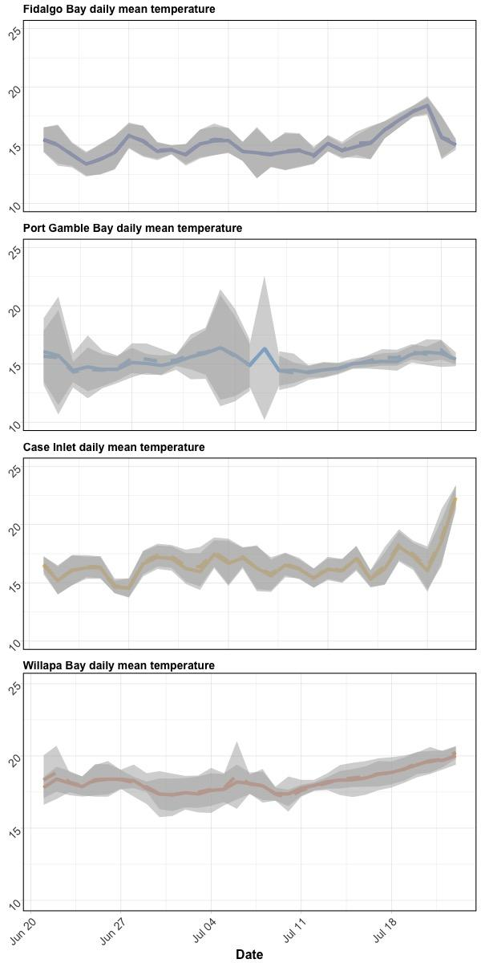

|  |
| --- |
| **Supplemental Figure 1:** Daily mean temperature in eelgrass (dashed lines) and unvegetated (solid lines) across bays during geoduck deployment. Gray ribbons denote standard deviations per day. |

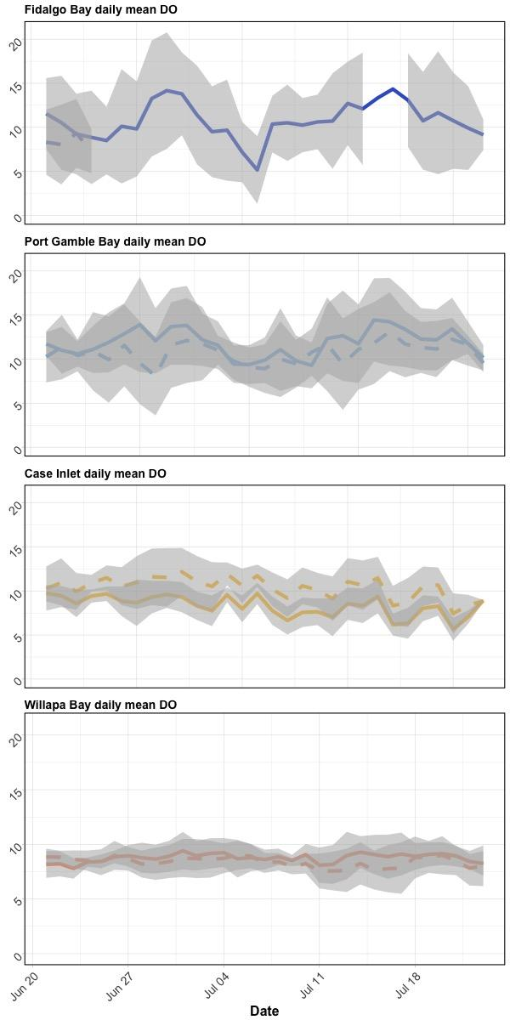

|  |
| --- |
| **Supplemental Figure 2:** Daily mean DO in eelgrass (dashed lines) and unvegetated (solid lines) across bays during geoduck deployment. Gray ribbons denote standard deviations per day. Fidalgo Bay eelgrass probe failed towards the beginning of the outplant period. |

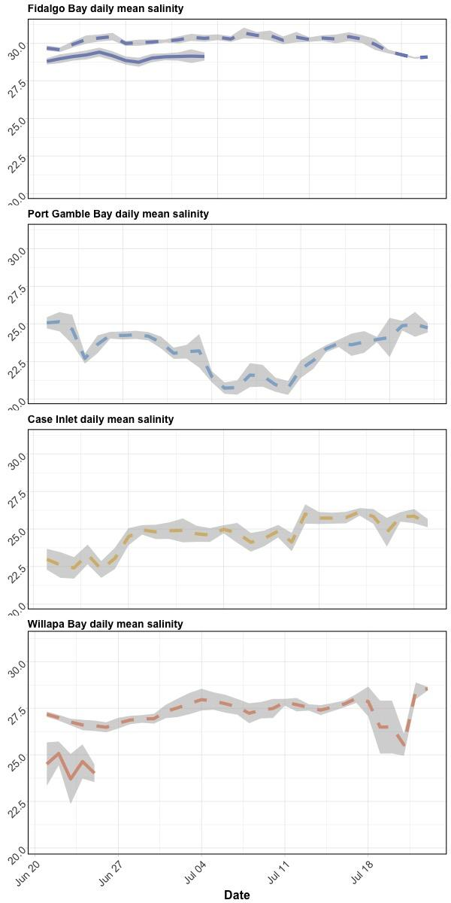

**Supplemental Figure 3**: Daily mean salinity in eelgrass (dashed lines) and unvegetated (solid lines) across bays during geoduck deployment. Gray ribbons denote standard deviations per day. Salinity probes failed at several sites; no habitat comparisons were made.

|  |  |  |  |  |  |  |  |
| --- | --- | --- | --- | --- | --- | --- | --- |
| **Supplemental Table 2**: SRM protein ANOVA results by Region (FB/PGB vs. CI/WB), Bay, and Habitat for all proteins combined, then each protein individually, with Pr(>F)-adjusted calculated via the Bonferroni Correction. Bold = significantly different abundance. Habitat was tested using 2-way ANOVA with abundance ~ Bay*Habitat. | | | | | | | |
|  | **Comparison** | **Df** | **Sum Sq** | **Mean Sq** | **F value** | **Pr(>F)** | **P.adj** |
| **all peptides combined** | **North vs. South** | **1** | **18.2** | **18.2** | **10.9** | **0.00010** | **0.0014** |
| **Bay** | **3** | **34.2** | **11.4** | **7.0** | **0.00012** | **0.0017** |
| Habitat | 1 | 1.2 | 1.2 | 0.75 | 5.4 | 14 |
| arachidonate | North vs. South | 1,133 | 7.4 | 7.4 | 1.3 | 0.26 | 3.6 |
| Bay | 3,131 | 60 | 20 | 3.7 | 0.014 | 0.20 |
| Habitat | 1,130 | 2.2 | 2.2 | 0.40 | 0.53 | 7.4 |
| catalase | North vs. South | 1,128 | 8.6E-05 | 8.6E-05 | 0.46 | 0.50 | 7.0 |
| Bay | 3,126 | 0.00019 | 6.4E-05 | 0.34 | 0.79 | 11 |
| Habitat | 1,125 | 1.4E-08 | 1.4E-08 | 7.4E-05 | 0.99 | 14 |
| cytochrome P450 | North vs. South | 1,133 | 0.0065 | 0.0065 | 0.96 | 0.33 | 4.6 |
| Bay | 3,131 | 0.015 | 0.0051 | 0.76 | 0.52 | 7.3 |
| Habitat | 1,130 | 0.0085 | 0.0085 | 1.3 | 0.26 | 3.7 |
| glycogen phosphorylase | North vs. South | 1,133 | 94 | 94 | 1.05 | 0.31 | 4.3 |
| Bay | 3,131 | 459 | 153 | 1.7 | 0.16 | 2.3 |
| Habitat | 1,130 | 114 | 114 | 1.3 | 0.26 | 3.6 |
| **HSP90-alpha** | **North vs. South** | **1,133** | **421,443** | **421,443** | **21** | **1.3E-05** | **0.00018** |
| **Bay** | **3,131** | **477,740** | **159,247** | **7.8** | **7.83E-05** | **0.0011** |
| Habitat | 1,130 | 567 | 567 | 0.028 | 0.87 | 12 |
| protein disulfide isomerase | North vs. South | 1,84 | 3.8 | 3.8 | 5.55 | 0.021 | 0.29 |
| Bay | 3,82 | 4.6 | 1.5 | 2.2 | 0.10 | 1.4 |
| Habitat | 1,81 | 0.01 | 0.006 | 0.0078 | 0.93 | 13 |
| **puromycin-sensitive** | **North vs. South** | **1,130** | **0.94** | **0.94** | **9.1** | **0.0031** | **0.043** |
| Bay | 3,128 | 1.2 | 0.40 | 3.87 | 0.011 | 0.15 |
| Habitat | 1,127 | 0.09 | 0.089 | 0.87 | 0.35 | 4.9 |
| sodium/potassium transporting ATPase | North vs. South | 1,88 | 0.65 | 0.65 | 0.42 | 0.52 | 7.2 |
| Bay | 3,86 | 3.2 | 1.06 | 0.68 | 0.56 | 7.9 |
| Habitat | 1,85 | 0.85 | 0.85 | 0.55 | 0.46 | 6.5 |
| superoxide dismutase | North vs. South | 1,66 | 0.0012 | 0.0012 | 1.8 | 0.18 | 2.5 |
| Bay | 3,64 | 0.0020 | 0.00067 | 1.02 | 0.39 | 5.5 |
| Habitat | 1,63 | 5.4E-05 | 5.4E-05 | 0.081 | 0.78 | 11 |
| **trifunctional enzyme β-subunit** | **North vs. South** | **1,88** | **252** | **252** | **11.1** | **0.0013** | **0.018** |
| **Bay** | **3,86** | **345** | **115** | **5.19** | **0.0024** | **0.034** |
| Habitat | 1,85 | 22 | 22 | 1.0 | 0.32 | 4.5 |

|  |  |  |  |  |  |  |  |  |
| --- | --- | --- | --- | --- | --- | --- | --- | --- |
| **Supplemental Table 3**: Mean coefficients of variation of SRM transition abundance for each protein, location | | | | | | | | |
| **Protein** | **CI-B** | **CI-E** | **FB-B** | **FB-E** | **PG-B** | **PG-E** | **WB-B** | **WB-E** |
| arachidonate 5-lipoxygenase | 0.84 | 0.57 | 0.44 | 0.33 | 0.46 | 0.64 | 0.48 | 0.58 |
| catalase | 0.61 | 0.52 | 0.47 | 0.42 | 0.50 | 0.66 | 0.50 | 0.43 |
| cytochrome P450 | 0.74 | 0.57 | 0.38 | 0.43 | 0.26 | 0.58 | 0.56 | 0.46 |
| glycogen phosphorylase (muscle form) | 0.55 | 0.49 | 0.35 | 0.35 | 0.37 | 0.61 | 0.51 | 0.47 |
| heat shock protein 70 | 0.59 | 0.61 | 0.20 | 0.33 | 0.37 | 0.44 | 0.45 | 0.38 |
| heat shock protein 90-alpha | 0.70 | 0.62 | 0.32 | 0.40 | 0.45 | 0.52 | 0.50 | 0.49 |
| protein disulfide isomerase | 0.63 | 0.50 | 0.38 | 0.31 | 0.38 | 0.70 | 0.41 | 0.43 |
| peroxiredoxin-1 | 0.56 | 0.46 | 0.31 | 0.33 | 0.42 | 0.46 | 0.40 | 0.36 |
| puromycin-sensitive aminopeptidase | 0.69 | 0.52 | 0.39 | 0.40 | 0.42 | 0.51 | 0.44 | 0.42 |
| ras-related protein rab-11B | 0.61 | 0.43 | 0.30 | 0.33 | 0.42 | 0.63 | 0.57 | 0.54 |
| Na/K transporting ATPase | 0.70 | 0.58 | 0.30 | 0.36 | 0.40 | 0.62 | 0.51 | 0.44 |
| Superoxide dismutase | 0.49 | 0.53 | 0.49 | 0.57 | 0.30 | 0.71 | 0.46 | 0.44 |
| Trifunctional Enzyme β-subunit | 0.61 | 0.48 | 0.41 | 0.38 | 0.46 | 0.63 | 0.52 | 0.53 |

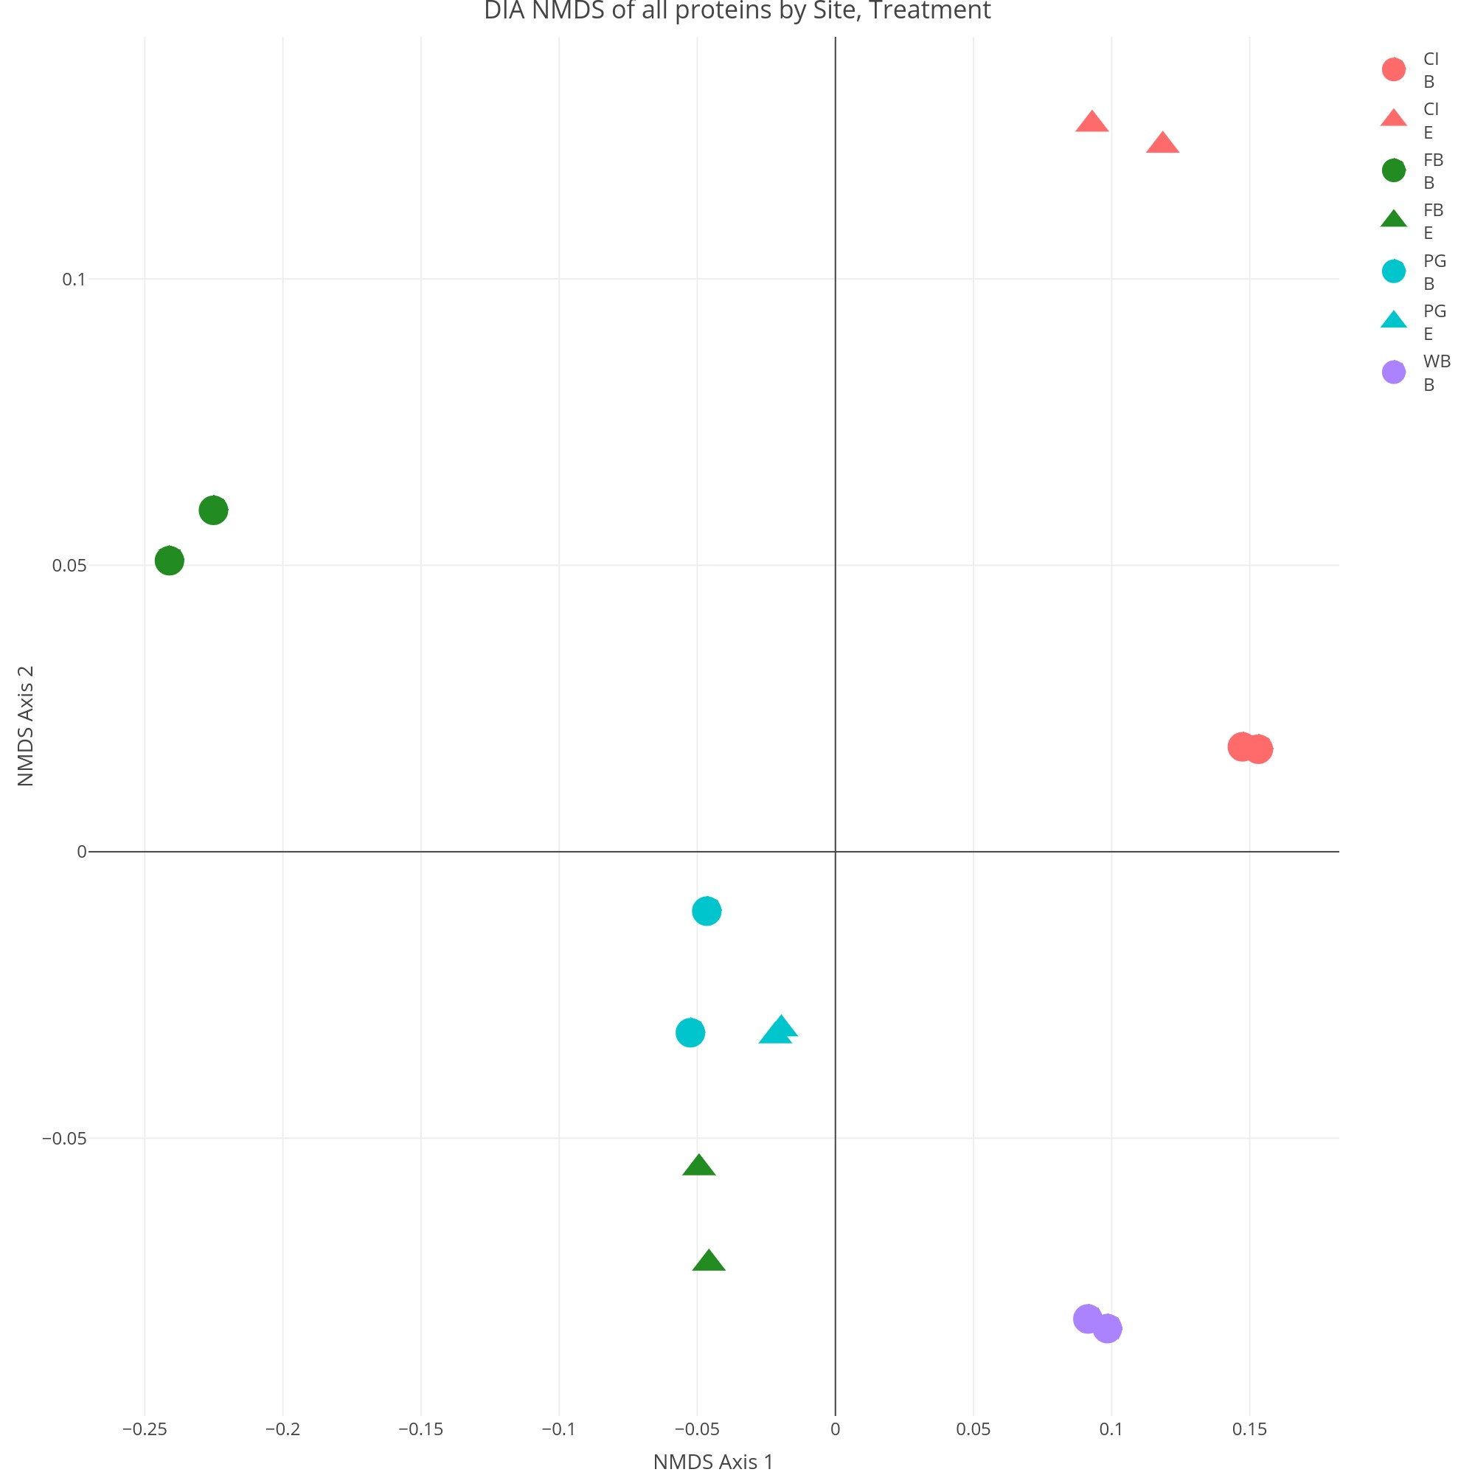

**Supplemental Figure 4**: Non-metric Multi-Dimensional Scaling plot (NMDS) showing patterns of similarity among DIA peptide abundances between technical replicates (same symbol/color), deployment bay (same color), and north/south region, where each point represents one geoduck. Relative proximity of points represents overall degree of peptide abundance similarity.

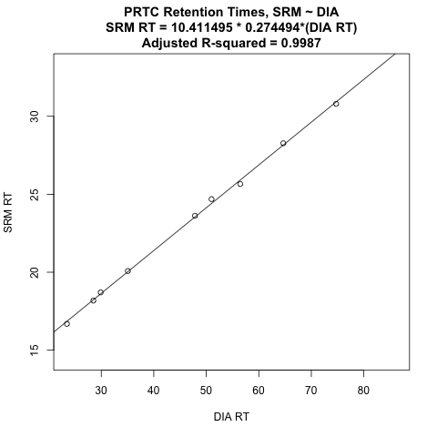

**Supplemental Figure 5**: Linear regression model fit of PRTC internal standard peptides in SRM against DIA, used to confirm identity of targeted peptides in SRm by calculating adjustment in retention time between SRM and DIA.

**Supplemental Figure 6 (Interactive, online)**: Dilution curve peptide abundance ratios regressed against predicted ratios from serial sample dilutions. Peptides with slope coefficient 0.2<x<1.5 and adjusted R2 >0.7 were included in analysis. Link to interactive figure: <http://owl.fish.washington.edu/generosa/Generosa_DNR/Dilution-Curve-Transitions.html>

**Supplemental Figure 7 (Interactive, online):** Non-metric Multi-Dimensional Scaling plot (NMDS) of SRM technical replicates. Link to interactive figure: <http://owl.fish.washington.edu/generosa/Generosa_DNR/NMDS-technical-replicate.html>

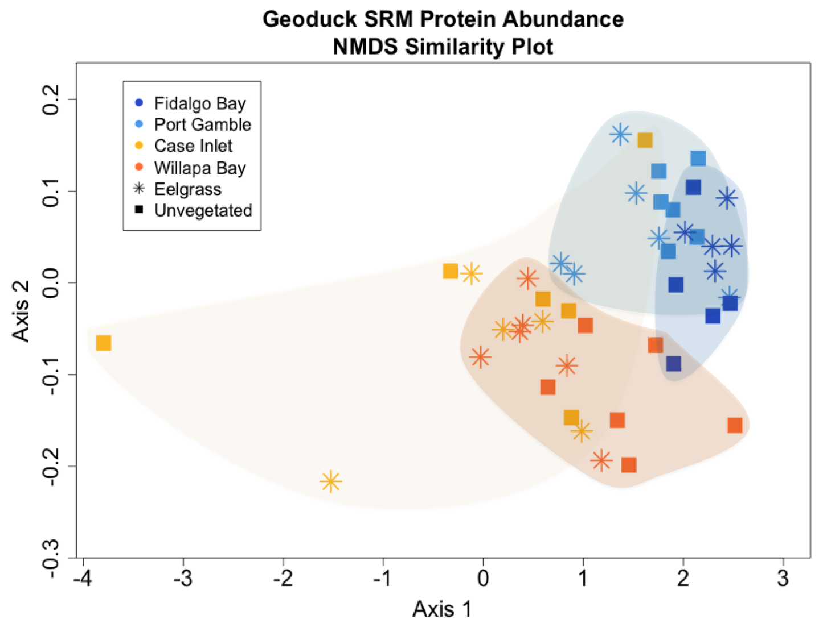

**Supplemental Figure 8**: Non-metric Multi-Dimensional Scaling plot (NMDS) showing patterns of similarity among targeted SRM peptide abundances between deployment locations, where each point represents one geoduck. Relative proximity of points represents overall degree of peptide abundance similarity.