​​

**Figure S1. Representative Barcode Rank Plots**

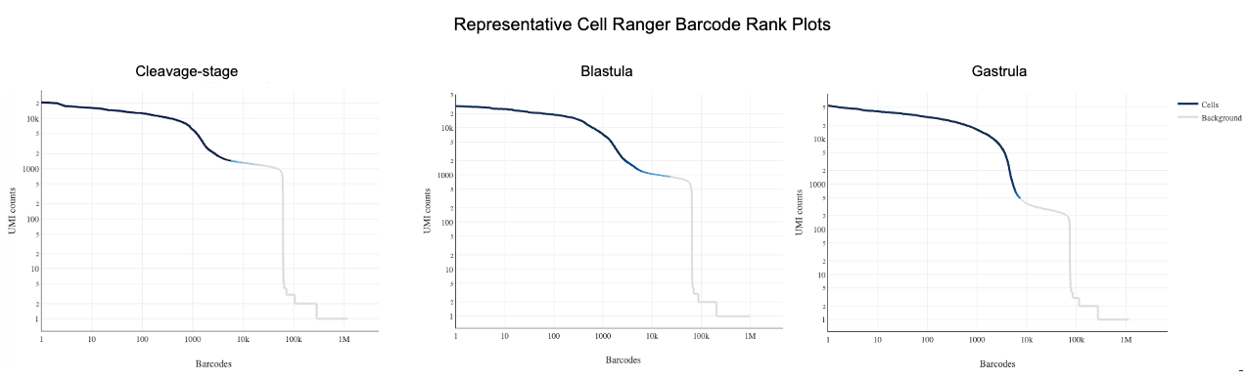

**Figure S2. Genes associated with PGCs in oyster gastrulae are not specifically expressed in cleavage + blastula clusters**. Dot plot illustrating expression of *vasa* and the top 10 PGC cluster marker genes in cleavage + blastula clusters. Dot color represents expression level and dot size represents fractional representation of cells expressing a gene.

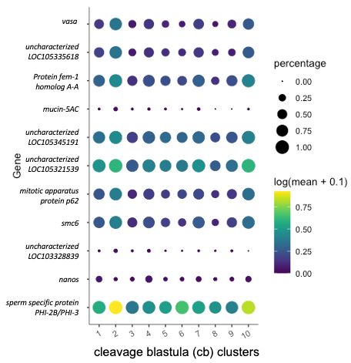

**Figure S3. UMAP of neural markers not expressed at the gastrula stage in *C. gigas.*** Expression patterns of select neural genes in UMAP space.

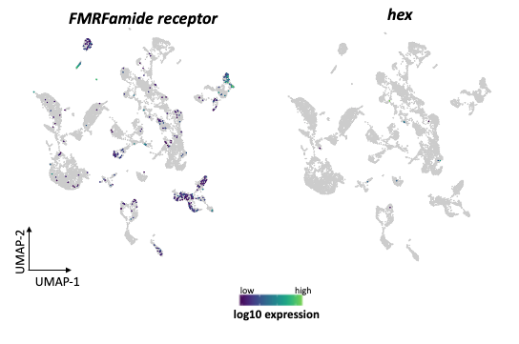

**Figure S4.** UMAP of cleavage + blastula cells color-coded according to library type. Colors: pooled cleavage stages (CP) and blastula (Bla).

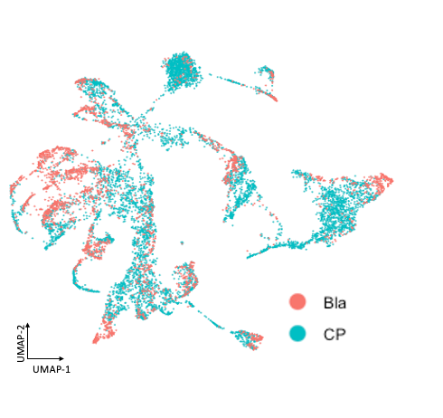

**Figure S5.** Cluster analysis of blastula cells visualized via UMAP. (A) UMAP plot in which cells are colored according to blastula clusters. (B) UMAP plot of cleavage-blastula cells, where cells are colored according to the blastula clusters and cells from the cleavage-stage embryos are gray.

