**Project Report**

PSMFC Subaward 23-084G for the period **May 1, 2023 through July 31, 2023**

Project Title: Gene activity and genetic selection in Pacific cod reared under thermal stress

Objective: Predict organismal and population outcomes of Pacific cod exposed to elevated temperature

Summary: Recent heat wave stress in the Gulf of Alaska has resulted in significant declines of Pacific cod, *Gadus macrocephalus*, in that region. In particular, overwintering success of juveniles is hypothesized to represent a critical bottleneck with food availability the previous summer affecting juvenile lipid reserves and thus, their ability to survive winter. The physiological and transcriptional responses of Pacific cod and whether selective mortality is present under thermal stress are unknown. The proposed project will address these questions critical to their survival under climate change by identifying regions of the genome and epigenome that respond to thermal stress and starvation. Juvenile Pacific cod will be reared in three temperatures under feeding and non-feeding conditions, then an integrated genomic approach will identify genes, gene variants, and epigenetic markers that respond to thermal stress and confer resilience. To complement the genomic approaches and further investigate temperature influences on energy resources, we will perform lipid analyses. This work will inform predictions of genetic selection and molecular response of Pacific cod in the Gulf of Alaska under climate change.  
  
**Progress and results**

We began genetic analysis on all experimental fish, with the following objectives: 1) identify the origin of experimental fish, which were juveniles when caught, 2) determine relatedness of individuals and overall genetic composition, and 3) inform selection of individuals for additional analyses (lipids, gene expression, methylation). To do so, we collected tissue from caudal fins (fin clips) from each fish upon terminating experimental treatments, then isolated DNA from ethanol-preserved tissue using the DNeasy Blood & Tissue Kit (Qiagen). DNA was sent to Novogene for QC, library prep, and sequencing using low-coverage whole genome sequencing technology (lcWGS). Raw sequencing data was received from Novogene and archived in multiple locations by UW and NOAA, then processed and analyzed using a lcWGS pipeline developed by NOAA. Briefly, the raw data was assessed for quality using the programs Fastqc and Multiqc, reads were trimmed to remove adapters, low-quality ends of reads, and poly-g tails, then they were aligned to the Pacific cod genome. After alignment, genotype likelihoods will be calculated for putatively polymorphic sites and all sites.

**Figure 1**. The average quality score of raw reads (y-axis) by position along read (x-axis), which shows that raw lcWGS data is of high quality. 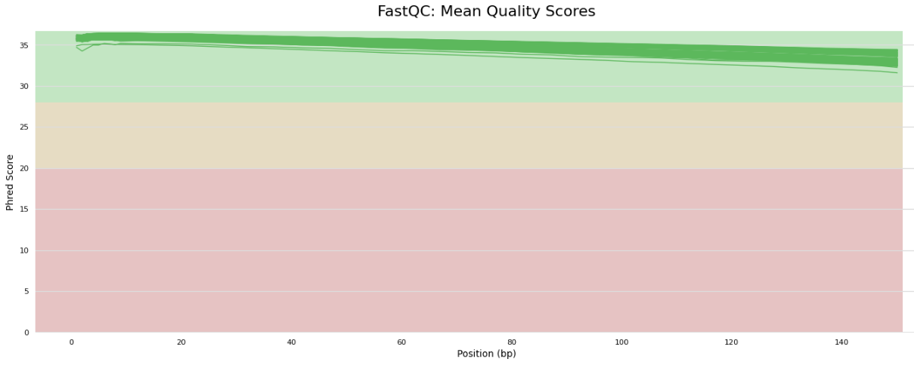

**Figure 2.** Trimmed lcWGS data statistics, showing the % of reads that are duplicates (y-axis) and the total number of reads (x-axis) on a per-sample basis. Overall, the data generated by lcWGS meets the quality standards required for genetic analysis.

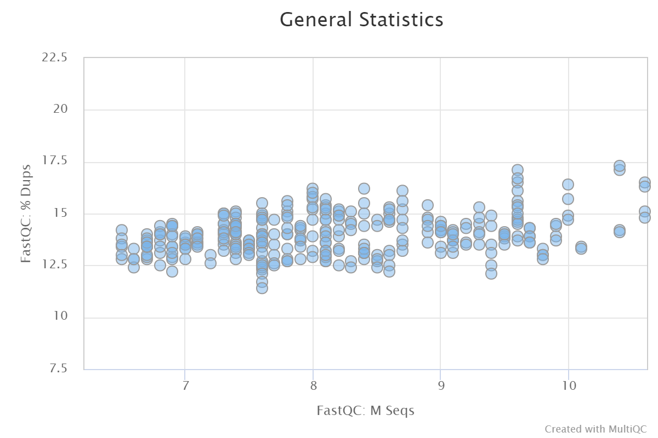

**Challenges**

None to report.