**Project Report**

PSMFC Subaward 23-084G for the period **February 1, 2023 through April 30, 2023.**

Project Title: Gene activity and genetic selection in Pacific cod reared under thermal stress

Objective: Predict organismal and population outcomes of Pacific cod exposed to elevated temperature

Summary: Recent heat wave stress in the Gulf of Alaska has resulted in significant declines of Pacific cod, *Gadus macrocephalus*, in that region. In particular, overwintering success of juveniles is hypothesized to represent a critical bottleneck with food availability the previous summer affecting juvenile lipid reserves and thus, their ability to survive winter. The physiological and transcriptional responses of Pacific cod and whether selective mortality is present under thermal stress are unknown. The proposed project will address these questions critical to their survival under climate change by identifying regions of the genome and epigenome that respond to thermal stress and starvation. Juvenile Pacific cod will be reared in three temperatures under feeding and non-feeding conditions, then an integrated genomic approach will identify genes, gene variants, and epigenetic markers that respond to thermal stress and confer resilience. To complement the genomic approaches and further investigate temperature influences on energy resources, we will perform lipid analyses. This work will inform predictions of genetic selection and molecular response of Pacific cod in the Gulf of Alaska under climate change.  
  
**Progress and results**

During the reporting period the primary activity included completion of the temperature trial and sampling of tissues. Temperature trial with juvenile cod lasted one month and included the following temperatures: 0C, 5C, 9C, and 16C. The trial took place at the Hatfield Marine Science Center in Newport, Oregon. Tissues sampled included blood, liver, and gill. Images from experiment and sampling activity are below. All samples were transported back to the University of Washington for preservation and later analysis.

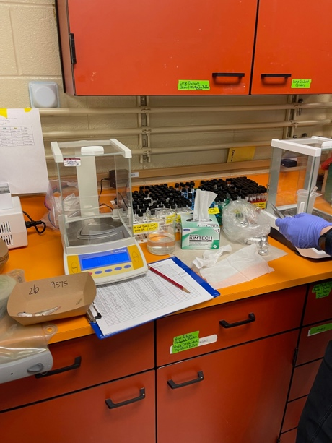 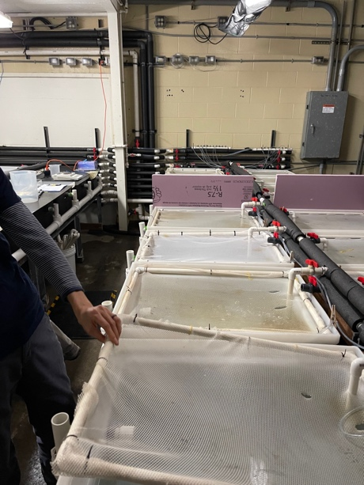

**Challenges**

None to report.