**Project Report**

Applying cutting-edge technology for reproductive control in emerging bivalve species

**11/1/19 – 04/30/20**

1. **Project summary**

To increase the productivity and sustainability of the shellfish aquaculture sector, while at the same time enabling hatchery responsiveness to both environmental challenges and market demands through breeding and maturation control, a time-efficient, practical, and cost-effective means to produce sterile shellfish is critically needed. The overarching goal of the proposed project is to develop a novel tool for conferring sterility on farmed shellfish that mitigates some of the shortcomings of ploidy manipulation. An attractive alternative to ploidy manipulation is the induction of sterility by inactivation of genes essential for germ cell formation.

One of the major roadblocks to the development of this technology is the lack of knowledge of these genes in bivalves. Single-cell RNA-Seq (scRNA-Seq) has emerged as a technology that will enable the identification of genes involved in germ cell differentiation via transcriptional profiling of single embryonic cells.

The primary milestone associated with our project will be a temporal atlas of gene expression in developing embryos at the single cell level. This outcome will not only have tremendous impact on the understanding of bivalve developmental biology, but importantly for our purposes, will provide gene targets for generating shellfish stocks that offer ecological security and optimal food production efficiency.

**B.     Summary of progress and results**

During the project period, geoduck broodstock were slow to mature during commercial maturation conditioning at the Jamestown Point Whitney Shellfish Hatchery. To make progress on our objectives despite the unavailability of geoduck gametes, we decided to initially use Pacific oysters (*Crassostrea gigas*), readily available on a weekly basis from the Taylor Shellfish Co. Hatchery, as a proxy, under the assumption that many of the critical processes involved in germ cell formation will be conserved in bivalves. The decision to use *C. gigas* as a proxy was fortuitous even if this assumption proves incorrect, since many of the operational steps in the protocol have been optimized and we remain unable to obtain geoduck gametes (See C, below).

We first conducted a series of trials to ascertain gamete handling and short-term storage limitations, fertilization efficiency, and to characterize the timing of cleavage divisions at a controlled temperature. For each set of trials, we procured gametes via strip spawning (gametes physically removed from shucked live oysters) from three females and three males. We initially used pooled sperm to fertilize oocytes and collected, fixed, and preserved a time series of embryonic stages representing early cleavage through early gastrula stages. We determined that at 20 C, variability in developmental timing among oocyte populations from individual females was sufficient to warrant visually tracking development instead of relying only on time.

The next set of experiments focused on efficiently dissociating live cells from different cleavage divisions during embryonic development. We first used the Liberase TM (Roche, 5401119001) enzyme, but found a higher proportion of dissociated cells, less clumping, and almost 100% live cells using the ‘cold’ protease *Bacillus licheniformis* (Creative Enzymes, NATE0633).

To optimize costs associated with scRNA-Seq, we decided to pool the first 8 cleavage divisions, necessitating a means to significantly stall embryonic development at each cleavage stage to enable pooling of live embryos from the same mating at each cleavage stage. We accomplished this by holding embryo subsamples from each stage at 4 C.

A population of embryos from a single pair mating were selected for scRNA-Seq based on high fertilization efficiency and developmental synchrony. We pooled early-cleavage divisions 2-7, and kept blastula separate due to the likely rarity of our target cell type in this group. Cells were dissociated to single cell suspensions and transported directly to the Trapnell lab at the UW Department of Genome Sciences for scRNA-seq transcriptional profiling via the 10x Genomics Chromium Single Cell 3′ Library Construction Kit v3 (San Francisco, CA). This technology combines dissociated, live cells with 10x Genomics’ ‘GelBead’ technology to prepare barcoded mRNA libraries of individual cells. Once complete, libraries are then sequenced on a high-throughput Illumina sequencing platform.

Differential expression analyses were performed between all cells expressing *vasa*, a known germ cell marker, and non-*vasa* expressing cells to identify candidate germ cell precursors (Fig 1) for future in-depth characterization of expressed genes related to germ cell formation.

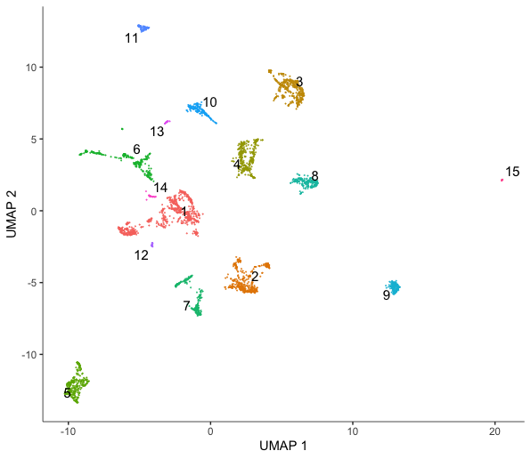 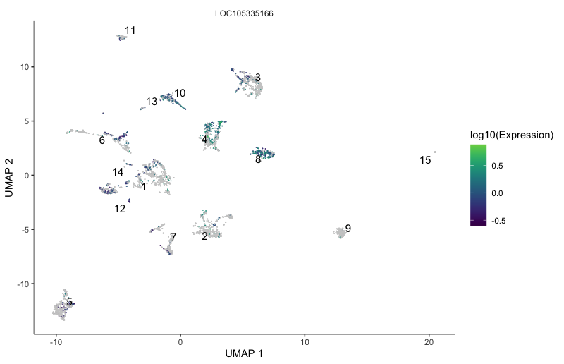

**Fig 1.** UMAP illustrating clustering of single cells via gene expression patterns in a *Crassostrea gigas* blastula sample (left panel). Vasa expression levels (gene ID: LOC105335166 in the same cells illustrates potential precursor cells involved in germ cell formation (right panel).

**C.     Challenges**

Our initial challenge in obtaining geoduck gametes was related to very slow maturation during commercial hatchery conditioning. We therefore arranged to obtain naturally matured wild geoduck in May, 2020 through the Washington Department of Fish and Wildlife.

The COVID-19 pandemic has subsequently resulted in non-essential laboratory closures at the University of Washington, denial of access to the Jamestown Point Whitney Shellfish Laboratory, and cessation of non-essential sampling by the Washington Department of Fish and Wildlife shellfish dive team.