**Final Project Report**

**Project Title:**EMERGING BIVALVE SPECIES REPRODUCTIVE CONTROL TECH

**Contract #:**20-04G-3  
(NOAA Award NA18NMF4720007) for the period **05/01/2018 - 04/30/2024**

1. **Project summary**   
    To increase the productivity and sustainability of the shellfish aquaculture sector, while at the same time enabling hatchery responsiveness to both environmental challenges and market demands through breeding and maturation control, a time-efficient, practical, and cost-effective means to produce sterile shellfish is needed. The overarching goal of the proposed project is to develop essential resources for conferring sterility on farmed shellfish that mitigates some of the shortcomings of ploidy manipulation.   
    One of the major roadblocks to the development of this technology is the lack of knowledge of the critical genes involved in reproductive development in bivalves. Single-cell RNA-Seq (scRNA-Seq) has emerged as a technology that will enable the identification of genes involved in germ cell differentiation via transcriptional profiling of single embryonic cells.   
    The primary milestones achieved as part of this project was performing scRNA-Seq on geoduck embryos as well incorporating a suite of five transcriptomic libraries to effectively identify genes involve in reproductive control in geoduck.

**B.     Summary of progress and results**

As part of this project scRNA-Seq was performed on geoduck embryo cells. These data are published as part of a data repository and are currently being incorporated into a manuscript expected to be completed by the end of the year.

The geoduck embryos were obtained from fertilized eggs, sourced from pooled parents at a commercial hatchery and transported to the University of Washington. Throughout the transport and until the time of sampling, the embryos were maintained at 16°C to preserve their viability and developmental integrity. The scRNA-seq experiment targeted 24,000 cells, aiming for an optimal dispersion of 6,000 cells across four separate 10x Genomics sequencing reactions. This extensive sampling was designed to capture a broad diversity of cell types and states present during early development. CellRanger software was employed to process the raw sequencing data from each of the four replicate libraries, generating a comprehensive profile of gene expression at the single-cell level. Following data processing, the Monocle3 tool was used for further analysis, allowing the visualization and characterization of cell populations within the embryos.

One of the significant outcomes of this study was the detailed expression pattern mapping of crucial genes such as the vasa homolog and sperm-specific histone homolog. These genes are pivotal in germ cell development and chromatin remodeling, respectively. The vasa homolog, identified in geoduck as PGEN_.00g008080, showed significant expression, underpinning its role in the embryonic development of geoduck. The study utilized UMAP (Uniform Manifold Approximation and Projection) for visualization, effectively clustering the 12,305 analyzed cells without additional filtering. This approach highlighted distinct cellular clusters and provided a visual representation of developmental heterogeneity. Furthermore, a top marker table for each cluster was developed, incorporating annotations for comparative purposes. This comprehensive marker analysis aided in the identification of cell types and states, enhancing the understanding of early developmental processes in geoduck embryos.

To complement this effort our group went on to integrate five transcriptomic libraries to more effectively identify genes involved in reproductive control in geoduck These data were published as part of a thesis at the University of Washington and as a poster at the National Shellfisheries Association Meeting. Specifically, we and annotated five RNA-seq transcriptome libraries from three different geoduck tissue types--gonad, heart, and ctenidia--across two life stages, larvae and juvenile.

Key findings from the study include the identification of reproductive genes within the gonad RNA-seq library, which was a primary focus due to its significance in reproductive biology. The analysis revealed a total of 13,682 genes within the gonad library, with 119 unique to this tissue. These genes are involved in crucial reproductive processes, marking them as potential targets for gene editing aimed at enhancing aquaculture practices and sustainability.

Comparative genomic analysis with other clam species within the *Venerida* clade, including the Manila clam and the hard clam, highlighted a significant phylogenetic relationship and shared genetic structures that are pivotal for understanding reproductive mechanisms across species. The study utilized both previously published and new genomic resources to compare homologous genes, providing a broader context for the evolutionary and functional dynamics of these clams.

Additionally, the research delved into the temporal variation of gene expression during reproductive cycles, notably leveraging data from studies on oysters to contextualize the gene expression observed in geoducks (Table 1). This approach has led to insights into reproductive maturation stages which are crucial for understanding and potentially manipulating reproductive cycles in aquaculture settings.

activie

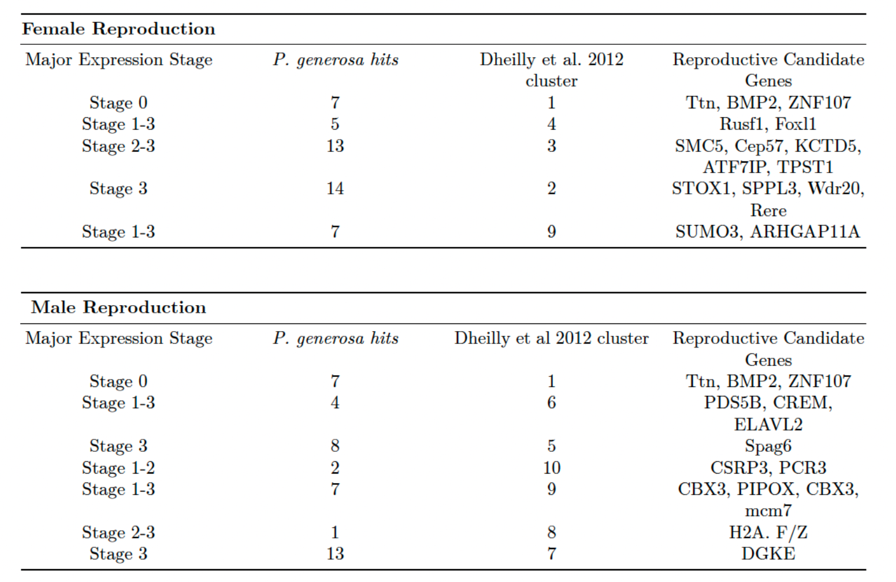

Table 1. Characterization of Reproductive Development Genes: *P. generosa* reproductive gene annotation summary using Dheilly et al., (2012) gene clusters (1-10) and major expression stages. *P. generosa* hits are the genes matched from *C. gigas* reproductive candidate genes by either predominantly female or male expression stages.

1. **Challenges**

Over the life of the award, we did experience challenges related to COVID, however with no-cost extensions we were able to complete the objectives of the project.

|  |  |  |  |  |
| --- | --- | --- | --- | --- |
| **PSMFC Job #** | **Project Title** | **Progress and Results** | **Challenges** | **Outreach/ Publications** |
| **1126G1.19** | EMERGING BIVALVE SPECIES REPRODUCTIVE CONTROL TECH | Completed sc-RNAseq on geoduck embryos.  Full annotation of geoduck gene sets. | COVID | Thesis:  Developing Tools and Resources for Maturation Control in Bivalvia. Olivia Cattau. 2023 http://hdl.handle.net/1773/50826  Presentation:  Development of an Alternative Sterility Method for Shellfish Aquaculture: Identification of Candidate Genes Involved in Germ Cell Specification. Pacific Coast Shellfish Growers Association (PCSGA) Meeting. 2023  Presentation:  Genomic Resources for the Pacific Geoduck (*Panopea generosa*) - Poster presented at National Shellfisheries Association Meeting in Baltimore MD, 2022. (https://d.pr/Kza1u9)  Data Repository: https://github.com/RobertsLab/project-maturation-control/ |