**Project Report**

Applying cutting-edge technology for reproductive control in emerging bivalve species

(NOAA Award NA18NMF4720007) for the period **05/1/22 – 10/31/22**

1. **Project summary** To increase the productivity and sustainability of the shellfish aquaculture sector, while at the same time enabling hatchery responsiveness to both environmental challenges and market demands through breeding and maturation control, a time-efficient, practical, and cost-effective means to produce sterile shellfish is critically needed. The overarching goal of the proposed project is to develop a novel tool for conferring sterility on farmed shellfish that mitigates some of the shortcomings of ploidy manipulation. An attractive alternative to ploidy manipulation is the induction of sterility by inactivation of genes essential for germ cell formation.  
    One of the major roadblocks to the development of this technology is the lack of knowledge of these genes in bivalves. Single-cell RNA-Seq (scRNA-Seq) has emerged as a technology that will enable the identification of genes involved in germ cell differentiation via transcriptional profiling of single embryonic cells.   
    The primary milestone associated with our project will be a temporal atlas of gene expression in developing embryos at the single cell level. This outcome will not only have tremendous impact on the understanding of bivalve developmental biology, but importantly for our purposes, will provide gene targets for generating shellfish stocks that offer ecological security and optimal food production efficiency.

**B.     Summary of progress and results**

* Sequencing and analysis of single-cell sequencing for geoduck early embryo (17 hour post fertilization) libraries. Top marker genes for cell groups have been identified and further functional annotation is currently underway.

Summary information on sequencing effort:

Visualization of 14 identifiable cell groups in geoduck embryo library sequenced:

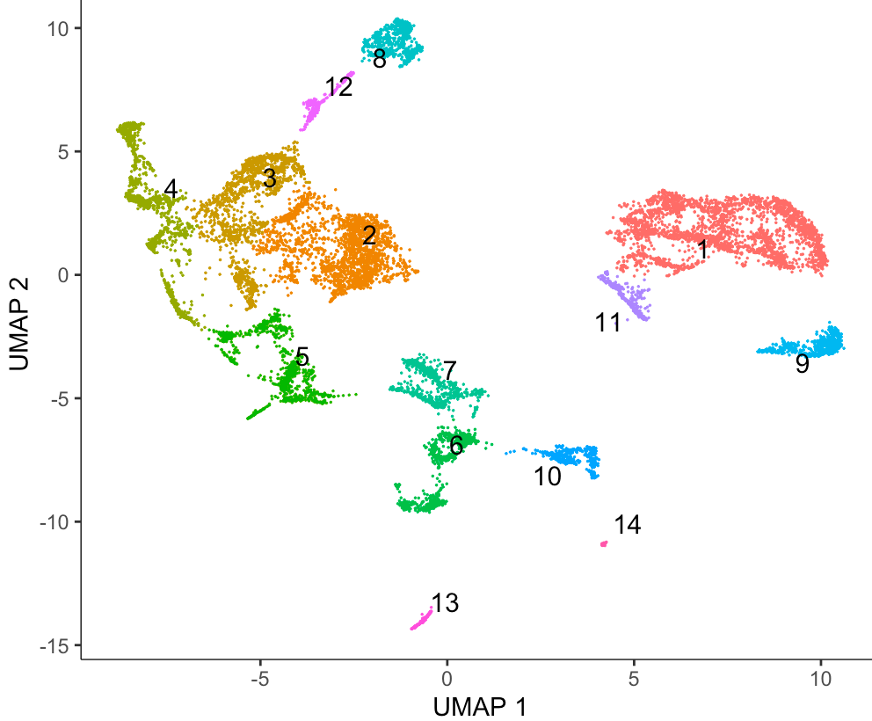

1. **Challenges**

No new challenges during this reporting period

|  |  |  |  |  |
| --- | --- | --- | --- | --- |
| **PSMFC Job #** | **Project Title** | **Progress and Results** | **Challenges** | **Outreach/ Publications** |
| **1126G1.19** | EMERGING BIVALVE SPECIES REPRODUCTIVE CONTROL TECH | Sequencing and analysis of single-cell sequencing for geoduck early embryo libraries. | None | First publication expected during next reporting period. |