Standard Operating Procedure for ethidium bromide (EtBr)

CAS: 1239-45-8

# Section 1 – Lab-Specific Information

**Building/Room(s) covered by this SOP:   FTR 209/213**

**Unit or department:   Roberts Lab**

**Principal Investigator Name:    Steven Roberts**

**Principal Investigator Signature/Date:  ___________________________________________________**

**This SOP was created by (if not PI):**

**Sam White**

**Chemical Hygiene Office**

**7/19/2024**

# Section 2 – Hazards

Ethidium bromide is considered a particularly hazardous chemical.

Ethidium bromide exists as a powder and as a prepared stock solution (10mg/mL).

**Hazards may include, but are not limited to:**

* The powder form is considered an irritant to the upper respiratory track, eyes and skin. Ethidium bromide is strongly mutagenic, causing living cell mutations. Even though there is no evidence at this time of human carcinogenicity or teratogenicity, this material should be considered a possible carcinogen or teratogen.
* Liquid form hazards should be considered to be similar to the powder form.

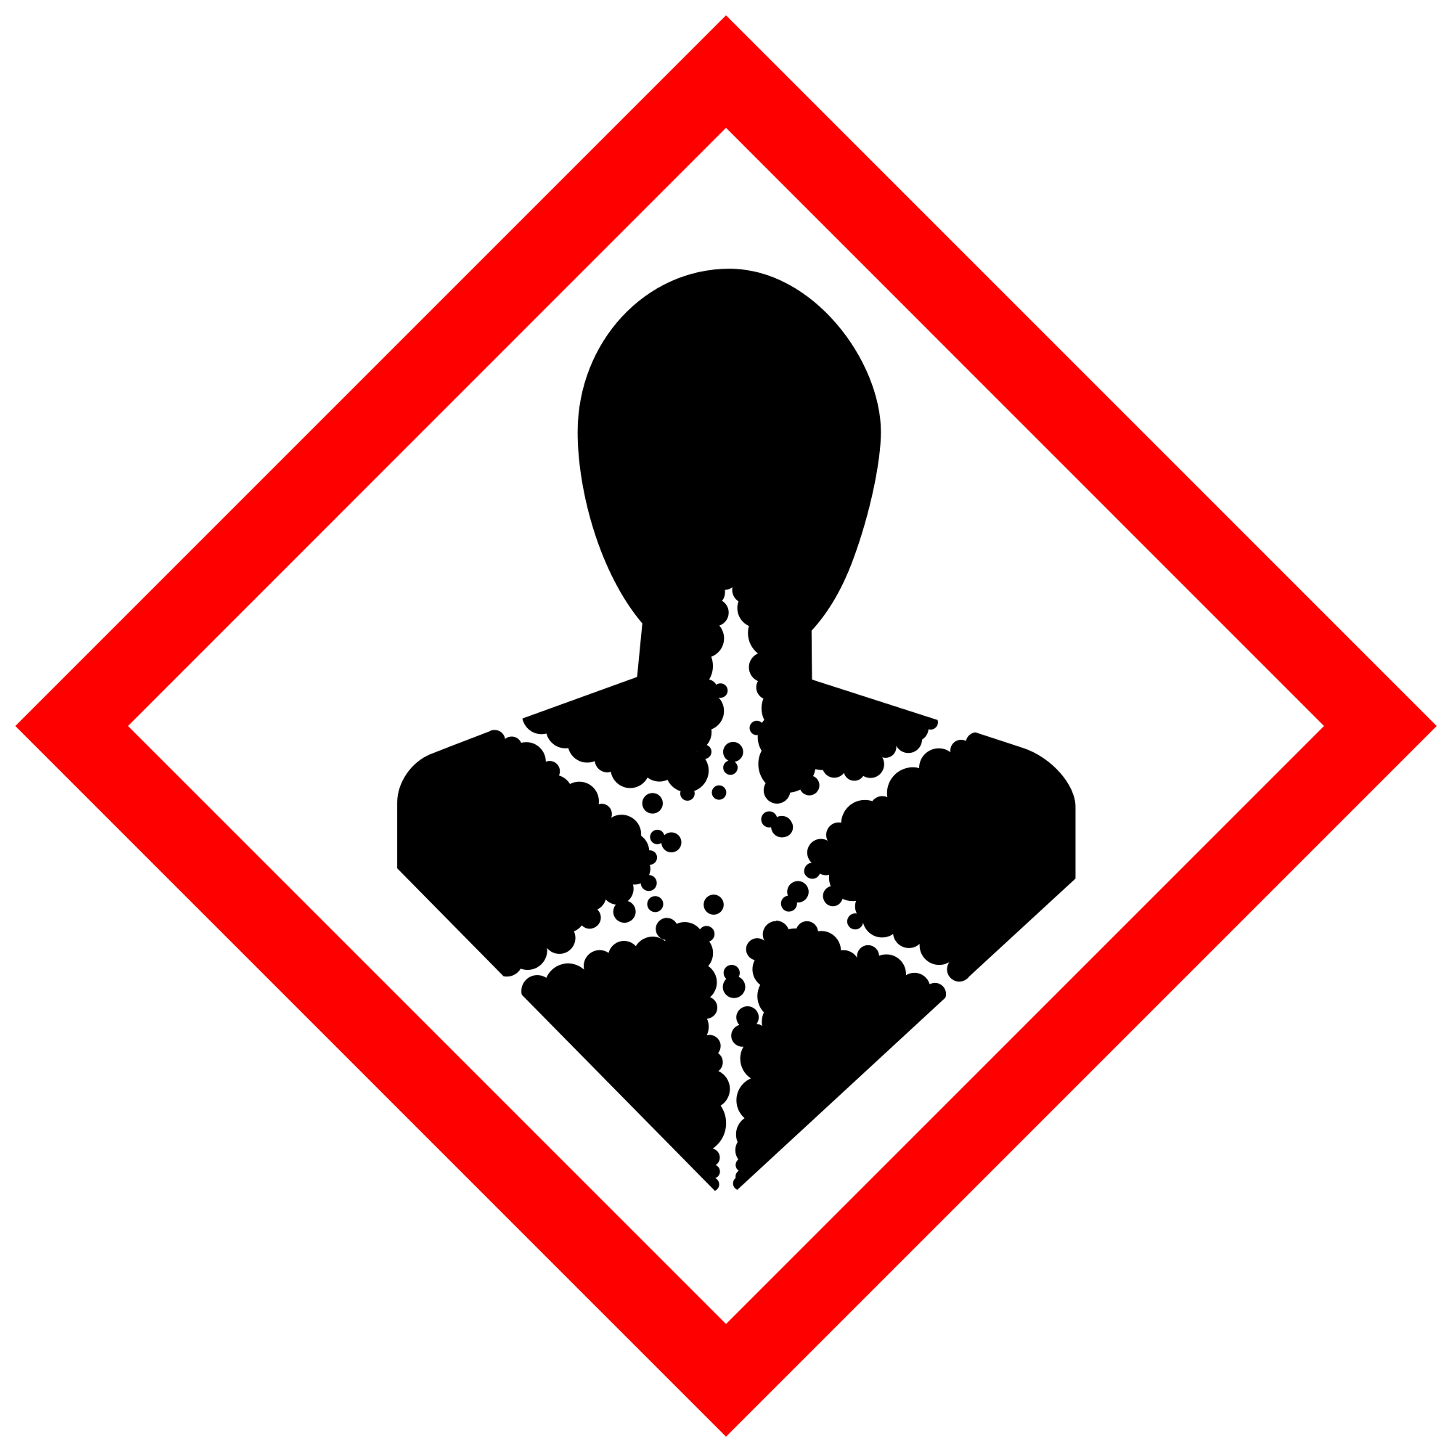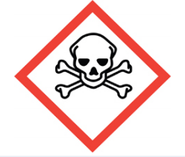

# Section 3 – Engineering Controls and Personal Protective Equipment (PPE)

## Engineering controls

All operations involving powder or mists of ethidium bromide must be done in a fume hood. Check for proper operation of the fume hood prior to use.

When an ultraviolet light source is used in your work with ethidium bromide, added caution is required. As a general rule, avoid exposing unprotected skin and eyes to intense UV sources. If the UV light is aimed upwards, wear a UV protective face shield when you are standing near the source. For prolonged work close to UV light boxes or other intense sources, it may be useful to wrap the end of the lab coat sleeves loosely with masking tape to prevent gaps where the wrist could be exposed. For low-intensity UV sources, the requirement for UV protection can be waived if the exposure to personnel has been measured and shown to be within permissible exposure levels. Contact EH&S Radiation Safety at 206-543-0463 or [radsaf@uw.edu](mailto:radsaf@uw.edu) if you need measurements of the UV levels in your facility.

Any chemical fume hood used must be tested and passed by EH&S.

## Hygiene measures

Avoid contact with skin, eyes, and clothing. Wash hands after removing PPE, before breaks, and immediately after handling the chemical. If ethidium bromide come(s) into contact with any PPE, the PPE shall be immediately removed and discarded properly. Any potentially exposed body parts should be washed immediately.

## Skin and body protection

Chemically compatible laboratory coats that fully extend to the wrist must be worn and be appropriately sized for the individual and buttoned to their full length. Personnel must also wear full-length pants, or equivalent, and close-toe shoes. The area of skin between the shoe and ankle must not be exposed.

Use Roberts Lab disposable lab coats.

## Hand protection

Hand protection is required for the activities described in this SOP.

Nitrile gloves are required.

Gloves must be inspected prior to use, including a check for pinholes.

Use proper glove removal technique (without touching glove’s outer surface) to avoid skin contact with this product. Dispose of contaminated gloves after use in accordance with applicable laws and good laboratory practices. Wash and dry hands immediately after glove removal.

## Eye protection

ANSI Z87.1-compliant eye protection is required for all work with the powder form of ethidium bromide. Ordinary prescription glasses will NOT provide adequate protection unless they also meet the Z87.1 standard and have compliant side shields.

Chemical splash goggles are required when using the powder form of ethidium bromide.

## Respiratory protection

Respiratory protection is required for the activities described in this SOP.

The powder form of ethidium bromide may ONLY be used within a fume hood.  
The liquid form has no respiratory requirements.

# Section 4 – Special handling and storage requirements

Liquid: Store in the dark and the cold, preferably in a plastic container.

Solid: Store in Chemicals Cabinet.

Ethidium bromide powder

* Clean the fume hood and any instruments and/or tools (e.g. scale, spatulas, etc.)upon completion of tasks with water*.*
* Clean all contaminated surfaces with water and dry.
* Place all contaminated disposable items in appropriate laboratory waste for disposal.
* Non‐disposable/re‐usable utensils, glassware, and other surfaces contaminated with ethidium bromide must be decontaminated at the end of the laboratory work session. Complete this inside fume hoodbefore removing any of the items.
* When work is completed, remove gloves and wash hands with soap and water.

# Section 5 – Spill and accident procedures

When working with ethidium bromide, try to minimize the potential for spills. Where practical, purchase ready-made stock solutions from chemical manufacturers in lieu of mixing your own solutions. If you prefer to mix your own solutions of ethidium bromide, protect yourself by doing this process in a fume hood. Perform all processes that generate ethidium bromide dusts or mists inside the fume hood to minimize inhalation exposures.

Prevent accidents by transporting small quantities of ethidium bromide in a secondary container instead of carrying large quantities.

Spills of ethidium bromide solutions should be absorbed and decontaminated with soap and water. Avoid raising dust when cleaning up solid spills by mixing with water and then absorbing the solution. All spill cleanup materials and absorbents should be bagged or placed in a sealed container with a [hazardous waste label](https://www.ehs.washington.edu/system/files/resources/how-to-label-chemical-waste-containers.pdf).

Spill clean up requires the same PPE specified Section 3.

Do **not** attempt to clean up any spill if **not** trained or comfortable. Evacuate the area and call 9-1-1 on campus phone for help. If the spill is out of control, call 9-1-1. If a person is injured, exposed or suspected of being exposed, call 9-1-1 and follow the EXPOSURE PROCEDURES (below).

Spill area must be cleaned up in the following manner: Clean spill area thoroughly with detergent solution followed by clean water.

Spill cleanup materials must be disposed of in the following manner: Double bag all waste in plastic bags labeled with the contents. Submit request to EH&S for pickup.

For questions on spill cleanup, contact EH&S spill consultants at 206‐543‐0467 during normal business hours (Monday-Friday, 8 a.m. to 5 p.m.).

Any spill, exposure or near miss incident requires the involved person or supervisor to complete and submit the [UW Online Accident Reporting System](https://oars.ehs.washington.edu/) (OARS) form on the EH&S website within 24 hours (certain [types of incidents require immediate notification](https://www.ehs.washington.edu/workplace/incident-reporting)).

**Exposures:** If a person is injured, exposed, or suspected of being exposed to ethidium bromide, follow procedures listed here:

**Perform first aid immediately.**

* **Inhalation exposure**: Move to fresh air. Call a physician or poison control center immediately. If breathing stops, provide artificial respiration.
* **Sharps injury** (needle stick or subcutaneous exposure): Scrub exposed area thoroughly for 15 minutes using warm water and sudsing soap.
* **Skin exposure:** Scrub exposed area thoroughly for 15 minutes using warm water and sudsing soap.
* **Eye exposure:** Use the eye wash for 15 minutes while holding eyelids open.

**Get Help.**

* **Call** 9-1-1 or go to nearest Emergency Department (ED); provide details of exposure:
  + - Agent
    - Dose
    - Route of exposure
    - Time since exposure
* **Bring** **the SDS and this SOP** to the Emergency Department
* **Notify your supervisor** as soon as possible for assistance
* **Secure the area** before leaving; lock doors and indicate spill if needed

**Report the incident to Environmental Health & Safety**.

* **Notify** **EH&S immediately** after providing first aid and/or getting help.
  + During business hours (M‐F/8‐5), call 206‐543‐7262.
  + Outside of business hours, call 206‐685‐UWPD (8973) to be routed to EH&S Staff On Call.
* Any spill, exposure or near miss incident requires the involved person or supervisor to complete and submit the [UW Online Accident Reporting System](https://oars.ehs.washington.edu/) (OARS) form on the EH&S website within 24 hours (certain [types of incidents require immediate notification](https://www.ehs.washington.edu/workplace/incident-reporting)).

# Section 6 – Waste accumulation and disposal procedures

Powders, concentrated solutions (>10ug/L), and grossly contaminated items are hazardous waste. Double bag all solid waste in plastic bags labeled with the contents. Label with a UW [Hazardous Waste Label](https://www.ehs.washington.edu/system/files/resources/how-to-label-chemical-waste-containers.pdf), accumulate according to requirements in the Chemical Waste Management section of the [UW Laboratory Safety Manual](https://www.ehs.washington.edu/resource/laboratory-safety-manual-510).

Dilute solutions (<10ug/L), like those used in staining agarose gels, may be disposed in sink drain. Agarose gels may be disposed of in the laboratory trash.

**All chemical waste containers must be labeled** with a [UW Hazardous Waste Label](https://www.ehs.washington.edu/chemical/hazardous-chemical-waste-disposal). Refer to [How to Label Chemical Waste Containers](https://www.ehs.washington.edu/system/files/resources/how-to-label-chemical-waste-containers.pdf).

To request a collection of chemical waste, submit a form on the [Chemical Waste Disposal](https://www.ehs.washington.edu/chemical/hazardous-chemical-waste-disposal) webpage on the EH&S website or directly in [MyChem](https://www.ehs.washington.edu/chemical/mychem) inventory. Contact EH&S at 206.616.5835 or [chmwaste@uw.edu](mailto:chmwaste@uw.edu) with questions.

Work area decontamination procedures as appropriate for the chemical in use should be followed.

# Section 7 – Protocol

# Section 8 – Special Precautions for animal use ( Yes No)

[**PARTICULARLY HAZARDOUS SUBSTANCE**](https://www.ehs.washington.edu/resource/particularly-hazardous-substances-655) **INVOLVED?**

**YES: Sections #9 to #11 are Mandatory.**

**NO: Sections #9 to #11 are Optional.**

# Section 9 – Approvals required

All staff working with ethidium bromide must be trained on this SOP prior to starting work. They must also review the ethidium bromide SDS, and it must be readily available in the laboratory. All training must be documented and maintained by the PI or their designee.

# Section 10 – Decontamination

# Areas in which ethidium bromide have been used should be washed with soapy water, rinsed with water, and then dried.

# Section 11 – Designated area

# The bench space next to the UV transilluminator and the cabinets beneath this area are designated for running/staining gels with ethidium bromide.

# Section 12 – Documentation of training

* Prior to using substances included in this SOP, laboratory personnel must be trained on the hazards described in this SOP, how to protect themselves from the hazards, and emergency procedures.
* Ready access to this SOP and to a Safety Data Sheet for each hazardous material described in the SOP must be made available in the lab space(s) where these substances are used.
* The Principal Investigator (PI), or Responsible Party, if the activity does not involve a PI, must ensure that their laboratory personnel have attended appropriate laboratory safety training (and refresher training where applicable).
* Training must be repeated following **any** revision to the content of this SOP.
* Training must be documented. This training sheet is provided as one option; other forms of training documentation (including electronic) are acceptable but records must be accessible and immediately available upon request.

**I have read and understand the content of this SOP:**

| **Name** | **Signature** | **Date** |
| --- | --- | --- |
| **Sam White** |  | **7/20/2024** |
|  |  |  |
|  |  |  |
|  |  |  |
|  |  |  |
|  |  |  |
|  |  |  |
|  |  |  |
|  |  |  |
|  |  |  |
|  |  |  |
|  |  |  |