**INSTRUCTIONS: This is an SOP template; it is complete when**

**1) All form fields have been completed to reflect chemical/lab-specific information,** including adding relevant procedure information, or deleted inapplicable information; and

**2) SOP has been signed and dated by the PI and relevant lab personnel.**

Use safety data sheets (SDSs) as a resource for chemical-specific information. Text highlighted in gray indicates where information should be added or edited. Delete all instructions in red text and “Draft” watermark after the SOP is approved by PI.

Standard Operating Procedure

Formaldehyde

# **Section 1 – Lab-Specific Information**

**Chemical(s) covered by this SOP:    formaldehyde**

**Building/Room(s) covered by this SOP:      FTR 209/213**

**Unit or department:    School of Aquatic & Fishery Sciences**

**Principal Investigator Name:   Steven Roberts**

**Principal Investigator Signature/Date:**

**Important Definitions**

* **Action level:** a concentration designated in regulations for a specific substance, calculated as an eight (8)-hour time-weighted average, which initiates certain required activities such as exposure monitoring and medical surveillance.
* **Permissible exposure limit (PEL):** the exposure limit designated in regulations for a specific substance, calculated as an eight (8)-hour time-weighted average, that should not be exceeded in a work day.
* **Short-term exposure limit (STEL):** the airborne concentration designate in regulations for a specific substance that should not be exceeded in a 15 minute period.
* **Acutely Toxic Material:** Substances that may be fatal or cause damage to target organs as the result of a single exposure or exposure of short duration. Acute toxins are quantified by substance’s LD50 or LC50.
* **Reproductive Toxic Material:** Substances that may affect the reproductive capabilities, including chromosomal damage (mutations) and effects on fetuses (teratogens).
* **Target Organ Toxic Material:** Substances that pose adverse health effects to specific organs such as the liver, kidneys, lungs, etc.
* **Carcinogen:** A chemical is considered to be a carcinogen if:
  1. It has been evaluated by the International Agency for Research on Cancer (IARC), and found to be a carcinogen or potential carcinogen; or
  2. It is listed as a carcinogen or potential carcinogen in the Annual Report on Carcinogens published by the National Toxicology Program (NTP) (Latest edition); or
  3. It is regulated by OSHA as a carcinogen.
* **Toxic Chemical:** A chemical falling within any of the following categories:
  1. A chemical that has a median lethal dose (LD50) of more than 50 milligrams per kilogram but not more than 500 milligrams per kilogram of body weight when administered orally to albino rats weighing between 200 and 300 grams each.
  2. A chemical that has a median lethal dose (LD50) of more than 200 milligrams per kilogram but not more than 1,000 milligrams per kilogram of body weight when administered by continuous contact for 24 hours (or less if death occurs within 24 hours) with the bare skin of albino rabbits weighing between two and three kilograms each.
  3. A chemical that has a median lethal concentration (LC50) in air of more than 200 parts per million but not more than 2,000 parts per million of gas or vapor, or more than two milligrams per liter but not more than 20 milligrams per liter of mist, fume, or dust, when administered by continuous inhalation for one hour (or less if death occurs within one hour) to albino rats weighing between 200 and 300 grams each.

**Section 2 – Hazards**

Formaldehyde is classified as a known human carcinogen and has been linked with cancers of the lung, nasopharyngeal and oropharynx, and nasal passages. It is also a reproductive toxin capable of exerting target organ damage upon prolonged and repeated exposure. Even at airborne levels as low as 0.1 parts per million (ppm), acute exposure health effects may be experienced including coughing, wheezing, watery eyes, skin irritation, and a burning sensation in the eyes, nose, and throat. Formaldehyde acts as a sensitizer and can cause an immune response upon initial exposure. Severe allergic reactions in the respiratory tract, skin, and eyes may occur upon ensuing exposures. Prolonged exposure to low levels of formaldehyde in air can cause asthma-like respiratory symptoms and various skin irritations such as dermatitis. Formaldehyde can be fatal if ingested. It

may be inhaled as a gas or vapor or absorbed through the skin as a liquid. Specific hazards depend upon both the form and concentration of the formaldehyde.

FORMTEXT REQUIRED - Describe any additional hazards associated with this/these chemicals

**Exposure Limits:**

WAC PEL (8 HR. TWA): 0.75 ppm

WAC STEL (15 min TWA): 0.2 ppm

WAC Action Level (8 HR. TWA): 0.5 ppm

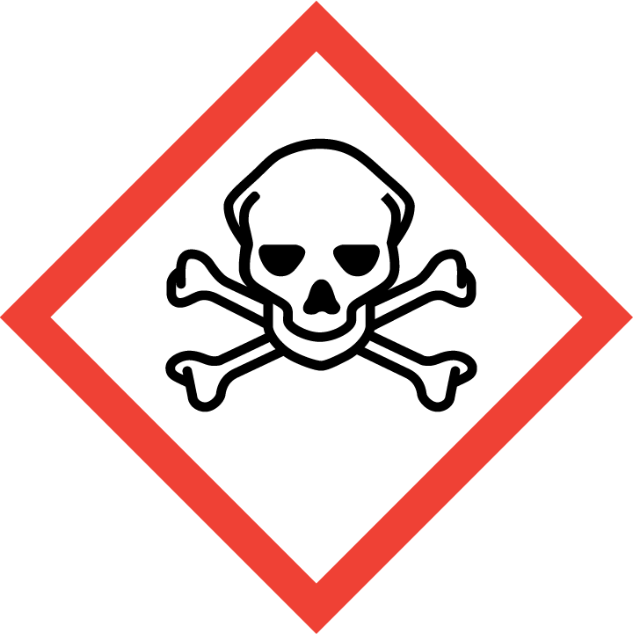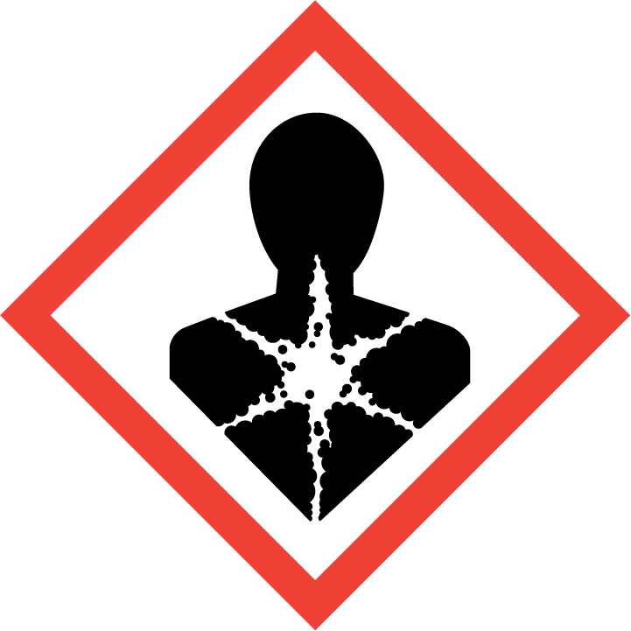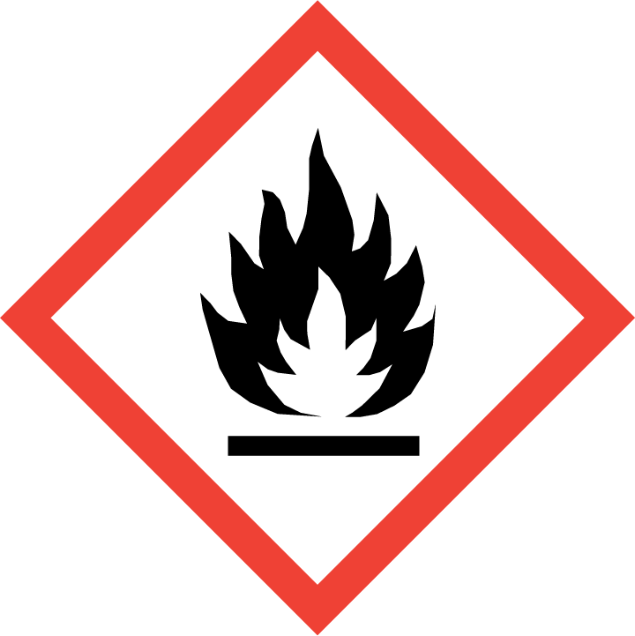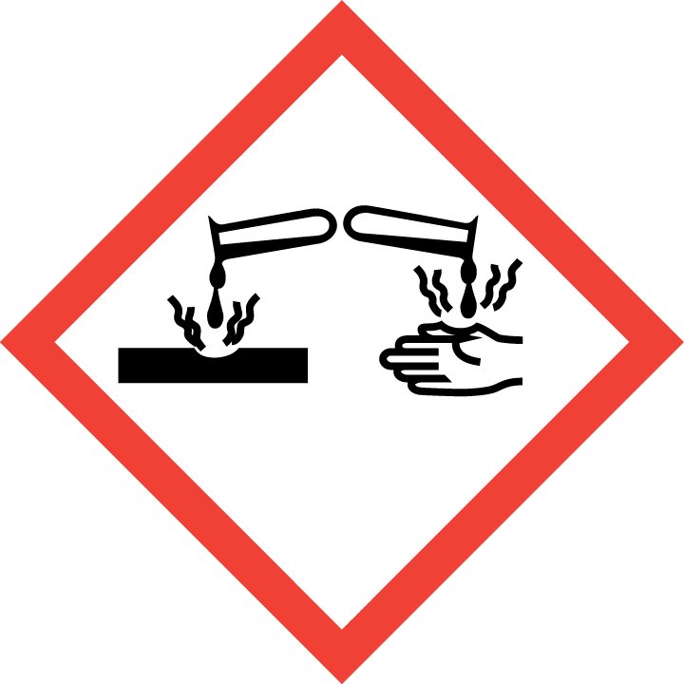

**Section 3 – Engineering Controls and Personal Protective Equipment (PPE)**

**Engineering Controls:** Use of formaldehyde must be conducted in a properly functioning chemical fume. The chemical fume hood must be tested and passed by EH&S. Routine use of formaldehyde-containing chemicals outside of hood or exhausted containment is acceptable only when airborne formaldehyde levels have been monitored during the procedure by EH&S and found to be below the action level of 0.5 ppm.

Fume hoods are in FTR 209 and FTR 213.

**Hygiene Measures:** Avoid contact with skin, eyes, and clothing. Wash hands after removing PPE, before breaks, and immediately after handling the chemical. If chemical comes into contact with any PPE, the PPE shall be immediately removed and discarded properly. Any potentially exposed body parts should be washed immediately.

**Skin and body protection.** Chemically compatible laboratory coats that fully extend to the wrist must be worn and be appropriately sized for the individual and buttoned to their full length. Personnel must also wear full-length pants, or equivalent, and close-toe shoes. The area of skin between the shoe and ankle must not be exposed.

Use Roberts Lab supplied disposable lab coats.

**Hand protection.** Hand protection is required for the activities described in this SOP. Two pairs of disposable nitrile exam gloves or one pair of thicker nitrile or butyl gloves (minimum 10 mil thickness) should be worn for concentrated chemical. Disposable nitrile exam gloves can be worn for solutions.

Gloves must be inspected prior to use, including a check for pinholes.

Use proper glove removal technique (without touching glove’s outer surface) to avoid skin contact with this product. Dispose of contaminated gloves after use in accordance with applicable laws and good laboratory practices. Wash and dry hands immediately after glove removal.

**Eye protection.** ANSI Z87.1-compliant eye protection is required for all work with these chemicals. Wear safety glasses with side shields or chemical safety goggles. Ordinary prescription glasses will NOT provide adequate protection unless they also meet the Z87.1 standard and have compliant side shields. If a splash is possible, also wear face protection such as a face shield.

**Respiratory protection.** Routine use of formaldehyde-containing chemicals outside of hood or exhausted containment is acceptable only when airborne formaldehyde levels have been monitored during the procedure by EH&S and found to be below the action level of 0.5 ppm.

If formaldehyde is being used outside of a chemical fume hood, respiratory protection is required for the activities described in this SOP.

Use of formaldehyde is NOT permitted outside of a fume hood.

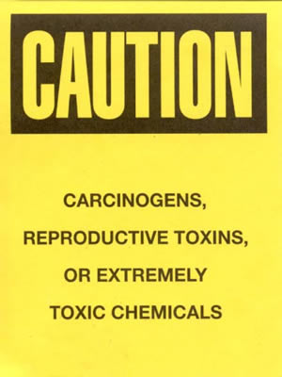**Section 4 – Special Handling and Storage Requirements**

* All preparation of formaldehyde-containing chemical solutions will be performed over plastic-backed absorbent pads inside fume hood. Pads will be disposed of after completion of tasks or immediately upon contamination.
* All work with formaldehyde shall be done in a designated area, as specified in Section 11 of this SOP.
* When needed, a sharps container will be in the immediate vicinity for safe sharps disposal.
* Store separately from incompatible materials, including strong oxidizers, ammonia, strong alkalis, isocyanates, peracids, anhydrides and inorganic acids.
* Suitable storage locations for flammable versions of formaldehyde include flammable storage cabinets that do not contain incompatible chemicals or flammable-proof refrigerators or freezers.
* Keep the amount of formaldehyde stored in the lab at a minimum.
* Dispose of any expired or unnecessary materials as hazardous waste.
* Label all aliquots and solutions clearly with the original manufacturer’s label, which should have the chemical name, hazard labels, and pictograms. The label should not be defaced in any way.
* Do not over purchase; only purchase what can be safely stored in the laboratory.
* Avoid contact with skin, eyes, and inhalation.
* Keep away from sources of ignition.
* Keep containers tightly closed. Store in a cool, dry, and well-ventilated area away from incompatible substances such as strong acids.
* Clean the fume hoodupon completion of tasks with water and paper towels*.*
* Clean all contaminated surfaces with water and dry.
* Place all contaminated disposable items in appropriate laboratory waste for disposal.
* Non-disposable/reusable utensils, glassware, and other surfaces contaminated with formaldehyde must be decontaminated at the end of the laboratory work session. Complete this inside fume hoodbefore removing any of the items.
* When work is completed, remove gloves and wash hands with soap and water.

**Section 5 – Spill and Accident Procedures**

Chemical spills must be cleaned up as soon as possible by properly protected and trained personnel. All other persons should leave the area.

**Spills inside a fume hood, BSC, glove box or approved containment; and Small Spills (250 ml or less) outside of fume hood or containment**

1. Spills, regardless of size, inside a fume hood can typically be cleaned up by trained people who are not sensitive to formaldehyde.
2. Small spills outside a fume hood (250 ml or less) can also be managed by trained people who are not sensitive to formaldehyde.
3. Personnel must wear a lab coat or smock, safety goggles, two pairs of disposable nitrile exam gloves or one pair of thicker nitrile or butyl gloves (minimum 10 mil thickness) or Silver Shield gloves and shoe covers as needed when cleaning up spills.
4. **Liquids:** Wipe up spilled liquids with absorbent pads. If using a formaldehyde neutralizing absorbent, cover the spill with the absorbent and allow to set for the prescribed contact time (usually 15 min.), and then scoop up and dispose of properly.
5. **Solids:** Gently cover paraformaldehyde solid spills with wetted paper towels or absorbent pads to avoid raising dust and then wipe up.
6. Clean the spill area thoroughly with detergent solution followed by clean water.
7. If spill is extensive within the containment, clean all interior surfaces after completion of the spill cleanup.

**Large spills (greater than 250 ml) outside of fume hood or containment**

1. Large formaldehyde spills (greater than 250 ml) outside a fume hood or containment may generate vapors above formaldehyde exposure limits; therefore, these spills require the use of respiratory protection.
2. Cover spill if possible to keep vapors down.
3. Evacuate area and restrict access. Attend to injured or exposed persons using emergency shower or eyewash. Follow procedures below in 8. Exposure Procedures.
4. As soon as possible report the spill in a safe area by notifying EH&S during normal business hours or call 9-1-1. Tell them that a spill has occurred, and you need help managing the spill. EH&S can arrange for a spill cleanup contractor. Notify supervisor.
5. **Only if staff are trained, have the proper PPE including respiratory protection and are comfortable with cleaning up the spill, they may proceed to clean it up.** Personnel must wear a lab coat or smock, safety goggles, two pairs of disposable nitrile exam gloves or one pair of thicker nitrile or butyl gloves (minimum 10 mil thickness) or Silver Shield gloves, shoe covers, and a respirator specifically for protection against formaldehyde. Respirator use requires enrollment in UW’s respirator program.
6. **Liquids:** Wipe up spilled liquids with absorbent pads. If using a formaldehyde neutralizing absorbent, cover the spill with the absorbent and allow to sit for the prescribed contact time (usually 15 min.), and then scoop up and dispose of properly.
7. **Solids:** Gently cover paraformaldehyde solid spills with wetted paper towels or absorbent pads to avoid raising dust and then wipe up.
8. Clean the spill area thoroughly with detergent solution followed by clean water.

Double bag all waste in plastic bags labeled with a hazardous waste label that reads "formaldehyde spill debris.

Do **not** attempt to clean up any spill if **not** trained or comfortable. Evacuate the area and call 9-1-1 on campus phone for help. If the spill is out of control, call 9-1-1. If a person is injured, exposed or suspected of being exposed, call 9-1-1 and follow the EXPOSURE PROCEDURES (below).

For questions on spill cleanup, contact EH&S spill consultants at 206‐543‐0467 during normal business hours (Monday-Friday, 8 a.m. to 5 p.m.).

Any spill, exposure or near miss incident requires the involved person or supervisor to complete and submit the [Online Accident Reporting System (OARS)](https://www.ehs.washington.edu/workplace/accident-and-injury-reporting) form on the EH&S website within 24 hours ([certain types of incidents](https://ehs.washington.edu/workplace/accident-and-injury-reporting) require immediate notification) at oars.ehs.washington.edu.

**Exposures:** If a person is injured, exposed, or suspected of being exposed to formaldehyde, follow procedures listed here:

**Perform first aid immediately.**

* **Inhalation exposure**: Move out of contaminated area; get medical help.
* **Sharps injury** (needle stick or subcutaneous exposure): Scrub exposed area thoroughly for 15 minutes using warm water and sudsing soap.
* **Skin exposure:** Use the nearest safety shower for 15 minutes; stay under the shower and remove clothing; use a clean lab coat or spare clothing for cover‐up.
* **Eye exposure:** Use the eye wash for 15 minutes while holding eyelids open.

**Get Help.**

* **Call** 9-1-1 or go to nearest Emergency Department (ED); provide details of exposure:
  + - Agent
    - Dose
    - Route of exposure
    - Time since exposure
* **Bring** **the SDS for the specific chemical and this SOP** to the Emergency Department
* **Notify your supervisor** as soon as possible for assistance
* **Secure the area** before leaving; lock doors and indicate spill if needed

**Report the incident to Environmental Health & Safety**.

* **Notify** **EH&S immediately** after providing first aid and/or getting help.
  + During business hours (M‐F/8‐5), call 206‐543‐7262.
  + Outside of business hours, call 206‐685‐UWPD (8973) to be routed to EH&S Staff On Call.
* The involved person or supervisor submits the UW Online Accident Reporting System (OARS) form on the EH&S website within 24 hours ([certain types of incidents](https://ehs.washington.edu/workplace/accident-and-injury-reporting) require immediate notification) at oars.ehs.washington.edu.

**Section 6 – Waste Disposal Procedures**

Waste containing formaldehyde is considered a hazardous chemical waste.

Double bag all used and contaminated (not grossly contaminated) disposable items, such as gloves, paper towels and absorbent pads, in plastic bags. Label as non-hazardous waste before disposing in the trash.

Place grossly contaminated disposable items in double plastic bags for hazardous waste pickup.

Waste formaldehyde-containing solutions with specimens or tissue samples must be separated before disposal. The specimens may be considered biohazardous waste, which would need to be handled according to procedures given at [www.ehs.washington.edu/biological/biohazardous-waste](http://www.ehs.washington.edu/biological/biohazardous-waste)

**Accumulate waste at the point of generation** in a sturdy, glass container, with a securely-closable/screw‐top lid.

**All chemical waste containers must be labeled** with a [UW Hazardous Waste Label](https://www.ehs.washington.edu/chemical/hazardous-chemical-waste-disposal). Refer to [How to Label Chemical Waste Containers](https://www.ehs.washington.edu/system/files/resources/how-to-label-chemical-waste-containers.pdf).

To request a collection of chemical waste, submit a form on the [Chemical Waste Disposal](https://www.ehs.washington.edu/chemical/hazardous-chemical-waste-disposal) webpage on the EH&S website or directly in [MyChem](https://www.ehs.washington.edu/chemical/mychem) inventory. Contact EH&S at 206.616.5835 or [chmwaste@uw.edu](mailto:chmwaste@uw.edu) with questions.

Work area decontamination procedures as appropriate for the chemical in use should be followed.

Wipe down work area with water-wetted paper towels. Dry area(s) with paper towels. Dispose of gloves and towels acorrding to procedure described above.

**Section 7 – Protocol/Procedure**

**NOTE:** Any deviation from this SOP requires approval from Principal Investigator.

# **Section 8 – Special Precautions for animal use (_X_Yes ___No)**

Use of formaldehyde, in animals will be documented and approved by [IACUC](https://oaw.uw.edu/iacuc/).

|  |  |  |
| --- | --- | --- |
| [**PARTICULARLY HAZARDOUS SUBSTANCE**](https://www.ehs.washington.edu/resource/particularly-hazardous-substances-655) **INVOLVED?** | **X YES:** | **Sections #9 to #11 are Mandatory** |

# **Section 9 – Approvals required**

All staff working with formaldehyde must be trained on this SOP prior to starting work. They must also review the formaldehyde SDS, and it must be readily available in the laboratory. All training must be documented and maintained by the PI or their designee.

Any staff working with formaldehyde-containing chemical must also complete the UW EH&S formaldehyde safety course prior to starting work.

# **Section 10 – Decontamination**

FORMTEXT REQUIRED - Insert descriptions of decontamination procedures for equipment, glassware, controlled areas (e.g., glove boxes, restricted access hoods, perchloric/hot acid fume hoods, designated laboratory areas), include cleaning solutions and materials.

# **Section 11 – Designated area**

# Fume hoods only.

# **Section 12 – Documentation of training**

* Prior to using substances included in this SOP, laboratory personnel must complete [EH&S’s Formaldehyde Training](https://www.ehs.washington.edu/training/formaldehyde-training-online). Training is required to be refreshed annually.
* Prior to using substances included in this SOP, laboratory personnel must be trained on the hazards described in this SOP, how to protect themselves from the hazards, and emergency procedures.
* Ready access to this SOP and to a Safety Data Sheet for each hazardous material described in the SOP must be made available in the lab space(s) where these substances are used.
* The Principal Investigator (PI), or Responsible Party, if the activity does not involve a PI, must ensure that their laboratory personnel have attended appropriate laboratory safety training (and refresher training where applicable).
* Training must be repeated following **any** revision to the content of this SOP.
* Training must be documented. This training sheet is provided as one option; other forms of training documentation (including electronic) are acceptable but records must be accessible and immediately available upon request.

**I have read and understand the content of this SOP:**

|  |  |  |
| --- | --- | --- |
| **Name** | **Signature** | **Date** |
| Sam White |  | 7/22/2024 |
| Click here to enter text. |  | Click here to enter a date. |
| Click here to enter text. |  | Click here to enter a date. |
| Click here to enter text. |  | Click here to enter a date. |
| Click here to enter text. |  | Click here to enter a date. |
| Click here to enter text. |  | Click here to enter a date. |
| Click here to enter text. |  | Click here to enter a date. |
| Click here to enter text. |  | Click here to enter a date. |
| Click here to enter text. |  | Click here to enter a date. |
| Click here to enter text. |  | Click here to enter a date. |