Standard Operating Procedure

Hydrochloric Acid

Print a copy and insert into your *Lab-Specific Chemical Hygiene Plan*.

**Section 1 – Lab-Specific Information**

**Building/Room(s) covered by this SOP:** **FTR 209/213**

**Unit or department:** **School of Aquatic & Fishery Sciences**

**Principal Investigator Name:** **Steven Roberts**

**Principal Investigator Signature/Date:**

**This SOP was created by (if not PI):** **Sam White**

**Name/Title/Date/Signature:   Sam White/CHO/09-30-2025**

# **Section 2 – Hazards**

Hydrochloric acid is a highly corrosive, strong inorganic/mineral acid. If not stored and handled properly, this can pose a serious threat to the health and safety of laboratory personnel, emergency responders and chemical waste handlers. May be harmful if inhaled. Material is extremely destructive to the tissue of the mucous membranes and upper respiratory tract. May be harmful if absorbed through skin and can cause skin burns. Causes eye burns. May be harmful if swallowed.

Signs and symptoms of exposure include burning sensations; coughing; wheezing; laryngitis; shortness of breath; spasms, inflammation and edema of the larynx; spasm, inflammation and edema of the bronchi; pneumonitis and pulmonary edema.

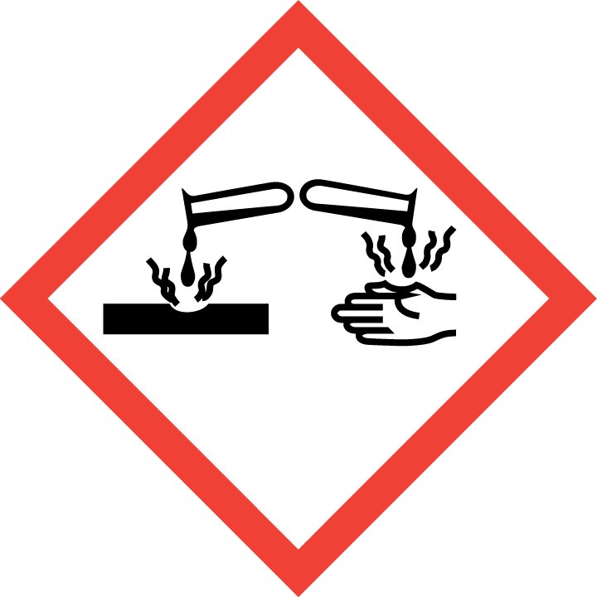GHS irritant pictogram

**Section 3 – Engineering and Personal Protective Equipment (PPE)**

**Engineering Controls:** The use of hydrochloric acid should be conducted in a properly functioning chemical fume hood. The chemical fume hood must be approved and certified by EH&S. Keep container lids tightly closed whenever possible.

**Hygiene Measures:** Avoid contact with skin, eyes, and clothing. Wash hands before breaks and immediately after handling hydrochloric acid.

**Hand Protection:** Chemical-resistant gloves (e.g., nitrile or neoprene) should be worn. **NOTE:** Consult with your preferred glove manufacturer to ensure that the gloves you plan on using are compatible with the specific chemical being used.

**Eye Protection:** ANSI-approved properly fitting safety glasses or chemical splash goggles are required. A face shield must also be worn if hydrochloric acid is being used in large quantities.

**Skin and Body Protection:** Laboratory coats must be worn, appropriately sized for the individual, and buttoned to their full length. A chemical-resistant/rubber apron is also required. Personnel must also wear full length pants, or equivalent, and close-toed shoes. Full length pants and close-toed shoes must be worn at all times by all individuals that are occupying the laboratory area. The area of skin between the shoe and ankle must not be exposed.

**Respiratory Protection:** Respirators should be used as a last line of defense (i.e., after engineering and administrative controls have been exhausted), and when Permissible Exposure Limit (PEL) has been exceeded or when there is a possibility that PEL will be exceeded. If this activity is necessary, contact EH&S at 206.543.7388 so a respiratory protection analysis can be performed.

# **Section 4 – Special Handling and Storage Requirements**

* Do not over purchase; only a minimum amount of hydrochloric acid should be stored in the laboratory.
* Avoid contact with skin and eyes. Avoid inhalation of vapor or mist.
* Always use inside a properly functioning chemical fume hood.
* **Note:** In case you need to dilute the concentration of hydrochloric acid, always add acid to water.
* Keep container upright and tightly closed in acid storage cabinet.
* Keep away from sources of ignition. Avoid heat, sparks, shock or friction when handling.
* Store in original container and inside proper secondary containment. Polypropylene/Nalgene tubs work well.
* Keep away from incompatible materials: Organic Acids, Bases, Amines, Alkali metals, Metals, permanganates, e.g. potassium permanganate, sodium hypochlorite (bleach), Fluorine, metal acetylides, hexalithium disilicide.. As such, hydrochloric acid should be stored away from these chemicals, if possible.

Organic acid

Oxidizing acid

* Use in the smallest practical quantities for the experiment being performed. Make up concentrated solutions in amounts that will be used up in the workshift/day.
* Submit old bottles for Chemical Waste Collection.
* Make a current copy of the SDS for hydrochloric acid available to all personnel working in the laboratory at all times.
* Keep containers closed when not in use.
* Transport all corrosives in secondary containment.

# **Section 5 – Spill and Accident Procedures**

If skin is exposed to hydrochloric acid, remove contaminated clothing and shoes, rinse for 15 minutes in the safety shower. Send someone to call 911 as soon as possible. If eye is exposed to hydrochloric acid, call 911 as soon as possible and flush eyes for 15 minutes in the eye wash, continue rinsing eyes during transport to hospital. If hydrochloric acid is inhaled, remove to fresh air and call 911. Bring Safety Data Sheet (SDS) with you to show medical personnel.

Immediately evacuate area if fumes present a serious health risk and ensure others are aware of the spill. During normal business hours (Monday – Friday, 8 AM – 5 PM), call EH&S at 206.543.0467 for further assistance. If it is after hours, call 911 for further assistance. If it is safe to clean up the spill, wear PPE listed above. Dilute spill with water and use sodium carbonate to neutralize the spill. Clean up neutralized spill with sponges, spill pads or paper towels. Double bag and securely fasten spill materials. Label as hazardous waste. Do not absorb the spill without neutralizing first.

Report the spill via the EH&S Online Accident Reporting System (OARS).

# **Section 6 – Waste Disposal Procedures**

Store waste hydrochloric acid in closed containers that are properly labeled, and in a designated area. The spill materials cannot go in the trash or down the drain. Request chemical waste collection via the EH&S website immediately.

# **Section 7 – Protocol**

Click here to enter text.

**NOTE:** Any deviation from this SOP requires approval from Principal Investigator.

# **Section 8 – Documentation of Training**

Prior to conducting any work with hydrochloric acid, the Principal Investigator must ensure that all laboratory personnel receive training on the content of this SOP.

**I have read and understand the content of this SOP:**

|  |  |  |
| --- | --- | --- |
| **Name** | **Signature** | **Date** |
| **Sam White** |  | **09-30-2025** |
|  |  |  |
|  |  |  |
|  |  |  |
|  |  |  |
|  |  |  |
|  |  |  |
|  |  |  |
|  |  |  |
|  |  |  |