Standard Operating Procedure for sodium hydroxide

sodium hydroxide 1310-73-2

# Section 1 – Lab-Specific Information

**Building/Room(s) covered by this SOP:** **FTR 209/213**

**Unit or department:** **School of Aquatic & Fishery Sciences**

**Principal Investigator Name:** **Steven Roberts**

**Principal Investigator Signature/Date:**

**This SOP was created by (if not PI):** **Sam White/CHO/09-30-2025**

**Name/Title/Date/Signature**

# Section 2 – Hazards

May be corrosive to metals. Causes severe skin burns and eye damage. Harmful to aquatic life.

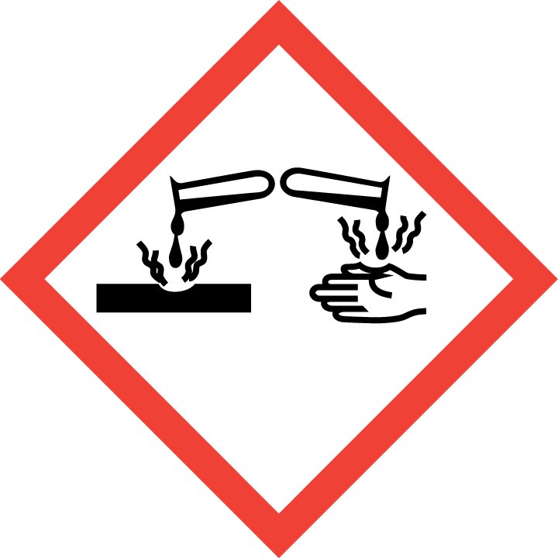

# Section 3 – Engineering Controls and Personal Protective Equipment (PPE)

## Engineering controls

A fume hood is not required for sodium hydroxide.

## Hygiene measures

Wear a laboratory coat, eye protection, and nitrile gloves when working with sodium hydroxide.

Avoid contact with skin, eyes, and clothing. Wash hands after removing PPE, before breaks, and immediately after handling the chemical. If sodium hydroxide come(s) into contact with any PPE, the PPE shall be immediately removed and discarded properly. Any potentially exposed body parts should be washed immediately.

## Skin and body protection

Chemically compatible laboratory coats that fully extend to the wrist must be worn and be appropriately sized for the individual and buttoned to their full length. Personnel must also wear full-length pants, or equivalent, and close-toe shoes. The area of skin between the shoe and ankle must not be exposed.

## Hand protection

Hand protection is required for the activities described in this SOP.

Gloves must be inspected prior to use, including a check for pinholes.

Use proper glove removal technique (without touching glove’s outer surface) to avoid skin contact with this product. Dispose of contaminated gloves after use in accordance with applicable laws and good laboratory practices. Wash and dry hands immediately after glove removal.

## Eye protection

ANSI Z87.1-compliant eye protection is required for all work with sodium hydroxide. Ordinary prescription glasses will NOT provide adequate protection unless they also meet the Z87.1 standard and have compliant side shields.

Safety glasses are minimum required eye protection.

## Respiratory protection

Respiratory protection is not required for the activities described in this SOP.

# Section 4 – Special handling and storage requirements

In general, sodium hydroxide must be stored below eye level. Use [MyChem](https://cspc.admin.uw.edu/mychem), the UW EH&S chemical inventory database, for the most up-to-date information on sodium hydroxide storage. Presently, sodium hydroxide is stored in the corrosives cabinet under the FTR 213 fume hood.

* Clean surfaces upon completion of tasks with water*.*
* Clean all contaminated surfaces with water and dry.
* Place all contaminated disposable items in appropriate laboratory waste for disposal.
* Non‐disposable/re‐usable utensils, glassware, and other surfaces contaminated with sodium hydroxide must be decontaminated at the end of the laboratory work session.
* When work is completed, remove gloves and wash hands with soap and water.

# Section 5 – Spill and accident procedures

REQUIRED - Insert descriptions of any specialized spill clean up procedures for materials used in this SOP, including the procedures for corrosive spill cleanup. Additional details of lab-specific spill cleanup should be provided if applicable.

Chemical spills must be cleaned up as soon as possible by properly protected and trained personnel. All other persons should leave the area.

Clean up spills using contents of the laboratory spill kit: absorbent pads.

Do **not** attempt to clean up any spill if **not** trained or comfortable. Evacuate the area and call 9-1-1 on campus phone for help. If the spill is out of control, call 9-1-1. If a person is injured, exposed or suspected of being exposed, call 9-1-1 and follow the EXPOSURE PROCEDURES (below).

Spill area must be cleaned up in the following manner: clean spill area thoroughly with detergent solution followed by clean water.

Spill cleanup materials must be disposed of in the following manner: double bag all waste in plastic bags labeled with the contents. Submit request to EH&S for pickup.

For questions on spill cleanup, contact EH&S spill consultants at 206‐543‐0467 during normal business hours (Monday-Friday, 8 a.m. to 5 p.m.).

Any spill, exposure or near miss incident requires the involved person or supervisor to complete and submit the [UW Online Accident Reporting System](https://oars.ehs.washington.edu/) (OARS) form on the EH&S website within 24 hours (certain [types of incidents require immediate notification](https://www.ehs.washington.edu/workplace/incident-reporting)).

**Exposures:** If a person is injured, exposed, or suspected of being exposed to sodium hydroxide, follow procedures listed here:

**Perform first aid immediately.**

* **Inhalation exposure**: Move out of contaminated area; get medical help.
* **Sharps injury** (needle stick or subcutaneous exposure): Scrub exposed area thoroughly for 15 minutes using warm water and sudsing soap.
* **Skin exposure:** Use the nearest safety shower for 15 minutes; stay under the shower and remove clothing; use a clean lab coat or spare clothing for cover‐up.
* **Eye exposure:** Use the eye wash for 15 minutes while holding eyelids open.

**Get Help.**

* **Call** 9-1-1 or go to nearest Emergency Department (ED); provide details of exposure:
  + - Agent
    - Dose
    - Route of exposure
    - Time since exposure
* **Bring** **the SDS and this SOP** to the Emergency Department
* **Notify your supervisor** as soon as possible for assistance
* **Secure the area** before leaving; lock doors and indicate spill if needed

**Report the incident to Environmental Health & Safety**.

* **Notify** **EH&S immediately** after providing first aid and/or getting help.
  + During business hours (M‐F/8‐5), call 206‐543‐7262.
  + Outside of business hours, call 206‐685‐UWPD (8973) to be routed to EH&S Staff On Call.
* Any spill, exposure or near miss incident requires the involved person or supervisor to complete and submit the [UW Online Accident Reporting System](https://oars.ehs.washington.edu/) (OARS) form on the EH&S website within 24 hours (certain [types of incidents require immediate notification](https://www.ehs.washington.edu/workplace/incident-reporting)).

# Section 6 – Waste accumulation and disposal procedure

**Accumulate waste at the point of generation** in a sturdy, [compatible container], with a securely-closable/screw‐top lid.

**All chemical waste containers must be labeled** with a [UW Hazardous Waste Label](https://www.ehs.washington.edu/chemical/hazardous-chemical-waste-disposal). Refer to [How to Label Chemical Waste Containers](https://www.ehs.washington.edu/system/files/resources/how-to-label-chemical-waste-containers.pdf).

To request a collection of chemical waste, submit a form on the [Chemical Waste Disposal](https://www.ehs.washington.edu/chemical/hazardous-chemical-waste-disposal) webpage on the EH&S website or directly in [MyChem](https://www.ehs.washington.edu/chemical/mychem) inventory. Contact EH&S at 206.616.5835 or [chmwaste@uw.edu](mailto:chmwaste@uw.edu) with questions.

Work area decontamination procedures as appropriate for the chemical in use should be followed.

# Section 7 – Protocol

**NOTE:** Any deviation from this SOP requires approval from Principal Investigator.

# Section 8 – Special Precautions for animal use (Yes No)

**N/A**

[**PARTICULARLY HAZARDOUS SUBSTANCE**](https://www.ehs.washington.edu/resource/particularly-hazardous-substances-655) **INVOLVED?**

**YES: Sections #9 to #11 are Mandatory.**

**NO: Sections #9 to #11 are Optional.**

# Section 9 – Approvals required

All staff working with sodium hydroxide must be trained on this SOP prior to starting work. They must also review the SDS, and it must be readily available in the laboratory. All training must be documented and maintained by the PI or their designee.

# Section 10 – Decontamination

# Section 11 – Designated area

# Section 12 – Documentation of training

* Prior to using substances included in this SOP, laboratory personnel must be trained on the hazards described in this SOP, how to protect themselves from the hazards, and emergency procedures.
* Ready access to this SOP and to a Safety Data Sheet for each hazardous material described in the SOP must be made available in the lab space(s) where these substances are used.
* The Principal Investigator (PI), or Responsible Party, if the activity does not involve a PI, must ensure that their laboratory personnel have attended appropriate laboratory safety training (and refresher training where applicable).
* Training must be repeated following **any** revision to the content of this SOP.
* Training must be documented. This training sheet is provided as one option; other forms of training documentation (including electronic) are acceptable but records must be accessible and immediately available upon request.

**I have read and understand the content of this SOP:**

| **Name** | **Signature** | **Date** |
| --- | --- | --- |
| **Sam White** |  | **09-30-2025** |
|  |  |  |
|  |  |  |
|  |  |  |
|  |  |  |
|  |  |  |
|  |  |  |
|  |  |  |
|  |  |  |
|  |  |  |
|  |  |  |
|  |  |  |