Probando la Orange Pi

Un proyecto de BricoLabs

Luis Llamas [lfllamas93@gmail.com](mailto:lfllamas93@gmail.com)

Sergio Alvariño [salvari@gmail.com](mailto:salvari@gmail.com)

diciembre-2016

Probando la Orange Pi y aprendiendo a usarla.

TRABAJO EN CURSO NO TERMINADO

# Empezar rápido desde linux

Para usar la Orange Pi Zero tendremos que crear imágenes arrancables en tarjetas micro SD.

## Crear una SD arrancable

Dependiendo de donde conectemos la tarjeta tendremos que usar diferentes rutas. En el procedimiento descrito a continuación ${card} será la ruta al dispositivo de la tarjeta y ${p} la partición (si la hay).

Si la tarjeta se conecta via adaptador USB, linux la va a asociar a un dispositivo /dev/sdx, por ejemplo en mi portátil el disco duro es /dev/sda las distintas particiones serán /dev/sda1, /devb/sda2, etc.

Si conectamos una memoria con un adaptador USB linux la podría mapear en /dev/sdb por ejemplo.

Si la memoria se conecta mediante una ranura SD, linux la asociará a un dispositivo /dev/mmcblk0 o /dev/mmcblk1, etc. etc. Dependerá de la ranura usada. Las particiones en este tipo de dispositivos tienen rutas como por ejemplo /dev/mmcblk0p1.

Los datos se pueden almacenar directamente en la memoria SD o en una partición creada en la memoria.

Resumiendo:

* ${card} será /dev/sdb o /dev/mmcblk0
* $card$ {p} será /dev/sdb1 o /dev/mmcblk0p1

Antes de seguir adelante hay que estar completamente seguro del dispositivo asociado a nuestra memoria SD para no armar ningún estropicio.

Hay varias comprobaciones que se pueden hacer:

dmesg |tail nos permitirá echar un ojo a los últimos mensajes en el log del sistema. Si acabamos de insertar la memoria veremos el dispositivo usado.

sudo fdisk -l nos permite ver las particiones montadas en nuestro linux, por ejemplo con mi SD en la ranura SD de mi portatil la salida es (entre otras cosas, he obviado las particiones de los discos duros):

Disk /dev/mmcblk0: 7.4 GiB, 7948206080 bytes, 15523840 sectors  
Units: sectors of 1 * 512 = 512 bytes  
Sector size (logical/physical): 512 bytes / 512 bytes  
I/O size (minimum/optimal): 512 bytes / 512 bytes  
Disklabel type: dos  
Disk identifier: 0x00000000

cat /proc/partitions también nos dará una lista de particiones, en mi portátil las que interesan son:

179 0 7761920 mmcblk0  
 179 1 7757824 mmcblk0p1

Descargamos la imagen de Jessie adaptada a la *Orange Pi Zero* desde la página <https://www.armbian.com/download/>

Descomprimimos la imagen y la grabamos en la tarjeta SD con el comando:

sudo dd if=./Armbian_5.24_Orangepizero_Debian_jessie_3.4.113.img of=/dev/mmcblk0

Insertamos la tarjeta en la *Orange Pi* y le damos alimentación. El primer arranque llevará alrededor de tres minutos, y tras ese tiempo aun hará falta un minuto más para poder hacer login. Este retardo es debido a que el sistema intentará actualizar la lista de paquetes y creará un area de swap de emergencia en la SD, y además cambiará el tamaño de la partición que hemos creado para ocupar todo el espacio libre en la SD.

De momento solo la he arrancado y efectivamente las particiones han cambiado tras el arranque así que tiene buena pinta.

Volvemos a insertar la SD en la *Orange Pi* y la conectamos con un cable ethernet al router de casa. El Armbian viene configurado por defecto para obtener su IP desde un servidor DHCP.

Como mi cutre-router no me da información de las IP asignadas usamos *nmap*:

nmap -sP 192.168.0.0 /24

Con eso averiguamos la IP asignada a la *Orange Pi Zero* y ya podemos hacer login con el siguiente comando [1]:

ssh root@192.168.0.109

¡Y ya estamos!

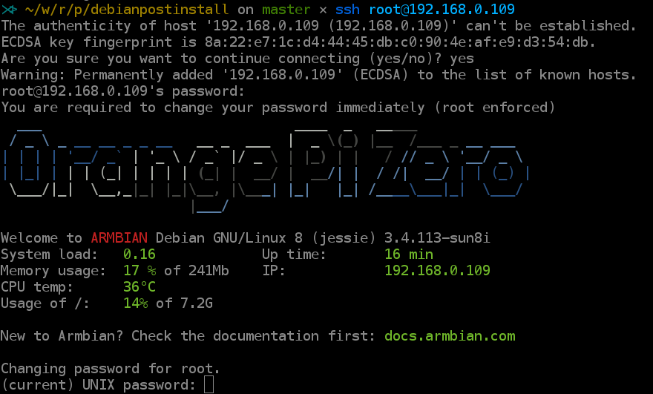

Primer login en *Orange Pi*

Lo primero es poner al dia el sistema:

apt-get update  
apt-get upgrade

Si quieres puedes reconfigurar el *time zone*:

dpgk-reconfigura tzdata

## Conexión WIFI

Vamos a comprobar que todo va bien:

root@orangepizero:~# iwconfig  
lo no wireless extensions.  
  
tunl0 no wireless extensions.  
  
wlan0 IEEE 802.11bgn ESSID:off/any  
 Mode:Managed Access Point: Not-Associated Tx-Power=20 dBm  
 Retry long limit:7 RTS thr:off Fragment thr:off  
 Encryption key:off  
 Power Management:on  
  
eth0 no wireless extensions.

Todo tiene buena pinta, vamos a ver si detecta WIFIs:

root@orangepizero:~# iwlist wlan0 scan |grep ESSID  
 ESSID:"wificlientesR"  
 ESSID:"casa_de_verano"  
 ESSID:"MOVISTAR_BEEF"  
 ESSID:"wificlientesR"  
 ESSID:"R-wlan90"  
 ESSID:"MOVISTAR_BAAF"  
 ESSID:"ababab"  
 ESSID:"WLAN 77"  
 ESSID:"castillo"  
 ESSID:"unaWifi"  
 ESSID:""  
 ESSID:"mikasa"

Para configurar el wifi echamos un ojo al fichero /etc/network/interfaces pero en ese mismo fichero encontramos el aviso:

# Armbian ships with network-manager installed by default. To save you time  
# and hassles consider using 'sudo nmtui' instead of configuring Wi-Fi settings  
# manually.

Así que basta con ejecutar sudo nwtui y ya podemos dar de alta nuestra wifi (yo la prefiero con IP estática).

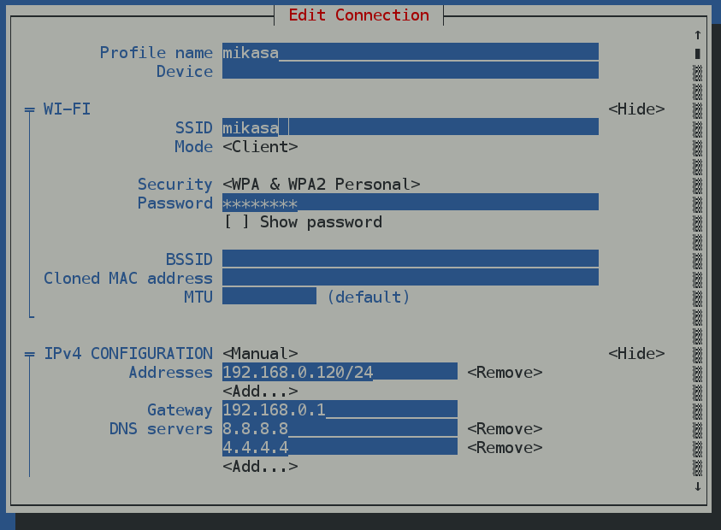

Configuración WIFI

Ejecutamos ifconfig y ya vemos nuestro nuevo interface configurado:

ifconfig  
  
wlan0 Link encap:Ethernet HWaddr a4:7c:f2:9a:97:7c  
 inet addr:192.168.0.120 Bcast:192.168.0.255 Mask:255.255.255.0  
 inet6 addr: fe80::a67c:f2ff:fe9a:977c/64 Scope:Link  
 UP BROADCAST RUNNING MULTICAST MTU:1500 Metric:1  
 RX packets:2 errors:0 dropped:0 overruns:0 frame:0  
 TX packets:8 errors:0 dropped:0 overruns:0 carrier:0  
 collisions:0 txqueuelen:1000  
 RX bytes:328 (328.0 B) TX bytes:852 (852.0 B)

# Orange Pi Zero, características técnicas

La tarjeta de desarrollo Orange Pi Zero viene equipada con un procesador Cortex A7 Allwinner H2+ quad core, con 256 o 512MB RAM, Ethernet, y puertos USB. Disponible en Aliexpress (tienda oficial) por 6.99 dolares, mas 3.39 dolares como gastos de envío.

## Especificaciones

* SoC – Allwinner H2(+) quad core Cortex A7 processor @ 1.2 GHz with Mali-400MP2 GPU @ 600 MHz
* System Memory – 256 to 512 MB DDR3-1866 SDRAM
* Storage – micro SD card slot
* Connectivity – 10/100M Ethernet + 802.11 b/g/n WiFi (Allwinner XR819 WiFi module) with u.FL antenna connector and external antenna
* USB – 1x USB 2.0 host ports, 1x micro USB OTG port
* Expansion headers – Unpopulated 26-pin “Raspberry Pi B+” header + 13-pin header with headphone, 2x USB 2.0, TV out, microphone and IR receiver signals
* Debugging – Unpopulated 3-pin header for serial console
* Misc – 2x LEDs
* Power Supply – 5V via micro USB port or optional PoE
* Dimensions – 52 x 46 mm
* Weight – 26 grams

## Esquema de pines

Un excelente esquema de pines puede conseguirse en [OSHLab](https://oshlab.com/orange-pi-zero-pinout/)

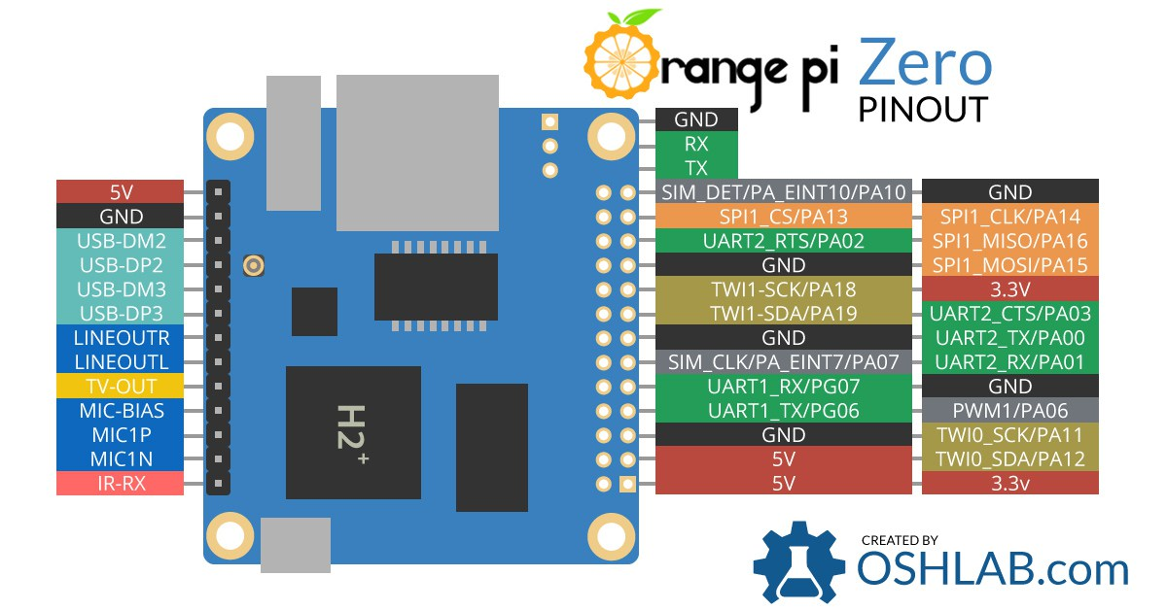

Pineado Orange Pi

## Esquemas eléctricos

Pueden bajarse de [aquí](http://harald.studiokubota.com/wordpress/wp-content/uploads/2016/11/Orange-Pi-Zero-Schanetics-v1_11.pdf)

# Accediendo al hardware desde linea de comandos

La memoria es más que suficiente para correr programas. El Armbian consume únicamente 40Mb en funcionamiento.

root@orangepizero:~# free  
 total used free shared buffers cached  
Mem: 247068 122300 124768 4620 7908 69548  
-/+ buffers/cache: 44844 202224  
Swap: 131068 0 131068

Vamos a hacer algunas pruebas con el hardware. En Armbian, como todo Unix que se precie, todo es un fichero.

En el directorio /sys/class encontraremos cosas interesantes:

root@orangepizero:~# ls /sys/class  
backlight cuse graphics i2c-dev mdio_bus power_supply script spidev thermal video4linux  
bdi devfreq hdmi ieee80211 mem ppp scsi_device spi_master tty vtconsole  
block disp hidraw input misc rc scsi_disk sunxi_cma_test udc  
bsg dma hwmon leds mmc_host rfkill scsi_host sunxi_dump usb_device  
cedar_dev gpio i2c-adapter lirc net rtc sound sunxi_info vc

## LEDs

Si miramos dentro del directorio leds veremos que hay un directorio que representa cada uno de los leds de la placa:

root@orangepizero:~# cd /sys/class/leds/  
root@orangepizero:/sys/class/leds# ls  
green_led red_led

Podemos ver, por ejemplo, a que evento está asociado cada led ejecutando cat green_led/trigger (tiene el valor default_on) o cat red_led/trigger (tiene el valor none).

root@orangepizero:/sys/class/leds# cat green_led/trigger   
none mmc0 mmc1 timer heartbeat backlight [default-on] rfkill0 phy1rx phy1tx phy1assoc phy1radio   
root@orangepizero:/sys/class/leds# cat red_led/trigger   
[none] mmc0 mmc1 timer heartbeat backlight default-on rfkill0 phy1rx phy1tx phy1assoc phy1radio

O podemos encender el led rojo ejecutando echo 1 > red_led/brightness, y para apagarlo ya os podéis imaginar que es echo 0 > red_led/brightness.

## GPIO

Podemos ver los GPIO disponibles ejecutando:

root@orangepizero:~# cat /sys/kernel/debug/gpio  
GPIOs 0-383, platform/sunxi-pinctrl, sunxi-pinctrl:  
 gpio-10 (? ) out hi  
 gpio-17 (red_led ) out lo  
 gpio-202 (xradio_irq ) in lo  
 gpio-354 (? ) out hi  
 gpio-362 (green_led ) out hi

Podemos activar un nuevo puerto GPIO, digamos el 15:

root@orangepizero:~# echo 15 >/sys/class/gpio/export

Ahora veremos el puerto activo:

root@orangepizero:~# cat /sys/kernel/debug/gpio   
GPIOs 0-383, platform/sunxi-pinctrl, sunxi-pinctrl:  
 gpio-10 (? ) out hi  
 gpio-15 (sysfs ) in lo  
 gpio-17 (red_led ) out lo  
 gpio-202 (xradio_irq ) in lo  
 gpio-354 (? ) out hi  
 gpio-362 (green_led ) out hi

En el directorio /sys/class/gpio/gpio15/ tendremos los interfaces usuales para puertos gpio definidos en el kernel de linux.

# Bibliotecas útiles

## Python

### Instalación de virtualenv

Para probar bibliotecas de Python instalamos:

sudo aptitude install python-pip  
sudo aptitude install python-virtualenv  
sudo aptitude install python-dev

El caso es que el virtualenv no me funciona después de ejecutar estos pasos. Finalmente he tenido que ejecutar, como *root*, los siguientes comandos:

pip install --upgrade pip  
pip install --upgrade virtualenv

Despues de eso ya he podido usar *virtualenv* sin problemas.

### orangepi_PC_gpio_pyH3

Nos clonamos el repo. Voy a hacer todas las pruebas desde la cuenta de **root**.

git clone https://github.com/duxingkei33/orangepi_PC_gpio_pyH3

Hay que cambiar el fichero orangepi_PC_gpio_pyH3/pyA20/gpio/mapping.h

La definicion de *STATUS_LED* debe quedar en el *GPA17* en lugar de *GPA15*:

{ "STATUS_LED", SUNXI_GPA(17), 2 },

Creamos un entorno para pruebas y lo activamos:

virtualenv test_A  
source test_A/bin/activate

Compilamos la biblioteca:

cd orangepi_PC_gpio_pyH3  
python setup.py install

Y ya podemos probar los ficheros de ejemplo.

### Acceso desde C

La biblioteca de Python *orangepi_PC_gpio_pyH3*, en realidad se basa en bibliotecas escritas en C que tenemos disponibles dentro del repo en el directorio *pyA20*

cd pyA20  
ls  
gpio/ i2c/ __init__.py spi/ utilities/

Nos interesa probar las bibliotecas en los directorios *gpio* e *i2c*, al menos de momento. Serían *gpio_lib* e *i2c_lib* respectivamente.

Probamos el acceso al *gpio* desde C con un programa sencillo que nos haga encender y apagar el led de la OPI.

sunxi_gpio_init();  
sunxi_gpio_set_cfgpin(SUNXI_GPA(17), SUNXI_GPIO_OUTPUT);  
while(1) {  
 sunxi_gpio_output(SUNXI_GPA(17), 1);  
 sleep(1);  
 sunxi_gpio_output(SUNXI_GPA(17), 0);  
 sleep(1);  
}

## Referencias

* [Probando la Orange Pi Zero](http://harald.studiokubota.com/wordpress/index.php/2016/11/19/orange-pi-zero-neat/)
* [GPIO from commandline](http://falsinsoft.blogspot.com.es/2012/11/access-gpio-from-linux-user-space.html)
* [mas de lo mismo](http://www.emcraft.com/stm32f429discovery/controlling-gpio-from-linux-user-space)
* [hilo GPIO en foro](https://forum.armbian.com/index.php/topic/3084-orange-pi-zero-python-gpio-library/)
* [WiringPi_OrangePi explicación lanefu](https://gist.github.com/lanefu/f16a67195c9fa35c466c6b50cdaeadea)
* [El repo donde pretende unificar WiringPI](https://github.com/lanefu/WiringOtherPi)
* [Otro Repo mas](https://github.com/lanefu/WiringPi-Python-OP)
* [Otro mas, este tio no para](https://gist.github.com/lanefu/f16a67195c9fa35c466c6b50cdaeadea)
* [Hilo en el foro hablando de unificiación de bibliotecas](https://forum.armbian.com/index.php/topic/2956-559-gpio-support-for-h2h3-boards-with-a-unified-wiringpi-library-in-a-neat-little-package/#entry20311)
* [Otro hilo](https://forum.armbian.com/index.php/topic/3084-orange-pi-zero-python-gpio-library/?hl=%2Bzero+%2Bgpio+%2Blibrary)
* [Otro hilo más con I2C SPI](https://forum.armbian.com/index.php/topic/3084-orange-pi-zero-python-gpio-library/)

# Monitorizar temperatura

Podemos ver estadísticas de nuestra OPI con:

sudo armbianmonitor -m  
  
Stop monitoring using [ctrl]-[c]  
Time CPU load %cpu %sys %usr %nice %io %irq CPU  
21:04:18: 1152MHz 0.08 0% 0% 0% 0% 0% 0% 40°C  
21:04:23: 240MHz 0.07 0% 0% 0% 0% 0% 0% 39°C  
21:04:28: 240MHz 0.15 6% 1% 0% 0% 4% 0% 40°C  
21:04:33: 240MHz 0.12 6% 1% 0% 0% 4% 0% 38°C  
21:04:38: 240MHz 0.11 2% 1% 0% 0% 0% 0% 39°C  
21:04:43: 240MHz 0.11 1% 0% 0% 0% 0% 0% 39°C  
21:04:49: 240MHz 0.10 1% 0% 0% 0% 0% 0% 38°C  
21:04:54: 240MHz 0.09 1% 0% 0% 0% 0% 0% 39°C  
21:04:59: 240MHz 0.08 2% 1% 0% 0% 0% 0% 38°C  
21:05:04: 240MHz 0.08 2% 1% 0% 0% 0% 0% 38°C  
21:05:10: 240MHz 0.07 2% 1% 0% 0% 0% 0% 40°C  
21:05:15: 240MHz 0.06 2% 1% 0% 0% 0% 0% 37°C  
21:05:20: 240MHz 0.06 2% 1% 0% 0% 0% 0% 39°C  
21:05:25: 240MHz 0.05 2% 1% 0% 0% 0% 0% 37°C  
21:05:30: 240MHz 0.05 2% 1% 0% 0% 0% 0% 39°C

También podemos instalar RPi-Monitor con el comando:

sudo armbianmonitor -r

Una vez instalado podemos visitar desde nuestro navegador la dirección ip de nuestra OPI Zero *http://opi-adress:8888* para ver las estadísticas.

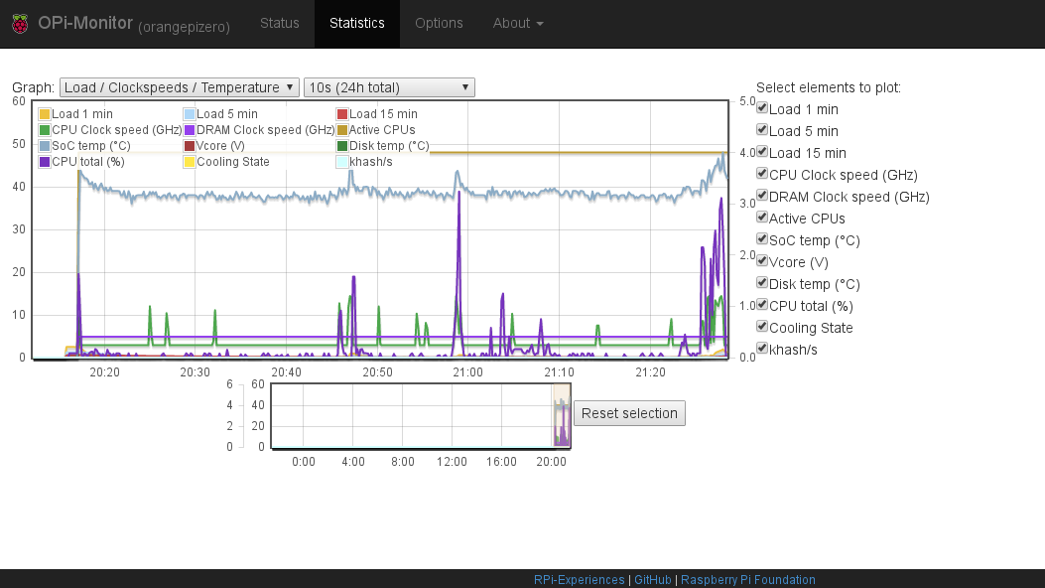

Estadísticas en RPi-Monitor

¡Ojo! Las gráficas no se refrescan automáticamente hay que recargar la página.

Para desinstalar el RPi-Monitor basta con:

sudo aptitude uninstall rpimonitor

# Referencias

* [Página oficial](http://www.orangepi.org/)
* [Recursos oficiales](http://www.orangepi.org/downloadresources/) aquí hay imágenes y los esquemáticos
* [Tienda en Aliexpress](https://www.aliexpress.com/store/1553371?spm=2114.8147860.0.0.F1q43C)
* <http://linux-sunxi.org/Bootable_SD_card>
* <https://www.armbian.com/orange-pi-zero/>
* <https://docs.armbian.com/User-Guide_Getting-Started/>
* <https://docs.armbian.com/Hardware_Allwinner/>
* [GPIO](https://linux-sunxi.org/GPIO) Una explicación de como acceder al gpio desde terminal
* [Info variada](https://linux-sunxi.org/Orange_Pi_Zero) Aquí tenemos el esquema de pines
* [GPIO desde el espacio de usuario](https://forum.armbian.com/index.php/topic/1886-gpio-access-from-user-space/)
* [sunxi-gpio](https://forum.armbian.com/index.php/topic/1471-solved-difficulty-accessing-gpio-via-the-sunxi-gpio-export-interface/)
* [orange pi español](http://orangepiweb.es/index.php)
* [ArchLinux ARM on Orange Pi](https://www.amedeobaragiola.me/blog/2016/06/04/archlinux-arm-on-orange-pi-one/)
* [Lakka Nightly Builds](http://mirror.lakka.tv/nightly/) Lakka is the official Linux distribution of RetroArch and the libretro ecosystem. Each game system is implemented as a libretro core, while the frontend RetroArch takes care of inputs and display. This clear separation ensures modularity and centralized configuration. Also nightly build for H3 is supported

# META

Este documento está escrito en [Markdown-Pandoc](http://pandoc.org/README.html). Pandoc es un sistema muy sencillo de documentación que permite generar múltiples formatos de salida.

Las fuentes del documento están en el directorio **doc/src** dentro del árbol de directorios del proyecto.

Los formatos de salida son el fichero **README.md** en formato *Markdown-Github* y los documentos que puedes encontrar en el directorio **doc/out** incluyendo un fichero en formato *pdf*.

Los documentos en los distintos formatos de salida se generan automáticamente sin mas que ejecutar:

$ cd doc  
$ make

Otras opciones que soporta el **makefile** serían:

reset

para regenerar todos los documentos de salida.

clean

para borrar todos los fichero de salida

pdf, latex, mediawiki, epub, odt, docx

genera el fichero de salida en el formato especificado: pdf, latex, etc. etc.

Ejemplos:

$ make reset  
$ make odt

## Requisitos

Necesitas tener instalaco **Pandoc**, hay [una pequeña introducción](https://github.com/brico-labs/pandoc_basico) en el el github de BricoLabs.

# Licencia

Attribution-ShareAlike 4.0 International  
  
=======================================================================  
  
Creative Commons Corporation ("Creative Commons") is not a law firm and  
does not provide legal services or legal advice. Distribution of  
Creative Commons public licenses does not create a lawyer-client or  
other relationship. Creative Commons makes its licenses and related  
information available on an "as-is" basis. Creative Commons gives no  
warranties regarding its licenses, any material licensed under their  
terms and conditions, or any related information. Creative Commons  
disclaims all liability for damages resulting from their use to the  
fullest extent possible.  
  
Using Creative Commons Public Licenses  
  
Creative Commons public licenses provide a standard set of terms and  
conditions that creators and other rights holders may use to share  
original works of authorship and other material subject to copyright  
and certain other rights specified in the public license below. The  
following considerations are for informational purposes only, are not  
exhaustive, and do not form part of our licenses.  
  
 Considerations for licensors: Our public licenses are  
 intended for use by those authorized to give the public  
 permission to use material in ways otherwise restricted by  
 copyright and certain other rights. Our licenses are  
 irrevocable. Licensors should read and understand the terms  
 and conditions of the license they choose before applying it.  
 Licensors should also secure all rights necessary before  
 applying our licenses so that the public can reuse the  
 material as expected. Licensors should clearly mark any  
 material not subject to the license. This includes other CC-  
 licensed material, or material used under an exception or  
 limitation to copyright. More considerations for licensors:  
 wiki.creativecommons.org/Considerations_for_licensors  
  
 Considerations for the public: By using one of our public  
 licenses, a licensor grants the public permission to use the  
 licensed material under specified terms and conditions. If  
 the licensor's permission is not necessary for any reason--for  
 example, because of any applicable exception or limitation to  
 copyright--then that use is not regulated by the license. Our  
 licenses grant only permissions under copyright and certain  
 other rights that a licensor has authority to grant. Use of  
 the licensed material may still be restricted for other  
 reasons, including because others have copyright or other  
 rights in the material. A licensor may make special requests,  
 such as asking that all changes be marked or described.  
 Although not required by our licenses, you are encouraged to  
 respect those requests where reasonable. More_considerations  
 for the public:   
 wiki.creativecommons.org/Considerations_for_licensees  
  
=======================================================================  
  
Creative Commons Attribution-ShareAlike 4.0 International Public  
License  
  
By exercising the Licensed Rights (defined below), You accept and agree  
to be bound by the terms and conditions of this Creative Commons  
Attribution-ShareAlike 4.0 International Public License ("Public  
License"). To the extent this Public License may be interpreted as a  
contract, You are granted the Licensed Rights in consideration of Your  
acceptance of these terms and conditions, and the Licensor grants You  
such rights in consideration of benefits the Licensor receives from  
making the Licensed Material available under these terms and  
conditions.  
  
  
Section 1 -- Definitions.  
  
 a. Adapted Material means material subject to Copyright and Similar  
 Rights that is derived from or based upon the Licensed Material  
 and in which the Licensed Material is translated, altered,  
 arranged, transformed, or otherwise modified in a manner requiring  
 permission under the Copyright and Similar Rights held by the  
 Licensor. For purposes of this Public License, where the Licensed  
 Material is a musical work, performance, or sound recording,  
 Adapted Material is always produced where the Licensed Material is  
 synched in timed relation with a moving image.  
  
 b. Adapter's License means the license You apply to Your Copyright  
 and Similar Rights in Your contributions to Adapted Material in  
 accordance with the terms and conditions of this Public License.  
  
 c. BY-SA Compatible License means a license listed at  
 creativecommons.org/compatiblelicenses, approved by Creative  
 Commons as essentially the equivalent of this Public License.  
  
 d. Copyright and Similar Rights means copyright and/or similar rights  
 closely related to copyright including, without limitation,  
 performance, broadcast, sound recording, and Sui Generis Database  
 Rights, without regard to how the rights are labeled or  
 categorized. For purposes of this Public License, the rights  
 specified in Section 2(b)(1)-(2) are not Copyright and Similar  
 Rights.  
  
 e. Effective Technological Measures means those measures that, in the  
 absence of proper authority, may not be circumvented under laws  
 fulfilling obligations under Article 11 of the WIPO Copyright  
 Treaty adopted on December 20, 1996, and/or similar international  
 agreements.  
  
 f. Exceptions and Limitations means fair use, fair dealing, and/or  
 any other exception or limitation to Copyright and Similar Rights  
 that applies to Your use of the Licensed Material.  
  
 g. License Elements means the license attributes listed in the name  
 of a Creative Commons Public License. The License Elements of this  
 Public License are Attribution and ShareAlike.  
  
 h. Licensed Material means the artistic or literary work, database,  
 or other material to which the Licensor applied this Public  
 License.  
  
 i. Licensed Rights means the rights granted to You subject to the  
 terms and conditions of this Public License, which are limited to  
 all Copyright and Similar Rights that apply to Your use of the  
 Licensed Material and that the Licensor has authority to license.  
  
 j. Licensor means the individual(s) or entity(ies) granting rights  
 under this Public License.  
  
 k. Share means to provide material to the public by any means or  
 process that requires permission under the Licensed Rights, such  
 as reproduction, public display, public performance, distribution,  
 dissemination, communication, or importation, and to make material  
 available to the public including in ways that members of the  
 public may access the material from a place and at a time  
 individually chosen by them.  
  
 l. Sui Generis Database Rights means rights other than copyright  
 resulting from Directive 96/9/EC of the European Parliament and of  
 the Council of 11 March 1996 on the legal protection of databases,  
 as amended and/or succeeded, as well as other essentially  
 equivalent rights anywhere in the world.  
  
 m. You means the individual or entity exercising the Licensed Rights  
 under this Public License. Your has a corresponding meaning.  
  
  
Section 2 -- Scope.  
  
 a. License grant.  
  
 1. Subject to the terms and conditions of this Public License,  
 the Licensor hereby grants You a worldwide, royalty-free,  
 non-sublicensable, non-exclusive, irrevocable license to  
 exercise the Licensed Rights in the Licensed Material to:  
  
 a. reproduce and Share the Licensed Material, in whole or  
 in part; and  
  
 b. produce, reproduce, and Share Adapted Material.  
  
 2. Exceptions and Limitations. For the avoidance of doubt, where  
 Exceptions and Limitations apply to Your use, this Public  
 License does not apply, and You do not need to comply with  
 its terms and conditions.  
  
 3. Term. The term of this Public License is specified in Section  
 6(a).  
  
 4. Media and formats; technical modifications allowed. The  
 Licensor authorizes You to exercise the Licensed Rights in  
 all media and formats whether now known or hereafter created,  
 and to make technical modifications necessary to do so. The  
 Licensor waives and/or agrees not to assert any right or  
 authority to forbid You from making technical modifications  
 necessary to exercise the Licensed Rights, including  
 technical modifications necessary to circumvent Effective  
 Technological Measures. For purposes of this Public License,  
 simply making modifications authorized by this Section 2(a)  
 (4) never produces Adapted Material.  
  
 5. Downstream recipients.  
  
 a. Offer from the Licensor -- Licensed Material. Every  
 recipient of the Licensed Material automatically  
 receives an offer from the Licensor to exercise the  
 Licensed Rights under the terms and conditions of this  
 Public License.  
  
 b. Additional offer from the Licensor -- Adapted Material.  
 Every recipient of Adapted Material from You  
 automatically receives an offer from the Licensor to  
 exercise the Licensed Rights in the Adapted Material  
 under the conditions of the Adapter's License You apply.  
  
 c. No downstream restrictions. You may not offer or impose  
 any additional or different terms or conditions on, or  
 apply any Effective Technological Measures to, the  
 Licensed Material if doing so restricts exercise of the  
 Licensed Rights by any recipient of the Licensed  
 Material.  
  
 6. No endorsement. Nothing in this Public License constitutes or  
 may be construed as permission to assert or imply that You  
 are, or that Your use of the Licensed Material is, connected  
 with, or sponsored, endorsed, or granted official status by,  
 the Licensor or others designated to receive attribution as  
 provided in Section 3(a)(1)(A)(i).  
  
 b. Other rights.  
  
 1. Moral rights, such as the right of integrity, are not  
 licensed under this Public License, nor are publicity,  
 privacy, and/or other similar personality rights; however, to  
 the extent possible, the Licensor waives and/or agrees not to  
 assert any such rights held by the Licensor to the limited  
 extent necessary to allow You to exercise the Licensed  
 Rights, but not otherwise.  
  
 2. Patent and trademark rights are not licensed under this  
 Public License.  
  
 3. To the extent possible, the Licensor waives any right to  
 collect royalties from You for the exercise of the Licensed  
 Rights, whether directly or through a collecting society  
 under any voluntary or waivable statutory or compulsory  
 licensing scheme. In all other cases the Licensor expressly  
 reserves any right to collect such royalties.  
  
  
Section 3 -- License Conditions.  
  
Your exercise of the Licensed Rights is expressly made subject to the  
following conditions.  
  
 a. Attribution.  
  
 1. If You Share the Licensed Material (including in modified  
 form), You must:  
  
 a. retain the following if it is supplied by the Licensor  
 with the Licensed Material:  
  
 i. identification of the creator(s) of the Licensed  
 Material and any others designated to receive  
 attribution, in any reasonable manner requested by  
 the Licensor (including by pseudonym if  
 designated);  
  
 ii. a copyright notice;  
  
 iii. a notice that refers to this Public License;  
  
 iv. a notice that refers to the disclaimer of  
 warranties;  
  
 v. a URI or hyperlink to the Licensed Material to the  
 extent reasonably practicable;  
  
 b. indicate if You modified the Licensed Material and  
 retain an indication of any previous modifications; and  
  
 c. indicate the Licensed Material is licensed under this  
 Public License, and include the text of, or the URI or  
 hyperlink to, this Public License.  
  
 2. You may satisfy the conditions in Section 3(a)(1) in any  
 reasonable manner based on the medium, means, and context in  
 which You Share the Licensed Material. For example, it may be  
 reasonable to satisfy the conditions by providing a URI or  
 hyperlink to a resource that includes the required  
 information.  
  
 3. If requested by the Licensor, You must remove any of the  
 information required by Section 3(a)(1)(A) to the extent  
 reasonably practicable.  
  
 b. ShareAlike.  
  
 In addition to the conditions in Section 3(a), if You Share  
 Adapted Material You produce, the following conditions also apply.  
  
 1. The Adapter's License You apply must be a Creative Commons  
 license with the same License Elements, this version or  
 later, or a BY-SA Compatible License.  
  
 2. You must include the text of, or the URI or hyperlink to, the  
 Adapter's License You apply. You may satisfy this condition  
 in any reasonable manner based on the medium, means, and  
 context in which You Share Adapted Material.  
  
 3. You may not offer or impose any additional or different terms  
 or conditions on, or apply any Effective Technological  
 Measures to, Adapted Material that restrict exercise of the  
 rights granted under the Adapter's License You apply.  
  
  
Section 4 -- Sui Generis Database Rights.  
  
Where the Licensed Rights include Sui Generis Database Rights that  
apply to Your use of the Licensed Material:  
  
 a. for the avoidance of doubt, Section 2(a)(1) grants You the right  
 to extract, reuse, reproduce, and Share all or a substantial  
 portion of the contents of the database;  
  
 b. if You include all or a substantial portion of the database  
 contents in a database in which You have Sui Generis Database  
 Rights, then the database in which You have Sui Generis Database  
 Rights (but not its individual contents) is Adapted Material,  
  
 including for purposes of Section 3(b); and  
 c. You must comply with the conditions in Section 3(a) if You Share  
 all or a substantial portion of the contents of the database.  
  
For the avoidance of doubt, this Section 4 supplements and does not  
replace Your obligations under this Public License where the Licensed  
Rights include other Copyright and Similar Rights.  
  
  
Section 5 -- Disclaimer of Warranties and Limitation of Liability.  
  
 a. UNLESS OTHERWISE SEPARATELY UNDERTAKEN BY THE LICENSOR, TO THE  
 EXTENT POSSIBLE, THE LICENSOR OFFERS THE LICENSED MATERIAL AS-IS  
 AND AS-AVAILABLE, AND MAKES NO REPRESENTATIONS OR WARRANTIES OF  
 ANY KIND CONCERNING THE LICENSED MATERIAL, WHETHER EXPRESS,  
 IMPLIED, STATUTORY, OR OTHER. THIS INCLUDES, WITHOUT LIMITATION,  
 WARRANTIES OF TITLE, MERCHANTABILITY, FITNESS FOR A PARTICULAR  
 PURPOSE, NON-INFRINGEMENT, ABSENCE OF LATENT OR OTHER DEFECTS,  
 ACCURACY, OR THE PRESENCE OR ABSENCE OF ERRORS, WHETHER OR NOT  
 KNOWN OR DISCOVERABLE. WHERE DISCLAIMERS OF WARRANTIES ARE NOT  
 ALLOWED IN FULL OR IN PART, THIS DISCLAIMER MAY NOT APPLY TO YOU.  
  
 b. TO THE EXTENT POSSIBLE, IN NO EVENT WILL THE LICENSOR BE LIABLE  
 TO YOU ON ANY LEGAL THEORY (INCLUDING, WITHOUT LIMITATION,  
 NEGLIGENCE) OR OTHERWISE FOR ANY DIRECT, SPECIAL, INDIRECT,  
 INCIDENTAL, CONSEQUENTIAL, PUNITIVE, EXEMPLARY, OR OTHER LOSSES,  
 COSTS, EXPENSES, OR DAMAGES ARISING OUT OF THIS PUBLIC LICENSE OR  
 USE OF THE LICENSED MATERIAL, EVEN IF THE LICENSOR HAS BEEN  
 ADVISED OF THE POSSIBILITY OF SUCH LOSSES, COSTS, EXPENSES, OR  
 DAMAGES. WHERE A LIMITATION OF LIABILITY IS NOT ALLOWED IN FULL OR  
 IN PART, THIS LIMITATION MAY NOT APPLY TO YOU.  
  
 c. The disclaimer of warranties and limitation of liability provided  
 above shall be interpreted in a manner that, to the extent  
 possible, most closely approximates an absolute disclaimer and  
 waiver of all liability.  
  
  
Section 6 -- Term and Termination.  
  
 a. This Public License applies for the term of the Copyright and  
 Similar Rights licensed here. However, if You fail to comply with  
 this Public License, then Your rights under this Public License  
 terminate automatically.  
  
 b. Where Your right to use the Licensed Material has terminated under  
 Section 6(a), it reinstates:  
  
 1. automatically as of the date the violation is cured, provided  
 it is cured within 30 days of Your discovery of the  
 violation; or  
  
 2. upon express reinstatement by the Licensor.  
  
 For the avoidance of doubt, this Section 6(b) does not affect any  
 right the Licensor may have to seek remedies for Your violations  
 of this Public License.  
  
 c. For the avoidance of doubt, the Licensor may also offer the  
 Licensed Material under separate terms or conditions or stop  
 distributing the Licensed Material at any time; however, doing so  
 will not terminate this Public License.  
  
 d. Sections 1, 5, 6, 7, and 8 survive termination of this Public  
 License.  
  
  
Section 7 -- Other Terms and Conditions.  
  
 a. The Licensor shall not be bound by any additional or different  
 terms or conditions communicated by You unless expressly agreed.  
  
 b. Any arrangements, understandings, or agreements regarding the  
 Licensed Material not stated herein are separate from and  
 independent of the terms and conditions of this Public License.  
  
  
Section 8 -- Interpretation.  
  
 a. For the avoidance of doubt, this Public License does not, and  
 shall not be interpreted to, reduce, limit, restrict, or impose  
 conditions on any use of the Licensed Material that could lawfully  
 be made without permission under this Public License.  
  
 b. To the extent possible, if any provision of this Public License is  
 deemed unenforceable, it shall be automatically reformed to the  
 minimum extent necessary to make it enforceable. If the provision  
 cannot be reformed, it shall be severed from this Public License  
 without affecting the enforceability of the remaining terms and  
 conditions.  
  
 c. No term or condition of this Public License will be waived and no  
 failure to comply consented to unless expressly agreed to by the  
 Licensor.  
  
 d. Nothing in this Public License constitutes or may be interpreted  
 as a limitation upon, or waiver of, any privileges and immunities  
 that apply to the Licensor or You, including from the legal  
 processes of any jurisdiction or authority.  
  
  
=======================================================================  
  
Creative Commons is not a party to its public  
licenses. Notwithstanding, Creative Commons may elect to apply one of  
its public licenses to material it publishes and in those instances  
will be considered the “Licensor.” The text of the Creative Commons  
public licenses is dedicated to the public domain under the CC0 Public  
Domain Dedication. Except for the limited purpose of indicating that  
material is shared under a Creative Commons public license or as  
otherwise permitted by the Creative Commons policies published at  
creativecommons.org/policies, Creative Commons does not authorize the  
use of the trademark "Creative Commons" or any other trademark or logo  
of Creative Commons without its prior written consent including,  
without limitation, in connection with any unauthorized modifications  
to any of its public licenses or any other arrangements,  
understandings, or agreements concerning use of licensed material. For  
the avoidance of doubt, this paragraph does not form part of the  
public licenses.  
  
Creative Commons may be contacted at creativecommons.org.

1. La password por defecto de Armbian es **1234**, nos pedirá cambiarla en el primer login.