***Robhoot***

***Deep Knowledge Ledger Network***

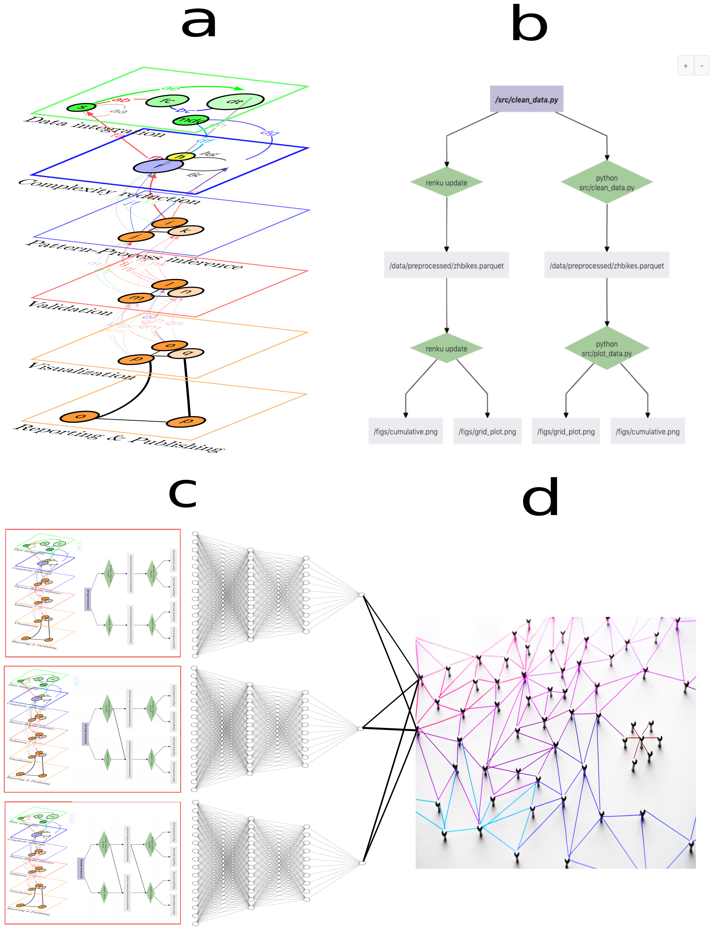

**Figure 1**: **Deep knowledge-based ledger *network technology****. a) End-to-end research cycle from data integration to reporting. b)* The knowledge graph (KG) tracking one research path of **a** (i.e., *Renku* open-source code). *c) Deep knowledge-based network* automatically explore a population of KGs to gain understanding of the data. d) The ledgeraccounts for all the KGs in a distributed network of mutually trusting/untrusting peers with every peer maintaining the population of the KGs (i.e., decentralized P2P git network like *Gitchain.*)