**Deep Knowledge Ledger Network**

**Acronyms: DeepKlen – Robhoot**

**Summary**

The DeepKlen-Robhoot project is trying to introduce new concepts to allow scientist and the public (Administration, NGOs, etc) to interact in a decentralized open-access knowledge network to gain informed decisions when solving complex social, environmental and technological problems. Current technologies for scientific inquiry are highly fragmented and thus only increase robustness, reproducibility and the interactions with the public marginally. The goal of DeepKlen-Robhoot is to propose a new hybrid-technology concept combining deep learning, automation and distributed ledger technology with the advances of neural biological networks to lay the foundation for a novel open-science ecosystem aiming to couple predictive and knowledge power in knowledge-inspired societies. DeepKlen-Robhoot is not set out to deliver a finished deep knowledge ledger network in the science ecosystem but provide a science-enabled technology in establishing a prototype proof-of-principle for an open public-science ecosystem.

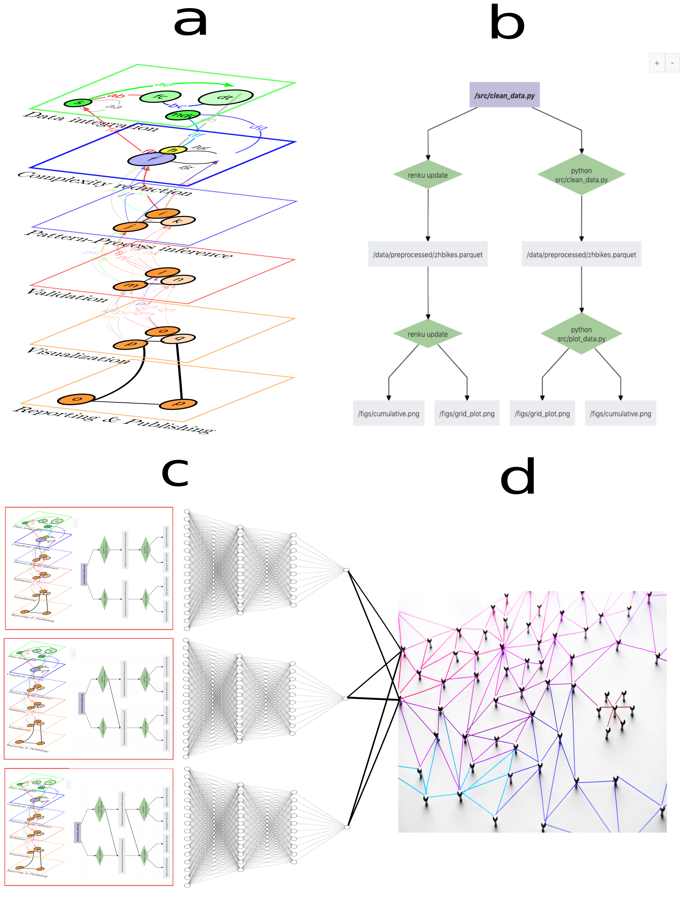

Figure 1: **Deep knowledge ledger network technology**. **a**) End-to-end research from data integration to reporting. **b**) The knowledge graph (KG) representing one research path of **a** (i.e., Renku open-source code). **c**) Deep knowledge-based algorithms exploring the population of KGs to gain process- and pattern-based knowledge of the data. **d**) The population of all KGs is stored in a distributed ledger network of mutually trusting/untrusting peers with every peer maintaining the population of the KGs (i.e., decentralized P2P git network like Gitchain.) The end-to-end automated research connects citizen data science and open-science to knowledge-inspired societies in a integrated loop.