Portfolio – Stage 1

Team Formation and Idea Development

# Team training

## Introduction of members :

|  |  |  |
| --- | --- | --- |
| Name | Thérèse-Marie Lefoulon | Robin David |
| strength | * Several joint projects: Simple Shell, HBnB | |
| Skills | * Rigorous * Attention to detail * Creative | * Organisation * Creativity * - Diligence |
| interests | * Tolkien's universe * Appetite for back-end development * Artistic creations | * Tolkien's universe   - Appetite for front-end development  - Artistic creations |
| Initial role | * Technical Manager/Support * Lead Back-end Developer | * Project Manager * Lead Front-end Developer |

## Organisation of work :

* Monday to Friday => In person, from 8:30 a.m. to 6 p.m. maximum
* Weekend/public holiday work => **Remote**, hours depending on availability
* Meetings/Reviews => Every morning – first hour
* Decisions => Approval by both members

## Selected tools :

* Support tools => **VSCode**
* Communication tool => **Discord**
* Technical monitoring => **Github**
* **Live Share + Branch git**

# Presentation of ideas

## 2.1. Link between the different ideas

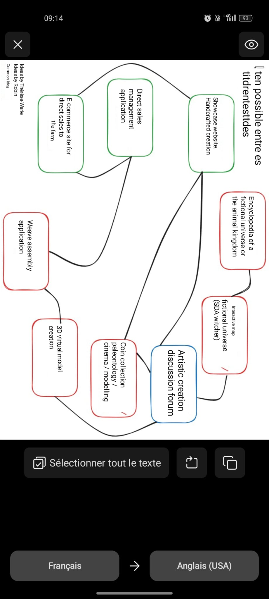

## 2.2. Link between the different ideas

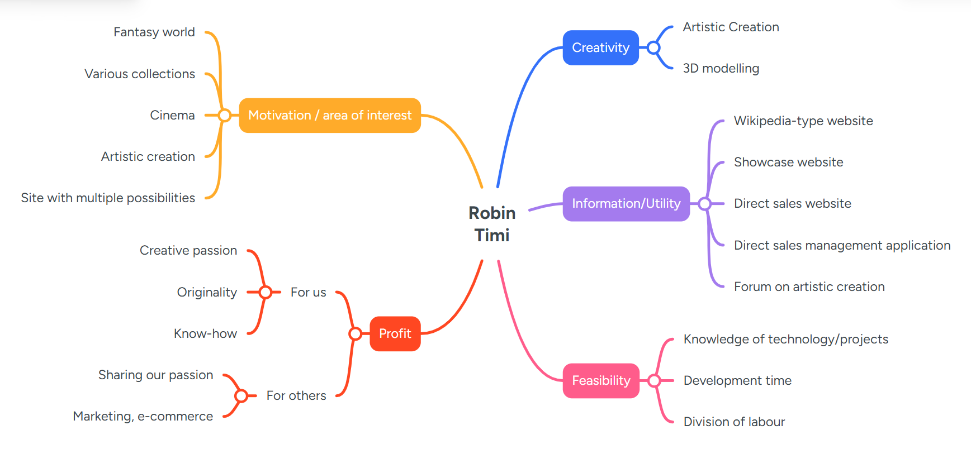

# Evaluation of ideas

## Evaluation criteria and scoring

We have chosen five evaluation criteria scored out of five points (1 = poor, 5 = excellent). Here are the proposed criteria and their respective descriptions.

|  |  |
| --- | --- |
| Criteria | Description |
| Technical feasibility | Ease of implementation with our current skills and resources |
| Potential impact | Interest for an audience, usefulness, attractiveness |
| Technical suitability | Relevance to the technologies we want to master or showcase |
| Scalability | Possibility of developing the project (adding features) |
| Originality/Differentiation | Ability to stand out from existing projects |

## Rating ideas

|  |  |  |  |  |  |  |
| --- | --- | --- | --- | --- | --- | --- |
|  | Feasibility | Impact | Technical suitability | Scalability | Originality | Total /25 |
| Wikipedia-style information site | 4 | 4 | 4 | 5 | 3 | **20** |
| Showcase site for creations | 5 | 4 | 4 | 4 | 4 | **21** |
| Virtual modelling creation web app | 2 | 5 | 4 | 5 | 5 | **21** |
| Collections website (coins, palaeontology, etc.) | 4 | 4 | 4 | 5 | 4 | **21** |
| Direct sales e-commerce website | 4 | 5 | 4 | 5 | 3 | **21** |
| Armour assembly app | 2 | 4 | 4 | 4 | 5 | **19** |
| Direct sales management app | 4 | 5 | 5 | 5 | 3 | **22** |
| Interactive map of the SDA universe + creations | 3 | 5 | 4 | 5 | 5 | **22** |

## Risks and constraints

|  |  |
| --- | --- |
| Idea | Main risks/constraints |
| Wikipedia-style information site | Large volume of content to be created, risk of duplication with Wikipedia, need for advanced user management |
| Showcase site for creations | Media management (high-quality images), need for a polished design, significant SEO optimisation |
| Virtual modelling creation web app | Technical complexity (3D or modelling), need for graphic resources, long development time |
| Collections website | Need for a minimum volume, media management (high-quality images), choice of a collection that is neither too small nor too large |
| E-commerce website | Security and payment management, compliance with legislation, ongoing maintenance |
| Armour assembly app | Highly targeted, difficulty in finding a wide audience, visual resources required |
| Direct sales management app | Inventory management, invoicing, legislation, integration with external tools (payment, logistics) |
| Interactive SDA map + creation | Performance with large volumes of interactive data, interactivity management, large database and management of multiple user data (for content creation) |

# Decision and refinement

## Selection of the final MVP (Minimum Viable Product) idea

We decided to go with the **Lord of the Rings interactive map + LOTR artwork project**, also incorporating a wiki-style information site. The interactive map and artwork are the two basic ideas we chose.

However, we felt that merging it with an encyclopaedia-type platform would be even more relevant, as it would provide a complete and detailed description of each place, character, creature, etc.

Why this choice:

* **Strong visual potential and appeal => showcases your front-end skills**
* **Interesting back-end => user management, gallery, chat**
* **Highly original => few similar projects in portfolios**
* **Potential for growth => showcase website creation, expansion into other areas**

## MVP improvements and challenges

Possible improvements:

* Guest mode (*unidentified user*) with limited content preview.
* Administrator mode, which will be the only mode to provide information. Will also have control over other users' publications (images, content).
* More advanced showcase of creations.
* Zoom function and interactive points on the map with images/videos.
* Animation effects on the map.
* Integration of a mini-forum or real-time chat.
* Filters by content type: places, characters, creations.
* Mobile version with smooth map navigation.
* Family tree (interactive or not) for each character.

Potential challenges:

* Copyright management for the SDA universe.
* Performance: optimisation of map and image loading times.
* Real-time synchronisation of chat or new creations.
* Security (authentication, content moderation).
* Learning new languages/tools.
* Development time management.
* Determining the appropriate deployment platform, especially for a database that is likely to grow.

## Clarification of the concept

Target audiences:

|  |  |  |
| --- | --- | --- |
| User type | Need/Motivation | Role |
| Fans of the SDA universe | Learn more about this universe or rediscover it in an interactive and visual form Share their creations | Guests or registered users |
| Site creators and administrators | Enrich the site's content Monitor the site's performance Manage other users | Admin |
| Curious | Discover a new fantasy universe | Guests or registered users |

* *Guests* : free browsing with limited access.
* *Registered users* : access to more content, ability to contribute.
* *Admins* : access to manage other users, moderate and validate content, role of editor and content manager.

Main expected features:

* Interactive clickable map with basic information about locations.
* Detailed information sheets on locations, characters, creatures, etc.
* Differentiated role management: guests, registered users, administrators.
* Responsive version (particularly for content sheets).
* Publication and promotion of artistic creations (images, texts, etc.).
* Filters by content type to facilitate navigation.

Expected results:

* A functional and immersive platform for exploring the world of The Lord of the Rings.
* A smooth user experience.
* Structured and readable content.
* Security management for user-submitted content.
* A solid code structure for future developments.

## Project objective

**The objective of this project is to offer all users an interactive way to explore the world of The Lord of the Rings.** There are few interactive platforms that centralise information about the world of The Lord of the Rings while integrating a visual map and a showcase of artistic creations.

This project therefore aims to make this universe more accessible and participatory by offering a space that is informative, interactive and creative.