课程编号： 北京理工大学 学年第 学期
2019级人工智能基础期末试题
班级 学号 姓名 成绩
一、True (T) or False (F) (10 points，one for each)
- From the view of strong AI, we can think that AlphaGo is intelligent. （ ）
- The optimization objectiveness in BP learning is the minimization of squared error. （ ）
- The annotated data is needed in unsupervised learning. （ ）
- In machine learning, the function that can fit to the training data completely must be the best. （ ）
- The architecture of Hopfield network is feed-forward. （ ）
- The optimal solution must be found out by using breadth-first search algorithm.
（ ）
- Ockham’s razor principal in machine learning means that we should prefer to simple functions. （ ）
- Leaf nodes in a decision tree correspond to attribute values（属性值）. （ ）
- We have to encode each solution into a symbol string in Evolutionary Programming algorithm. （ ）
- Reinforcement Learning is a kind of Supervised Learning. （ ）

二、Fill in the blanks (20 points，two for each)
- From the view of computation, a Decision Tree is actually a .
- A neuron in artificial neural network is a composite（混合的） function composed of and .
- The heuristic information in Ant Colony Optimization algorithm is .
- In Evolutionary Computation algorithms，we decrease the solution diversity by using operators and increase the diversity by using
operators.
- Given two groups of data points, the first is 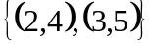 and the second is 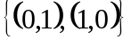， then the perceptron which can be used to classify these two groups of data points is

.
- When using the Minimum Description Length (MDL) criterion to solve the problem of Decision Tree learning, we should consider two code lengths, which are the decision tree and the additional data which can not be explained by the decision tree .
- The overfitting problem in Machine Learning is:
.

三、Calculations (50 points)
- The following figure shows a Pac-Man game. The Pac-Man (open mouth) should move to the positions of monsters and eat them. The black blocks in the figure is the areas where the Pac-Man can move, others not. Now you are required to program a shortest path from the current position of Pac-Man to the position of the monster in the right.

Please use A* search method to solve this problem:
1) Design your Heuristic Function，and explain whether and why it is an admissible heuristic. [3 points]
2) According to your designed Heuristic Function, draw the search graph and label the value of heuristic function (h value), the value of evaluation function (f value), and the expansion order of nodes in the graph. [7 points]

2. Xiaozhao usually goes to work by riding a bicycle or taking a bus. If he goes to work by bus, the probability that he could be late is 10%; if he goes to work by bicycle, the probability that he could be late is 2%. Furthermore, he goes to work by bus in four of five working days each week. Today, Xiaozhao is late. Please apply the Bayes decision rule to infer the transportation tool used today by him. [10 points]

3. Two categories of data points are shown in the following figure. The first group of data points lie in a rectangle, shown as solid dots in the rectangle. The second group of data points lie in a triangle, shown as hollow dots in the triangle. Now only these data points are given. Except these points, we have no other information about the rectangle and the triangle.
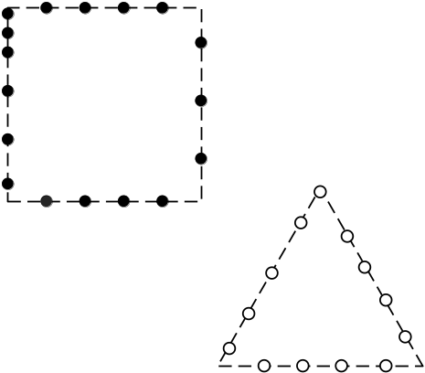
Please design a Clustering algorithm for classifying the data points above into two clusters. Estimate the clustering effectiveness of your designed algorithm and analyze the reason behind. [10 points]

4. Two categories of data points are given in the following figure, shown as 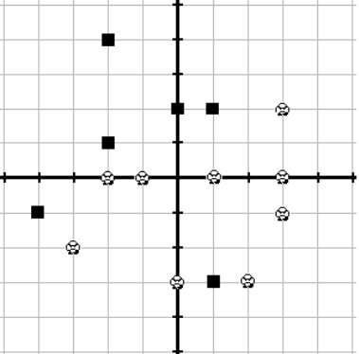 and respectively. Furthermore, the two black and thick solid lines in the figure denote the X-axis and the Y-axis, respectively. The point of intersection of them is the origin point.
x
Now you are required to use Decision Tree to classify the data points above. If you choose “whether the value of y is less than 0” as root node, please compute the Information Gain of it. [10 points]

5. Given Game Tree as follows.
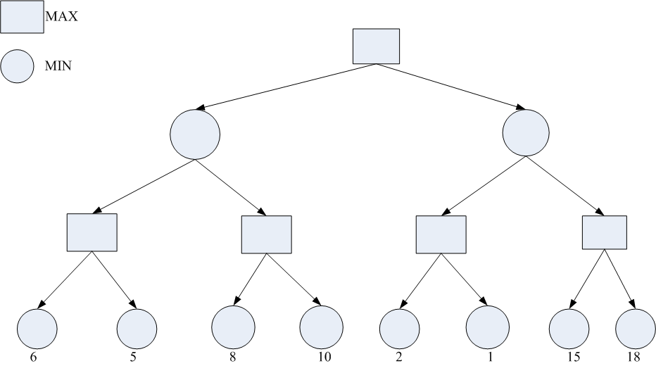
Please perform - pruning operation on this game tree, where the tree is expanded according to the order of from-left-to-right. Label the backtracking values and pruning results (label them by ×) in the corresponding positions in the graph. Then explain the final goal of computation. [10 points]

四、Algorithm (20 points)
1. Apply Artificial Neural Network (ANN) to recognize the character T. The recognition task is: for an inputted binary image with the size of 20×20, ANN can judge whether it is the character T. Here each point in a binary image takes value 1 (black) or 0 (white). The following figure shows an example of the input images:

The questions are:
- Please draw the structure of ANN fulfilling the above character recognition task (don’t consider the weights). [5 points]
- Please develop a Particle Swarm Intelligence algorithm to learn the weights of your designed ANN:
2-1) describe the pseudo-codes（伪代码） of this algorithm. [10 points]
2-2) explain the data condition for performing this algorithm and learning process of it. [5 points]

