CUSTOMER CHURN PREDICTION
Using a Multi-Layer Perceptron
Predicting telecom subscriber attrition from tabular account, billing and service data
A Project Report Submitted in Partial Fulfilment of the Requirements for
Semester 5 Evaluation of B.Tech (Computer Science and Engineering)
Subject: Deep Learning
Submitted by (Group –)
Name | Roll No.
Sritam Mishra | FET-BAML-2024-28-035
Dhruv Dash | FET-BAML-2024-28-036
Sarthak Kumar Patel | FET-BAML-2024-28-037
Binayak Bhoi | FET-BAML-2024-28-038

Guided by: Mr. Yugnash (Trainer)
Department of Computer Science & Engineering
Faculty of Engineering & Technology (FET), Sri Sri University
Academic Year 2026 – 2027

DECLARATION
We, the undersigned members of the project team, hereby declare that the project report entitled “Customer Churn Prediction Using a Multi-Layer Perceptron” is an authentic record of the work carried out as part of the Semester 5 Deep Learning project under the guidance of Mr. Yugnash (Trainer).
The report is prepared from the supplied project notebook and presentation. The implementation, dataset processing, model experiments and reported results are documented in those project materials. Any information not available in the supplied files, such as individual roll numbers, has not been invented.
Team Members:
- Sritam Mishra
- Dhruv Dash
- Sarthak Kumar Patel
- Binayak Bhoi
Place: ______________________________
Date: ______________________________

ACKNOWLEDGEMENT
We express our sincere gratitude to Mr. Yugnash (Trainer) for his guidance and support throughout the development of this project. His direction helped the team structure the problem, implement the neural-network models and interpret the experimental results.
We also thank the Department of Computer Science & Engineering, Faculty of Engineering & Technology, Sri Sri University, for providing the academic environment and resources required to carry out this Deep Learning project.
Finally, we acknowledge the contributions of all four team members—Sritam Mishra, Binayak Bhoi, Dhruv Dash and Sarthak Kumar Patel—for their cooperation in data analysis, preprocessing, model development, experimentation and presentation of the work.

ABSTRACT
Customer churn prediction is the task of identifying subscribers who are likely to discontinue a service. In telecom, retaining an existing customer can be supported by identifying risk before cancellation occurs. This project studies churn prediction using account, service, demographic and billing information from the IBM Telco Customer Churn dataset.
The proposed system uses a Multi-Layer Perceptron (MLP). Two implementations are examined: a NumPy-based MLP built from scratch with manual forward propagation and backpropagation, and a Keras MLP with two hidden layers. The Keras implementation compares Sigmoid, Tanh and ReLU hidden-layer activations under the same training conditions.
The dataset contains 7,043 customer records. CustomerID is removed, categorical attributes are label-encoded, TotalCharges blanks are converted to 0.0, features are standardized, and an 80/20 stratified train-test split is used. SMOTE is then applied only to the training data, changing the training distribution from 4,139 non-churners and 1,495 churners to 4,139 examples in each class.
On the held-out test set of 1,409 customers, the Keras Sigmoid model reports 77.36% accuracy, 56.10% precision, 67.65% recall and 0.838 ROC-AUC. The NumPy implementation reports 39.18% accuracy, 29.48% precision, 92.78% recall and 0.686 ROC-AUC. The experiments demonstrate the effect of implementation and training choices on churn-prediction performance.

TABLE OF CONTENTS

Contents
DECLARATION 2
ACKNOWLEDGEMENT 3
ABSTRACT 4
TABLE OF CONTENTS 5
1. INTRODUCTION 7
1.1 Background 7
1.2 Motivation 7
1.3 Problem Statement 7
1.4 Objectives 7
1.5 Scope 7
2. LITERATURE REVIEW & EXISTING SYSTEM 8
2.1 Existing Methods 8
2.2 Deep-Learning-Based Approaches 8
2.3 Limitations of Existing Systems 8
2.4 Proposed Improvement 8
3. PROPOSED SYSTEM / METHODOLOGY 9
3.1 System Overview 9
3.2 Workflow 9
3.3 Dataset 9
3.4 Preprocessing 9
3.5 Algorithm / Model 10
4. SYSTEM DESIGN & IMPLEMENTATION 11
4.1 Architecture Details 11
4.2 Technologies Used 11
4.3 Implementation Steps 11
4.4 Important Code Snippet 11
5. EXPERIMENTAL SETUP & RESULTS 13
5.1 Dataset Details 13
5.2 Training Configuration 13
5.3 Evaluation Metrics 13
5.4 Results 13
6. RESULTS ANALYSIS & DISCUSSION 16
6.1 Confusion Matrix 16
6.2 Predictions and Output Quality 16
6.3 Comparison with Baseline / Alternative Configurations 16
6.4 Observations 16
6.5 Strengths 16
6.6 Limitations 17
7. CONCLUSION, FUTURE SCOPE & REFERENCES 18
7.1 Conclusion 18
7.2 Future Scope 18
7.3 Limitations Recap 18
7.4 References 18

1. INTRODUCTION

1.1 Background
Customer churn prediction uses historical customer information to estimate whether a subscriber is likely to leave a service. The supplied project focuses on telecom churn and uses tabular information covering demographics, account characteristics, subscribed services and billing variables. The dataset contains 7,043 records and an observed churn rate of approximately 26.5%.

1.2 Motivation
The project is motivated by the need to identify customers at risk of churn before cancellation. The presentation notes that a model which always predicts “stay” can achieve approximately 74% accuracy while detecting no actual churners. This makes class-imbalance handling and recall important parts of the modelling workflow.

1.3 Problem Statement
Develop a deep-learning-based binary classification system that predicts whether a telecom customer will churn using 19 input attributes derived from account, demographic, service and billing information.

1.4 Objectives
- Prepare the Telco Customer Churn dataset for machine-learning and deep-learning experiments.
- Encode categorical attributes and standardize the numerical feature representation.
- Handle class imbalance in the training data using SMOTE without modifying the held-out test set.
- Implement an MLP from scratch using NumPy and manual backpropagation.
- Implement a Keras MLP and compare Sigmoid, Tanh and ReLU hidden-layer activations using accuracy, precision, recall and ROC-AUC.

1.5 Scope
The scope covers offline churn classification using the supplied Telco Customer Churn dataset, preprocessing, exploratory analysis, a NumPy MLP, Keras MLP variants, evaluation and interpretation. The supplied materials do not document deployment to a live telecom CRM, real-time scoring, automated customer communication, or a production monitoring pipeline.

2. LITERATURE REVIEW & EXISTING SYSTEM

2.1 Existing Methods
The supplied notebook imports conventional supervised-learning components including Decision Tree, Random Forest and XGBoost classifiers, alongside the neural-network implementation. However, the supplied notebook does not record completed experimental results for these conventional classifiers. Therefore, they are treated here as considered existing modelling approaches rather than reported baselines.

2.2 Deep-Learning-Based Approaches
The project investigates Multi-Layer Perceptrons for tabular churn prediction. The NumPy implementation uses one hidden layer with 16 ReLU units and a one-unit Sigmoid output. The Keras implementation uses 19 inputs, Dense(32), Dense(16), and a one-unit Sigmoid output. Three hidden-layer activations—Sigmoid, Tanh and ReLU—are evaluated under identical optimizer, loss, epoch and batch-size settings.

2.3 Limitations of Existing Systems
- Class-imbalanced data can make raw accuracy misleading because a model may favor the majority non-churn class.
- A from-scratch neural network requires careful learning-rate and optimization choices; the supplied NumPy experiment showed loss remaining near 0.693 throughout training.
- Different activation functions can produce different optimization and generalization behavior, so a single activation cannot be assumed to be optimal for every dataset.

2.4 Proposed Improvement
The project addresses these issues through a reproducible preprocessing pipeline, stratified splitting, feature standardization and SMOTE applied only to the training data. It then compares a transparent from-scratch MLP with framework-based Keras variants so that both the neural-network mechanics and the effect of activation functions can be examined.

3. PROPOSED SYSTEM / METHODOLOGY

3.1 System Overview
The end-to-end system starts with the IBM Telco Customer Churn CSV file, removes the customer identifier, fixes blank TotalCharges values, encodes categorical attributes, separates the target, performs a stratified train-test split, standardizes the features and balances only the training data using SMOTE. The processed data is then passed to the NumPy MLP and Keras MLP variants. Each model produces a binary churn prediction and a churn probability used for evaluation.

3.2 Workflow
- Input: Telco customer records containing demographic, account, service and billing attributes.
- Preprocessing: Remove CustomerID, convert 11 blank TotalCharges values to 0.0, convert Churn from Yes/No to 1/0, and label-encode categorical variables.
- Scaling and balancing: Perform an 80/20 stratified split, standardize features using StandardScaler, and apply SMOTE to the training set only.
- Model / decision step: Train the NumPy MLP and Keras MLP with Sigmoid, Tanh and ReLU hidden activations. Convert predicted probabilities to classes using a 0.5 threshold.
- Output: Churn class prediction and probability-based evaluation metrics including accuracy, precision, recall and ROC-AUC.

3.3 Dataset
The project uses the IBM Telco Customer Churn dataset loaded from the file named “WA_Fn-UseC_-Telco-Customer-Churn.csv” in the supplied notebook. The raw dataframe has 7,043 rows and 21 columns. After dropping CustomerID and separating Churn, 19 input features remain. The target distribution is 5,174 non-churners and 1,869 churners.
Dataset Property | Value
Records | 7,043
Raw columns | 21
Model input features | 19
Non-churn / Churn | 5,174 / 1,869
Observed churn rate | 26.5% (approximately)
Blank TotalCharges values | 11
Train / Test split | 80% / 20% stratified
Training set before SMOTE | 4,139 / 1,495
Training set after SMOTE | 4,139 / 4,139

3.4 Preprocessing
- CustomerID is removed because it is an identifier rather than a predictive customer attribute.
- The 11 blank entries in TotalCharges are replaced with 0.0 and the column is converted to floating-point format.
- Churn is converted from Yes/No to binary 1/0 labels.
- Categorical object columns are label-encoded using Scikit-learn LabelEncoder.
- The dataset is split using stratification with test_size = 0.2 and random_state = 42.
- StandardScaler is fitted on the training data and then applied to both training and test data.
- SMOTE with random_state = 42 is fitted only on the scaled training data.
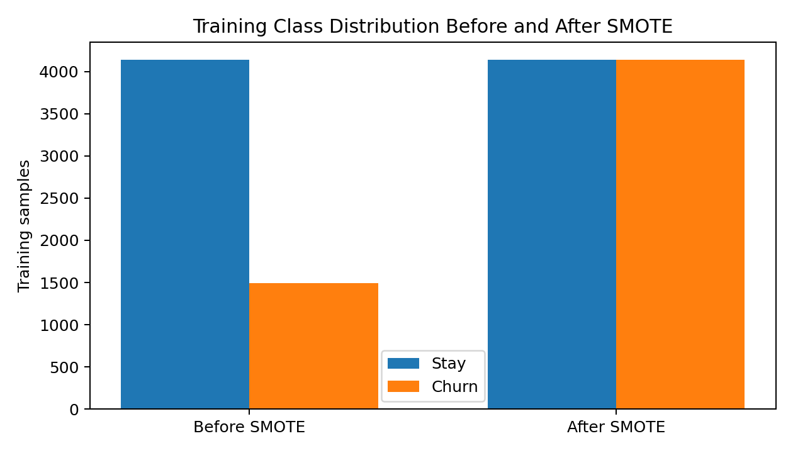
Figure 3.1. Training class distribution before and after SMOTE, using counts reported by the notebook.

3.5 Algorithm / Model
The NumPy MLP contains 19 input features, a hidden layer of 16 ReLU units and a single Sigmoid output unit. Weights are initialized with small random values, forward propagation computes hidden and output activations, binary cross-entropy is used as the loss, and gradients are propagated backward to update the weights with a learning rate of 0.01 for 100 epochs.
The Keras model contains Dense(32), Dense(16), and Dense(1) layers. The final output uses Sigmoid activation. The hidden layers use one of three activation functions: Sigmoid, Tanh or ReLU. All three variants use the Adam optimizer, binary cross-entropy loss, 50 epochs, batch size 32 and a 20% validation split of the SMOTE-balanced training data.

4. SYSTEM DESIGN & IMPLEMENTATION

4.1 Architecture Details
The Keras architecture used for the activation-function comparison is summarized below. The output is a single probability representing the predicted churn class.
Stage | Layer Type | Output Size | Configuration
Input | Input / Dense input | 19 | 19 standardized features
Hidden 1 | Dense | 32 | Selected activation: Sigmoid / Tanh / ReLU
Hidden 2 | Dense | 16 | Same selected hidden activation
Output | Dense | 1 | Sigmoid probability

The NumPy model is a smaller from-scratch architecture with 19 inputs → 16 ReLU hidden units → 1 Sigmoid output. Its forward and backward passes are implemented directly with NumPy matrix operations.

4.2 Technologies Used
- Python for data processing and model implementation.
- Pandas for loading, cleaning and manipulating the dataset.
- NumPy for the from-scratch MLP matrix calculations.
- Scikit-learn for encoding, splitting, scaling and evaluation metrics.
- imbalanced-learn for SMOTE.
- TensorFlow / Keras for the framework-based MLP experiments.
- Matplotlib and Seaborn for exploratory plots, training curves and visualization.
- Jupyter Notebook for the supplied implementation workflow.

4.3 Implementation Steps
- Load the Telco Customer Churn CSV and inspect its shape, types and feature values.
- Remove CustomerID and correct the TotalCharges representation.
- Explore numerical and categorical variables through descriptive statistics and plots.
- Encode the target and categorical attributes and store the encoders.
- Split the data into stratified training and test sets and standardize the features.
- Apply SMOTE only to the training set.
- Train the NumPy MLP for 100 epochs and evaluate it on the untouched test set.
- Train Keras MLP variants with Sigmoid, Tanh and ReLU hidden activations for 50 epochs.
- Compare the models using accuracy, precision, recall and ROC-AUC.

4.4 Important Code Snippet
class MLP:
def __init__(self, input_size, hidden_size=16, learning_rate=0.01):
self.W1 = np.random.randn(input_size, hidden_size) * 0.01
self.b1 = np.zeros((1, hidden_size))
self.W2 = np.random.randn(hidden_size, 1) * 0.01
self.b2 = np.zeros((1, 1))
self.learning_rate = learning_rate
def forward(self, X):
self.Z1 = X @ self.W1 + self.b1
self.A1 = relu(self.Z1)
self.Z2 = self.A1 @ self.W2 + self.b2
self.A2 = sigmoid(self.Z2)
return self.A2
def create_model(activation='relu'):
model = Sequential([
Dense(32, activation=activation,
input_shape=(X_train_smote.shape[1],)),
Dense(16, activation=activation),
Dense(1, activation='sigmoid')
])
model.compile(optimizer='adam',
loss='binary_crossentropy',
metrics=['accuracy'])
return model

5. EXPERIMENTAL SETUP & RESULTS

5.1 Dataset Details
The notebook uses 7,043 customer records. After removing CustomerID and the target, 19 features are used for prediction. The stratified split produces 5,634 training records and 1,409 test records. The training set contains 4,139 non-churners and 1,495 churners before SMOTE, and 4,139 examples of each class after SMOTE.

5.2 Training Configuration
Parameter | Value
Input size | 19 features
Train / Test split | 80% / 20%, stratified
NumPy hidden layer | 16 ReLU units
NumPy output | 1 Sigmoid unit
NumPy learning rate | 0.01
NumPy epochs | 100
Keras hidden layers | 32 units + 16 units
Keras activations compared | Sigmoid, Tanh, ReLU
Keras optimizer | Adam
Keras loss | Binary cross-entropy
Keras epochs | 50
Keras batch size | 32
Keras validation split | 20% of SMOTE-balanced training data
Hardware | Not specified in supplied notebook/presentation

5.3 Evaluation Metrics
- Accuracy: proportion of all test records classified correctly.
- Precision: proportion of predicted churners that are actual churners.
- Recall: proportion of actual churners detected by the model.
- ROC-AUC: area under the receiver operating characteristic curve, using predicted probabilities.

5.4 Results
Model | Accuracy | Precision | Recall | F1-Score | ROC-AUC
NumPy MLP | 39.18% | 29.48% | 92.78% | 44.75% | 0.686
Sigmoid | 77.36% | 56.10% | 67.65% | 61.33% | 0.838
Tanh | 76.15% | 54.68% | 59.36% | 56.92% | 0.806
ReLU | 75.80% | 54.14% | 57.75% | 55.89% | 0.813

The NumPy model's loss remained close to 0.693 throughout its 100 epochs, while the Keras variants produced substantially higher test accuracy and ROC-AUC. Among the three Keras activation variants, the reported test metrics are close, with the Sigmoid configuration recording 77.36% accuracy and 0.838 ROC-AUC.
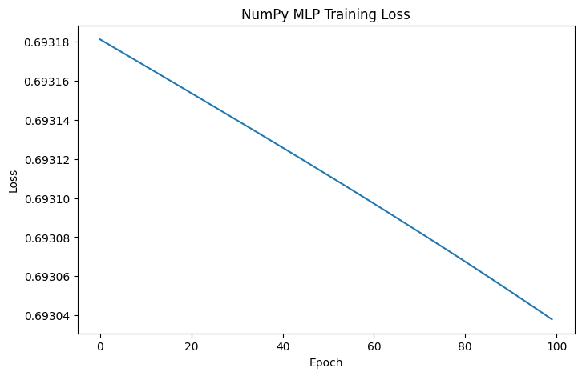
Figure 5.1. NumPy MLP training loss over 100 epochs.
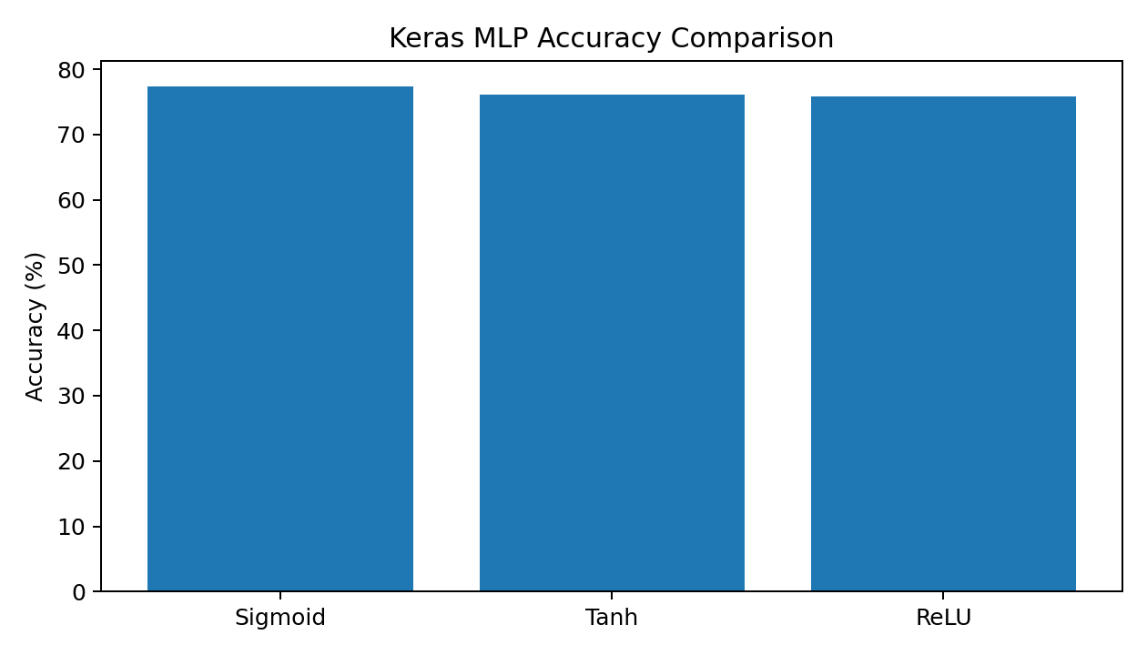
Figure 5.2. Accuracy comparison of the three Keras activation variants.
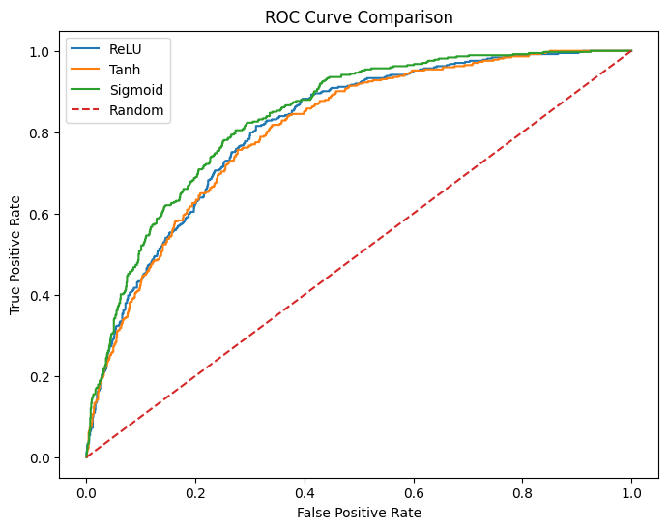
Figure 5.3. ROC curve comparison generated in the supplied notebook.

6. RESULTS ANALYSIS & DISCUSSION

6.1 Confusion Matrix
The supplied notebook does not directly print the confusion-matrix arrays. For the Sigmoid model, the matrix below is reconstructed from the reported test-set class count (374 churners), precision and recall values. This reconstruction is included for interpretation and is not presented as a separately printed notebook output.
 | Predicted: Stay | Predicted: Churn
Actual: Stay | 837 | 198
Actual: Churn | 121 | 253

For the reconstructed Sigmoid matrix, 253 of 374 churners are detected, corresponding to the reported recall of 67.65%. The corresponding false-positive count is 198, consistent with the reported precision of 56.10%.

6.2 Predictions and Output Quality
The project outputs a churn probability from the final Sigmoid unit and converts that probability to a class using a 0.5 threshold. The Keras models show substantially stronger overall classification behavior than the from-scratch NumPy model on the supplied test set. The NumPy model has very high recall (92.78%) but low precision (29.48%), indicating that it flags many customers as potential churners.

6.3 Comparison with Baseline / Alternative Configurations
The supplied materials do not report a conventional machine-learning baseline result. Instead, the experimental comparison is between the NumPy MLP and three Keras MLP activation variants. The Keras Sigmoid configuration reports 77.36% accuracy versus 39.18% for the NumPy MLP, and 0.838 ROC-AUC versus 0.686. The Keras models use Adam and a deeper 32→16 hidden structure, whereas the NumPy model uses a single 16-unit hidden layer and a fixed learning rate of 0.01.

6.4 Observations
- The dataset is imbalanced in the target variable: 5,174 non-churners versus 1,869 churners.
- SMOTE changes the training distribution to an even 4,139 / 4,139 while leaving the test set untouched.
- The NumPy MLP loss remains around 0.693, indicating limited learning under the supplied training configuration.
- The Keras variants achieve test accuracy between approximately 75.80% and 77.36%.
- The project presentation identifies contract type as an important churn signal, with reported churn rates of 42.7% for month-to-month customers, 11.3% for one-year customers and 2.8% for two-year customers.
- Tenure and TotalCharges have a reported correlation of 0.83 in the project presentation.

6.5 Strengths
- The preprocessing pipeline explicitly addresses missing values, categorical encoding, scaling and class imbalance.
- SMOTE is applied only to the training data, preserving an untouched test set for evaluation.
- The project compares a from-scratch neural network with framework-based implementations and isolates the activation function as the main Keras experimental variable.
- Multiple metrics are reported, including recall and ROC-AUC rather than relying on accuracy alone.

6.6 Limitations
- The supplied project materials do not document a completed conventional-machine-learning baseline experiment even though several classifiers are imported in the notebook.
- The notebook does not directly print confusion matrices or F1 scores; F1 values in this report are derived from the reported precision and recall.
- The hardware and exact software-version configuration are not specified in the supplied notebook/presentation.
- The work is evaluated on the supplied dataset and held-out test split; no external dataset validation is documented.
- The report does not claim production deployment or real-world retention impact because the supplied materials do not document such deployment.

7. CONCLUSION, FUTURE SCOPE & REFERENCES

7.1 Conclusion
This project develops a telecom customer churn prediction pipeline using a Multi-Layer Perceptron. The workflow combines data cleaning, categorical encoding, standardization and SMOTE-based training-set balancing with two neural-network implementations. The from-scratch NumPy model demonstrates the mechanics of forward propagation and backpropagation, while the Keras experiments compare Sigmoid, Tanh and ReLU hidden-layer activations under consistent training conditions. On the supplied held-out test set, the Keras Sigmoid model reports 77.36% accuracy, 56.10% precision, 67.65% recall and 0.838 ROC-AUC.

7.2 Future Scope
- Evaluate the same preprocessing pipeline against the conventional classifiers imported in the notebook, such as Decision Tree, Random Forest and XGBoost.
- Perform systematic hyperparameter tuning for learning rate, hidden-layer size, regularization, batch size and training duration.
- Evaluate the trained system on additional telecom churn datasets to assess generalization beyond the supplied test split.
- Investigate threshold selection and cost-sensitive evaluation when false negatives and false positives have different business costs.
- Develop a deployment layer that exposes churn probabilities through an API or dashboard and integrates with a retention workflow.

7.3 Limitations Recap
The conclusions are bounded by the supplied dataset, the single train-test split, the reported training configurations and the absence of documented production validation. The report also distinguishes directly reported metrics from values derived from those metrics.

7.4 References
[1] IBM Telco Customer Churn dataset, loaded in the supplied notebook as “WA_Fn-UseC_-Telco-Customer-Churn.csv”.
[2] Untitled7 (1).ipynb, supplied project implementation notebook, Customer Churn Prediction.
[3] Customer_Churn_Prediction_Presentation.pptx, supplied project presentation.
[4] TensorFlow / Keras, framework used in the supplied notebook for the MLP experiments.
[5] imbalanced-learn, SMOTE implementation used in the supplied notebook for training-set balancing.
[6] Scikit-learn, preprocessing, train-test splitting, scaling and evaluation utilities used in the supplied notebook.
Source note: The information, methodology, implementation details, and experimental results presented in this report are based on the project work carried out using the IBM Telco Customer Churn dataset, the developed Jupyter Notebook implementation, and the accompanying project presentation.

