JavaScript:  
  
1. Everything in JS happens inside an **Execution context,**

**Ex Context is like a box or container**

|  |  |
| --- | --- |
| Memory Component is called Variable Environment | Code Component is called (Thread of Execution) where whole js code is executed |
| Key : Value pair  a : 10  function : {….} | Code one by one  1…………  2………….  3………… |

JS is synchronous single threads language it’s mean JS only complete one command in one time and specific order and also code also execute one time after complete one then go next one.

What happen when you run a JS program?

Answer is a Execution context is created

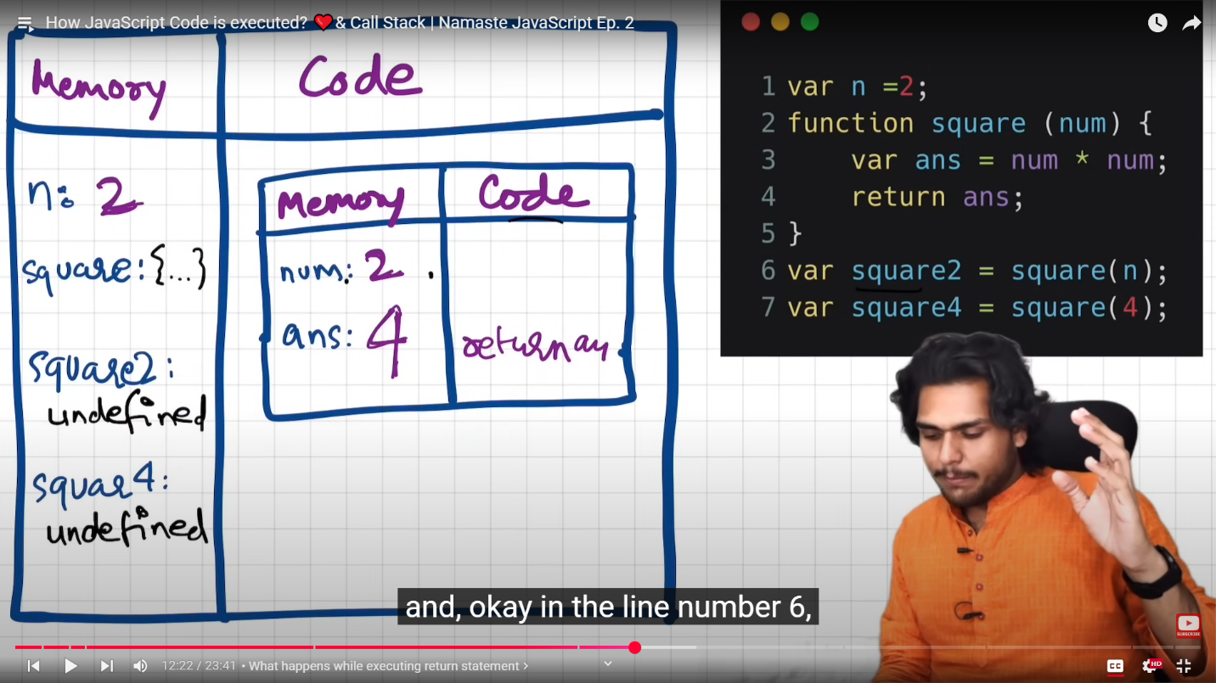

When we run this image program global execution context created  
  
The execution context created in two phases.  
1 is creation phase this is also know as memory creation phase and it’s also critical phase.

With this image js will allocate memory to all the variable and functions.

When 1 line run it’s take some space in memory and named n and value store undefined

When 2 line run the function name take space and named square and value is full code it store

And same goes for square2 and square4 take space and named memory and value is undefined

And in 2nd phase is code execution phase

And again the JS program run line by line

Now when it see n = 2 now the variable value now take place n=2 in memory

