My Coffee — Sales & Operations Analytics (Power BI)

**Author:** Stanislav Ukrainets

**Company (simulated):** My Coffee (London-based, 6 branches)

**Analysis windows:**

• Last year: 1 Jan 2024 – 2 Mar 2024

• Current year: 1 Jan 2025 – 2 Mar 2025

**Data:** Synthetic (generated to simulate real-world café operations)

# 1) Project Overview

Production-style reporting for My Coffee to help managers quickly understand sales performance, branch comparisons, product winners/laggards, waste drivers, and customer reviews, with week-over-week and same week last year context.

**Note:** Data are generated to simulate real case work; insights on seasonality, trends, and reviews are illustrative.

# 2) Objectives

* Provide an executive Home dashboard with core KPIs and week/year comparisons.
* Highlight top/bottom products and waste-driving items by category and product.
* Offer branch-level performance views for operational benchmarking.
* Enable product deep dives (price vs. demand signals, underperformers to improve/re-price/retire).
* Surface review analytics (rating trends and detailed feedback).

# 3) Data & Scope

## Tables (8 total)

Fact tables (4):

* Sales_Fact_Table
* Waste_Fact_Table
* Reviews_Fact_Table
* Forecast_Fact_Table

**Decision note:** I kept Forecast as a separate fact (rather than merging into Sales) to avoid mixing observed and predicted data; this keeps measures unambiguous and comparisons explicit.

Dimension tables (4):

* Branch_Lookup_Table
* Product_Lookup_Table
* Product_Category_Table
* Calendar_Dim_Table (generated inside Power BI)

## Sources & storage

• CSV: All fact/lookup tables stored in /Data folder.

• Calendar: Generated inside Power BI at refresh (not a CSV).

**Decision note:** I stayed with CSV in /Data so reviewers can open and refresh immediately; a PostgreSQL back end was considered for governance and incremental refresh, but deferred to keep setup friction low.

## Net Sales definition (project-specific)

Net Sales = Gross Sales minus VAT only. No discounts are modeled in this version.

**Decision note:** I kept Net Sales = Gross minus VAT only to keep the KPI logic transparent in a simulated dataset; promotions/discounts were possible but unnecessary here.

## Week logic

Week comparisons use week number vs. the same week number last year (Power BI default week numbering; not ISO).

**Decision note:** I chose same week-number YoY (non-ISO) because stakeholders often think “week 32 vs week 32 last year”; ISO was an option but heavier than needed.

# 4) Modelling Approach

## Star schema

Facts connect to dimensions via keys; single-direction filters from dimensions to facts (one-to-many). Conformed dimensions (product/category) enable consistent slicing across all facts.

**Decision note:** I considered a flat table and a snowflake, but chose a star schema to keep relationships clear, visuals fast, and future facts easy to add.

## Calendar_Dim_Table (generated in Power BI)

Created at refresh by deriving Min/Max dates from the fact tables and expanding to a full contiguous range. Includes attributes such as Year, Quarter, Month, Week Number (Power BI default), Day, WeekStart, etc. Enables automatic updates as new data arrives and supports partial-week and same week last year comparisons.

**Decision note:** I debated a static CSV calendar; generating it in Power BI lets it auto-expand to min/max fact dates and avoids maintenance for cloners.

## Keys & relationships

Primary keys set in dimension tables; corresponding foreign keys present in fact tables.

Relationship directions are single (dimension → fact) to avoid ambiguity and keep evaluation performant.

## Data quality steps

* Standardised headers and data types
* Removed unnecessary columns
* Checked for duplicates and nulls

# 5) Report Experience (4 Pages)

## A. Home (Executive Dashboard)

* Branch selector & period controls (week focus).
* KPIs: Gross Sales, Net Sales, Waste %, plus WoW and YoY (same week #).
* Gross Sales vs. prior year trend line.
* Category matrix (Gross/Net/Waste %).
* Top 10 Bestsellers, Top 10 Bottom Sellers, Top 10 by Waste.

**Decision note:** I prioritised a lean KPI → trend → category → top/bottom flow to front-load the “what”; deeper exploration sits on Product/Branch pages.

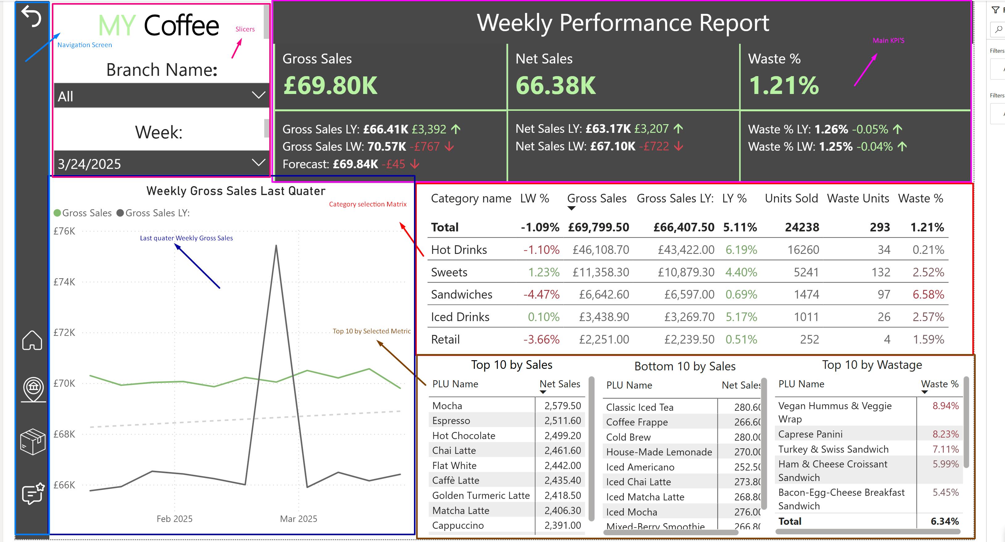

## B. Branch

* Compare branches across the selected month/period with core KPIs.
* Identify strong vs. weak performers quickly.

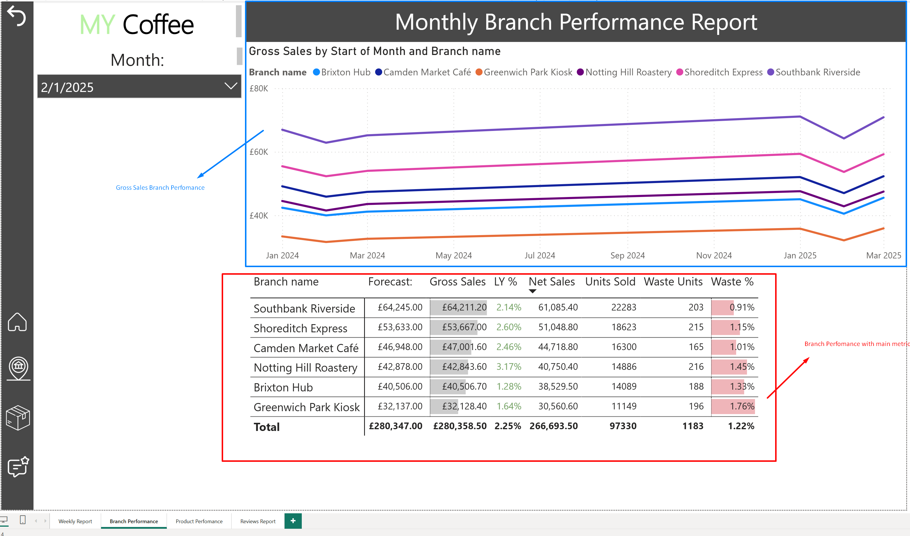

## C. Product

* Product selector with KPIs (Net Sales, Units, Waste %, Gross Margin, Gross Sales).
* Price adjustment visual to see possible scenarios of NET sales.
* Product metric selection slicer with line chart for selected product.

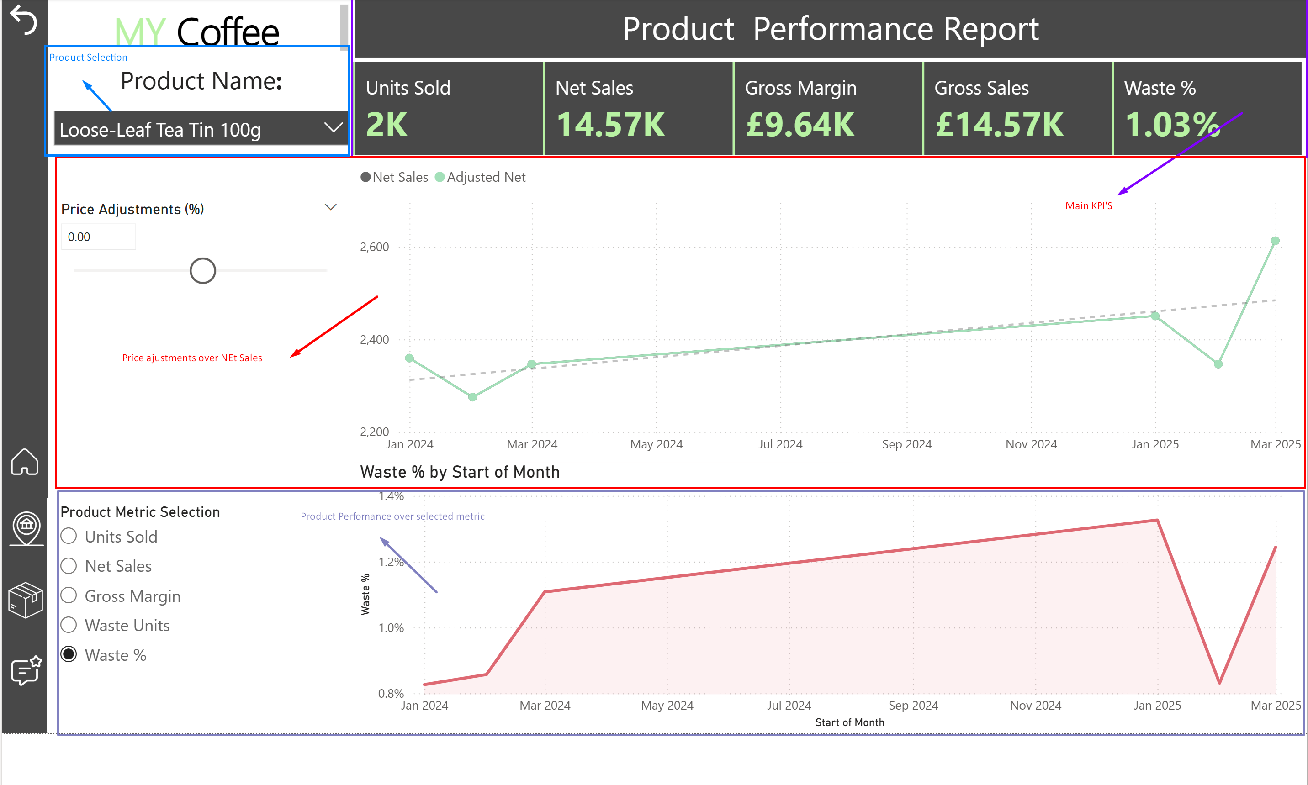

## D. Reviews

* Average rating & volume (overall/period).
* Rating trend over time.
* Detailed reviews table (rating, comment, branch, date).

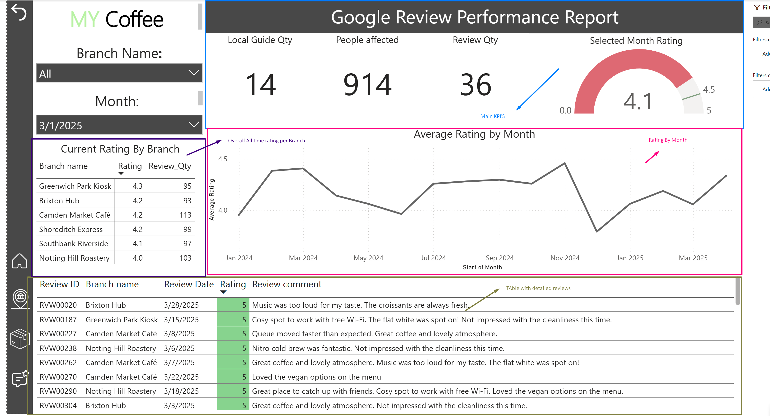

## Navigation

Page buttons in the bottom-left corner; no fixed colour scheme for this version.

**Decision note:** Bottom-left page buttons create consistent muscle memory; heavy theming was skipped to keep focus on numbers.

# 6) Assumptions & Limitations

* Synthetic data limits seasonality, trend fidelity, and review realism.
* Scope exclusions: labour, promotions, loyalty, and other datasets are not included.
* No discounts modeled; VAT-only deduction for Net Sales.
* RLS not planned for this portfolio build.

# 7) How to Run

1. Clone/download the repository.
2. Ensure the /Data folder is present at the project root with the CSV files.
3. Open the .pbix in Power BI Desktop (recent version).
4. If prompted, update the folder path parameter to match your local machine.
5. Refresh to generate the Calendar_Dim_Table and load visuals.

**Decision note:** I omitted DAX from the README to keep it concise; measures are discoverable in the PBIX for those who want exact definitions.

# 8) Deliverables & Assets

* Power BI file: MyCoffee_Analytics.pbix
* Data: /Data/*.csv
* Model diagram: assets/model_diagram.png
* Report screenshots: Home.png, Branch.png, Product.png, Reviews.png

