**CHAPTER 1**

**RELEVANCE**

ASCII art is a technique of composing pictures with printable text characters. It stemmed from the inability of graphical presentation on early computers. The widespread usage of ASCII art can be traced to the computer bulletin board systems of the late 1970s and early 1980s. The limitations of computers of that time period necessitated the use of text characters to represent images. Along with ASCII's use in communication, however, it also began to appear in the underground online art groups of the period. An ASCII comic is a form of webcomic which uses ASCII text to create images. In place of images in a regular comic, ASCII art is used, with the text or dialog usually placed underneath.

During the 1990s, graphical browsing and variable-width fonts became increasingly popular, leading to a decline in ASCII art. Despite this, ASCII art continued to survive through online MUDs, an acronym for "Multi-User Dungeon", (which are textual multiplayer role-playing video games), Internet Relay Chat, E-mail, message boards and other forms of online communication which commonly employ the needed fixed-width. Even with the wide availability of digital images and graphics nowadays, ASCII art remains popular due to the enormous growth of text-based communication channels over the Internet and mobile communication networks, such as instant messenger systems, Usenet news, discussion forums, email and short message services (SMS). In addition, ASCII art has already evolved into a popular art form in cyberspace.

**CHAPTER 2**

**LITERATURE SURVEY**

**2.1** **ASCII art synthesis**

Most existing ASCII art generation methods accept only line drawing as input. To generate ASCII arts from natural photographs, XU et al. proposed a method. It first extracts the features of the input image and then matches these features during ASCII art generation. But this method generates ASCII art that can be overcrowded with excessive structure, especially when the target resolution is small. This is because of lack of texture suppression. Also their character placement pays no attention to neighboring rows, and may cause visual artifact when there exists contour near the text boundary. In the method proposed, the scale of texture being suppressed can be controlled and more attention is paid on the boundary between text rows to minimize the potential visual artifact.

**2.2** **Contour Detection**

Classical edge detectors like Canny are unable to distinguish structural lines and texture lines. To distinguish structural lines and texture lines, the notion of scale is required. Kang et l proposed a 1D flow-based DoG filter to extract structural lines under different scales but their method cannot be directly extended to 2D texture. There was also the option of machine-learning based approaches but they heavily depend on the preparation of extensive training dataset.

**2.3** **Texture smoothing**

Xu et al proposed the relative total variation (RTV) metric to smooth textures, based on the assumption that texture pixels should have higher RTV values than structure line/ edge pixels. Methods proposed by Cho et al and Aubry et al generally suffer from the inability to distinguish structure from string-contrast texture due to their filtering nature. In the proposed method a perception-motivated model allows the extraction of structure lines even if the contrast of structure lines is weaker than or similar to that of the surrounding texture.

The figure below illustrates the difference in generating the ASCII art for three images, namely a racket, a cartoon image of a man with glasses and a cycle. There are structure based ASCII are generated for the three images in two of the methods proposed by Xu el at. These images seem overcrowded shrouding the clarity of the actual picture. Finally there is an image of the aASCII art generated by the method proposed in the paper

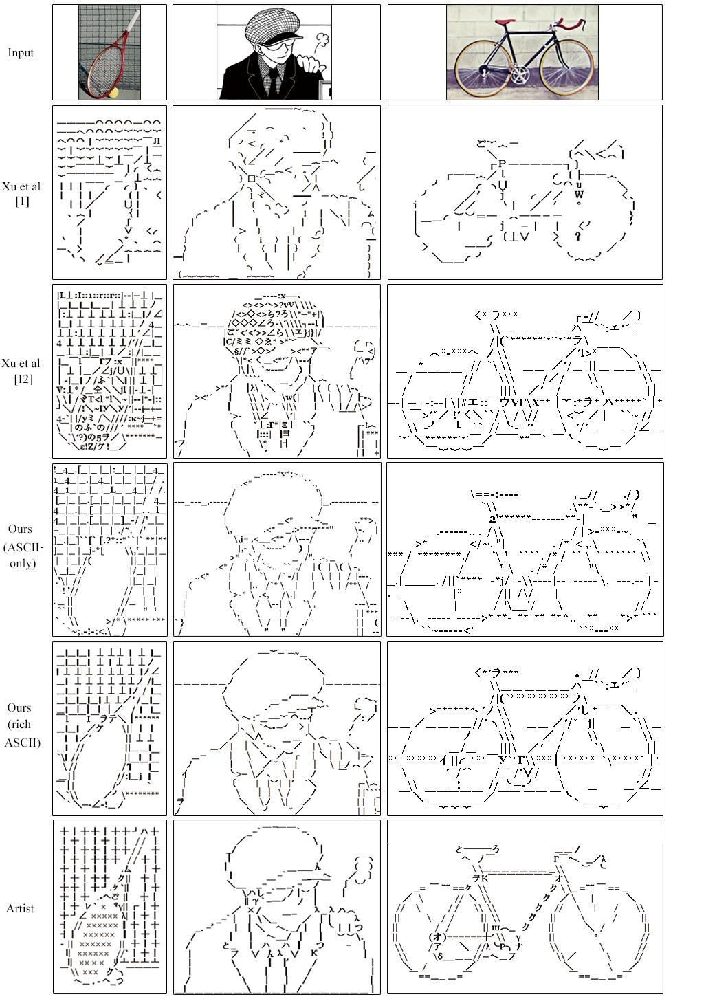

Fig.2. 1. Comparison of different ASCII art generation methods

**CHAPTER 3**

**OBJECTIVE**

Tone-based ASCII art maintains the intensity distribution of the reference image where as the structure-based ASCII art captures the major structure of the image content. In general tone-based ASCII art requires higher text resolution for producing sufficient tone variety. On the other hand, structure-based ASCII art utilizes the shape of characters to approximate the image structure, without manually following the pixel values.

In real world applications such as optical character recognition (OCR) and ASCII art a metric is needed to tolerate misalignment and also account for the differences in transformation (translation, orientation and scaling). The existing shape similarity metrics are either alignment- sensitive or transformation-invariant. This method proposes a novel alignment-insensitive shape similarity metric and allows controlled deformation of the reference image to increase the chance of character matching.

To create ASCII art from natural photographs, one need to identify the main structure from the photographs, and then use text characters to represent the identified main structure, but extracting sensible structure from natural photographs without excessive amount of undesirable details is extremely challenging.

There are 3 observations:-

• When creating the ASCII art from natural photographs, the artists can intelligently drop the detailed textures and preserve only the main structure is the created art.

• According to different target ASCII art resolutions, the artists adapt their work by dropping different amounts of texture details.

• The main structure inside the photograph should always be preserved no matter how weak the structure is. Effective preservation of the main structure with weak contrast from the texture region is a key challenge in generating sensible ASCII art from natural photographs.

Thus the requirements:-

• A texture-aware line extraction method

• For varying resolution requirements, the amount of extracted lines should be controllable

• Structure line extraction method should be sensitive to human perception

To achieve these goals, the human perception of structure-from-texture is modeled using the non-classical receptive field (non-CRF) modulation. 2 of its key properties are:-

• Scale aware texture suppression ability which allows controlling the amount of removed textures based on different target resolutions

• Orientation selectivity which helps to distinguish weak-contrast structure from texture

The existing models generally tend to remove most of the textures from the contour detection as a result weak-contrast structure within the texture maybe undesirably removed. So the proposed model can directly control the scale of texture suppression and can better distinguish weak-contrast structure from the texture region.

Xu’s structure-based method optimizes the character arrangement in each row separately but the proposed optimization scheme optimizes the character arrangement not only inside each row, but also between every two neighboring rows. The primary aim is to build a visual perception mechanism which can better separate weak structure from the crowded texture, and can also better control the scale of texture suppression.

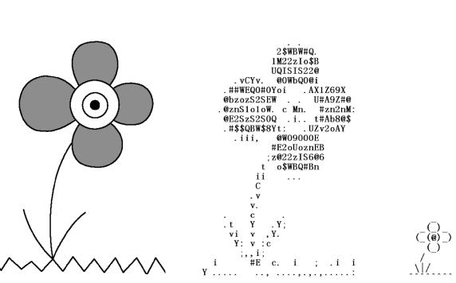

1. (b) (c)

Fig.3. 1. ASCII art. (a) A reference image. (b) Tone-based ASCII art generated by the program PicText, requiring the text resolution 30x29 in order to depict the content, though not very clearly. (c) Structure-based ASCII art manually designed by an artist, with a significant lower text resolution of 8x7.

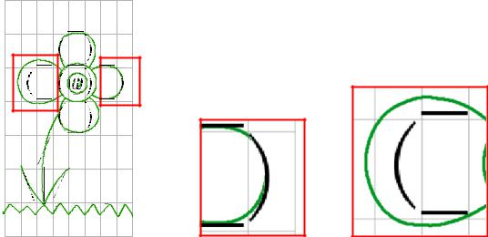

1. (b) (c)

Fig.3. 2: (a) By inspecting the overlapping image between the edge map of the reference image and the structured-based ASCII art two matching strategies employed by ASCII artists: (b) misalignment is tolerated; (c) the reference image is deformed to increase the chance of matching.

**CHAPTER 4**

**PROJECT SCHEDULE**

|  |  |  |  |  |  |  |  |
| --- | --- | --- | --- | --- | --- | --- | --- |
| **WORK** | **SEPT** | **OCT** | **NOV** | **DEC** | **JAN** | **FEB** | **MAR** |
| TOPIC  FINALISATION |  |  |  |  |  |  |  |
| LITERATURE REVIEW |  |  |  |  |  |  |  |
| STUDY OF MATLAB SOFTWARE |  |  |  |  |  |  |  |
| PHASE 1: STRUCTURE EXTRACTION |  |  |  |  |  |  |  |
| PHASE 1 TESTING |  |  |  |  |  |  |  |
| PHASE 2: TEXT REPLACEMENT |  |  |  |  |  |  |  |
| PHASE 2 TESTING |  |  |  |  |  |  |  |
| PREPARATION OF REPORT |  |  |  |  |  |  |  |