**FlyAway (An Airline Booking Portal)**

**-By Robin Singh Kuntal**

This document contains sections for:

* Login Form for the user in HTML form
* Separate Login Form for the Admin in HTML form
* Java Servlet for admin validation
* User Dashboard for searching flights using inputs like Source, Destination and date using HTML
* Java Servlet for retrieving the required information after the user enter the details
* Admin Dashboard for Edit, Update and Delete operation for flight schedule using HTML and Java Servlet
* Java Servlet for performing CRUD (Create, Retrieve, Update and Delete) operation
* HTML page for entering details of flights which are needed to be updated
* Separate HTML page for dummy payment page
* MySQL Database creation named Flyaway1. In that creating different tables for Flight Schedule, User Details and Admin Details
* Core Concepts used in development of the project
* Unique Selling Points of the Application
* Conclusions

## **Tools and Technology used in this Project**

* JSP, HTML, CSS, Bootstrap for View.
* JAVA Servlets as Controller
* MySQL database using Hibernate for Model to create tables for admin and flight details. Hosted on a remote server at AWS RDS.
* Tomcat 8.5 as an Application Server.
* Eclipse: As an IDE to code for the application.
* Java: A programming language to develop the web pages, databases.
* Maven: To create a web-enabled Maven project and build deployable war file.
* Git: To connect and push files from the local system to GitHub
* GitHub: To store the application code and track its versions
* Scrum: An efficient agile framework to deliver the product incrementally

**Project Link**

|  |  |
| --- | --- |
| Repository Name | FlyAway |
| GitHub Link | https://github.com/RobinKuntal01/Flyaway |

**Sprint Planning ( Planned for 4 sprints )**

|  |  |
| --- | --- |
| **Sprint number** | **Modules** |
| 1 | Design homepage and travel details page. |
| 2 | Fetch available flights from database and redirect to user details page. |
| 3 | Checkout page with details of flight and form for payment details. |
| 4 | Admin Login page and Admin Dashboard page with all the flights data fetched from the database along with change password and add flight button.  Testing |

**FlowChart**

HomePage

Travel Details Page

Admin Login Page

Fetching All Flight DETAILS FORM THE DATABASE

Fetching Availabe Flights Table

Ad

Admin Dashboard

Available Flight Details

Update or Delete Flight Table

Change Password

Traveller Details

Confirmation Page

**To demonstrate the product capabilities, below are the sub-sections configured to highlight appearance and user interactions for the project:**

* Creating the project in Eclipse
* Creating a Login Page in HTML for a login point for the user/client (**index.html**)
* Creating a Login Servlet in Java used to validate user credentials. As per the project requirement the user credentials are hardcoded **(LoginServlet.java)**
* Creating a Dashboard Servlet in Java to Welcome the user to Dashboard after the login validation and providing a Logout option(**DashboardServlet.java**)
* Creating a Logout Servlet in Java to handle logout request and redirect user to the Login Page (**LogoutServlet.java**)
* Pushing the code to GitHub repository

## **Step 1:** Creating a new Dynamic Web Project in Eclipse

* Open Eclipse
* Go to File -> New -> Dynamic Web Project.
* Type in any project name and click on “Finish.”
* Select your project and go to src -> main -> webapp->Right click and create new HTML file 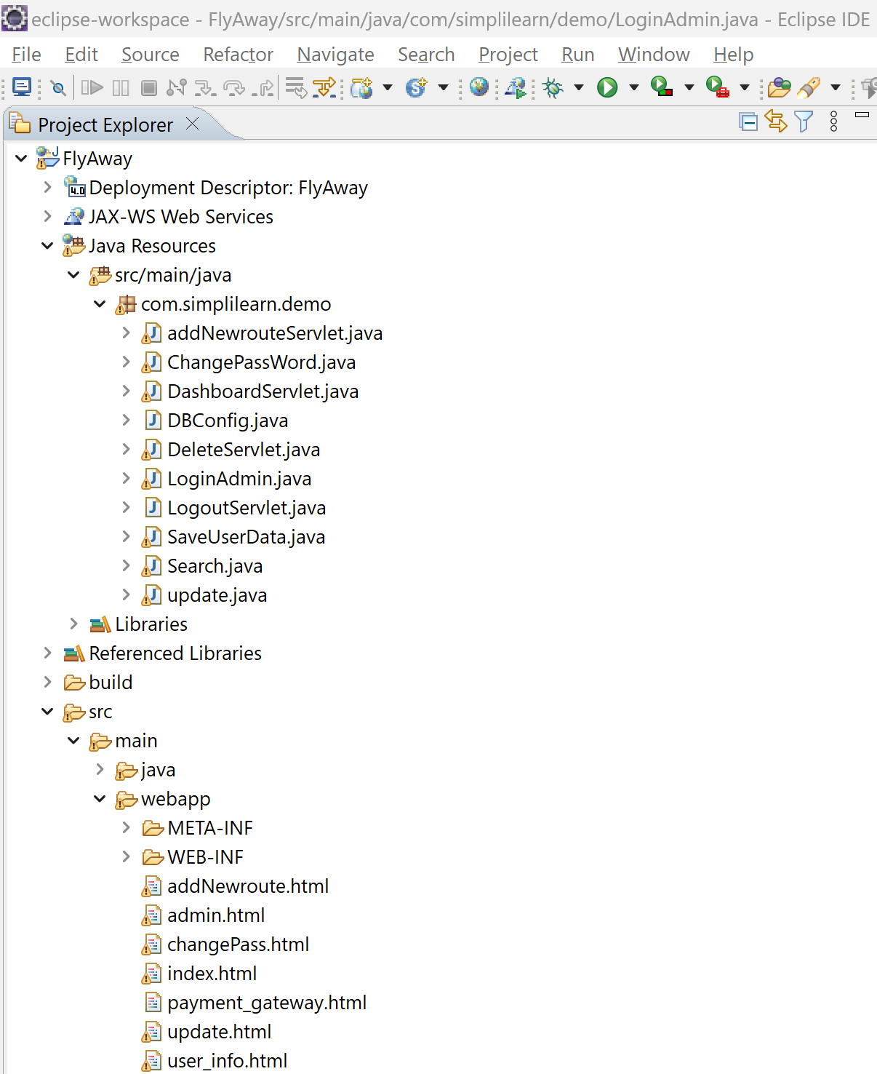

## **Step 2:** Creating a HomePage in HTML for a login point for the user/client **(index.html)**

<!DOCTYPE html>

<html>

<head>

<meta charset="ISO-8859-1">

<title>Insert title here</title>

</head>

<body>

<style type="text/css">

.mainBox{

display: flex;

justify-content: center;

}

.inBox{

margin:25px;

padding:25px;

border-width: 25px;

border-color:yellow;

}

h1{

color: red;

}

</style>

<div class=mainBox>

<div class = inBox>

<h1>Welcome to FlyAway Flight Booking Website</h1>

<form action="search" method="post">

From:<input type="text" name="from">

To: <input type="text" name="to">

Date:<input type="date" name="date"><br><br>

<input type="submit" value="Search">

<a href="admin.html">Admin Dashboard</a>

</form>

</div>

</div>

</body>

</html>

**Step 3:** Creating a Login Servlet in Java used to validate Admin credentials. As per the project requirement the user credentials are hardcoded **(AdminLogin.java)**

**package** com.simplilearn.demo;

**import** javax.servlet.annotation.WebServlet;

**import** javax.servlet.http.HttpServlet;

**import** javax.servlet.http.HttpServletRequest;

**import** javax.servlet.http.HttpServletResponse;

**import** java.io.IOException;

**import** java.io.PrintWriter;

@WebServlet("/admin")

**public** **class** LoginAdmin **extends** HttpServlet {

**public** **static** **boolean** *isLoggedIn* = **false**;

**public** **static** String *password* = "Admin";

**public** **static** String *email* = "admin@flyaway.com";

@Override

**public** **void** doPost (HttpServletRequest req, HttpServletResponse resp) **throws** IOException {

PrintWriter out = resp.getWriter();

String email = req.getParameter("email");

String pass = req.getParameter("pass");

**if** (email.equals(LoginAdmin.*email*) && pass.equals(LoginAdmin.*password*)){

*isLoggedIn* = **true**;

out.println("You have LoggedIn");

resp.sendRedirect("dashboard");

}

**else** {

*isLoggedIn* = **false**;

out.println("Login Failed : Incorrect email or Password");

}

out.close();

}

}

## **Step 4:** Creating a Dashboard Servlet in Java to Welcome the Admin to Dashboard **(DashboardServlet.java)**

@WebServlet("/dashboard")

**public** **class** DashboardServlet **extends** HttpServlet {

**private** **static** **final** **long** ***serialVersionUID*** = 1L;

@Override

**protected** **void** doGet(HttpServletRequest req, HttpServletResponse resp) **throws** ServletException, IOException {

// **TODO** Auto-generated method stub

PrintWriter out=resp.getWriter();

resp.setContentType("text/html");

Properties props=**new** Properties();

InputStream in=getServletContext().getResourceAsStream("/WEB-INF/application.properties");

props.load(in);

Connection conn=DBConfig.*getConnection*(props);

**if**(conn!=**null**) {

out.print("Connection Established");

Statement stmt;

**try** {

stmt=conn.createStatement();

out.print("<table width=75% border=1>");

out.print("<caption>Airline Table Schedule : </caption>");

ResultSet rs=stmt.executeQuery("select * from airline_table");

ResultSetMetaData rsmd = rs.getMetaData();

**int** totalColumn = rsmd.getColumnCount();

out.print("<tr>");

**for**(**int** i=1; i<=totalColumn; i++) {

out.print("<th>" + rsmd.getColumnName(i)+"</th>");

}

out.print("<tr>");

**while**(rs.next()) {

out.print("<tr><td>"+ rs.getInt(1)+"</td><td>"+ rs.getString(2)+"</td><td>"+

rs.getString(3)+"</td><td>"+ rs.getString(4)+"</td><td>"+ rs.getString(5)+"</td><td>"+

rs.getString(6)+"</td><td>"+ rs.getInt(7)+"</td><td>");

}

out.print("</table>");

out.print("<br><br>");

out.print("<a href=update.html>Update or Delete a Route</a>");

out.print("<br><br>");

out.print("<a href=addNewroute.html>Add a New Route</a>");

out.print("<br><br>");

out.print("<a href=changePass.html>Change Password?</a>");

out.print("<br><br>");

out.print("<a href='logout'> Logout </a>");

} **catch** (Exception e) {

// **TODO**: handle exception

}}

**else** {

out.println("Error While Connecting");

}}

@Override

**protected** **void** doPost(HttpServletRequest req, HttpServletResponse resp) **throws** ServletException, IOException {

// **TODO** Auto-generated method stub

doGet(req, resp);

}}

## **Step 3:** Creating a DataBase Flyaway1 in MySQL and adding tables named airline_table, user_table and admin_table

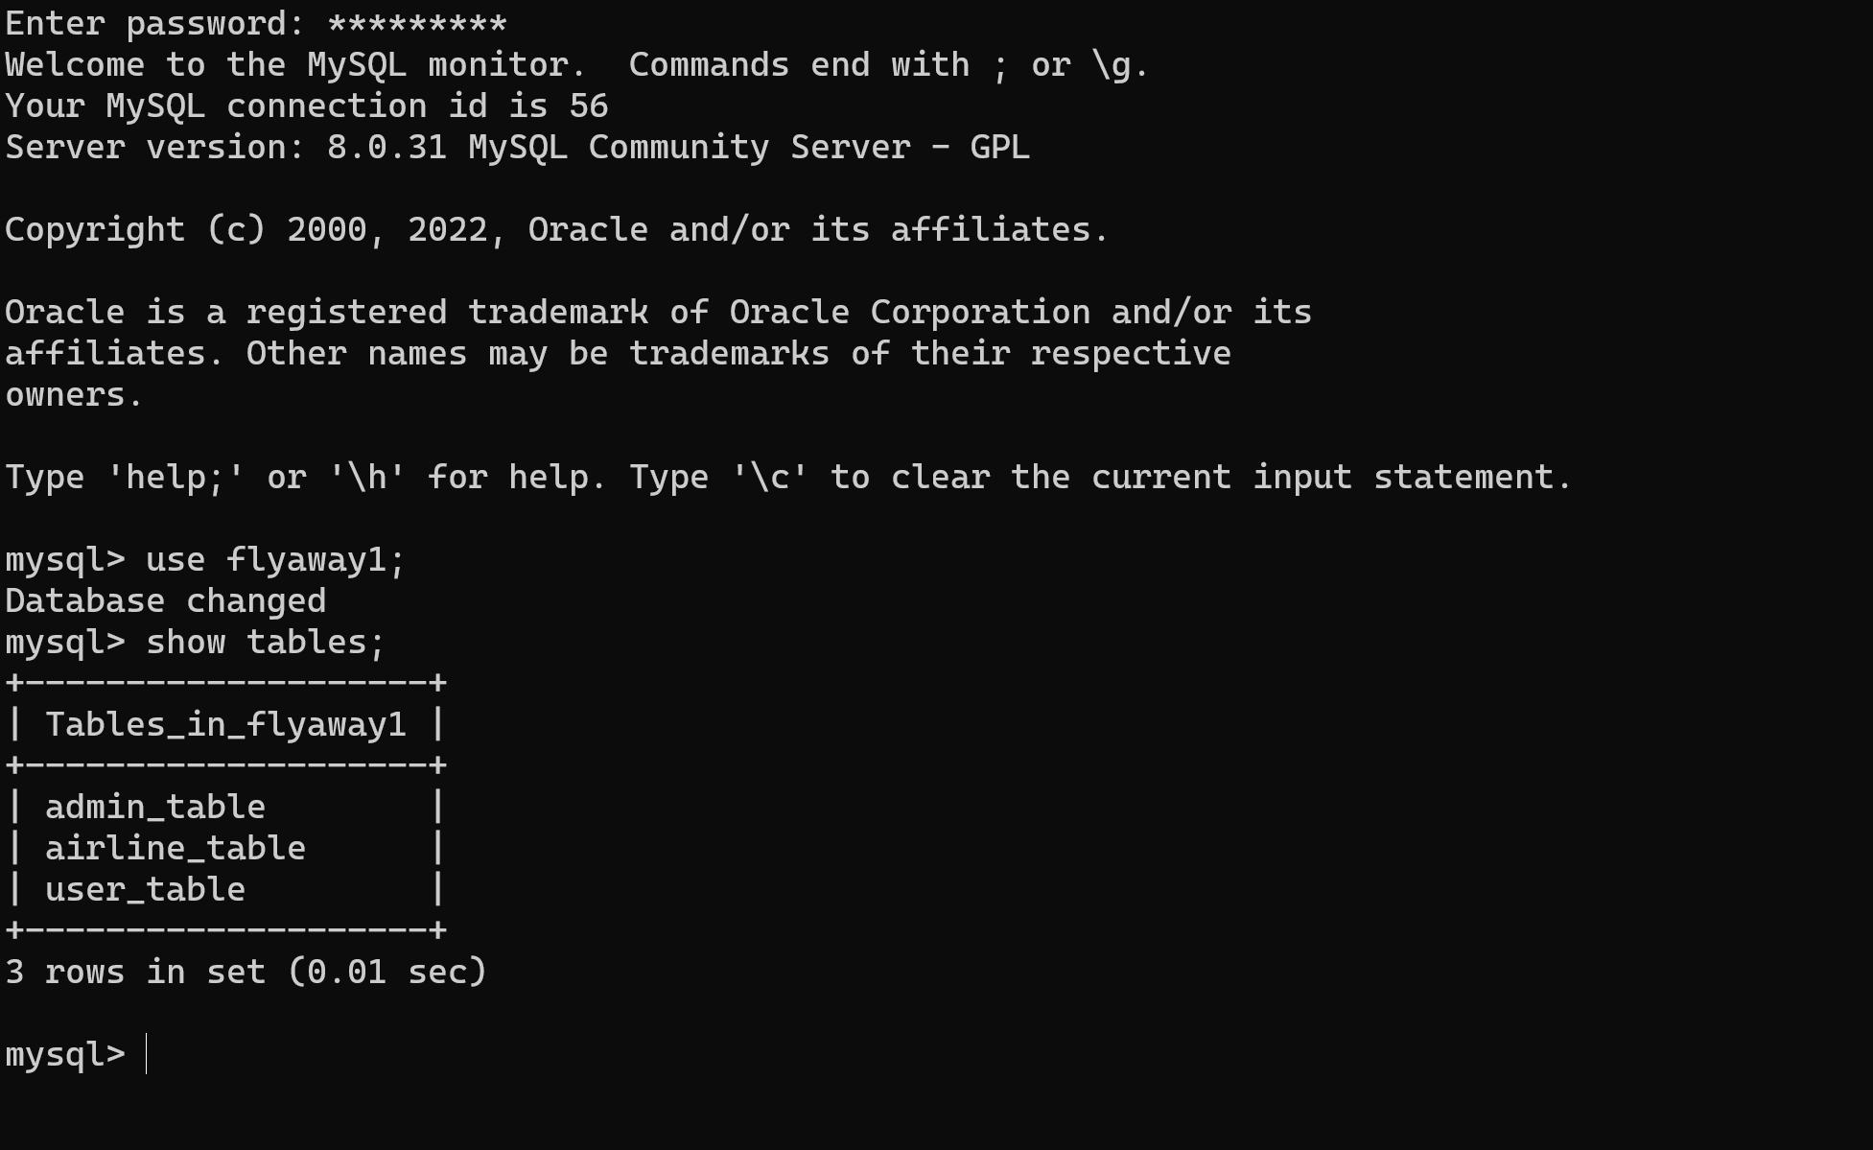

**Adding Data dummy to all these tables**

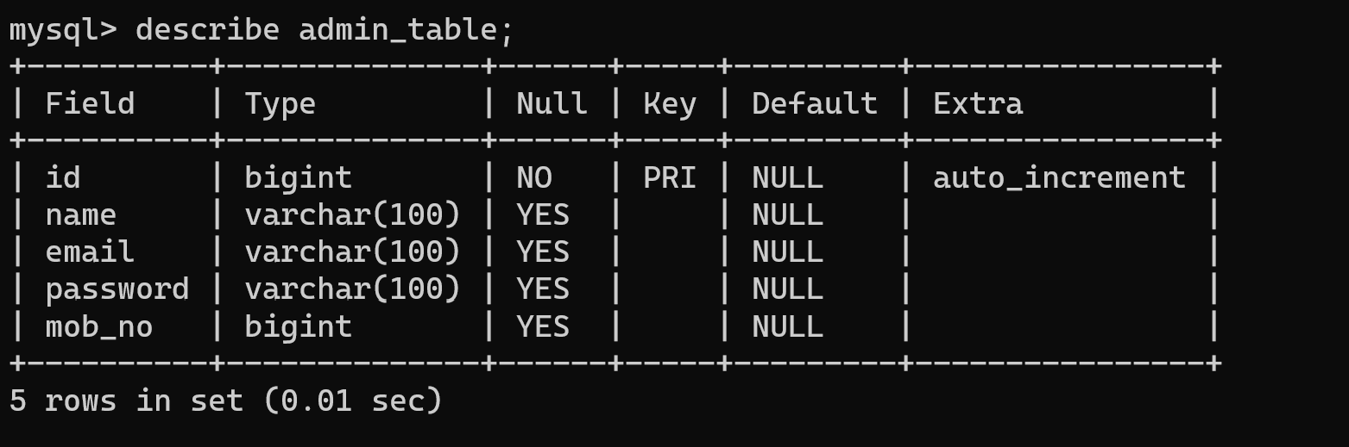

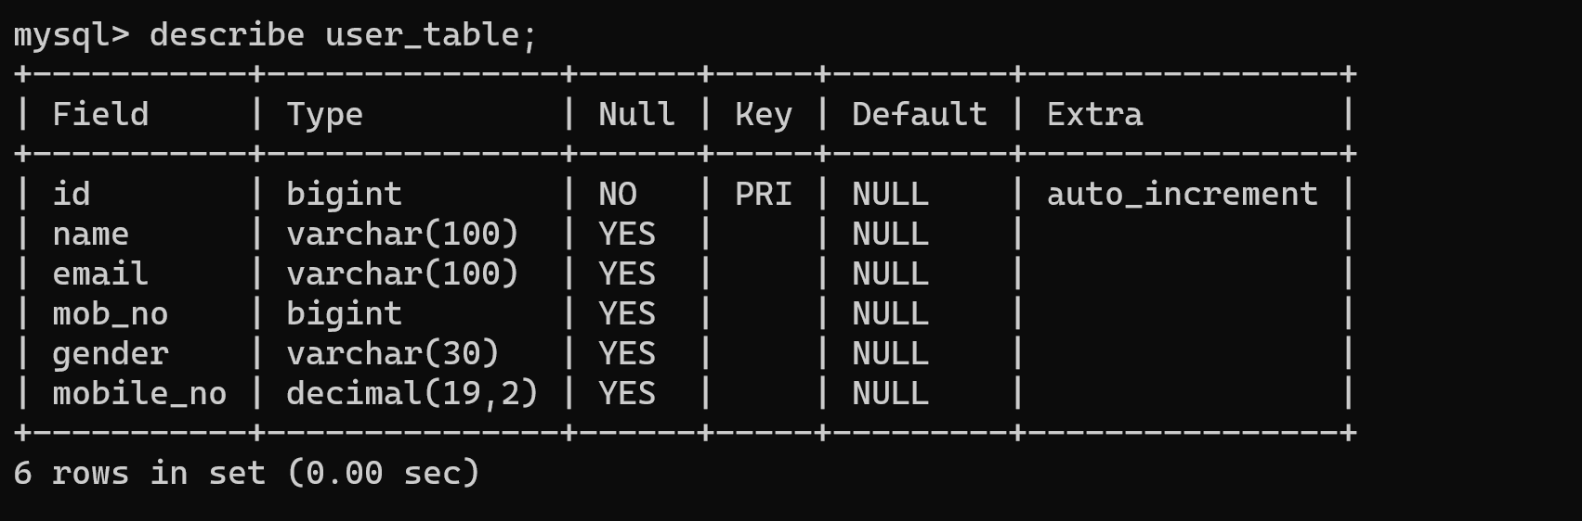

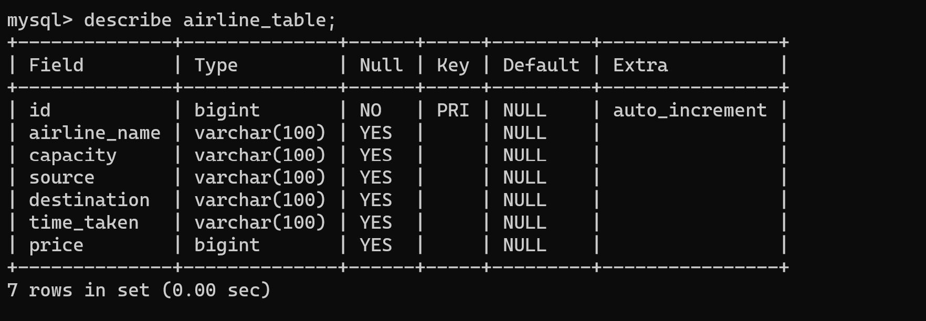

## **Step 4:** Creating Search Servlet in Java for Searching the required flight and present it to the user in a Tabular Form and the user can Select the flight by clicking **BOOK** button which will redirect the user to Personal Information page

@WebServlet("/search")

**public** **class** Search **extends** HttpServlet {

**private** **static** **final** **long** ***serialVersionUID*** = 1L;

**public** Search() {

**super**();

// **TODO** Auto-generated constructor stub

}

**protected** **void** doGet(HttpServletRequest req, HttpServletResponse resp) **throws** ServletException, IOException {

PrintWriter out=resp.getWriter();

resp.setContentType("text/html");

// get data from index page

String source = req.getParameter("from");

String destination = req.getParameter("to");

Properties props=**new** Properties();

InputStream in=getServletContext().getResourceAsStream("/WEB-INF/application.properties");

props.load(in);

Connection conn=DBConfig.*getConnection*(props);

**if**(conn!=**null**) {

**try** {

PreparedStatement ps = conn.prepareStatement("SELECT * FROM airline_table WHERE source=? AND destination=?");

ps.setString(2, destination);

ps.setString(1, source);

out.print("<table width=75% border=1>");

out.print("<caption>Search Results : </caption>");

ResultSet rs = ps.executeQuery();

ResultSetMetaData rsmd = rs.getMetaData();

**int** totalColumn = rsmd.getColumnCount();

out.print("Search Results for Flights from "+source+"to "+destination);

out.print("<tr>");

**for**(**int** i=1; i<=totalColumn; i++) {

out.print("<th>" + rsmd.getColumnName(i)+"</th>");

}

out.print("<tr>");

**while**(rs.next()) {

out.print("<tr><td>"+ rs.getInt(1)+"</td><td>"+ rs.getString(2)+"</td><td>"+ rs.getString(3)+"</td><td>"+ rs.getString(4)+"</td><td>"+ rs.getString(5)+"</td><td>"+

rs.getString(6)+"</td><td>"+ rs.getInt(7)+"</td><td>"+"<a href=user_info.html>BOOK</a> "+"</td>");

}

out.print("</table>");

} **catch** (Exception e) {

// **TODO**: handle exception

}}

**else** {

out.println("Error While Connecting");

}}

**protected** **void** doPost(HttpServletRequest request, HttpServletResponse response) **throws** ServletException, IOException {

// **TODO** Auto-generated method stub

doGet(request, response);

}}

## **Step 5:** Creating HTML page **user_info.html**. Here user will has to provide his/her details which will be saved in Flyaway1 database>user_table

<form action=*"save"* method=*"post"*>

<label for=*"name"*>Name:</label>

<input type=*"text"* id=*"name"* name=*"name"* required><br>

<label for=*"email"*>Email:</label>

<input type=*"email"* id=*"email"* name=*"email"* required><br>

<label for=*"mobile_no"*>Mobile Number:</label>

<input type=*"text"* id=*"mobile_no"* name=*"mobile_no"* required><br>

<label for=*"gender"*>Gender:</label>

<input type=*"text"* id=*"gender"* name=*"gender"* required><br>

<input type=*"submit"* value=*"Book"*>

</form>

## **Step 6:** Creating SaveUserData Servlet which get the data from **user_info.html** and then dump it in MySQL inside user_table

@WebServlet("/save")

**public** **class** SaveUserData **extends** HttpServlet {

@Override

**protected** **void** doGet(HttpServletRequest req, HttpServletResponse resp) **throws** ServletException, IOException {

// **TODO** Auto-generated method stub

//1. check the connectivity

Properties props=**new** Properties();

InputStream in=getServletContext().getResourceAsStream("/WEB-INF/application.properties");

props.load(in);

//2.get connection object

Connection conn=DBConfig.*getConnection*(props);

//3.get parameters from html

String name=req.getParameter("name");

String email=req.getParameter("email");

**int** mobile_no= Integer.*parseInt*(req.getParameter("mobile_no"));

String gender=req.getParameter("gender");

//4.write query to insert data

PrintWriter out=resp.getWriter();

**if**(conn!=**null**) {

out.print("connection Established");

//query to insert data using prepared statements

**try** {

PreparedStatement stmt=conn.prepareStatement("insert into user_table (name,email,mob_no,gender) values (?,?,?,?)");

stmt.setString(1, name);

stmt.setString(2, email);

stmt.setInt(3, mobile_no);

stmt.setString(4, gender);

**int** x=stmt.executeUpdate();

**if**(x>0) {

System.***out***.println("Data inserted successfully");

out.print("Data inserted Successfully");

//action

resp.sendRedirect("payment_gateway.html");

}

**else** {

System.***out***.println("Error While Inserting a Data");

}

} **catch** (SQLException e) {

// **TODO** Auto-generated catch block

e.printStackTrace();

}}

@Override

**protected** **void** doPost(HttpServletRequest req, HttpServletResponse resp) **throws** ServletException, IOException {

// **TODO** Auto-generated method stub

doGet(req, resp);

}}

## **Step 7:** Creating dummy payment page in HTML format

<h1>Payment Gateway</h1>

<form action=*"fetch"* method=*"post"*>

<label for=*"name"*>Name on Card:</label>

<input type=*"text"* id=*"name"* name=*"name"* required><br>

<label for=*"card-number"*>Card Number:</label>

<input type=*"text"* id=*"card-number"* name=*"card-number"* required><br>

<label for=*"expiry-date"*>Expiry Date:</label>

<input type=*"text"* id=*"expiry-date"* name=*"expiry-date"* required><br>

<label for=*"cvv"*>CVV:</label>

<input type=*"text"* id=*"cvv"* name=*"cvv"* required><br>

<button type=*"submit"*>Submit Payment</button>

## **Step 6: Pushing the code to GitHub repository**

## ●Open your command prompt and navigate to the folder where you have created your files.

## cd <folder path>

## ●Initialize repository using the following command:

## git init

## ●Add all the files to your git repository using the following command:

## git add .

## ●Commit the changes using the following command:

## git commit . -m <commit message>

## ●Push the files to the folder you initially created using the following command:

## git push -u origin master

## 