**LockedMe – Virtual Key for Repositories**

**-By Robin Singh Kuntal**

This document contains sections for:

* Sprint planning and Task completion
* Core concepts used in project
* Flow of the Application.
* Demonstrating the product capabilities, appearance, and user interactions.
* Unique Selling Points of the Application
* Conclusions

## Sprints planning and Task completion

The project is planned to be completed in 3 sprint. Tasks assumed to be completed in the sprints are:

* Documenting the flow of the application and preparing a flow chart
* Initializing Git and GitHub account to keep track of new functionalities
* Listing out the core concepts and algorithm along with the source code
* Writing the Java program to fulfill the project requirements
* Testing the Java program against various test case scenario
* Pushing the code to GitHub
* Project document highlighting its unique points, capabilities and user interactions

## Core concepts used in project

Collections framework, File Handling, Sorting, Flow Control, Recursion, Exception Handling, Streams API

To demonstrate the product capabilities, below are the sub-sections configured to highlight appearance and user interactions for the project:

* Creating the project in Eclipse
* Writing a program in Java for the entry point of the application (**mainMethod.java**)
* Writing a program in Java to display Menu options available for the user (**homeMenu.java**)
* Writing a program in Java to handle Menu options selected by user (**fileHandler.java**)
* Writing a program in Java to perform the File operations as specified by user (**fileOperation.java**)
* Pushing the code to GitHub repository

## **Step 1:** Creating a new project in Eclipse

* Open Eclipse
* Go to File -> New -> Project -> Java Project -> Next.
* Type in any project name and click on “Finish.”
* Select your project and go to File -> New -> Class.
* Enter “mainMethod”in any class name, check the checkbox “public static void main(String[] args)”, and click on “Finish.”

## **Step 2:** Writing a program in Java for the entry point of the application (**mainMethod.java**)

package lockedMe.sourceCode.com;

import java.util.Scanner;

public class mainMethod {

public static void main(String[] args) {

// Create "main" folder if not present in current folder structure

fileOperations.createMainFolderIfNotPresent("main");

homeMenu.printHomescreen();

handleWelcomeScreenInput();

fileHandler.handleWelcomeScreenInput();

}

## **Step 3:** Writing a program in Java to display Menu options available for the user (**homeMenu.java**)

* Select your project and go to File -> New -> Class.
* Enter **MenuOptions** in class name and click on “Finish.”
* **MenuOptions** consists methods for -:
  1. Displaying Welcome Screen
  2. Displaying Initial Menu
  3. Displaying Secondary Menu for File Operations available

**Step 3.1 : Writing method to display Home Screen Message**

package lockedMe.sourceCode.com;

public class homeMenu {

public static void printHomescreen() {

String welCome = "*************Weclome to LockedMe*****************\n" +

"**********This Program was created by Robin Singh Kuntal************\n";

String functionalities = ("// Use this Program to Retreive your files\n"

+ "// And also to Add, Delete or Search for a file");

System.out.print(welCome);

System.out.print(functionalities);

}

**Output:**

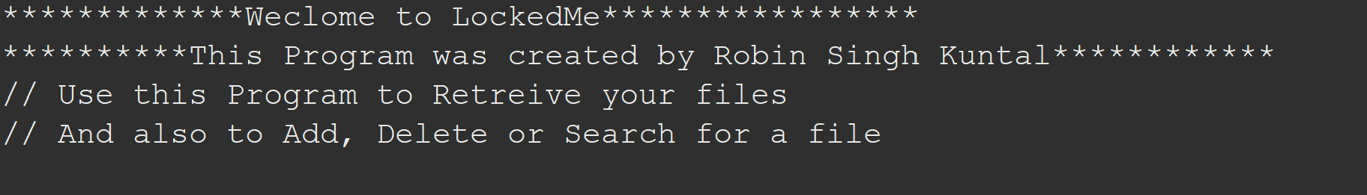

**Step 3.2: Writing method to display Initial Menu**

public static void printMenuoptions() {

String menu = "\n\n****** Please select the action you want to perform from below ******\n\n"

+ "1) Retrieve all files inside \"main\" folder\n"

+"2) Display menu for File operations\n"

+ "3) Exit program\n";

System.out.println(menu);

}

**Output:**

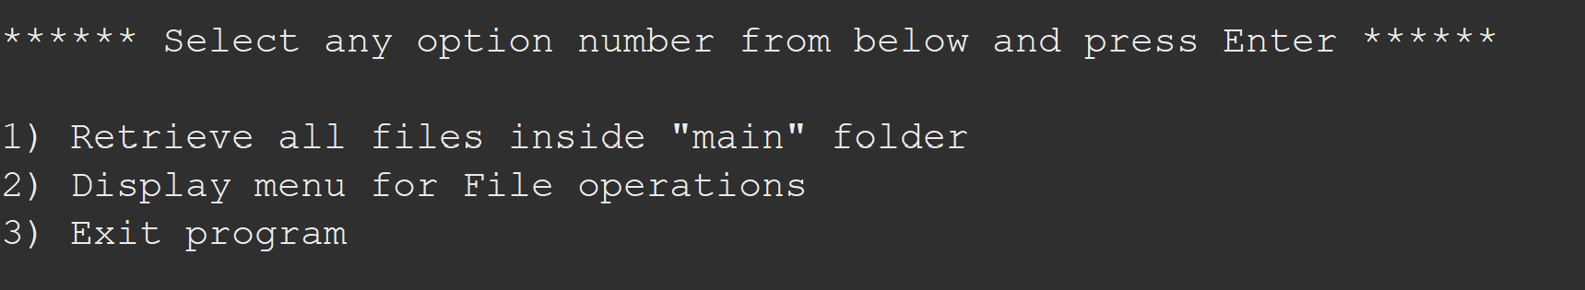

**Step 3.3: Writing code for inner options menu**

public static void innerOperationMenu() {

String fileMenu = "\n\n****** Select any option number from below and press Enter ******\n\n"

+ "1) Add a file to \"main\" folder\n"

+ "2) Delete a file from \"main\" folder\n"

+ "3) Search for a file from \"main\" folder\n"

+ "4) Show Previous Menu\n"

+ "5) Exit program\n";

System.out.println(fileMenu);

}

**Output:**

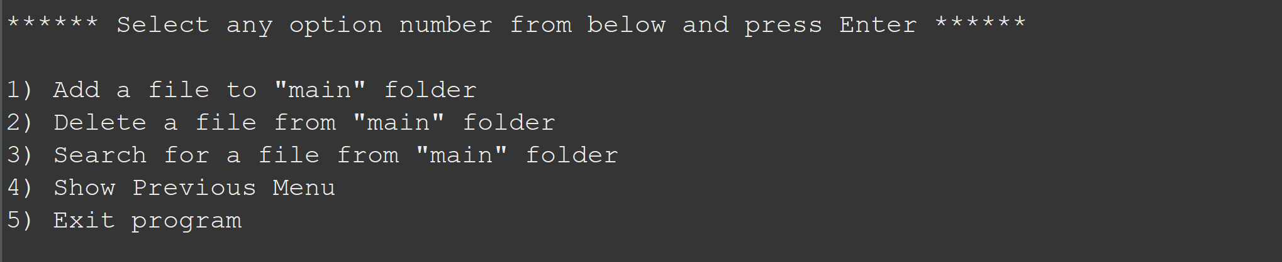

## **Step 4:** Writing a program in Java to handle Menu options selected by user (**HandleOptions.java**)

* Select your project and go to File -> New -> Class.
* Enter **HandleOptions** in class name and click on “Finish.”
* **HandleOptions** consists methods for -:
  1. Handling input selected by user in initial Menu
  2. Handling input selected by user in secondary Menu for File Operations

**Step 4.1:** Writing method to handle user input in initial Menu

package lockedMe.sourceCode.com;

import java.util.List;

import java.util.Scanner;

public class fileHandler {

public static void handleWelcomeScreenInput() {

boolean running = true;

Scanner sc = new Scanner(System.in);

homeMenu.innerOperationMenu();

do {

try {int input = sc.nextInt();

switch (input) {

case 1:

fileOperations.displayfiles("main");

break;

case 2:

homeMenu.innerOperationMenu();

fileHandler.handleFileMenuOptions();

break;

case 3:

System.out.println("Program exited successfully.");

running = false;

sc.close();

System.exit(0);

break;

default:

System.out.println("Please select a valid option from above.");

}

} catch (Exception e) {

System.out.println(e.getClass().getName());

handleWelcomeScreenInput();

}

} while (running == true);

}

**Output:**

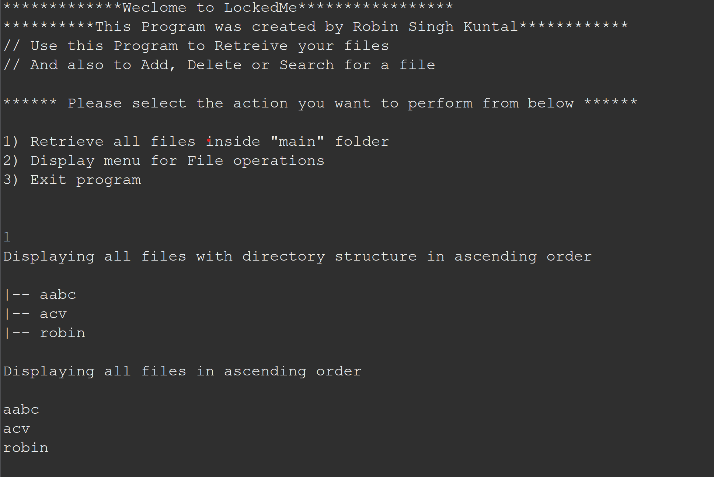

**Step 4.2:** Writing method to handle user input in Secondary Menu

public static void handleFileMenuOptions() {

boolean running = true;

Scanner sc = new Scanner(System.in);

do {

try {

homeMenu.innerOperationMenu();

fileOperations.createMainFolderIfNotPresent("main");

int input = sc.nextInt();

switch (input) {

case 1:

// File Add

System.out.println("Enter the name of the file to be added to the \"main\" folder");

String fileToAdd = sc.next();

fileOperations.createFile(fileToAdd, sc);

break;

case 2:

// File/Folder delete

System.out.println("Enter the name of the file to be deleted from \"main\" folder");

String fileToDelete = sc.next();

fileOperations.createMainFolderIfNotPresent("main");

List<String> filesToDelete = fileOperations.displayFileLocations(fileToDelete, "main");

String deletionPrompt = "\nSelect index of which file to delete?” + "\n(Enter 0 if you want to delete all elements)";

System.out.println(deletionPrompt);

int idx = sc.nextInt();

if (idx != 0) {

fileOperations.deleteFileRecursively(filesToDelete.get(idx - 1));

} else {

// If idx == 0, delete all files displayed for the name

for (String path : filesToDelete) {

fileOperations.deleteFileRecursively(path);

}

}

break;

case 3:

// File/Folder Search

System.out.println("Enter the name of the file to be searched from \"main\" folder");

String fileName = sc.next();

fileOperations.createMainFolderIfNotPresent("main");

fileOperations.displayFileLocations(fileName, "main");

break;

case 4:

homeMenu.printMenuoptions();

return;

case 5:

// Exit

System.out.println("Program exited successfully.");

running = false;

sc.close();

System.exit(0);

default:

System.out.println("Please select a valid option from above.");

}

} catch (Exception e) {

System.out.println(e.getClass().getName());

handleFileMenuOptions();

} while (running == true);

**Output:**

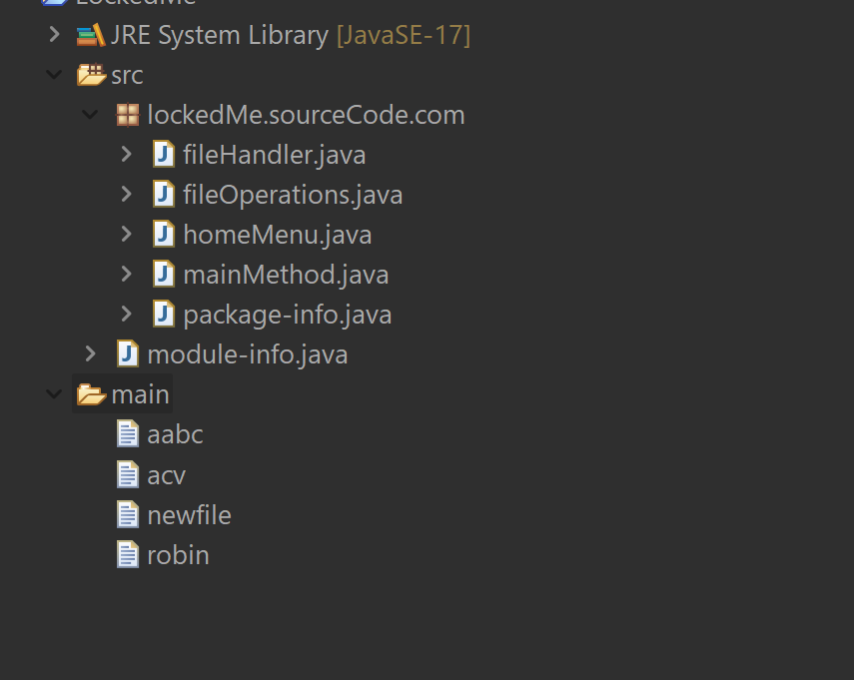

New File created

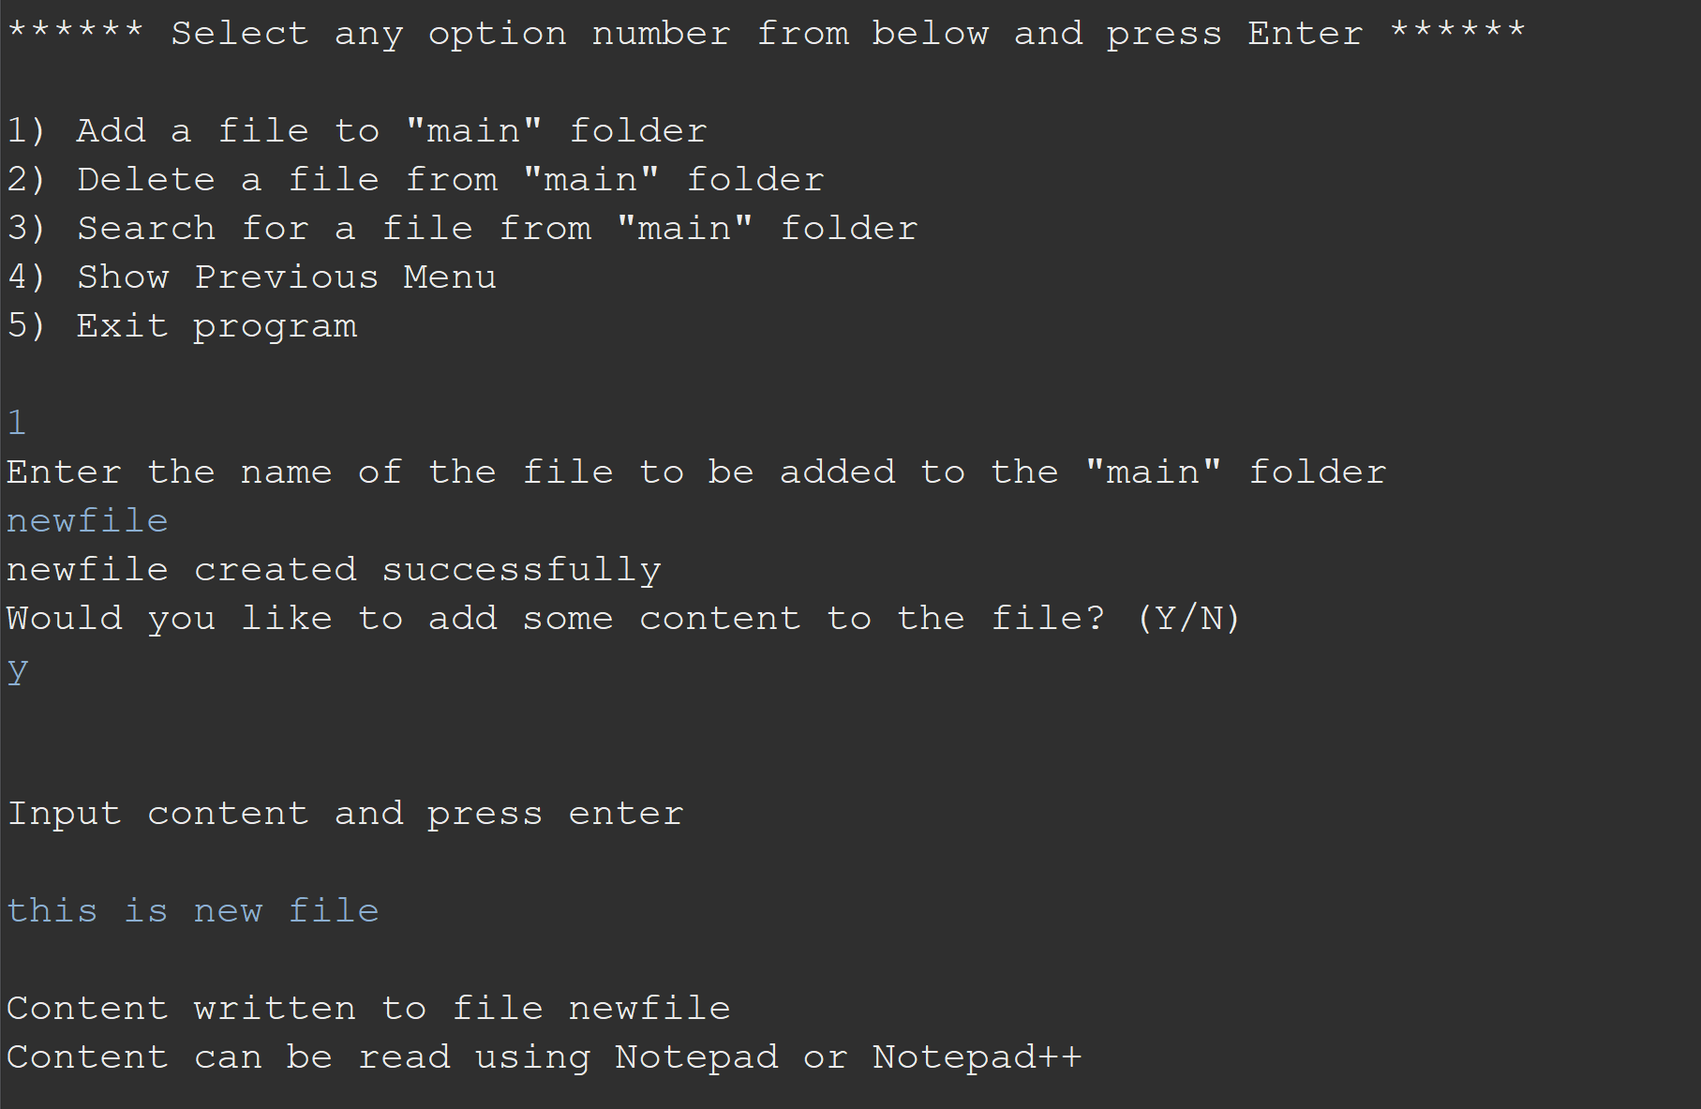

}

## **Step 5:** Writing a program in Java to perform the File operations as specified by user (**FileOperations.java**)

* Select your project and go to File -> New -> Class.
* Enter **FileOperations** in class name and click on “Finish.”
* **FileOperations** consists methods for -:
  1. Creating “main” folder in project if it’s not already present
  2. Displaying all files in “main” folder in ascending order and also with directory structure.
  3. Creating a file/folder as specified by user input.
  4. Search files as specified by user input in “main” folder and it’s subfolders.
  5. Deleting a file/folder from “main” folder

**Step 5.1:** Writing method to create “main” folder in project if it’s not present

public class fileOperations {

public static void createMainFolderIfNotPresent(String folderName) {

File file = new File(folderName);

// If file doesn't exist, create the main folder

if (!file.exists()) {

file.mkdirs();

}

}

**Step 5.2:** Writing method to display all files in “main” folder in ascending order and also with directory structure. (“`--" represents a directory. “|--” represents a file.)

public static void displayfiles(String path) {

fileOperations.createMainFolderIfNotPresent("main");

// All required files and folders inside "main" folder relative to current

// folder

System.out.println("Displaying all files with directory structure in ascending order\n");

// listFilesInDirectory displays files along with folder structure

List<String> filesListNames = fileOperations.listFilesInDirectory(path, 0, new ArrayList<String>());

System.out.println("Displaying all files in ascending order\n");

Collections.sort(filesListNames);

filesListNames.stream().forEach(System.out::println);

}

public static List<String> listFilesInDirectory(String path, int indentationCount, List<String> fileListNames) {

File dir = new File(path);

File[] files = dir.listFiles();

List<File> filesList = Arrays.asList(files);

Collections.sort(filesList);

if (files != null && files.length > 0) {

for (File file : filesList) {

System.out.print(" ".repeat(indentationCount * 2));

if (file.isDirectory()) {

System.out.println("`-- " + file.getName());

// Recursively indent and display the files

fileListNames.add(file.getName());

listFilesInDirectory(file.getAbsolutePath(), indentationCount + 1, fileListNames);

} else {

System.out.println("|-- " + file.getName());

fileListNames.add(file.getName());

}

}

} else {

System.out.print(" ".repeat(indentationCount * 2));

System.out.println("|-- Empty Directory");

}

System.out.println();

return fileListNames;

}

**Output:**



**Step 5.3:** Writing method to create a file/folder as specified by user input.

public static void createFile(String fileToAdd, Scanner sc) {

FileOperations.createMainFolderIfNotPresent("main");

Path pathToFile = Paths.get("./main/" + fileToAdd);

try {

Files.createDirectories(pathToFile.getParent());

Files.createFile(pathToFile);

System.out.println(fileToAdd + " created successfully");

System.out.println("Would you like to add some content to the file? (Y/N)");

String choice = sc.next().toLowerCase();

sc.nextLine();

if (choice.equals("y")) {

System.out.println("\n\nInput content and press enter\n");

String content = sc.nextLine();

Files.write(pathToFile, content.getBytes());

System.out.println("\nContent written to file " + fileToAdd);

System.out.println("Content can be read using Notepad or Notepad++");

}

} catch (IOException e) {

System.out.println("Failed to create file " + fileToAdd);

System.out.println(e.getClass().getName());

}

}

**Output:**

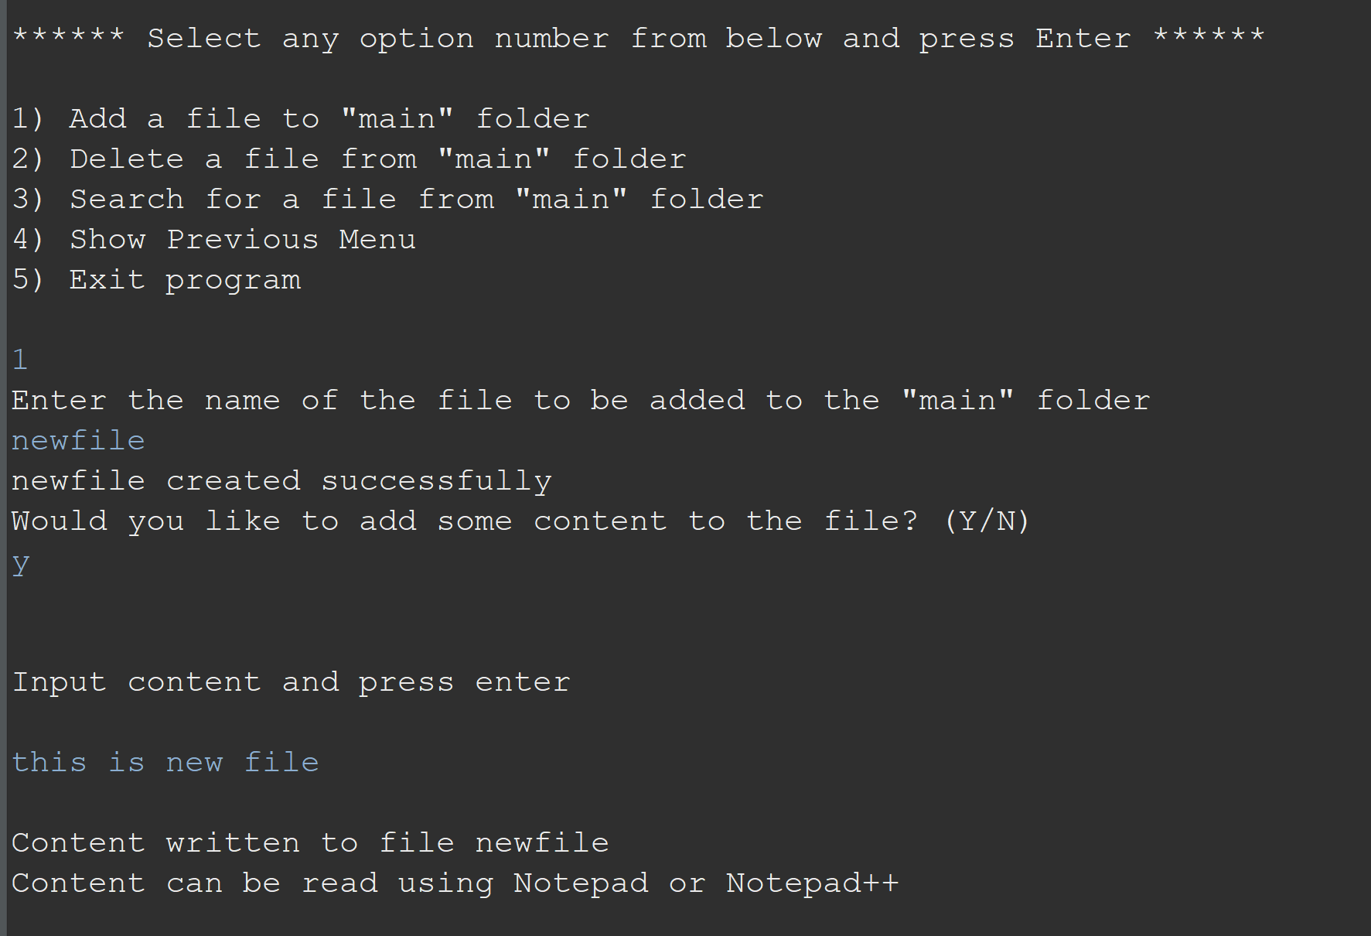

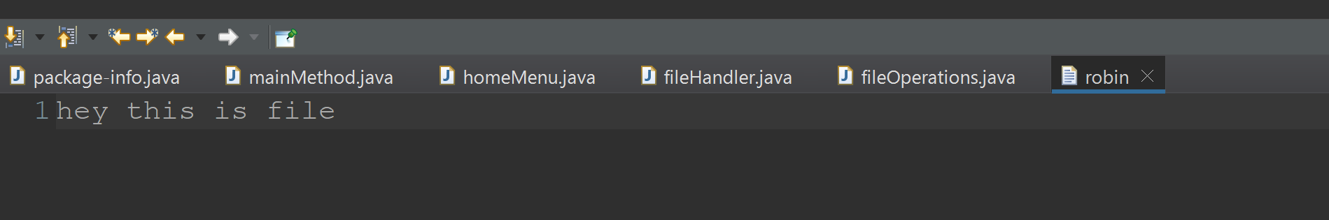

Input given to the file

**Step 5.4:**  Writing method to search for all files as specified by user input in “main” folder and it’s subfolders.

public static List<String> displayFileLocations(String fileName, String path) {

List<String> fileListNames = new ArrayList<>();

FileOperations.searchFileRecursively(path, fileName, fileListNames);

if (fileListNames.isEmpty()) {

System.out.println("\n\n***** Couldn't find any file with given file name \"" + fileName + "\" *****\n\n");

} else {

System.out.println("\n\nFound file at below location(s):");

List<String> files = IntStream.range(0, fileListNames.size())

.mapToObj(index -> (index + 1) + ": " + fileListNames.get(index)).collect(Collectors.toList());

files.forEach(System.out::println);

}

return fileListNames;

}

public static void searchFileRecursively(String path, String fileName, List<String> fileListNames) {

File dir = new File(path);

File[] files = dir.listFiles();

List<File> filesList = Arrays.asList(files);

if (files != null && files.length > 0) {

for (File file : filesList) {

if (file.getName().startsWith(fileName)) {

fileListNames.add(file.getAbsolutePath());

}

// Need to search in directories separately to ensure all files of required

// fileName are searched

if (file.isDirectory()) {

searchFileRecursively(file.getAbsolutePath(), fileName, fileListNames);

}

}

}

}

**Step 5.5:**  Writing method to delete file/folder specified by user input in “main” folder and it’s subfolders. It uses the searchFilesRecursively method and prompts user to specify which index to delete. If folder selected, all it’s child files and folder will be deleted recursively. If user wants to delete all the files specified after the search, they can input value 0.

public static void deleteFileRecursively(String path) {

File currFile = new File(path);

File[] files = currFile.listFiles();

if (files != null && files.length > 0) {

for (File file : files) {

String fileName = file.getName() + " at " + file.getParent();

if (file.isDirectory()) {

deleteFileRecursively(file.getAbsolutePath());

}

if (file.delete()) {

System.out.println(fileName + " deleted successfully");

} else {

System.out.println("Failed to delete " + fileName);

}

}

}

String currFileName = currFile.getName() + " at " + currFile.getParent();

if (currFile.delete()) {

System.out.println(currFileName + " deleted successfully");

} else {

System.out.println("Failed to delete " + currFileName);

}

}

## **Step 6:** Pushing the code to GitHub repository

* Open your command prompt and navigate to the folder where you have created your files.

**cd <folder path>**

* Initialize repository using the following command:

**git init**

* Add all the files to your git repository using the following command:

**git add .**

* Commit the changes using the following command:

**git commit . -m <commit message>**

* Push the files to the folder you initially created using the following command:

**git push -u origin master**

## Unique Selling Points of the Application

1. The application is designed to keep on running and taking user inputs even after exceptions occur. To terminate the application, appropriate option needs to be selected.
2. The application can take any file/folder name as input. Even if the user wants to create nested folder structure, user can specify the relative path, and the application takes care of creating the required folder structure.
3. User is also provided the option to write content if they want into the newly created file.
4. The application doesn’t restrict user to specify the exact filename to search/delete file/folder. They can specify the starting input, and the program searches all files/folder starting with the value and displays it. The user is then provided the option to select all files or to select a specific index to delete.
5. The application also allows user to delete folders which are not empty.
6. The user is able to seamlessly switch between options or return to previous menu even after any required operation like adding, searching, deleting or retrieving of files is performed.
7. When the option to retrieve files in ascending order is selected, user is displayed with two options of viewing the files.
   1. Ascending order of folders first which have files sorted in them,
   2. Ascending order of all files and folders inside the “main” folder.
8. The application is designed with modularity in mind. Even if one wants to update the path, they can change it through the source code. Application has been developed keeping in mind that there should be very less “hardcoding” of data.

## Conclusions

Further enhancements to the application can be made which may include:

* Conditions to check if user is allowed to delete the file or add the file at the specific locations.
* Asking user to verify if they really want to delete the selected directory if it’s not empty.
* Retrieving files/folders by different criteria like Last Modified, Type, etc.
* Allowing user to append data to the file.