ABI-VR application

# Set up:

1: Plug in the sensors and place them on either side of the laptop. The sensors should be about 1.5-2 meters apart.

2: Plug in the headset. The headset has 2 cables to plug in: the HDMI cable and one USB cable.

3: Connect the controllers. Pushing a button on the controllers should turn them on.

4: To make sure the devices are all working open the “Oculus” desktop app. Click the “Devices” tab on the left-hand side of the screen. If all the devices are connected you should see a screen similar to this:

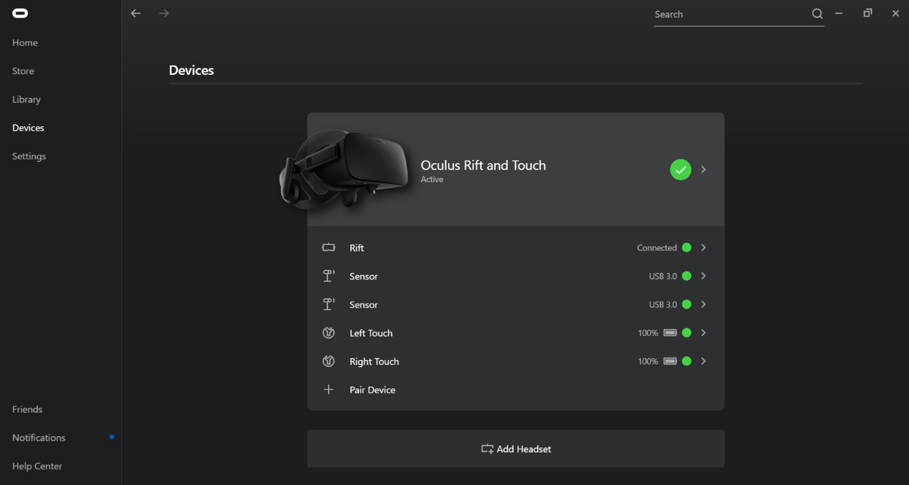

# The application:

1: Open the folder with the application build. There should be a file with extension EXE, for example “ABI-VR.exe”. Double click this file to open the application. A window should pop up: 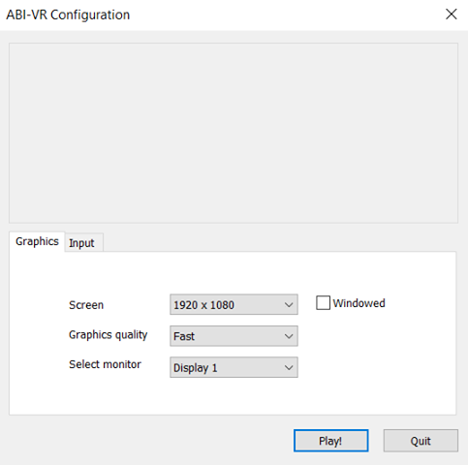

choose the ‘Fantastic’ graphics quality option and click ‘Play!’.

2: Put on the headset and face the sensors. While the application loads you will see a grey screen with the Unity logo. After the load is complete you should see the main menu in front of you. If the main menu is behind you& this is probably because the sensors aren’t set up correctly.

# Sensor setup:

If the sensors aren’t set up the sensors correctly the first time, follow these steps:

* Open the oculus desktop application again.
* Go to the Devices tab.
* Click the “Oculus Rift and Touch” button on the top of the screen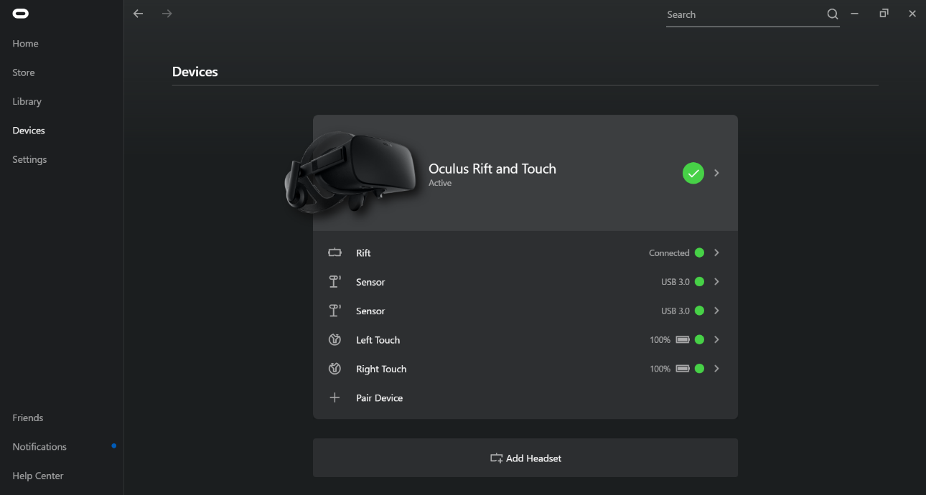
* Another screen should pop up from the right-hand side. Scroll down in the side screen until you see the “Reset Sensor Tracking” option and click it: 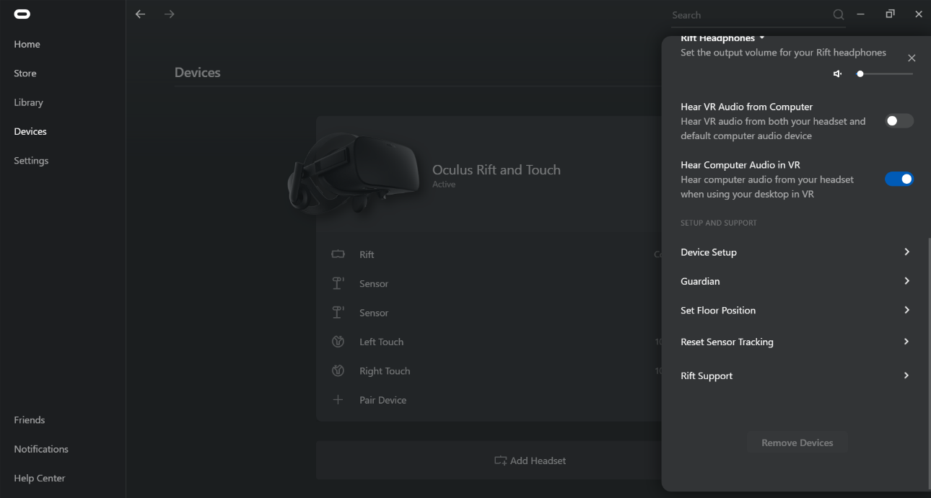
* When you do this, you will see another screen: 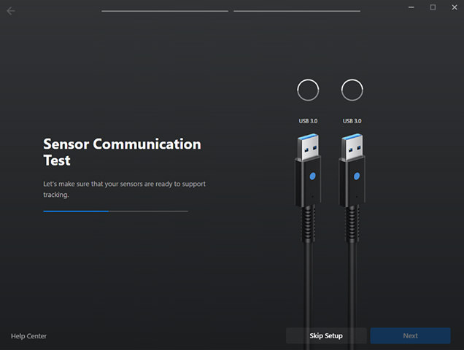
* Follow the instruction on the screen until you see this screen: 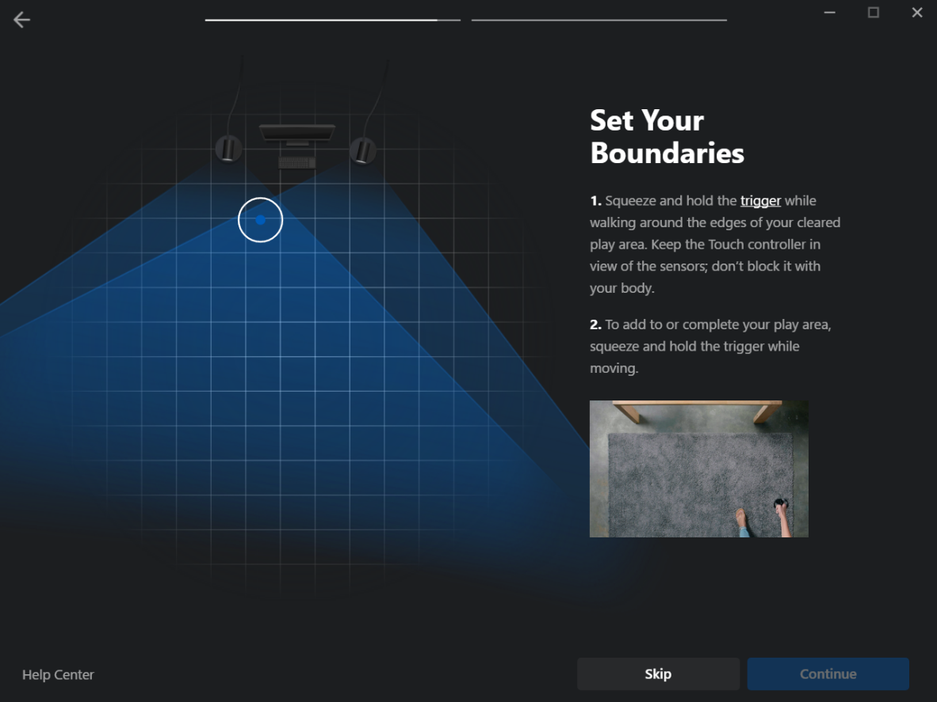
* Click ‘Skip’, ‘Acknowledge & Skip Set Up’
* Keep following the instructions on the screen. You will be asked to continue in the headset, this is to confirm the sensor positions. After you do this the setup is complete and you can restart the ABI-VR application.
* The menu should now be in the right place.