HW #5.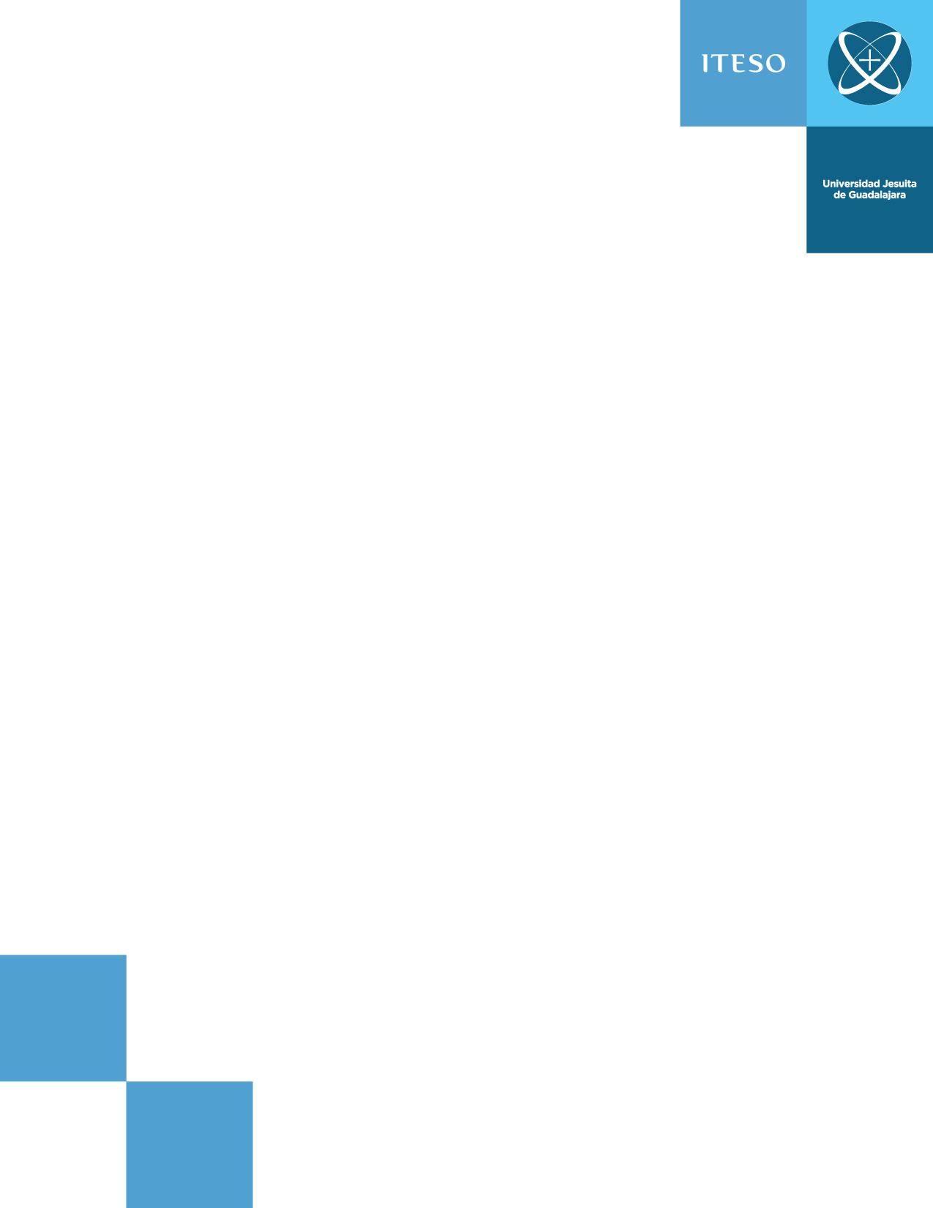



**Team:**

Robin Moisés Salgadp

Esteban González Moreno.

**Date:** 2 de marzo de 2019.

**Teacher:** Ramírez Pérez Abisai.



In Magenta is the signal “out”, in cyan is the “Selector” and in yellow is the “inp”

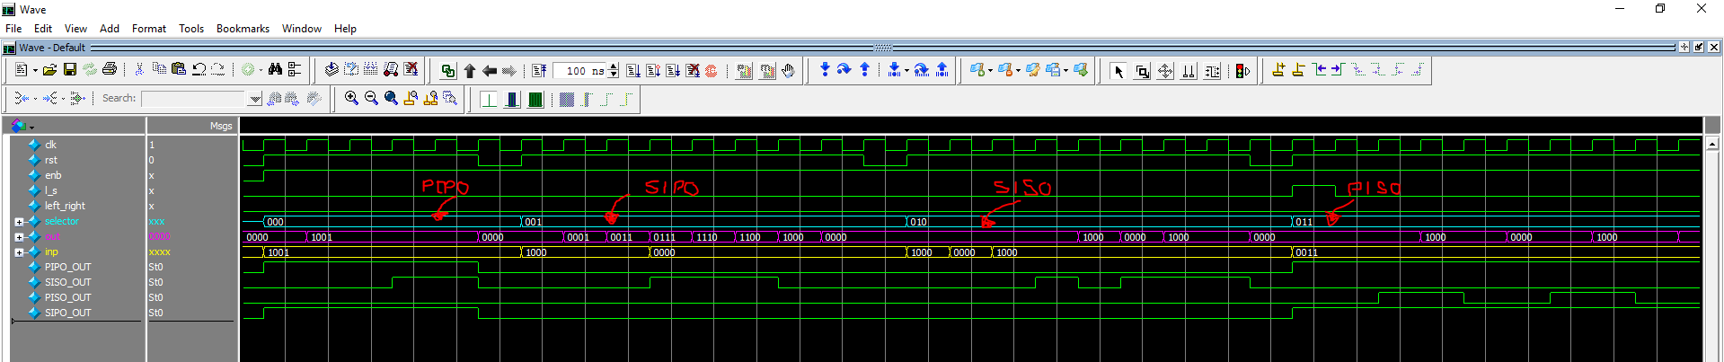

Continuation of the simulation in time . . .

